CTCT 2200/2203
Computer Literacy

Fall 2023

Business/Marketing Education
College of Education

Professor:
Dr. Elisha Wohleb
wohleec@auburn.edu
334-844-8724
Office: 0303B Haley Center

Office Hours:
Tuesday
8:00-11:00

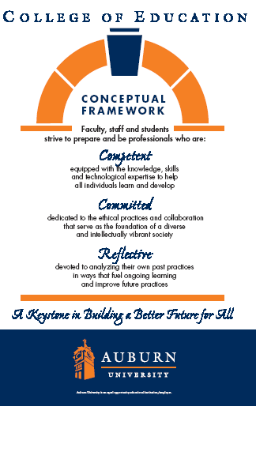

AUBURN UNIVERSITY SYLLABUS

Course Number: | CTCT 2200/2203
Course Title: | Computer Literacy
Credit Hours: | 3 semester hours (Lecture 3)
Class Time: | M/W 12:00-12:50 (Friday – lab days)
Prerequisites: | None
Co requisites: | None
Instructor: | Dr. Elisha Wohleb
Office Location: | 0303b Haley Center
Office Hours : | TU 8:00-11:00  Other times by appointment
Office Phone: | 334-844-8724
E-mail: | wohleec@auburn.edu
1. Date Syllabus Prepared: Fall 2023

- Texts:
LMS Integrated for MindTap® Computing, 1 term (6 months) Technology for Success *I would recommend purchasing Cengage Unlimited.

COURSE OVERVIEW

Course Description:
This course is designed to provide the student with the knowledge of basic computer concepts with an emphasis on both the personal computer and computing at work. Topics include hardware, application and system software, the Internet and World Wide Web (WWW), communications, e-commerce, societal issues, database management, systems analysis and design, programming, information systems, career opportunities, certification in the computer field, and computer trends.
Student Learning Outcomes:
- Plan, develop, and deliver oral presentation using presentation software.(290-3-3-.25-1-b-2-2003)
- Use computer hardware and software in word processing, spreadsheet, and database software to create, modify, and print documents. .(290-3-3-.25-1-b-3-2003)
- Demonstrate knowledge of computer technology (290-3-3-.25-1-a-3-2003)
- Explain computer network management and support (290-3-3-.25-1-b-10-2003)
- Demonstrate knowledge of information processes. (290-3-3-.25-1-a-2003)

Course Requirements:
- Read lesson materials in MindTap
- Complete the Computer Concepts Exam for each module.
- Complete the discussion or each module – remember to respond to at least two of your classmates.
- Complete and turn in assignments at the assigned time. This is a very fast-paced course. It is highly recommended that you stay on schedule with assignments. Late assignments will not be accepted. All weekly assignments are due as presented in MindTap, typically each Sunday night by 11:59pm.
- Complete a Final Project which includes selecting a chapter from the MindTap lessons and creating a presentation. See week 16 for a detailed description of the requirements. No late presentations will be accepted.

Course Outline:

See Fall 2023 Schedule in Canvas

EVALUATION METHOD(S):

The final course grade is based on three major components:

Component 1: Weekly Assignments 75%
Component 2: Discussions 15%
Component 2: Final Project 10%

Grading Scale (10-point):

90-100 A
80-89.9 B
70-79.9 C
60-69.9 D
<60 F

3. Class Policy Statements:

Participation: Students are expected to participate in all class discussions and participate in all exercises. It is the student’s responsibility to contact the instructor if assignment deadlines are not met. Students are responsible for initiating arrangements for missed work.

Late Work will not be accepted.

Attendance/Absences: For on campus students, attendance is required at each class meeting. Distance learning students must log on and participate in Canvas weekly. If an exam is missed, a make-up exam will be given only for University-approved excuses as outlined in the Student Policy eHandbook; the URL is www.auburn.edu/studentpolicies. Arrangement to take the make-up exam must be made in advance. Students who miss an exam because of illness need a doctor’s statement for verification of sickness and should clear the absence with the instructor the day they return to class. Other unavoidable absences from campus must be documented and cleared with the instructor in advance.

Unannounced quizzes: There will be no unannounced quizzes.

Accommodations: Students who need accommodations are asked to electronically submit their approved accommodations through AU Access and to arrange a meeting during office hours the first week of classes, or as soon as possible if accommodations are needed immediately. If you have a conflict with my office hours, an alternate time can be arranged. To set up this meeting, please contact me by e-mail. If you have not established accommodations through the Office of Accessibility, but need accommodations, make an appointment with the Office of Accessibility, 1228 Haley Center, 844-2096 (V/TT).

Honesty Code: The University Academic Honesty Code and the Student Policy eHandbook (www.auburn.edu/studentpolicies) pertaining to cheating will apply to this class.

Professionalism: As faculty, staff, and students interact in professional settings, they are expected to demonstrate professional behaviors as defined in the College’s conceptual framework. These professional commitments or dispositions are listed below:
- Engage in responsible and ethical professional practices
- Contribute to collaborative learning communities
- Demonstrate a commitment to diversity
- Model and nurture intellectual vitality

Distance Learning Students: Unless specific instructions have been given for a designated course, students in distance education courses shall take all closed resource examinations under the supervision of ProctorU.
The instructor reserves the right to make changes to the syllabus, class requirements, and schedule.

