**CTEC 3020**

**Primary Math and Science**

# Auburn University Syllabus, Fall 2023

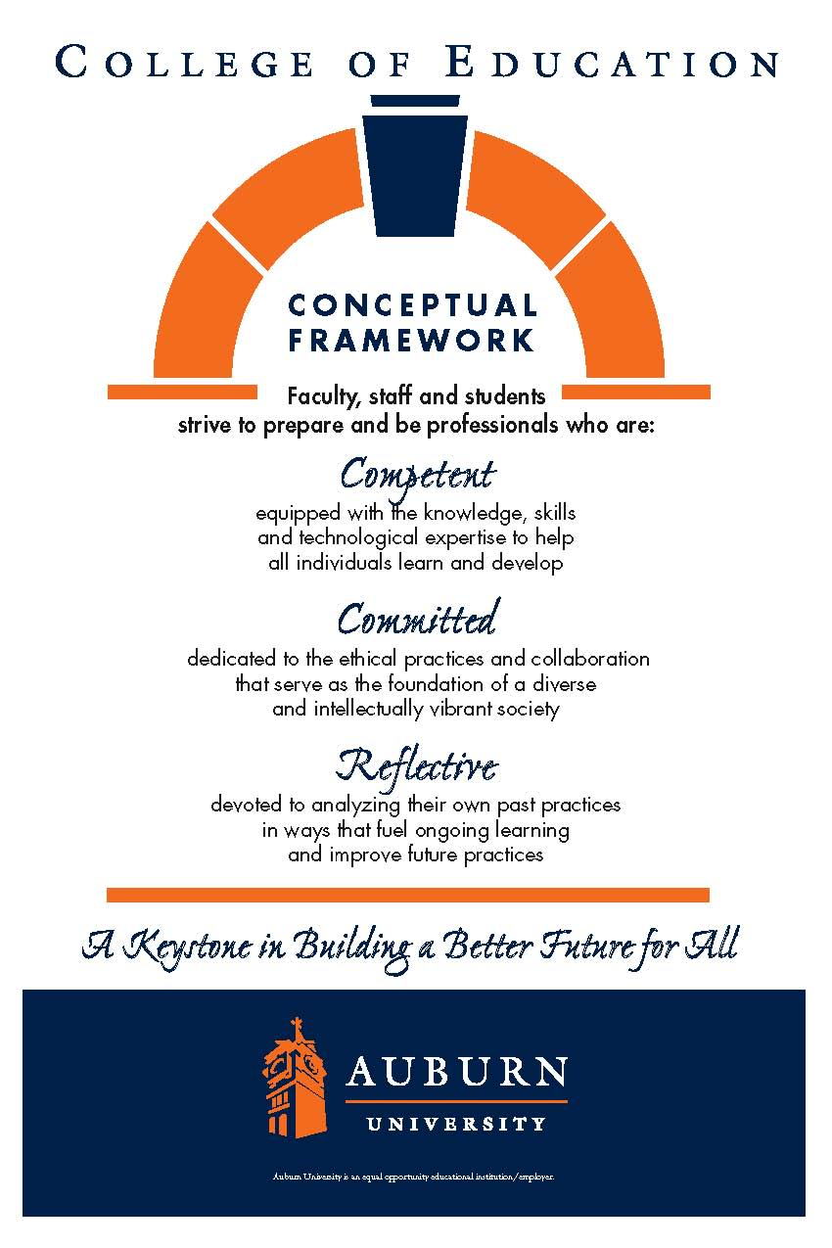

**Schedule: T/R 8:15-12:15, M 5:00-7:30**

**Location: Haley**

**Credit Hours:** 3 semester hours

**Prerequisites:** Admission to Early Childhood Teacher Education, Completion of CTEC 3030/4911 and CTEC 3200/4200

**Co-requisites:** CTEC 4912

**Instructor:** Ms. Lindsay Griffies

**E-mail:** griffli@auburn.edu

**Office:** 5014 Haley Center

**Office Hours:** By appointment

**Phone:** 334-321-8182 Please call/text between the   
 hours of 8:00 am-8:00pm

**Required Texts:**

Chaille, C. M., & Davis, S. M. (2015). *Integrating math and science in early childhood classrooms through big ideas: A constructivist approach.* New York, NY: Pearson.

Parrish, S. (2010). *Number talks: Whole number computation, grades K-5*. Sausalito, CA: Math Solutions.

Van de Walle, J. A., Lovin, L. A. H., Karp, K. S., & Bay-Williams, J. M. (2018). *Teaching student centered mathematics: Developmentally-appropriate instruction for grades pre-k – 2.* New York, NY: Pearson.

*Required reading includes articles posted to Canvas. All readings will be announced on Canvas and provided whenever possible (in Files).*

*You are required to have a* ***composition notebook*** *for your combined math journal and science notebook.*

\***Important Websites:**

**Use these websites as resources for assignments and teaching, both in-class and for practicum.**

**\*NAEYC Code of Ethics**

[**https://www.naeyc.org/about-us/people/naeyc-gb/apply-for-board-service/code-of-ethics**](https://www.naeyc.org/about-us/people/naeyc-gb/apply-for-board-service/code-of-ethics)

**\*Claire Warden Mind-stretchers Academy: Bringing Learning Alive**

[**https://mindstretchers.academy/**](https://mindstretchers.academy/)

[**https://mindstretchers.academy/pages/reflective-practice-and-research**](https://mindstretchers.academy/pages/reflective-practice-and-research)

**\*NCTM, has videos of excellent teaching**

National Council of Teachers of Mathematics (NCTM):  [http://www.nctm.org](http://www.nctm.org/)

**\*Your *Number Talks* text by Sherry Parrish has NT videos to watch, also.**

**Investigations in Number, Data, & Space**

- curriculum & the CCSS:<https://investigations.terc.edu/CCSS/>

- online games/activities. K-1**:**<http://investigations.terc.edu/library/Games_K1.cfm>

- online games/activities, 2-3**:**<http://investigations.terc.edu/library/Games_23.cfm>

- games/activities to do offline:<http://investigations.terc.edu/families/doing_math/books_and_resources/>

- Investigations support resources (number talks, blackline masters, CCSS, math links, etc):<https://sites.google.com/site/get2mathk5/home/investigations-support>

- Illuminations:<http://illuminations.nctm.org>

- Blackines:<https://sites.google.com/site/get2mathk5/home/templates-graphic-organizers>

**Professional Development - inside mathematics (problem of the month by grade level, video:**<http://insidemathematics.org>

**Math Dictionary for Kids:**<http://www.amathsdictionaryforkids.com/dictionary.html>

**Next Generation Science Standards**

- A Framework for K-12 Science Education: [https://www.nap.edu/download.php?record_id=13165#](https://www.nap.edu/download.php?record_id=13165)

**Children & Nature Network:**<http://www.childrenandnature.org>

**Engineering Toys for Girls**

- GoldieBlox (Debbie Sterling, founder) website:<http://www.goldieblox.com/pages/about>

- GoldieBlox YouTube Channel:<https://www.youtube.com/channel/UCJUn6QmXuFV9CkuJB9T7F_w>

**Academic Language**

- New Teacher Center Oral Language Development:<http://old.newteachercenter.org>

**Other** **Useful Websites**

National Association for the Education of Young Children:<http://www.naeyc.org>

National Science Teachers Association (NSTA):<http://www.nsta.org>

National Council of Teachers of English (NCTE):<http://www.ncte.org>

Alabama Math, Science, and Technology Initiative:<http://www.amsti.org>

Alabama State Department of Education: http://www.alsde.org

American Montessori Society:<http://www.amshq.org>

North American Montessori Teachers Association:<http://www.montessori-namta.org>

**COURSE DESCRIPTION**

This course is to provide pre-service teachers opportunities to be more knowledgeable and practical in early childhood (Pre-K, K-3rd grade) curriculum and instruction in the areas of mathematics and science. Pre-service teachers will have a better understanding of children’s learning and development, curriculum development, and instructional methods. Based on their understanding of early learning standards as well as aforementioned areas, pre-service teachers will apply their knowledge to designing, implementing, and evaluating the interdisciplinary curriculum. In addition, through hands-on activities and teaching demonstrations, they will also develop effective teaching strategies working with young children that can be used in their future classrooms.

**COURSE OBJECTIVES**

Upon completion of the course, students will be able to:

1. Identify important mathematics /science content, process skills, and attitudes appropriate to young children. (NAEYC Standard 1b, 4a, 4b, 4c, & 4d)

2. Become acquainted with the principles and elements of curriculum development (e.g., goal setting, planning, implementing, and assessing curriculum) in mathematics and science. (NAEYC Standard 1a, 1b, 1c, 4b, 4c & 4d)

3. Develop an understanding that early childhood curriculum is an integrated curriculum, and that children’s learning in mathematics and science takes place in integrated learning experiences with concrete materials in a variety of contexts. (NAEYC Standard 4c)

4. Design, implement, and evaluate developmentally appropriate curricular content, strategies, and instructional materials, and reflect on their performance. (NAEYC Standards 1a, 1b, 1c, 4b, 4c, & 4d)

5. Understand how to record, report, and evaluate the development level of young children through naturalistic/performance-based assessment and utilize developmentally appropriate assessment and reporting techniques. (NAEYC Standards 3a, 3b, & 3c)

**AUBURN COLLEGE OF EDUCATION-CONCEPTUAL FRAMEWORK**

Competent

Competent professionals demonstrate the knowledge and skills needed to facilitate the learning of the individuals they serve. Their competence enables them to model and promote active, collaborative, and ongoing learning. Their efforts are enhanced by their abilities to foster learning communities that are safe, stimulating, and enriched with diversity; engage in reasoned and purposeful decision making; and implement their professional practices in proactive, flexible, and self-regulating ways.

We recognize that the development of professional competence is linked to levels of preparation and experience. We also acknowledge that competence continues to develop over the course of an entire career.

Committed

Committed professionals make reasoned decisions based on thoughtfully constructed values. As a College, we strive to nurture values that support the learning of all people, honor diversity, protect the integrity of learning, and expand the scholarship of our professions. We view these values as professional dispositions, and we define them as filters for responsible decision-making. Our College emphasizes the conscious development of commitments related to professional responsibilities and ethics, collaboration, diversity, and intellectual vitality.

Reflective

We choose to frame reflection as a critical and pervasive habit of mind that permeates and fuels the ongoing expansion of competence and the continued development of reasoned commitments. Reflective professionals subject their own competencies and commitments to continuous scrutiny as they systematically monitor the impact of their professional practices on the individuals they serve and make adjustments as needed. Thoughtful reflection emphasizes reviewing and analyzing past practices in ways that influence and improve future practices. This stance inspires self-initiated professional growth and results in increased capacities for addressing the complexities and dilemmas situated within the work of educational and human services professionals.

**COURSE REQUIREMENTS**

1. Math Journal & Science Journal **(50 Points) ( Due December 1):**

* In class reflections (some you may have you will have to finish at home)
* Daily notes (on campus and in classroom)

Your process for investigating how you plan your Integrated Science Unit

2. Big Idea Chaille Chapter Group Presentations) **(50 Points):**

* Each person, with one or two others, will present and lead discussion of a chapter from *Integrated Math and Science,* including an activity, lesson plan, and evaluation of student learning. Include meaningful discussion questions, additional resources, and suggested activities to be done, upon which each person will reflect and discuss online. Further instructions will be made available on Canvas.

3. Van de Walle Independent Weekly Group Meetings **(100 Points):**

* Each week, a different person will be responsible for submitting their groups discussion topics and notes. Each presentation should include synthesized information from the chapter along with practical applications of the information. Your weekly meetings should be one hour. How do you integrate nature in these lessons and curriculum?

4. Integrated Math/Science Unit **(100 Points): (Due Dec 7)**

Further instructions will be provided for this practice edTPA assignment. Briefly, your integrated unit will be determined by the children’s interests in your classroom, and build on a nature-based science topic, integration of math, children’s literature, writing, and investigation. For example, this may be a project investigating an insect or butterflies found in the school yard, culminating with a book-making project that the children make using the photos and descriptions they take of the insects, its habitat, feeding habits, etc., including observations they do of the insect or tree or ant hill, etc. You will justify your decision based on your observations of the children’s interests and the Next Generation Science Standards, and the Alabama College and Career Ready State Standards for Math and Language Arts.

* 3 linked lessons integrating science, math, and literacy (including writing, but also will include at least one of the following — poetry, literature, research, music lyrics, all constructed by students)
* Video record and reflect on one of the three linked lessons (50/100 pts.)— required reflections will contain commentary on planning, implementing, and reflecting on student learning; upload video on Canvas.

5. Number Talks **(60 Points) (Due: October 27):**

* Lesson plan design,
* Trial run with class peers
* Implement in classroom with students (video recorded)
* Implementation and video reflection paper.

6. **Participation in class, in small groups, in section groups, and any other assigned meetings (40 points).**

* Be sure you have read the policies related to COVID-19 regarding attendance and participation.
* If we have zoom meetings you must be ON TIME and keep you video on for the entire class/meeting as scheduled.

You must mute unless you are adding to the discussion and be ready to respond if called on.

* ·Offer insight from readings and video recordings required for outside reading and viewing.
* ·Be the emerging professional you are the semester before your internship.

**GRADES**

**A = 91-100% (400- 360 points), B = 81-90% (359- 320 points), C=71-80% (319- 280 points), D=61-70% (279- 240 points), F=60% or below (239-0 points).**

**Fall 2023 – 3020 Course Schedule**

**\*This schedule is subject to change. The instructor will announce changes through Canvas announcement. Check Canvas regularly for updates and information.**

|  |  |
| --- | --- |
|  | **August 17** – Thursday (Haley 8:15-12:15)  Introductions, Syllabus 3020,4912, Journal entry 1, horse problem-Journal 2, Integrating Math and Science, Journal 3, ALEX standards  Sign up for Chaille presentations |
| **August 22 – AMSTI (8:30-3:30) Math**  Journal 4 – Reflection from AMSTI | **August 24 – AMSTI (8:30-3:30) Math**  Journal 5 – Reflection from AMSTI |
| **August 29 – Tuesday (Haley 8:15-12:15)**  Arboretum-observe/take pictures/discuss  Journal 6, Science Presentation, Journal 7, Discuss Chaille 1-3, Journal entry 8 (locker problem, Journal 9, Work on presentations | **August 31 – Thursday (Haley 8:15-12:15**)  Journal 10 (handshake problem), Chaille Presentations 4-6, Journal 11, NT Chapters 1-2 (J-12) Number Talks Video (Journal 13) |
| **September 5 – Tuesday (Haley 8:15-12:15)**  Journal 14 (store problem), Chaille Presentations 7-9, Journal 15, Math presentation, Journal 16 (can of coke), Journal 17-Number Talks 3-4 | **September 7 – Thursday (Haley 8:15-12:15)**  Journal 18 (Shakira’s Number)  Discuss practicum, lesson plans, forms, placements/assignments/canvas  Due: Teaching Student Math Ch 1-2 Journal 19 |
| September 12 – Tuesday **(First day of 4912)** | September 14 – Thursday  IGDP Due: September 21 (Chapter 3-4) |
| September 19 – Tuesday | September 21 – Thursday Independent Group IGDP Due: September 21 (Chapter 5-7) |
| **September 26 – AMSTI (8:30-3:30)**  **Science, Journal 20 - AMSTI** | **September 28 – AMSTI (8:30-3:30)**  IGDP Due: September 28 (Chapter 8**), Jour-21** |
| **October 2 – Monday**  **Ashley Smith – PLT, Journal 22** | **October 5 –**  IGDP Due: October 5 (Chapter 9) |
| **October 9 – Monday**  **Haley 2442-Number Talks/ Integrated Unit** | October 12 – Thursday  IGDP Due: October 12 (Chapter 10) |
| **October 16 – Monday (No Class)** | October 19 – Thursday  IGDP Due: October 19 (Chapter 11) |
| **October 23 – Monday**  **Guest Speaker, VandeWalle** | October 26 – Thursday  IDGP Due: October 26 (Chapters 12-13)  Number Talks Due |
| **October 30 – Monday (No Class)** | November 2  IDGP Due: November 2 (Chapter 14) |
| November 6 – Monday  Guest Speaker & VandeWalle | November 9– Thursday  IDGP: Due November 9 (Chapter 15) |
| November 13 – Monday | November 16 – Thursday  IDGD: Due November 16 (Chapters 16-17) |
| **November 21-November 25 (Thanksgiving Break)** |  |
| November 28 – Tuesday | November 30 – Thursday  Math/Science Journal Due |

**CLASS POLICY STATEMENTS**

Participation: Students are expected to participate in all class discussions and participate in all exercises. It is the student’s responsibility to contact the instructor if assignment deadlines are not met. Students are responsible for initiating arrangements for missed work.

Attendance/Absences: In-person attendance is expected and required at each class meeting. Exceptions to in-person attendance will be granted for COVID-19 or other medical related reasons. It is your responsibility to inform the professor if you are unable to attend in person. In these cases, the student will be able to attend online. If an assignment is missed, a make-up assignment will be given only for University-approved excuses as outlined in the [Student Policy eHandbook](http://www.auburn.edu/student_info/student_policies/#http://www.auburn.edu/student_info/student_policies/). Arrangement to take the make-up assignment must be made in advance. Students who miss an assignment because of illness need a doctor’s statement for verification of sickness and should clear the absence with the instructor the day they return to class. Other unavoidable absences from campus must be documented and cleared with the instructor in advance. **Each unexcused absence** will result in 5 points deducted from the class participation grade. If points from absences exceed the 25 points allotted for class participation, the points will be taken from the final total.

Accommodations: Students who need accommodations are asked to electronically submit their approved accommodations through AU Access and to arrange a meeting the first week of classes, or as soon as possible if accommodations are needed immediately. If you have not established accommodations through the Office of Accessibility, but need accommodations, make an appointment with the Office of Accessibility, 1228 Haley Center, 844-2096 (V/TT). See<https://fp.auburn.edu/disability/faculty/syllabus.asp>

Honesty Code: The University Academic Honesty Code and the [Student Policy eHandbook](http://www.auburn.edu/student_info/student_policies/#http://www.auburn.edu/student_info/student_policies/) Rules and Regulations pertaining to Cheating and Plagiarism will apply to this class. See<https://sites.auburn.edu/admin/universitypolicies/Policies/AcademicHonestyCode.pdf>

Professionalism: As faculty, staff, and students interact in professional settings, we are expected to demonstrate professional behaviors as defined in the College’s conceptual framework. From NAEYC, early childhood professional commitments or dispositions are:

|  |
| --- |
| 1. Creates a caring and supportive learning environment and encourages self-directed learning by each student. |
| 2. Demonstrates behaviors that are consistent with the ideals of fairness and the belief that all students can learn. |
| 3. Demonstrates, models, and exemplifies a commitment to diversity. |
| 4. Engages in responsible and ethical professional practices (shows trustworthiness, nurtures professional relationships, maintains confidentiality regarding students and school matters). |
| 5. Demonstrates professionalism by being prepared, dressing professionally, communicating appropriately, and fulfilling attendance expectations. |
| 6. Shows respect for and cooperates with students, families, colleagues, and members of the community. |
| 7. Shows initiative and self-direction in classroom activities (e.g., organization and management of classroom, planning and implementation of instruction). |
| 8. Follows policy regarding use of digital tools and models digital citizenship and responsibility (e.g., the appropriate use of social media). |
| 9. Contributes to collaborative learning community, models and nurtures intellectual vitality, and demonstrates interest and enthusiasm for the profession. |
| 10. Accepts/acts on constructive criticism and suggestions in a professional way. |
| 11. Monitors and adjusts own professional dispositions as necessary. |
| 12. Reflects on and analyzes past practices to stimulate ongoing improvement for future practice. |

**Competent Professionals (See COE website:** [**http://www.education.auburn.edu/about-the-college/conceptual-framework/conceptual-framework-background/proficiencies/**](http://www.education.auburn.edu/about-the-college/conceptual-framework/conceptual-framework-background/proficiencies/)

1. Understand the central concepts, tools of inquiry, and structures of the content they teach or practice.

2. Create learning experiences that make the content they teach or practice meaningful for individuals.

3. Understand how individuals differ in their approaches to learning and create instruction or implement other professional practices adapted to this diversity.

4. Use knowledge of how individuals learn and develop to provide educational opportunities that support intellectual, social, and personal development.

5. Understand and use a variety of evidence-based professional practices in reasoned and flexible ways to encourage individual development of critical thinking, problem solving, and performance skills.

6. Use an understanding of individual and group motivation and behavior to create a learning environment that encourages positive social interaction, active engagement in learning, and self-motivation.

7. Use knowledge of effective verbal and non-verbal communication to foster active inquiry, collaboration, and supportive interaction in learning environments.

8. Plan professional practices based upon knowledge of subject matter, individuals, the community, and identified goals.

9. Understand and use formal and informal assessment strategies to evaluate and ensure continuous progress toward identified goals.

10.Use technology in appropriate ways.

**Committed Professionals**

11. Engage in responsible and ethical professional practices.

12. Contribute to collaborative learning communities.

13. Demonstrate a commitment to diversity.

14. Model and nurture intellectual vitality.

**Reflective Professionals**

15. Analyze past practices to stimulate ongoing improvement of future practices.

**\*Mobile Device Policy:** Smartphone use or text messaging or unapproved iPad/Tablet or laptop usage during the class session is viewed as extremely unprofessional and will result in an automatic loss of 5 points of **Class Participation and Professional Behavior grade points** (under COURSE REQUIREMENTS) **for the first occurrence; additional points will be deducted for repeated occurrences**. It is best that phones, iPads, and laptops not be visible during the class session to avoid any misunderstanding of their use.