

Thursdays, 12:30- 3:15 pm

Haley Center 2406

**Martina P. McGhee, Ph.D.**

Haley Center, 5026

[mpm0060@auburn.edu](mailto:mpm0060@auburn.edu)

Office Phone: 334- 844- 6791

Community Office Hours: W: 3:30-5:00; By appointment

**Course Description**

This course supports entering elementary education majors with the knowledge, skills, and dispositions required for the elementary teaching profession. Students will be introduced to the professional expectations of elementary teachers and to the organization of elementary schools. They will reflect on important dispositions necessary to become an inclusive, reflective educator who strives for continual professional growth and equity in schools.

**Course Objectives**

*Students will:*

* Describe the dispositions and instructional philosophies that create a supportive, equitable, and inclusive learning environment.
* Explain the research-based rationale behind current learning theory and the Learning Cycle. (AQTS 290-3-3-.04(2)(c)4.(ii)
* Evaluate the appropriate use of “best practice” strategies for instruction in content areas. (AQTS 290-3-3-.04(2)(ii)
* Develop lesson plans that align with standards and incorporate research-based strategies for student learning. (AQTS 290-3-3-.04(1)(iii)
* Develop a variety of assessments for summative and formative purposes. (AQTS 290-3-3-.04(2)(c)5.(i, ii) (AQTS 290-3-3-.04(5)(c)5.(ii,iii,iv,v,vi,vii,viii,ix,x)
* Create an integrated unit plan for instruction at a chosen grade level for diverse learners. (AQTS 290-3-3-.04(2).(I, ii,iii)
* Consider the role of reflection in continuous improvement as an elementary educator. (AQTS 290-3-3-.04(5)(c)2.(vi)
* Reflect on the role of the elementary teacher as a professional. (AQTS 290-3-3-.04(5)(c)2.(viii)

**CIEP Alignment**

|  |  |
| --- | --- |
| **CIEP Standards** | **Course Assignment** |
| Standard 1 | Integrated Unit Plan |
| Standard 5.1 | Professional Book Club  Website Portfolio (includes teaching philosophy) |
| Standard 5.2 | Professional Book Club |

**Essential Questions**

* What is good teaching?
* What does it mean to be a professional in the Education field?
* How can I become an effective elementary school teacher?
* How can I design a unit plan that meets standards, addresses students’ learning needs, and connects to students’ lives?

**Required Texts & Materials**

Texts: (Selected for Book Clubs during the first week of classes)

* We Want to do More Than Survive: Abolitionist Teaching and the Pursuit of Educational Freedom (Love)
* Pushout: The Criminalization of Black Girls in Schools (Morris)
* The Reason I Jump (Higashida)
* Reaching and Teaching Students in Poverty (Gorski)
* Black Ants and Buddhists: Thinking Critically and Teaching Differently in the Primary Grades (Cowhey)
* These Kids Are Out of Control: Why We Must Reimagine Classroom Management for Equity (Milner)
* The Language Lens for Content Classrooms: A Guide for K-12 Educators of English and Academic Language Learners (Ottow)
* Unearthing Joy: A Guide to Culturally and Historically Responsive Curriculum and Instruction ([Muhammad](https://shop.scholastic.com/teachers-ecommerce/teacher/books/unearthing-joy-9781338856606.html))

Additional Resources:

* Alabama Educator Code of Ethics State of Alabama Department of Education
* [Alabama Core Teaching Standards](https://www.alabamaachieves.org/wp-content/uploads/2021/09/Alabama-Core-Teaching-Standards_290-4-3-.03-004.pdf)

Materials:

* Markers and/or crayons
* Post-it notes
* Composition Notebook (for Educator’s Journal)
* Mask

**Assessments of Learning**

Professional Reading Book Club **20%**

**Due September 28th**

Each group will explore a unique aspect of the education system, the experiences of students, or impactful practices*.* After you’ve completed the reading for each week you will complete the following tasks: conduct/record a weekly literature circle; post FlipGrid video of a profound quote from the text and respond to two of your peers’ videos. Once you have finished reading the book, as a group you will share about your book through a one-page Infographic and a book talk commercial. **See the assignment guidelines for more information and the rubric.**

Active in Education **10%**

**September 15th** Submit Issue

**October 6th** ResearchGraphic Organizer & Reflection

**October 27th** Poster (Gallery Walk)

In this project, you will explore a form of teacher professionalism outside one’s individual classroom. In the Active in Education Project, you will research a current presidential candidate’s policy and consider its potential effects.  Then, you will exercise your professional right and responsibility by advocating and acting for yourself (as a professional) and/or your students and families on this issue.  **See the assignment guidelines for more information and the rubric.**

Integrated Unit Plan **30%**

**Due November 30th**

This assignment serves as a culminating project to demonstrate your learning from the semester. Working with assigned classmates, you will complete an integrated unit plan for a given grade level and model your learning for the other members of the cohort. **See the assignment guidelines for more information and the rubric.**

Professional Portfolio Website **15%**

**Due Final Exam December 5th 1:30- 3:30)**

Students will design a website to house important assignments that will serve as a portfolio that exhibits their exemplary work throughout the semester. This website will include products from the Professional Book Club, Current Issues in Education, Integrated Unit Plan, Reading Responses, and other in-class assignments/activities. **See the assignment guidelines for more information and the rubric.**

Reading Responses **10%**

Each week you will be assigned various articles, blog posts, videos or other content to serve as the “textbook”. These readings will help you develop a deeper understanding of various aspects of becoming an elementary teacher. For five (5) weekly readings, you will complete one of the provided comprehension activities and reflection. You get to decide which weeks you complete reading responses. This reading response will be completed in your journal. A photo or scanned image of your journal will count as your submission into Canvas. Each reading response needs to be submitted to Canvas before the class session when the reading will be reviewed. **See the assignment guidelines for more information and the rubric.**

Educator Journal & Course Participation **15%**

**Due November 17th**

Each teacher candidate will keep and educator’s journal. Journaling provides a detailed record of all the activities completed throughout the course. The educator’s journal will have a table of contents that details the date and page number of various recorded activities. In addition, it will a glossary at the back to catalog academic terms and their definitions learned from the readings. At the conclusion of the semester, each candidate will need to submit a digital record of their educator’s journal. **See the assignment guidelines for more information and the rubric.**

**Grading**

A: 90-100% of total points

B: 80-89% of total points

C: 70-79% of total points

D: 60-69% of total points

F: 0-59% of total points

If students have a concern with a specific grade received, Dr. McGhee is willing to meet with them in order to discuss their learning, understanding, and effort.

**Course Policies, Format & Structure**

**Communication**

Email is my preferred method of communication. When emailing be conscious of the time of day. You will receive a response to your email within two working days. If your email is received after 5 pm, those two days begin at 8 am the next workday.

**Expectations**

As you prepare to be professional educators, I am expecting thoughtfulness and thoroughness. Being an educator is a great responsibility that we must take seriously. Our impact on our students follows them the rest of their lives. I have prepared this class carefully and with a lot of consideration. I expect the same from you.

**Submitting Assignments**

All assignments should be uploaded to Canvas. Assignments emailed to Dr. McGhee will not be graded. When submitting assignments, you will need to have a file name that includes lastname_firstname_assignment or groupnumber_assginment.

*Examples:*

* McGhee_Martina_ReadingResponse1
* Group1_Step3

**Canvas**:

Canvas is Auburn University’s Learning Management System (LMS). It is where course information, resources, and materials are hosted along with where you will post assignments, and grades are posted. Students are expected to access the platform regularly for course updates and information. A student troubleshooting support page for Canvas is available here: http://wp.auburn.edu/biggio/canvas/student-help/ Technical support for students is available through the Help Desk.

**Lectures/Discussions**

Class lectures will cover material listed on the class schedule and will consist of material that may not be covered in the class text(s) and will also involve activities and discussions that will help aid your understanding of the topic(s) covered; participation is required.

**Assigned Readings**

Each week you are expected to read the assigned reading(s). This will be the first activity that you should complete. You should make sure to complete the first assigned reading(s) before the first-class meeting listed so you are prepared to discuss the text content in class. Not all course readings will be covered in class, but students are responsible for the information in all assigned readings.

**In-person Classroom Protocols**

Face Covering Policy

The university permits individual faculty members to require face coverings in their classrooms and instructional laboratories. All students enrolled in this course are required to properly wear a face covering that covers the nose and mouth while inside the classroom, laboratory, studio, or office. Failure to comply with this requirement represents a potential Code of Student Conduct violation and may be reported as a non-academic violation. Please consult the [Classroom Behavior Policy (Links to an external site.)](https://sites.auburn.edu/admin/universitypolicies/Policies/PolicyonClassroomBehavior.pdf) for additional details.

**Attendance**

Attendance is required at each class meeting. Excused absences are defined in the *Student Policy E- handbook*, and include the following: illness, death of an immediate family member, trips for a university-sponsored organization, intercollegiate athletic events, subpoena for court, or religious holiday. In addition, students are excused for testing positive for COVID. As our class is discussion and activity-based, Zoom is not an option for class attendance

**Students must provide appropriate documentation to the instructor the day the student returns to class**. Two unexcused absences will result in the lowering of a letter grade on the final grade. At a third unexcused absence, the student will have a conference with the elementary education faculty. Three tardies equal one unexcused absence.

In the event of any absence, excused or unexcused, you must notify Dr. McGhee in advance to meet the necessary session assignments and expectations. Upload any attendance related documentation to the designated place on Canvas.

**Make-Up Policy**

Arrangements to make up missed major examination (e.g. hour exams, mid-term exams) due to properly authorized excused absences must be initiated by the student within one week from the end of the period of the excused absences. Except in unusual circumstances, such as continued absence of the student or the advent of University holidays, a make-up exam will take place within two weeks from the time that the student initiates arrangements for it. Except in extraordinary circumstances, no make-up exams will be arranged during the last three days before the final exam period begins. The format of the make-up exam will be (as specified by instructor).

**Late Assignments**

Graded course assignments are to be submitted by the listed due date and must be completed in a thorough manner. Major assignments that are incomplete or submitted after the listed due date will be reduced by 10% for each day they are submitted late for up to three calendar days. All assignments must be completed, whether credit is given, in order to pass this course. Late weekly assignments will not receive credit. Unexcused late assignments are unacceptable. It is the student’s responsibility to contact the instructor if assignment deadlines are not met and are responsible for initiating arrangements for missed work. Students must satisfy all course objectives to pass the course.

**Technology**

Technology in the Classroom

Students are expected to keep all cell phones, tablets, laptops and other electronic devices off during class time unless permission have been granted. **No use of electronic devices for text messaging will be permitted during class time unless otherwise stated!** If you have children or someone in your care, please communicate with me about keeping your phone on silent. While students may use an iPad, laptop or similar device for viewing the readings and completing in-class assignments, students should not use the devices for social media or Internet surfing during class. If this becomes an issue, a student may be asked to leave the class session.

**Guidelines Related to COVID**

Your health and safety, and the health and safety of your peers, are my top priorities as we continue to live through a global pandemic. If you are experiencing any symptoms of COVID-19, or if you have had a direct exposure, you need to follow the guidelines on the [COVID Resource Center website](http://auburn.edu/covid-resource-center/reporting/). **If you test positive for COVID, you must self-report the positive test result** [**here**](http://auburn.edu/covid-resource-center/reporting/).

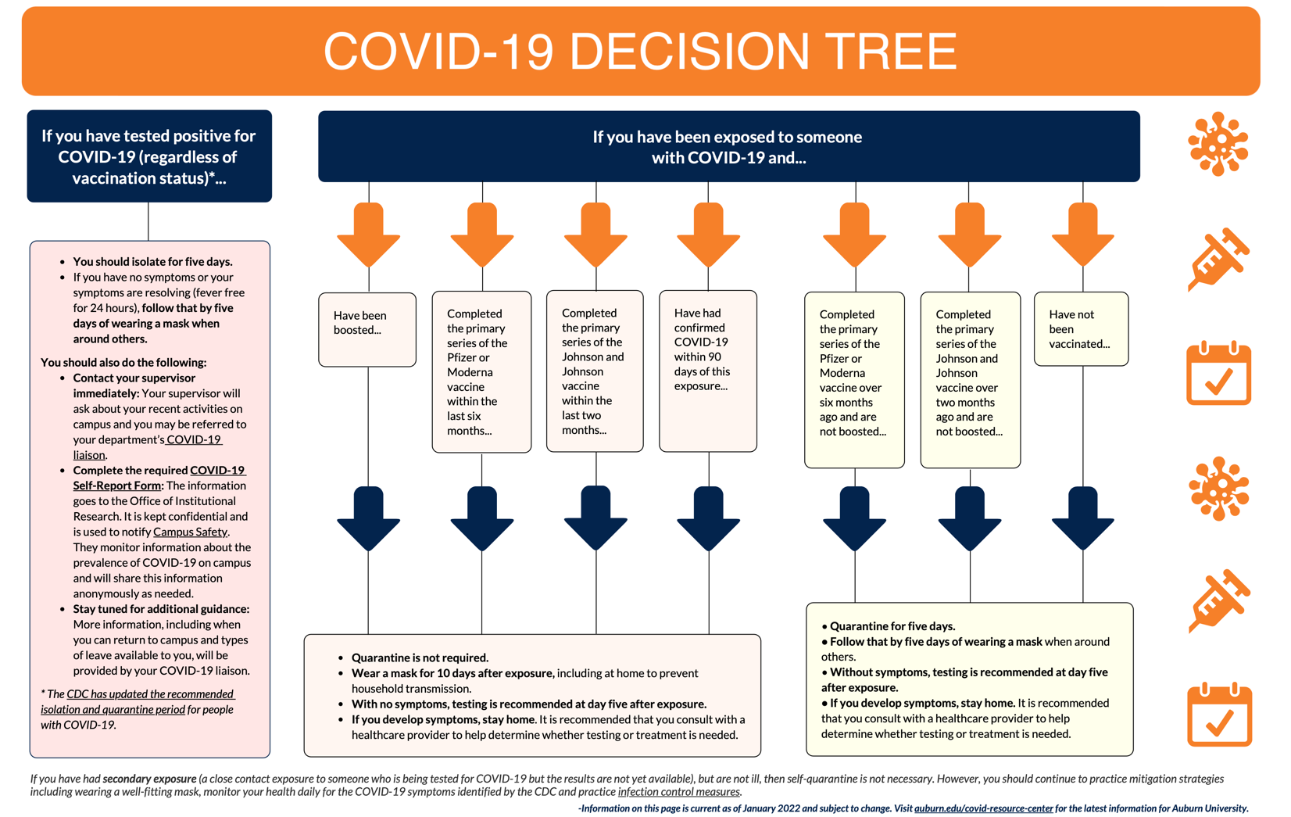

**Testing & Vaccination Resources on Campus:**

Auburn University Medical Clinic offers COVID testing. You may schedule a test appointment by calling 334-844-9825. COVID vaccinations are available on campus. You can find information on vaccines and make an appointment [here](http://auburn.edu/covid-resource-center/vaccine-information/).

**Possibility of Transitioning to Remote Instruction**

In the event that the University is forced to move to fully online instruction, please be assured that the learning goals and outcomes of the course will not change; however, some aspects of the course will change in terms of the mode of delivery, participation, and assessment methods. If an announcement is made for remote instruction, Dr. McGhee will communicate with the class about course changes within two days.  Dr. McGhee will work with students to reconstruct a revised course calendar.  Please be prepared for this contingency by ensuring that you have access to a computer and Internet.

Assignments & Schedule subject to change due to pandemic

The course schedule and assignments are designed with the most up-to-date information and policies in mind. If the situation changes, I will make every effort to keep the schedule as consistent as possible; however, please note that the due dates for assignments may be changed during the semester in response to the changing health and safety requirements or policies of the University. When changes are made, they will be communicated via Canvas Announcement, Canvas message, and all assignment due dates will be updated.

**Health and Well-Being Resources**

These are difficult times, and academic and personal stress is a natural result. Everyone is encouraged to take care of themselves and their peers. If you need additional support, there are several resources on campus to assist you:

* [COVID Resource Center](http://auburn.edu/covid-resource-center/)
* [Student Counseling and Psychological Services](http://wp.auburn.edu/scs/)
* [AU Medical Clinic](https://cws.auburn.edu/aumc/)
* If you or someone you know are experiencing food, housing or financial insecurity, please visit the [Auburn Cares Office](http://aucares.auburn.edu/)

**Academic Integrity**

The University Student Academic Honesty Code on the University Policies site ([Academic Honesty Code](https://sites.auburn.edu/admin/universitypolicies/default.aspx)) pertaining to academic honesty will apply to this class. Make sure to give credit for any words and ideas that are not originally your own!

**Accommodations**

Students who need accommodations are asked to electronically submit their approved accommodations through AU Access and to arrange a meeting during office hours the first week of classes, or as soon as possible if accommodations are needed immediately. If you have a conflict with my office hours, an alternate time can be arranged. To set up this meeting, please contact me by e-mail. If you have not established accommodations through the Office of Accessibility, but need accommodations, make an appointment with the Office of Accessibility, 1228 Haley Center, 844-2096 (V/TT).

**Title IX Statement**

Auburn University is committed to providing an environment that is free from discrimination and harassment based upon protected class. If you believe you have been the victim of harassment or discrimination based on race, color, religion, national origin, disability, age, or sex (including sexual orientation, gender identity, and gender expression), we encourage you to report it. If you report sexual assault or sexual misconduct to a faculty member, the faculty member is obligated to notify the University’s Title IX Coordinator about the basic facts of the incident. For more information about your Title IX reporting and resource options at Auburn University, please go to: [Title IX](http://www.auburn.edu/titleix)

**Professionalism**

As faculty, staff, and students interact in professional settings, they are expected to demonstrate professional behaviors as defined in the College’s conceptual framework.

These professional commitments or dispositions are listed below:

* Engage in responsible and ethical professional practices
* Contribute to collaborative learning communities
* Demonstrate a commitment to diversity
* Model and nurture intellectual vitality
* Diversity of learners

**Course Contingency**

If class meetings are disrupted due to faculty illness, emergency, or crisis situation, the syllabus and other course plans and assignments may be modified to allow completion of the course. If this occurs, an addendum to this syllabus and/or course assignments will replace the original materials.

**\*\*Course Calendar is attached.**