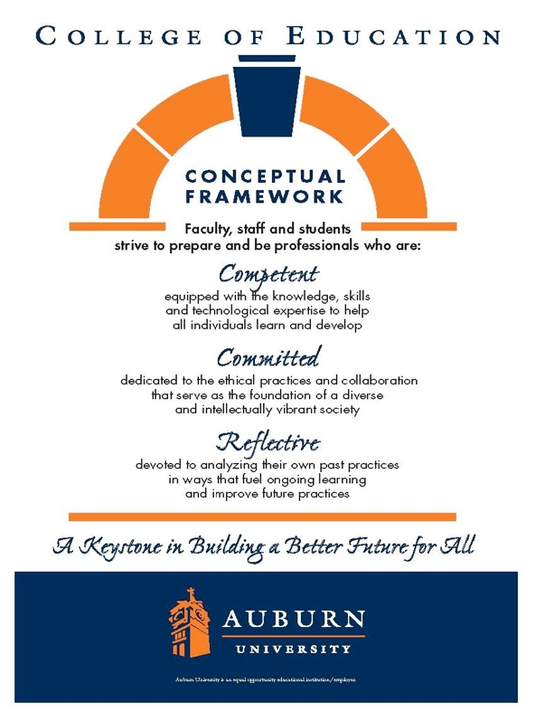
CTEE 7420/7426 Auburn University
Date Syllabus Prepared: August 2023
Department: Department of Curriculum & Teaching Elementary Education
Program: Elementary Education
Course Title: Curriculum and Teaching Language Arts Credit Hours: 3 semester credit
Prerequisites: Graduate standing
Course Number: CTEE 7420/7426
Course Credit: Fall 2023

Instructor(s):
Dr. Jennifer VanSlander
jzv0020@auburn.edu
503-930-8092

Office Hours: Virtually upon request

Schedule: See Calendar

Texts or Major Resources

Required Texts: Readings will be provided in Canvas

Additional Resources:
APA 7 Style Manual-Highly recommended
Common Core State Standards: http://www.corestandards.org/ELA-Literacy/
Alabama Course of Study for Language Arts:
https://www.alabamaachieves.org/wp-content/uploads/2021/08/2021-Alabama-English-Language-Arts-Course-of-Study.pdf

Course Description: Throughout this course, learners will explore age-appropriate content and pedagogical practices which enhance the instruction of children in kindergarten through grade six in the language arts to promote meaningful learning across the elementary school curriculum.

Course Objectives:

As a result of participation in this course students will:

- Discuss concepts, principles, theories, and inquiry tools associated with language arts
- read, reflect, and discuss assigned readings
- discuss the role of the following in the language arts: reading, writing, listening, speaking
- design and assess learner-centered lessons that use appropriate and effective learner- centered lessons that integrate technology and address identified ACOS and NCTE guidelines
- select and support the use of instructional strategies that meet the needs of diverse learners
- demonstrate effective oral and written communication
- identify the resources for enhancing professional growth using technology
- utilize culturally responsive pedagogy in developing student-centered learning activities
- demonstrate reflection and self-evaluation as a basis for professional growth
- demonstrate knowledge of safe, responsible, legal and ethical uses of technologies including fair-use and copyright guidelines and Internet user protection policies

Course Assignments:

All assignments are due no later than 11:59 p.m. on the due date identified in Canvas.

NOTE: ALL ASSIGNMENTS AND DUE DATES ARE SUBJECT TO CHANGE.
PLEASE CHECK CANVAS ANNOUNCEMENTS AND EMAIL FOR UPDATES.

VoiceThread Assignment/Discussion (20+10 Points) VoiceThread platform used to develop an introduction.
Library Tutorial 20 Points
Theory and Action Research
Brief Outline 10 Points
Zoom Conference 10 Points
Annotated Bibliography 20 Points
Common Core Assignment Part 1 Discussion 10 Points
Common Core Assignment Part II 25 Points
For this assignment, you will review the Common Core State Standards for grades K-6, as well as state standards for those states that have not adopted Common Core. You will compare and contrast these standards and support the acceptance or rejection of Common Core in a 4-5 page paper using APA style (7th edition). Assignment and grading criteria will be posted in Canvas.
Literature Review Part I 10 Points
Multicultural Book Review/Discussion (10 + 5 Points)
This assignment provides an opportunity for you to explore high quality, multicultural children’s literature and consider how it might be utilized in the elementary classroom. You will turn in one copy and upload a copy to the discussion board for your classmates to download. Assignment and grading criteria will be posted in Canvas.
Culturally Relevant Pedagogy and Multicultural Literature Discussion 10 Points
Narrated Theory Presentation Assignment/Discussion (20+10 Points)
Theory and Action Research Assignment 10 Points
Literature Review/Peer Review (25 Points)
Reading Comprehension Discussion (10 Points)
Final Literature Review Assignment (70 Points)
Writing Curriculum and Instruction Assignment (25 Points)

Course Policy Statements:
- Attendance: Students are expected to attend all classes and will be held responsible for any content covered in the event of an absence.

- Excused Absences: Students are granted excused absences from class for the following reasons: illness of the student or serious illness of a member of the student’s immediate family, the death of a member of the student’s immediate family, trips for student organizations sponsored by an academic unit, trips for university classes, trips for participation in intercollegiate athletic events, subpoena for a court appearance, and religious holidays. Students who wish to have an excused absence from class for any other reason must contact the instructor in advance of the absence to request permission. The instructor will weigh the merits of the request and render a decision. When feasible, the student must notify the instructor prior to the occurrence of any excused absences, but in no case shall such notification occur more than one week after the absence. Appropriate documentation for all excused absences is required. Please see the Tiger Cub for more information on excused absences.

- Make-Up Policy: Arrangement to make up a missed major examination (e.g., hour exams, mid-term exams) due to properly authorized excused absences must be initiated by the student within one week of the end of the period of the excused absences(s). Except in unusual circumstances, such as the continued absence of the student or the advent of university holidays, a make-up exam will take place within two weeks of the date that the student initiates arrangements for it. Except in extraordinary circumstance, no make-up exams will be arranged during the last three days before the final exam period begins.

- Academic Honesty Policy: The University Student Academic Honesty Code on the University Policies site (https://sites.auburn.edu/admin/universitypolicies/default.aspx) pertaining to cheating apply to this class.

- Disability Accommodations: Students who need special accommodations in class, as provided by the Americans with Disabilities Act, should arrange for a confidential meeting with the instructor during office hours in the first week of classes (or as soon as possible if accommodations are needed immediately). The student must bring a copy of their Accommodations Letter and an Instructor Verification Form to the meeting. If the student does not have these forms, they should make an appointment with the Program for Students with Disabilities, 1288 Haley Center, 844-2096 (V/TT).

- Course contingency: If normal class and/or lab activities are disrupted due to illness, emergency, or crisis situation, the syllabus and other course plans and assignments may be modified to allow completion of the course. If this occurs, an addendum to your syllabus and/or course assignments will replace the original materials.

- Cell Phones/Electronic Devices: Students are expected to keep all cell phones on vibrate/silent ring during class time.

- Professionalism: As faculty, staff, and students interact in professional settings, they are expected to demonstrate professional behaviors as defined in the College’s conceptual framework. These professional commitments or dispositions are listed below:
- Engage in responsible and ethical professional practices
- Contribute to collaborative learning communities
- Demonstrate a commitment to diversity
- Model and nurture intellectual vitality

I. Late Work: Grades on late work are reduced at a rate of 10% of overall eligible points per day the assignment is submitted late. Work will not be accepted after 48 hours past the posted due date in Canvas. After 48 hours past the posted due date, the assignment will receive a score of Zero (0). For example, if a 10 point paper is due by 11:59 p.m. Sunday but is submitted Tuesday, 2 points will be deducted for a tardy submission (in addition to any points deducted due to quality of work). If the assigned is submitted at 12:00 a.m. Wednesday, the assignment will not be graded and receive a score of zero. Exceptions to this policy may be made by the supervising professor due to emergency situations or other excused reasons (i.e., hospitalization).

J. Work Quality: If submitted work does not meet quality standards or receives a failing grade, at the professor’s discretion students may be given an opportunity to resubmit work to earn up to half of the deducted points. For example, if a 10 point assignment receives a score of 5/10, the instructor may allow/request a resubmission. The assignment will be assessed a second time and up to half of the deducted points (5) can be earned, meaning a final score of 7.5/10.

Grading Plan:
The final grade for the course is based on the following:
90%-100%= A
80%-89% = B
70%-79% = C
60%-69% = D
Below 60% = F

Please note that this is only a plan; point totals for the course may change during the semester if assignments are added or deleted. Detailed instructions will be available in Canvas.

Course Schedule

One individual synchronous, virtual (Zoom) session will be conducted to discuss the literature review assignment. The session is to provide an opportunity for you to ask questions about the major assignment for the semester. Please see the Module for Week 3 to sign-up for your meeting with your primary supervisor. The meeting will last approximately 15-30 minutes, depending on how prepared you are for the meeting.

Week | Topic | Assignments
Week 1  August 16-20 | Introduction to the Language Arts  Action Research topics  Zoom Session  Voice Thread  Outline of research | Whole Class Zoom session, Thursday, August 17 7:00 p.m.  Discussion: Introduction Voice Thread  Discussion: How can I use Voice Thread in the classroom?
Week 2  August 21-27 | Research Interest Topic | Discussion: Area of interest in research
Week 3  August 28-September 3 | Library Tutorial (finding sources) | Library Tutorial  Brief Outline  Individual Zoom Conference
Week 4  September 4-10 | Annotated Bibliographies | Annotated Bibliography Assignment
Week 5  September 11-17 | Common Core State Standards | Discussion: Common Core Assignment Part I
Week 6  September 18-24 | Common Core State Standards | Common Core Assignment Part I
Week 7  September 25-  October 1 | Literature Review Part I | Literature Review Part I
Week 8  October 2-8 | Multicultural Literature &  Culturally Responsive  Teaching | Multicultural Book Review Assignment  Upload Book Review in Multicultural Book Review Discussion Board
Week 9  October 9-15 | Culturally Relevant Pedagogy and Multicultural Literature | Discussion: Culturally relevant pedagogy and multicultural literature  Sign up for Learning Theory/Theorist
Week 10  October 16-22 | Learning Theories | Narrated Theory Presentation Assignment and Discussion
Week 11  October 23-2 | Theory and Action Research | Theory and Action Research Assignment  Email draft Literature Review to assigned peer for review
Week 12  October 3-November 5 | Literature Review/Peer Reviews | Submit peer review revisions of Literature Review
Week 13  November 6-12 | Content Area Reading and Writing  Reading Comprehension | Reading Comprehension Discussion  Final Literature Review
Week 14  November 13-19 | Writing Curriculum & Instruction | Writing Curriculum & Instruction Assignment
Thanksgiving Break
Week 15  November 27-December 3 | Digital Writing | Digital Writing and Editing Discussion

