**\*\*SUBJECT TO CHANGE\*\***

|  |  |
| --- | --- |
|  | **Auburn University**  **College of Education**  **Department of Curriculum and Teaching** |

|  |  |
| --- | --- |
| Course Number: CTSE 4060  Course Title: Curriculum and Teaching II – Social Science  Credit Hours: 4 Semester Hours  Term: Fall 2023  Day/Time: T/Th 12:30-3:15  Room: Haley 1414 | Jesus A. Tirado  5074 Haley Center  203-809-5429 (cell)  [jat0088@auburn.edu](mailto:jat0088@auburn.edu)  Office Hourse:  Wed, 9-11 (Zoom or in person) |

Required Resources:

CTSE 4060 Course Packet (Available in Auburn Bookstores)

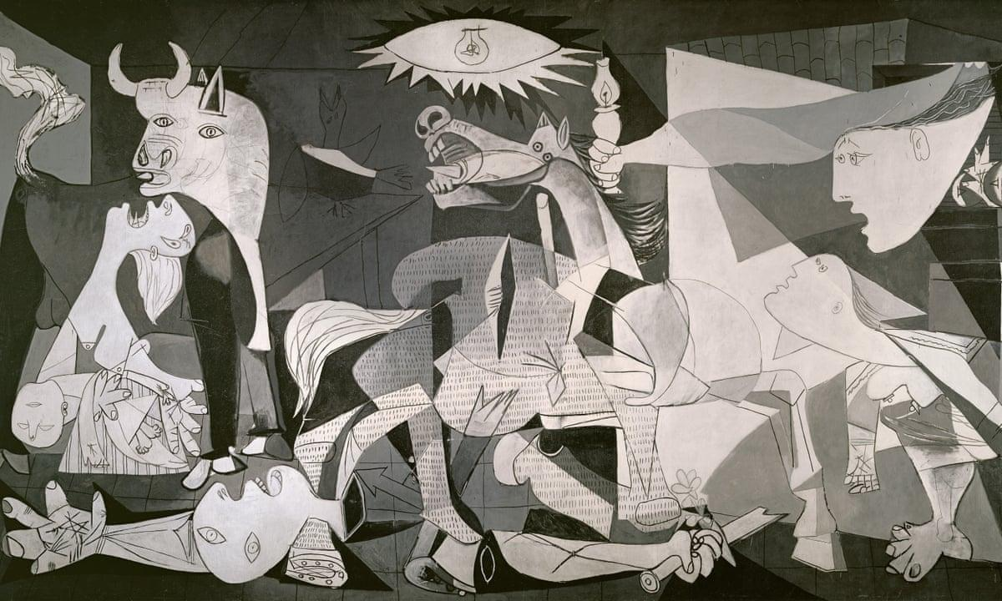

*Pablo Picasso, 1937, Guernica,* [*Museo Reina Sofía*](https://en.wikipedia.org/wiki/Museo_Nacional_Centro_de_Arte_Reina_Sof%C3%ADa)*,* [*Madrid*](https://en.wikipedia.org/wiki/Madrid)*,* [*Spain*](https://en.wikipedia.org/wiki/Spain)

**Take a minute:** Look at the painting above. Have you seen this painting before? What does it mean to you?? What do you think about the images here?

**Course Description**: CTSE 4060 is the third in a four-course sequence designed to prepare competent, committed, reflective social studies professionals. This course is designed to assist students in curriculum decision making and planning for instruction, evaluation, and classroom management. Students will reflect upon broad issues concerning middle and secondary schools, the social studies, and the individual disciplines and develop a personal rationale for social studies teaching. Attention will be given to the overall mission of social studies as well as curriculum issues surrounding scope and sequence plans and specific social studies subjects. Because field-based practice is an integral component of quality teacher preparation, students will be paired with expert classroom teachers who have worked closely with university faculty in numerous capacities in order to observe, implement, and reflect upon problem-based historical inquiry teaching in classroom settings. Students will observe and assist mentor teachers weekly for nine weeks and in the tenth week, the students will teach a three-day mini-unit of their own design. The lessons they design will incorporate design principles emphasized in the program: authenticity, scaffolding, collaboration, and multiple intelligences. This lab will total 36 hours.

**Course Objectives:**

Upon completion of this course, students will be able to:

* Evaluate various proposals for scope and sequence in the social studies.
* Analyze the purpose of social studies, select content pertinent to those purposes, and assess student learning in terms of social studies goals (SS2.1)
* Articulate criteria for deciding what to teach and how to teach it in a middle or secondary social studies course and justify the choice of those criteria.
* Assess materials and activities for appropriateness in meeting the goals of the social studies.
* Examine the purposes of the secondary school and the supporting roles of the academic areas, administration, and service areas for the school.
* Describe national and state standards for social studies literacy among 13-18 year olds.
* Assess the congruence between the contemporary secondary school and secondary social studies instruction and the goals advocated by professional social studies organizations and leaders.
* Use computer technology tools and applications to plan and implement multi-media social science instruction.
* Design and implement instructional strategies intended to develop deep content knowledge in learners.
* Select, integrate, and translate the content and methods of investigation of history and the social studies disciplines for use in social studies instruction. (SS2.2)
* Use a variety of approaches to instruction that are pertinent to the nature of social studies content and goals and to use them in diverse settings and with students with diverse backgrounds, interests, and abilities. (SS2.3)

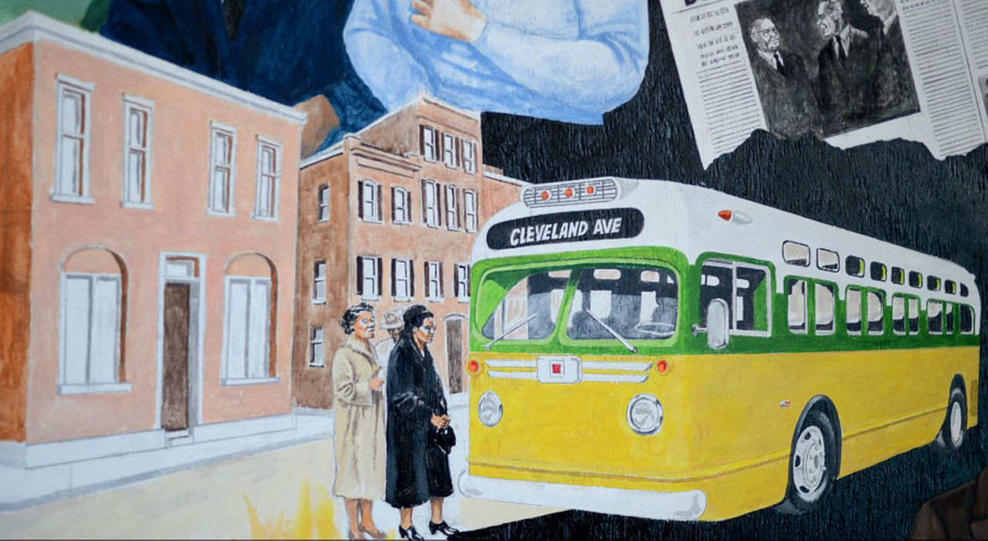

**Mural in Montgomery, AL**

**What is the goal of public art? What are some examples of public art that you remember?**

**Course Schedule:**

|  |  |
| --- | --- |
| Date & Topic | Lesson Plan |
| WEEK 1 Day 1  8/17 - Introduction to Class | Introduction to Induction Protocol  Metaphor work  Syllabus Discussion |
| WEEK 2 Day 1  8/22 - Observations *Meet at Mell Lobby* | Discussion about Observations  How to do Observations  Readings about Ethnographic Observation |
| WEEK 2 Day 2  8/24 - What is Social Studies? | Reading Discussion:  Barr, Barth, & Shermis |
| WEEK 3 Day 1  8/29 - What is Social Studies for? (Part II) | Reading Discussion:  Slouka |
| 8/31 - LAB #1 | AUBURN CITY SCHOOLS |
| WEEK 4 Day 1  9/5 - What is Social Studies doing? (Part III) | Induction Protocol  Reading Discussion:  Rebell  Ravitch  **Due: Curriculum Workshop Frame** |
| 9/7 – LAB #2 | AUBURN CITY SCHOOLS |
| WEEK 5 Day 1  9/12 - What is the difference between depth and coverage? | Induction Protocol  Reading Discussion:  Newman  Metzger  **Due: Curriculum Workshop Map** |
| 9/14 – LAB #3 | AUBURN CITY SCHOOLS |
| WEEK 6 Day 1  9/19 - How do we learn Social Studies? | Class at Collins Museum  Induction Protocol  Reading Discussion:  Edutopia article on Multiple Intelligence ([link](https://www.edutopia.org/multiple-intelligences-research)) |
| 9/21 – LAB #4 | AUBURN CITY SCHOOLS |
| WEEK 7 Day 1  9/26 - How should we teach about diversity in Social Studies? | Induction Protocol  Reading Discussion:  Brown, Brown, & Ward  Due: Graphic Novel Assignment (Link)  **DUE: PIH Unit Map** |
| 9/28 – LAB #5 | AUBURN CITY SCHOOLS |
| WEEK 8  10/3 - Should social studies be patriotic? | Induction Protocol  Reading Discussion:  Westheimer  Planning Commentary (in class)  **Due: Lesson Plans #1 Draft** |
| 10/5 – LAB #6 | AUBURN CITY SCHOOLS |
| WEEK 9 Day 1  10/10  How should we organize Social studies? | Induction Protocol  Reading/Discussion  NCSS C3 Framework (selections in packet)  Lesson Plans Workshop |
| 10/12 – LAB #7 | AUBURN CITY SCHOOLS |
| WEEK 10 Day 1  10/17 - What does Social Studies prepare students for in the nation? | Induction Protocol  Reading/Discussion  Bradley Commission  **Due: Lesson Plans #2 (to Tirado and Teacher)** |
| 10/19 – LAB #8 | AUBURN CITY SCHOOLS |
| WEEK 11 Day 1  10/24 - What does Social Studies prepare students for in the world? | Induction Protocol  Reading/Discussion:  Engle & Ochoa  Kniep  Final Lesson Workshop *submission to teacher and Dr. Tirado |
| 10/26 – LAB #9 | AUBURN CITY SCHOOLS |
| 10/30-11/3 – LAB TEACHING | Teaching Your Lesson @ AUBURN CITY SCHOOLS  *\*\*make sure that you either record your teaching AND schedule with me for your observation\*\** |
| WEEK 12 Day 1  11/7 - What is included in Social Studies? | Induction Protocol  Reading/Discussion:  Kumler & Vosburg-Bluem |
| WEEK 12 Day 2  11/9 - What is the value of local history? Difficult history? | Podcast: Early Black Auburn ([link](https://earlyblackauburn.com/blog/)) - Listen to Pebble Hill and one other  Class at Pebble Hill (12:30-3 pm)  101 S Debardeleben St, Auburn, AL 36830 |
| WEEK 13 Day 1  11/14 - How do we create a democratic classroom? | Podcast: How accurate are your grades? ([link](https://www.cultofpedagogy.com/accurate-grades/))  Assessment of Student Learning Due  Fendler (2011) |
| WEEK 13 Day 2  11/16  Are there other ways to teach Social Studies? | Meeting with Drs. Rein and Hestler  Reading:  Turtle Island Collective  Indigenous Civics ([link](https://visionsofed.com/2019/11/04/episode-128-an-anticolonial-approach-to-civic-education-with-leilani-sabzalian/)) |
| WEEK 14 Day 1  11/28- Can we teach for a better Democracy? | Reading:  Rizga Piece ([Link](https://www.theatlantic.com/education/archive/2019/06/how-black-teachers-segregated-district-teach-civics/591856/))  The problem we all live with Podcast ([Link](https://www.thisamericanlife.org/562/the-problem-we-all-live-with-part-one))  Questions about Internship |
| WEEK 14 Day 2  11/30 - What is schooling? | Reading Discussion:  Sizer  Due: Philosopher Paper on Canvas (last date) |

*All dates subject to change*

**Assignments & Evaluation:**

1. Lesson Plan and Lab Teaching at AUBURN City Schools (35 Points)
   1. Planning - Curriculum Workshop Frame & Map (10 points)
   2. Draft 1 (5 Points)
   3. Draft 2 (5 Points)
   4. Lab Teaching, Final Draft of Lesson & Self and Peer Assessment (15 points)
2. Assessment of Student Learning (15 Points)
3. Philosophy Paper (15 points)
4. Classwork (20 Points)
   1. Pebble Hill (5 pts)
   2. Graphic Novel Assignment(5 pts)
   3. All other class work (5 pts)
5. Attendance and Participation (10 Points)

Total Points (100 points)

*Core Competency--See # 1 in General Policies and Professional Performance Index*

*Core Competency--See # 2 in General Policies*

**Rubrics & Grading Scale:**

Letter Grades will be assigned on the basis of:

* A (Exemplary): 90-100 points;
* B (Competent) : 80 - 89 points;
* C (Approaching Competence): 70 - 79 points;
* D (Minimal): 60 - 69 points;
* F (Unsatisfactory) below 60 points.

Students must satisfy all course objectives to pass the course. Detailed rubrics and models will be provided for each assignment listed above.

Professionalism: As faculty, staff, and students interact in professional settings, they are expected to demonstrate professional behavior as defined in the College’s conceptual framework. These professional commitments or dispositions are listed below:

* Engage in responsible and ethical professional practices
* Contribute to collaborative learning communities
* Demonstrate a commitment to diversity
* Model and nurture intellectual vitality

Professionalism in Social Science Education courses is a Core Proficiency. Specific professional expectations include:

* Students are expected to participate in all class discussions and in all exercises as described in the Professional Performance Index. Students must receive at least an “Approaching Competence (C)” assessment of proficiency on the Professional Performance Index to exit the course.
* Assignments are due on announced dates. Unexcused late assignments are unacceptable.
* Attendance is required. Punctuality is essential. Those with more than one unexcused absence can receive no more than a “D” for the course. Three unexcused tardies are the equivalent of an absence. E-mail or phone and leave a message at my office number above if you are going to miss class.
* Texts will be heavily used in class. BRING COURSE PACKET EACH DAY.
* Monitor your e-mail account regularly for class messages.

**Class Policy Statements:**

Students must receive at least an “Approaching Competence (C)” assessment of competency on the Professional Performance Index to exit the course. Those who fail to meet this standard on the first attempt may submit one revision. If functional performance is not demonstrated on the second draft, the course must be repeated. In the case of the professional philosophy statement, the second draft must be turned in within the first two weeks of internship and an “approaching competence” score must be attained to exit internship.

Assignments are due on announced dates. Unexcused late assignments are unacceptable.

**Cell phones and other mobile media devices should not be used during class or in field experiences**. Devices should be turned off and put away during all professional meetings at AU or in the field. Laptops or iPads should not be left open throughout class but used only to access material directly related to class activities.

**Attendance is required.** Punctuality is essential. Those with more than one unexcused absences can receive no more than a “D” for the course. Three unexcused tardies are the equivalent of an absence. E-mail or phone and leave a message at my number if you are going to miss class.

**Contingency:** If normal class and/or lab activities are disrupted due to illness, emergency, or crisis situation (such as an H1N1 flu outbreak), the syllabus and other course plans and assignments may be modified to allow completion of the course. If this occurs, an addendum to your syllabus and/or course assignments will replace the original materials.

**Excused absences:** Students are granted excused absences from class for the following reasons: illness of the student or serious illness of a member of the student’s immediate family, the death of a member of the student’s immediate family, trips for student organizations sponsored by an academic unit, trips for university classes, trips for participation in intercollegiate athletic events, subpoena for a court appearance, and religious holidays. Students who wish to have an excused absence from class for any other reason must contact the instructor in advance of the absence to request permission. The instructor will weigh the merits of the request and render a decision. When feasible, the student must notify the instructor prior to the occurrence of any excused absences, but in no case shall such notification occur more than one week after the absence. Appropriate documentation for all excused absences is required. Please see the Student Policy eHandbook for more information on excused absences. Students are responsible for initiating arrangements for missed work due to excused absences.

**Make-Up Policy:** Arrangement to make up missed work due to properly authorized excused absences must be initiated by the student within one week of the end of the period of the excused absences(s). Except in unusual circumstances, such as the continued absence of the student or the advent of university holidays, make-up work will be completed within two weeks of the date that the student initiates arrangements for it. Except in extraordinary circumstances, no make-up work will be arranged during the last three days before the final exam period begins.

**Academic Honesty Policy**: All portions of the Auburn University student academic honesty code (Title XII) found in the Student Policy eHandbook will apply to university courses. All academic honesty violations or alleged violations of the SGA Code of Laws will be reported to the Office of the Provost, which will then refer the case to the Academic Honesty Committee.

**Disability Accommodations:** Students who need accommodations are asked to electronically submit their approved accommodations through AU Access and to arrange a meeting during office hours the first week of classes, or as soon as possible if accommodations are needed immediately. If you have a conflict with my office hours, an alternate time can be arranged. To set up this meeting, please contact me by e-mail. If you have not established accommodations through the Office of Accessibility, but need accommodations, make an appointment with the Office of Accessibility, 1228 Haley Center, 334-844-2096 & <https://accessibility.auburn.edu>.

**Course contingency:** If normal class and/or lab activities are disrupted due to illness, emergency, or crisis situation, the syllabus and other course plans and assignments may be modified to allow completion of the course. If this occurs, an addendum to your syllabus and/or course assignments will replace the original materials.

**Face coverings:** The university permits individual faculty members to require face coverings in their classrooms and instructional laboratories. As such, when the community levels are low to medium, according to the CDC, we will make mask wearing optional. When the levels are rated high, masks will be mandatory. please consult the CDC’s official page by following this link (<https://www.cdc.gov/coronavirus/2019-ncov/your-health/covid-by-county.html>).