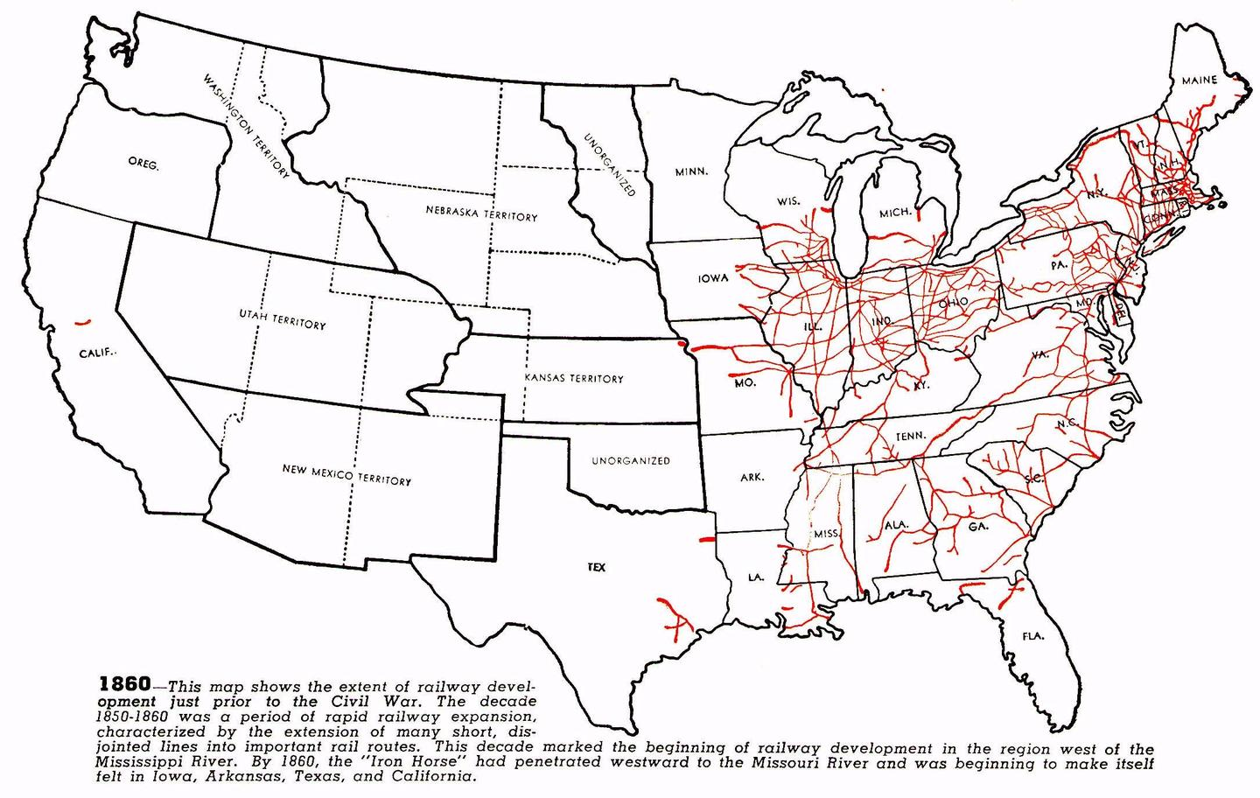

**CTSE 5050/6050* Analyzing Persistent Issues in History and Geography - Fall 2023**

**Time: Mondays 5:00-7:50 pm on Zoom**

**Instructor:**

Dr. Jesús A. Tirado

[jat0088@auburn.edu](mailto:jat0088@auburn.edu)

203-809-5429

Office Hours: Wednesday, 9-11am and by appointment, Zoom meeting available

**Description:**

Persistent public issues are, by their very nature, interdisciplinary. Social Studies educators must understand the disciplinary tools used by content experts as well as cognitive learning processes in those disciplines. This course will engage learners in the examination of local, national, and international issues that feature the intersection of the disciplines of History and Geography and how learning occurs in the brain. Students will deliberate solutions to public issues centered on international conflicts, urban growth, inequity, and other injustices. The course will use spatial and geographic representations to discuss human interactions with each other and the environment along with the growth of regions, geographic patterns, and culture (GSS2.1-GSS2.5). This will occur in tandem with historical thinking skills from making personal connections, thinking critically and chronologically, using primary sources, historical analysis, conducting research, evaluating connections to the past, and thinking about decision-making (GSS3.1-GSS3.7). Students will also examine the different learning processes that occur when engaging in interdisciplinary problem-solving. Students will learn metacognition processes, the value of thinking like experts, how the brain links and organizes content and ideas, and the different structures of teaching and learning history and geography.

**Accessibility:**

As this class will be offered over distance-education, all the class sessions will be held over Zoom. This will allow us to use close captioning to help students who are hard of hearing as well as those with physical challenges. Every accommodation approved by Auburn University will also be met. All materials will be available on Canvas throughout the semester. The final exam will be administered online, and students will be able to discuss accommodations prior to the administrating of the final.

**Resources**:

Pertinent articles, editorials, books, maps, and curriculum materials will be provided on pertinent historical/geographic topics.

Main Course Texts:

1. Barton, K. C. & Levstik, L. S. (2004). *Teaching History for the Common Good*. Lawrence Erlbaum Associates.*

Resources:

1. Atlanta through the Archives. Georgia Tech. <https://storymaps.arcgis.com/stories/87d3865f1f7a42eb92627e046d398731>
2. Avalon Project, Yale Law School. “The Middle East, 1916-2001.” <https://avalon.law.yale.edu/subject_menus/mideast.asp>
3. Bunton, M. (2013). *The Palestinian-Israeli Conflict: A Very Short Introduction*. Oxford University Press. *Reference Only
4. Jenkins, K. (1991). *Re-thinking History*. Routledge. (Chapter 1) *pdf on Canvas
5. Mahler, G. S., (2019). *The Arab-Israeli conflict : an introduction and documentary reader*. Routledge. *available through the library
6. Mapping Inequality: Redlining in New Deal America. University of Richmond. <https://dsl.richmond.edu/panorama/redlining/#loc=5/39.1/-94.58>
7. Rothstein, R. (2017). *The Color of Law*.
8. Shin, E. E. & Bednarz, S. W. (Eds.) (2019). Spatial Citizen Education: Citizenship through Geography. Routledge. (Chapters 1, 2, 6, & 10) *pdfs on Canvas
9. Smith, C. (2021). *How the Word is Passed: A Reckoning with the History of Slavery Across America*. Little, Brown and Company*Reference Only

**Course Questions:**

**PIH:** “What policies should governments pursue to promote social and economic justice?”

**Course Objectives**:

1. Students will identify value conflicts in three historical/geographical issues.
2. Students will analyze multiple perspectives on three historical/geographical issues.
3. Students will produce a dialectically reasoned position on each of the three issues.
4. Students will identify learning challenges in analyzing and evaluating issues: prior knowledge; learner misconceptions; building conceptual schema; transfer.
5. Students will deconstruct design principles for supporting learners investigating complex issues.
6. Students will analyze authentic formative and summative assessments related to each issue.
7. Students develop and deconstruct an authentic assessment related to an interdisciplinary history/geography issue that supports, encourages, and evaluates deep learning.

**Course Content Outline:**

**Week 1 (August 21)**: Introduction to the course: Teaching History and Geography

Reading due:

* Chapter 1 of Jenkin’s book (available as pdf)
* Review of *How People Learn Summary* [link](https://cft.vanderbilt.edu/guides-sub-pages/how-people-learn/)

Agenda:

* Course introduction and exploration of the syllabus.
* Discuss the reading of called “What is History?”.
* Introduction to the PIH Framework and the goals of this class.

**Week 2 (August 28)**: Teaching Local History and Geography, Part 1

Reading due:

* Chapter 1 & 2 of Barton and Levstik’s book. Discussion questions over the Canvas page.
* Crash Course <https://www.youtube.com/watch?v=Ajn9g5Gsv98>
  + <https://www.commonlit.org/en/texts/olaudah-equiano-recalls-the-middle-passage>
  + <https://www.commonlit.org/en/texts/on-being-brought-from-africa-to-america>
  + <https://www.commonlit.org/en/texts/the-narrative-of-the-life-of-frederick-douglass-excerpt-from-chapter-1>

Agenda:

* Mini Unit Question: What should we do with plantation sites?
* Discussing portrayals of Plantation life, economy and examining maps, historical Census data, Testimony/Primary Sources, and the physical place of a local plantation through a virtual visit.
* Introduction of Museum Task. *Model available on PIH Website*

**Week 3 (September 4 - Asynchronous):** Teaching Local History and Geography, Part 2

Reading due:

* Chapter 3 & 5 from Barton and Levstik
* Duncan (2020) (on Canvas)
* Discussion questions over the Canvas page.

Agenda:

Work on Exhibit with Groups

**Week 4 (September 11):** Teaching Local History and Geography, Part 3

Reading Due:

* Chapter 5 from Barton and Levstik (Discussion Board)
* TED Talk: “Why we must confront the painful parts of US history” Hasan Kwame Jeffries

Agenda:

* Share the virtual museum.
* Discuss larger themes of this kind of history and how they have impacted the way we learn

**Week 5 (September 18)**: Reflection on Teaching Local History and Geography

Reading Due:

* Chapters 7 & 9 from Barton and Levstik
* Hard History Framework from Teaching for Justice Podcast, Season 1, Episode 12
* Discussion questions on Canvas

Learning Activities:

* Discussion of the role that plantations and enslavement play in our class.
* Looking at alternative materials to teach enslavement stories including graphic novels, art, and examining the legacy of enslavement
* Review of essay prompt in small groups

**Week 6 (September 25):** Teaching National History and Geography: Redlining, Part 1

Reading Due:

* Richard Rothstein Video ([link](https://www.youtube.com/watch?v=r9UqnQC7jY4))
* Chapter 8 from Barton and Levstik
* Discussion questions on Canvas

Agenda:

Introduction to national history and questions:

CQ: *How should rethink and reimagine urban centers with the history of redlining?*

Geographic examination of Redlining through maps, census data, phonebooks, and photographs, students will examine the urban growth of Atlanta, Birmingham, and Richmond from the 1880’s, 1920’s, 1960s, 1990’s and the past decade.

Introduction of structured academic Controversy

**Week 7 (October 2 asynchronous)**: Teaching National History and Geography: Redlining, Part 2

Reading due:

* Chapter 10 from Barton and Levstik
* Habitat for Humanity *5 Policy Solutions* - [link](https://www.habitat.org/stories/5-policy-solutions-advance-racial-equity-housing)
* Brookings Institute - [link](https://www.brookings.edu/articles/americas-formerly-redlines-areas-changed-so-must-solutions/)
* Discussion Questions on Canvas

Agenda:

* Complete Lesson Activities from Previous Week
* Work on SAC sides and discussion
* Introduction to final essay assignment

**Week 8 (October 9)**: Teaching National History and Geography: Redlining, Part 3

Reading due:

* Chapter 6 of Barton & Levstik
* Examining Graphic Novels about redlining, “How did we get here?” Comic ([link](https://theknowfresno.org/comic/))
* Discussion Questions on Canvas

Agenda:

* Review Legacy of Redlining
* Participation in the SAC
* Discussion of mapping scaffolds to help secondary students understand and interpret the history of redlining and the impact of gentrification in their own neighborhood(s).

**Week 9 (October 16 asynchronous)**: Reflections on Teaching US History and Geography

Reading due:

* Chapter 4 from Barton and Levstik,
* Discussion Questions on Canvas

Lesson Activities:

* Reflect on the different ways that the American narrative has shaped schooling.
* Examine different history textbooks to see how urban history is taught and how redlining is included or not. *textbook chapters provided over Canvas*

**Week 10 (October 23)**: Teaching International History and Geography: Israeli-Palestinian Conflict, Part1

Reading Due:

* Read chapter 10 of Shin & Bednarz’s book (pdf)
* Discussion Questions on Canvas

Agenda:

* Central Question: What actions of the Israeli government toward the Palestinians are justified?
* Introduce students to the Israel-Palestinian Conflict, examine historic and currents maps, conflicts over settlement zones, timeline of Israeli-Palestinian conflict, articles focusing on Israeli Airstrikes of 2021 and the construction of the Border Wall
* Introduction to Critical Media and Timeline Activity

**Week 11 (October 30 asynchronous)**:

Lesson activities: No class this week for students to complete their essay.

* Essay due this week

**Week 12 (November 6 asynchronous)**: Teaching International History and Geography: Teaching the Israeli-Palestinian Conflict, Part 2

Reading Due:

* Read chapter 6 of Shin & Bednarz’s book
* Review Material
* Discussion Questions on Canvas

Agenda:

* Complete previous lesson activities
* Examining critical media literacy
* Creating a timeline of the Israeli-Palestinian conflict that integrates Critical Media Literacy and questions about Israeli government policy, peace plans, and the Palestinian Authority

**Week 13 ( November 13):** Teaching International History and Geography: Teaching the Israeli-Palestinian Conflict, Part 3

Reading Due:

* Read chapter 7 of Shin & Bednarz’s book
* Discussion Questions on Canvas

Agenda:

* Sharing of the timeline
* Examine world history textbooks for instances of Critical Media Literacy and maps that connect to the world today. *Textbooks samples will be provided over Canvas.
* Discussion of Final

**Week 14 (November 27)**: Reflections on teaching Global History

Reading due:

* Read chapter 1 & 2 out of Shin & Bednarz’s book
* Discussion Questions on Canvas

Lesson Activities:

* Discuss the ways that we teach world history
* Final Exam in class: Students in groups will develop, construct, and create a learning activity for secondary students with appropriate scaffolds and explanations for an analogous case to the Palestinian/Israeli conflict.

Assignments and Projects:

* Dialectical essay on interdisciplinary history/geography issue (30% course grade)
  + This essay (6-8 pages) should explore and debate one of two questions:
    - *Should plantations be allowed on the National Register of Historic Places?*
    - *Should cities institute policies to protect neighborhoods from gentrification?*
  + Essay should:
    - highlight the connections between history and geography,
    - include references to the course readings and the content,
    - include examples of disciplinary thinking and skills,
    - reference the different connections to learning skills and sciences that we’ve discussed.
* Performance in culminating activity assessment for each unit (3). (30% course grade, 10% each)
  + Each culminating unit will account for 10% of the overall grade for this course.
* Final Exam – Creation of lesson plan to partner with the third unit. (25% course grade)
* Class participation/professionalism/formative assessments. (15% course grade)

Professional Performance Index (PPI): Descriptive Evaluation Criteria

For Use in Assessing Contributions to Class Activities & Professionalism

Exemplary

90 –100 – A Defines own standards beyond those established. Work reflects serious consideration of readings and shows substantial variety and significant creativity. Demonstrates ability to ask pertinent questions as well as answer them. Demonstrates holistic view of the subject and of high school students in instructional decisions. Significant leadership in contributing to the content of class sessions.

Competent

80–89 – B Formulates useful questions. Shows creativity. Physically and mentally alert to standards. Places subject in context of social studies content courses. Answers questions independently. Draws some parallels to other experiences and readings.

Approaching Competence

70–79 – C Physically and mentally present. Did not engage the content.

Minimal

60–69 – D Does not understand or meet basic standards. Physically and/or mentally. Absent too often.

Unsatisfactory

<59 – F Massive indifference to standards of professional behavior and scholarship or professional negligence in a laboratory experience.