**Auburn University**

**College of Education**

**School of Kinesiology**

**Course Syllabus**

##### 1. Course Number: KINE 3000-001

**Course Title:** Medical Terminology for Allied Health Professions

**Course Hours:** 3 semester hours

**Prerequisites:** none

**Co-requisites:** none

**Class Meeting Times:** on-line course taken through **Caduceus International Publishing**

**Instructor:** Dr. JoEllen Sefton, jms0018@auburn.edu **COVID Back-up Instructor:** Ms Frances Neal,[fkn0001@auburn.edu](mailto:fkn0001@auburn.edu)

**Office:** Kinesiology Building #291

**Office Hours**: In Person – Tuesdays 9-10 am; Virtual Wednesdays 1 – 2 pm <https://auburn.zoom.us/j/2706265458>

**Communication** – please communicate **ONLY** through Auburn email. **Do not use Canvas email** for communication with your instructor, they will not receive the email and will not respond. (This will not be an allowable excuse for missing a deadline).

##### 2. Date Syllabus Prepared: July 18, 2023

##### 3. Required Text(s):

**Purchase Your Online E-Textbook through AU Access. (See additional instructions at the end of this syllabus.**

**What is All Access?**

All Access is Auburn’s program of delivering course materials to you digitally. Sometimes this will be a textbook, sometimes an access code. Your instructor has coordinated with the Bookstore to deliver this content for the course and help make sure you have what you need. All Access makes sure you are ready the first day of class, and the material is so much cheaper with this delivery that it’s the best way we can help you succeed in your courses at Auburn….financially and academically.

**What content am I getting?**

For this course, KINE 3000, you’re getting life-time access to a license for the Caduceus course, and it is required content for the course. You will access to course materials and animations after the course if you wish to review the materials or study for other courses, entry exams, or licensing exams.

**How do I find it?**

·       You will get an email right before classes start from [noreply@auburn.edu](mailto:noreply@auburn.edu) that will have your code for Caduceus access.  You'll also get another email with redemption instructions.

**What does it cost?**

The price you’ll be billed is $121.15. This site will act like your text book and you’ll have lifetime access so you can use it to study for future board exams, etc. For the first week of class, everyone gets this content for free.  All students in this course start as opted in to pay for the content for the course.

If you want to opt out and not be charged, all you have to do is follow the instructions (see <https://www.aubookstore.com/t-txt_allaccessoptout1.aspx>  ). You’ll lose access at the end of the first week of class unless you’ve purchased it on your own.

The opt in deadline **is September 1**, you will receive a reminder on August 31, 2023.

**How do I pay?**

If you’re still opted in on August 28th then we’ll send the charge to your next ebill.  This will be labeled as the course on your ebill so you’ll know. You’ll get an email a few days before to remind you about the deadline.

**What if I’m on scholarship?**

We can charge All Access content to any scholarship that we charge at the Bookstore.  Those will be done automatically when we bill.

**What is the refund policy?**

For this course, we can only offer refunds to students who have dropped the course or withdrawn from the university. Please contact us at [books@auburn.edu](mailto:books@auburn.edu) if you need our help.

**What if I need help?**

* For most digital content in All Access, Google Chrome works best as a browser and you’ll want to make sure it’s up to date.
* I’m always happy to help as well, especially if you have a question about All Access or something doesn’t look right.

**Russell Weldon** [**books@auburn.edu**](mailto:books@auburn.edu) **or 844-1352**

* Also, <http://aub.ie/allaccess> has more info as well.

**Make certain to select the correct section (001, 002, 003, etc) when creating your account!**

**You can then go to the AU Canvas page for the course, and click on register under “Caduceus Online Activities” to set up your account. The Canvas course is also where you will access your 2 exams.**

**COVID 19 Policies**

This fully on-line course should have few impacts from changes at Auburn University due to COVID 19. Any changes will be announced on the course Canvas site. The current COVID policy and procedures can be found at: [COVID-19 Resource Center (auburn.edu)](https://auburn.edu/covid-resource-center/policies/)

Students who test positive for COVID 19 should contact the [Student Health Center](https://cws.auburn.edu/aumc/) or their health care provider to receive care and for the latest direction on quarantine and self-isolation. Remember to get a note from your health care provider and email that note to the course instructor. Please **Contact your instructor immediately** if you are too sick to complete your course assignments. See the course requirements and late work policies below. We will continue to follow those policies while also being as responsive as possible to the current situation. If you have a child or a family member that becomes ill and requires your care contact your instructor and he/she will work with you to devise a plan to help you complete your work and fulfill your family responsibilities. Your instructor wants you to be successful in this course while ensuring policies are fair to all students. **Early communication with your instructor is key**.

If I test positive and become too ill to continue teaching this course, I have listed a back-up instructor above who will take over this course. You likely won’t even notice the change. The course will progress with all deadlines in place.

Your health and safety, and the health and safety of your peers, are my top priorities. My hope is that if you are feeling ill or if you have been exposed to someone with any virus, you will stay home to protect others.

##### 4. Course Description:

Using web-based experiences, students learn medical terminology/abbreviations used in Allied Health Care Professions; and how to apply this knowledge to health care documentation. **If you have any technically related questions or concerns make certain to address the support team at Caduceus through the contact us portal on the content delivery platform (**[**support@cipcourses.com**](mailto:support@cipcourses.com)**).**

This course material is an online computer-based classroom course. The tutorial format has an 800 page online printable textbook contains interactive audio-visual lecture pages that prepare each student for the 1000 self-testing flashcards and the 800 multiple choice self-test questions. **These activities must be completed in full before you can take the final exam** online in chapter 16 of E-Textbook. This work is worth 20% of the online course grade and is specifically designed to prepare you for a comprehensive evaluations and final examination online. The online Quizzes, Exams and Final are worth 80% of your grade.

**This online classroom course is specifically designed to:**

1. Improve your medical vocabulary skills.
2. Prepare you for advanced professional preparation courses by incorporating content taught in advanced medical and scientific courses.
3. Provide you with color medical pictures that will visually assist you in understanding why specific word parts were selected to form the thousands of specialized compound Medical, Scientific, and English terms discussed in this course.
4. Help prepare you for professional school admission tests like the GRE, MCAT, PCAT & DAT.
5. Provide you with the word part and compound term memorization, repetition, and reinforcement needed to assure mastery of this unique “Language of Medicine”.
6. Provide you with an opportunity to study and replay the audio-visual online lectures and complete the self-testing activities at a convenient time and place.

##### 5. Course Objectives:

The students will:

1. Spell and Define flashcard prefixes, suffixes, and stem words.
2. Identify and Explain the function of specific word parts.
3. Describe how medical compound terms (words) are constructed.
4. Build compound terms using multiple word parts in a combining form.
5. Fracture and Analyze key compound medical terms found on the Word Part Flashcards, Multiple Choice Questions, and Lecture Slides.
6. Define key compound medical terms found on the flashcards, both Literally and Actually.
7. Spell and Define medical equipment, treatment, disease, and diagnostic compound terms.
8. Identify Visually and Describe Verbally some of the medical problems, disorders, and diseases presented in the lectures.
9. Interpret and Understand medical course content, literature, records, and research.
10. Interpret and Understand word (term) meanings from a wide variety of academic disciplines in the Arts, Sciences, Humanities, Education, Agriculture, and Technology.

##### Course Description

Exams, quizzes and assignments will NOT be re-opened after the due dates. Please note you may have a quiz and an exam due the same day. All assignments close at 7 pm CT. **Your 2 exams only are taken through ProctorU via the Canvas website.**

| Due Date (last day assignment will be open – working ahead is encouarged) | Assignment | Description |
| --- | --- | --- |
| Thursday  August 17, 2023 | Chapter: 1: Overview of Interactive Textbook | 1. Lecture: Orientation 2. Lecture: Introduction |
| Thursday  August 24, 2023 | Chapter: 2: The Basics of Medical Terminology | 1. Lecture: Basics of Medical Terminology 2. Lecture: Basics of Medical Terminology 3. Lecture: Basics of Medical Terminology 4. Self-Test: Chapter Exercise 5. Quiz |
| Thursday  August 31, 2023 | Chapter: 3: Body, Diagnosis, Equipment, Instruments, and Treatment | 1. Lecture: Diag Equip Inst 2. Lecture: Diag Equip Inst 3. Lecture: Diag Equip Inst 4. Lecture: Diag Equip Inst 5. Self-Test: Chapter Exercise 6. Quiz |
| Thursday  September 7, 2023 | Chapter: 4: Integrated Medicine | 1. Lecture: Integrated Medicine 2. Self-Test: Chapter Exercise 3. Quiz |
| Thursday  September 14, 2023 | Chapter: 5: Self-Testing Flash Cards  **Make sure you have scheduled your Exam 1 test date/time with The AU Testing Center** | 1. FlashCard: (A- to EMBRYO-) 2. FlashCard: (-EMESIS to MUC/O-) 3. FlashCard: (MULTI- to -SPASM) 4. FlashCard: (SPERM/O- to YO) |
| Thursday  September 21, 2023 | Chapter: 6: Musculo/skeletal System Lectures | 1. Lecture: Musculoskeletal System 2. Lecture: Musculoskeletal System 3. Lecture: Musculoskeletal System 4. Lecture: Musculoskeletal System 5. Self-Test: Chapter Exercise 6. Quiz |
| Thursday  September 28, 2023 | Chapter: 7: Nervous System and Special Senses Lectures  **\*First Exam* (CH 1-7) comprehensive** | 1. Lecture: Nervous System 2. Lecture: Nervous System 3. Lecture: Nervous System 4. Lecture: Nervous System 5. Self-Test: Chapter Exercise 6. Quiz 7. **FIRST EXAM – go to the AU CANVAS course website to access the exam through SmarterProctoring or ProctorU** |

| Due Date | Assignment | Description |
| --- | --- | --- |
| Thursday  October 5, 2023  *Fall Break Friday the 13th* | Chapter: 8: Circulatory (Cardio/vascular) System Lectures | 1. Lecture: Circulatory System 2. Lecture: Circulatory System 3. Lecture: Circulatory System 4. Lecture: Circulatory System 5. Self-Test: Chapter Exercise 6. Quiz |
| Thursday  October 12, 2023 | Chapter: 9: Respiratory System Lectures | 1. Lecture: Respiratory System 2. Lecture: Respiratory System 3. Self-Test: Chapter Exercise 4. Quiz |
| Thursday  October 19, 2023 | Chapter: 10: Integumentary (Skin) System Lectures | 1. Lecture: Integumentary System 2. Lecture: Integumentary System 3. Lecture: Integumentary System 4. Lecture: Integumentary System 5. Self-Test: Chapter Exercise 6. Quiz |
| Thursday  October 26, 2023 | Chapter: 11: Digestive System Lectures | 1. Lecture: Digestive System 2. Lecture: Digestive System 3. Lecture: Digestive System 4. Self-Test: Chapter Exercise 5. Quiz |
| Thursday  November 2, 2023 | Chapter: 12: Urinary System Uro/genital System | 1. Lecture: Urogenital 2. Lecture: Urogenital 3. Self-Test: Chapter Exercise 4. Quiz |
| Thursday  November 9, 2023 | Chapter: 13: Reproductive Systems and Sexually Transmitted Infections  **Make sure you have scheduled your Exam 2 test date/time with The AU Testing Center** | 1. Lecture: Sexually Transmitted Infections 2. Self-Test: Chapter Exercise 3. Quiz |
| Thursday  November 16, 2023 | Chapter: 14: Endocrine System  Chapter: 15: Appendix and Bibliography | 1. Lecture: Endocrine 2. Self-Test: Chapter Exercise 3. Quiz 4. Lecture: Appendix |
| Thursday  November 30, 2023 | **Chapter: 16: Second Exam Due (comprehensive)**  Once you take the second exam the course will close. You cannot go back and access the course | 1. Quiz 2. **\*SECOND Exam – go to the AU CANVAS course website to access the exam through SmarterProctoring and ProctorU** |

**7. Important Dates**

**Aug 16 – Sept 6** Dropping all courses during this period will result in a $100 resignation fee

**Aug 22** Last day to add a course

**Aug 23 – Sept 6** Dropping a course during this period will result in a **$100 drop fee/course**

**Feb 1. - 15th class day** Last day to drop from course with no grade. Last day for a potential tuition refund for dropped classes

**Sept 6 – 15th class day** Last day to withdraw from course with no grade assignment

##### Exam Dates

**NOTE Exams will be locked after this date/time! Plan accordingly, schedule exam times in advance.**

Closes Thursday: **September 28 (7:00 PM CT)** **FIRST EXAM closes**

Closes Thursday: **November 30th (7:00 PM CT) SECOND EXAM closes**

**How to take the exams**

* Your 2 exams will be accessed through the AU Canvas course website for this course.
* Quizzes and all of the other assignments are accessed through the Caduceus website.

**On Canvas you will see 2 versions of each exam. One version is for taking the exam at the AU Testing Center using SmarterProctoring. The other version is for those who are off campus and cannot use the AU testing Center – this exam uses ProctorU.**

**MAKE SURE YOU CHOSE THE CORRECT VERSION OF THE EXAM**

**On-Campus Students – should take the exam at the AU Testing Center.**

The AU testing center is located at: Biggin Hall Second Floor, 112 South College Street, Auburn University AL 36849. You can find information about their hours of operation and scheduling here. All the information you need on SmarterProctoring can be found on this page: [The Biggio Center for the Enhancement of Teaching & Learning (auburn.edu)](https://biggio.auburn.edu/programs/testing-services-programs/student-testing).

**NOTE: you must bring your AU ID card to the testing center to take the exams**. Copies on your phone will not be accepted.

Prior to taking the exam: first go to **Smarter Proctoring** on the Canvas site (left side menu) and set up your account. Go ahead and schedule your exam by going to SmarterProctoring to schedule the exam. **DO NOT wait until the last minute** - you will need to find an available slot at the testing center for your exam. Waiting too late and finding no slots is not a reason for an extension.

**Off-Campus Students – should take the exam via ProctorU.**

You do not have to pre-schedule your exam. When you are ready to take your exam log into Canvas, click on the appropriate exam (Midterm or Final) that says “ProctorU version”. ProctorU will walk you through the process. At the end of this syllabus you’ll find more information on ProctorU and the equipment and technical requirements needed.

* You must turn off pop-up blockers prior to opening the exam. At the top of your screen on the left hand side look for the lock icon by the refresh icon. Click on this lock. And Turn on allow pop-ups.
* It also helps to clear your cache and browsing history (go to settings, or control H shortcut on many computers).

##### 8. Course Requirements/Evaluation:

All course work will be completed and graded on-line. It is vital in a web-based course that students remain current on course work. Quizzes and exams will remain accessible only for specific dates. Work not completed by the required date will receive a grade of zero. Quizzes and tests are to be taken on an individual basis and without books, notes, computer sites, or outside help.

**\* PLEASE NOTE:** Any concerns regarding points or questions on a quiz or exam must be communicated to the instructor via e-mail with **24 HOURS of the closing of the assignment/assessment or exam.** Questions will not be reviewed, or additional points given after that time. No Exceptions. If you experience problems while completing a quiz/exam you must email the instructor immediately. We can often go in and re-set the assessment and you can complete the assessment on time. Do not wait until the next day to report a problem if you want credit for the assessment.

| Assignment | Number of Assignments | Total Points for Assignment | Total **Points** | % Total grade | |
| --- | --- | --- | --- | --- | --- |
| Chapter Exercises | 50 | 1.75 | 87.5 | 9% | |
| Quizzes | 12 | 21.88 | 262.5 | 26% | |
| Exam 1 | 1 | 250 | 250 | 25% | |
| Exam 2 | 1 | 400 | 400 | 40% | |
|  | **TOTAL** | | **1000** | **100** |  |

YOUR GRADE = Your total points / Total points for the course

* Content Completions will not be tabulated until the end of the course, this percentage is a running tally over the term.

All content must be completed to access the evaluations

##### Grading Scale

| Grade | Grading Scale | | | Points | | |
| --- | --- | --- | --- | --- | --- | --- |
| A | 89.6% | - | 100.0% | 900 | - | 1000 |
| B | 79.6% | - | 89.6% | 800 | - | 896 |
| C | 69.6% | - | 79.6% | 700 | - | 796 |
| D | 59.6% | - | 69.6% | 600 | - | 696 |
| F | ≤ | - | 59.6% | 0 | - | 596 |

##### 9. Exams and Assessments

Assignments are due on/before the date assigned unless an excused absence is **pre-arranged**. **No late work will be accepted.** All exams are taken through The AU Testing Center and Smarterproctoring or the ProctorU system (off campus students) via the course Canvas website.

**Both exams are comprehensive.**

##### All exams/quizzes are timed. Students are asked to review exams after they are graded and look up missed questions. If the answer is still unclear, please make an appointment or send your instructor an e-mail to review the question and we will be happy to go over any questions. Any grade changes or modifications must be made within 5 days of completing the assessment. No changes will be made after that time.

**On-campus students** will take exams through the AU Testing Center via SmarterProctoring. You must create an account. See “how to take the exams” above

**ProctorU** – **ProctorU will be used to take exams for students that are off campus.** Proctor U requires that you have a web camera with a working microphone. Instructions on how to use ProctorU are attached at the end of this syllabus. There is a link in the instructions that allows you to test your computer and equipment to insure it works with the ProctorU system. I strongly suggest you check this out right away so that you can **solve problems prior to your first exam**. If you do not have equipment that works with the ProctorU system, you may use a library computer or take the exam at a testing center. When you take your exam make sure you do not have any additional reference materials, cell phones, additional computer screens, or other potential sources of exam help available on or around your desk area. You will be videotaped to insure you received no help from outside individuals. You will not be able to stop once you start the exam (no restroom breaks). If you have computer problems during the exam the video will allow us to see what happened and will validate your claim, allowing us to have you re-take the exam. You will also have a proctor available to help you with the system if needed. A demonstration link is provided in the instructions at the end of the syllabus.

##### 10. Class Policy Statements:

Missed Assignments/illness: It is the student’s responsibility to contact the instructor **PRIOR TO** the missed assignment if an illness or emergency requires the student to miss quiz/exam due dates. Any missed work due to a **university approved excuse** **MUST be made up within 5 days**.

Email communication: You will be expected to communicate with your instructor in a professional manner using only your Auburn University email account (not Canvas email or messaging). Consider your emails to your instructor like you would write a letter for a job application.

* Include a salutation and sign all e-mails, just as you would a letter.
* Address your instructor as Ms., Mr., or Dr. as appropriate.
* Include the course number and section number (KINE 3003-002), as well as your name and any other information we need to fix your problem. This will help us to solve your problem more quickly. Remember that we each teach multiple classes, and an email saying “can you check my grade for the last quiz” isn’t adequate information for us to help you. If you write “I’m Kaitlin McGinnis in KINE 3003-001, can you check to see why I could not complete quiz #4 covering the digestive system” will allow us to immediately find and solve your issue.
* Do not use texting format or other abbreviations in your email. Write in full words using complete sentences and punctuation.
* If you are upset, do not send the email.
* Do not assume that you will get an immediate response. Your instructor may be out of town.
* Email your primary instructor first. If the problem cannot be solved, email the secondary instructor.
* Professional communication will help prepare you for employment; we will model that in this course.
* **Emails that do not follow these requirements will not be answered.**

Questions/help: Students are encouraged to ask questions and seek extra help on a regular basis. **Please do not wait until the day before an exam is due**. The goal is to keep up and enjoy the material! I make every attempt to respond to e-mails quickly, however, please do not assume that you will receive an immediate response.

Unannounced quizzes: There will be no unannounced quizzes.

Disability Accommodations: "Students who need accommodations are asked to electronically submit their approved accommodations through AU Access and to arrange a meeting during office hours the first week of classes, or as soon as possible if accommodations are needed immediately. If you have a conflict with my office hours, an alternate time can be arranged. To set up this meeting, please contact me by e-mail. If you have not established accommodations through the Office of Accessibility, but need accommodations, make an appointment with the Office of Accessibility, 1228 Haley Center, 844-2096 (V/TT)."

Honesty Code: The University Academic Honesty Code and the Student Policy eHandbook regulations pertaining to cheating will apply to this class. This is especially important in an on-line course. Please remember the idea is to learn the material so that it will help you in your future careers. If you do not put in an honest effort the course will be of no use to you.

Course Evaluations: Students are requested to complete the online course evaluation through the AU eValuate system available through the “Students” tab on the Auburn University main page or through AUAccess. Completing these evaluations are very important to improving the quality of the class.

Professionalism: As faculty, staff, and students interact in professional settings, they are expected to demonstrate professional behaviors as defined in the College’s conceptual framework. These professional commitments or dispositions are listed below:

* + - See email communication requirements listed above.
    - Behave and communicate professionally on-line and in any postings. Unprofessional postings will result in the removal of this privilege and the inability to gain points. Additionally, you may be removed from this course for unprofessional conduct.
    - Remember that postings may be misinterpreted, and not to post responses when you are angry.

**\*This goes for e-mail correspondence with classmates and the instructor.**

* + - Remember all of your discussions are public; it is easy to forget this in chat rooms or on the discussion board.
    - **If you find a posting that you find offensive or inappropriate, please notify the instructor immediately.**
    - Use only your auburn email account for communication.
    - Do not use texting abbreviations in postings or e-mails.
    - Engage in responsible and ethical professional practices
    - Contribute to collaborative learning communities
    - Demonstrate a commitment to diversity.
    - Model and nurture intellectual vitality.

## **Bias, Incidents, Concerns, or Complaints:**

Auburn has several resources to help you and your classmates if you are experiencing problems. You can find more information at Auburn Cares.

**Auburn Cares:**

[http://aucares.auburn.edu/](https://nam11.safelinks.protection.outlook.com/?url=http%3A%2F%2Faucares.auburn.edu%2F&data=05%7C01%7Crudisme%40auburn.edu%7Cee2f3535f8b94298a80408da71aa0108%7Cccb6deedbd294b388979d72780f62d3b%7C1%7C0%7C637947272215926639%7CUnknown%7CTWFpbGZsb3d8eyJWIjoiMC4wLjAwMDAiLCJQIjoiV2luMzIiLCJBTiI6Ik1haWwiLCJXVCI6Mn0%3D%7C3000%7C%7C%7C&sdata=NY3kPy%2FH9c45wuGsWm8clKKISfjGRCEJ%2BTZs6QBq3Yg%3D&reserved=0)

**Auburn Cares FAQ:**

[http://aucares.auburn.edu/frequently-asked-questions/](https://nam11.safelinks.protection.outlook.com/?url=http%3A%2F%2Faucares.auburn.edu%2Ffrequently-asked-questions%2F&data=05%7C01%7Crudisme%40auburn.edu%7Cee2f3535f8b94298a80408da71aa0108%7Cccb6deedbd294b388979d72780f62d3b%7C1%7C0%7C637947272215926639%7CUnknown%7CTWFpbGZsb3d8eyJWIjoiMC4wLjAwMDAiLCJQIjoiV2luMzIiLCJBTiI6Ik1haWwiLCJXVCI6Mn0%3D%7C3000%7C%7C%7C&sdata=Pwu14E%2B21yx94vCeQfrlSgyJit2q0GAGDmlzj4jAJWs%3D&reserved=0)

For information about reporting concerning or worrisome behavior, a student conduct violation, hazing, crimes, or academic, non-academic, or general complaints, please visit [https://studentaffairs.auburn.edu/complaint-concern/](https://nam11.safelinks.protection.outlook.com/?url=https%3A%2F%2Fstudentaffairs.auburn.edu%2Fcomplaint-concern%2F&data=05%7C01%7Cjms0018%40auburn.edu%7Cf8a069a2f38e4937125308db9dd9b161%7Cccb6deedbd294b388979d72780f62d3b%7C1%7C0%7C638277330542845890%7CUnknown%7CTWFpbGZsb3d8eyJWIjoiMC4wLjAwMDAiLCJQIjoiV2luMzIiLCJBTiI6Ik1haWwiLCJXVCI6Mn0%3D%7C3000%7C%7C%7C&sdata=6t8ql4WrJ1uGGuuU5l%2BVf5e8JdIlcnaqBs0VqkgBKtk%3D&reserved=0).

Regarding bias, Auburn University values freedom of expression and the open exchange of ideas. While openness protects the expression of controversial ideas, there are times when actions or expression can negatively affect individuals or groups. A bias-related incident involves conduct (acts, behaviors, or communications) against a person, motivated by the offender’s biases regarding age, disability, ethnicity, gender, gender identity/expression, nation origin/nationality, race, religion, sex, sexual orientation, veteran status or other identity. These acts, behaviors, conduct or communications may produce an unwelcoming environment. A bias incident may involve behavior which does not rise to the level of a violation of Auburn University policy, including legally protected free speech.

The Bias Education and Response Team (BERT) consists of a cross-disciplinary group of staff and faculty who will ensure that students, faculty, and staff have the means to report bias incidents. This group of professionals share information about incidents reported to the BERT, and advocate for prevention and awareness programs. BERT members will also connect those impacted by bias-related incidents with immediate and ongoing support resources. Students can report a bias incident at [https://studentaffairs.auburn.edu/bert/](https://nam11.safelinks.protection.outlook.com/?url=https%3A%2F%2Fstudentaffairs.auburn.edu%2Fbert%2F&data=05%7C01%7Cjms0018%40auburn.edu%7Cf8a069a2f38e4937125308db9dd9b161%7Cccb6deedbd294b388979d72780f62d3b%7C1%7C0%7C638277330543002140%7CUnknown%7CTWFpbGZsb3d8eyJWIjoiMC4wLjAwMDAiLCJQIjoiV2luMzIiLCJBTiI6Ik1haWwiLCJXVCI6Mn0%3D%7C3000%7C%7C%7C&sdata=gSb4Jh4KtLA0dMl%2FFFVnq%2FEGmLpy%2BeYNqHS359Pm7c4%3D&reserved=0).

**AU Access Instructions**

**To opt in or out of an All Access class:**

**1.Log into AU Access, and then Select Student Menu:**

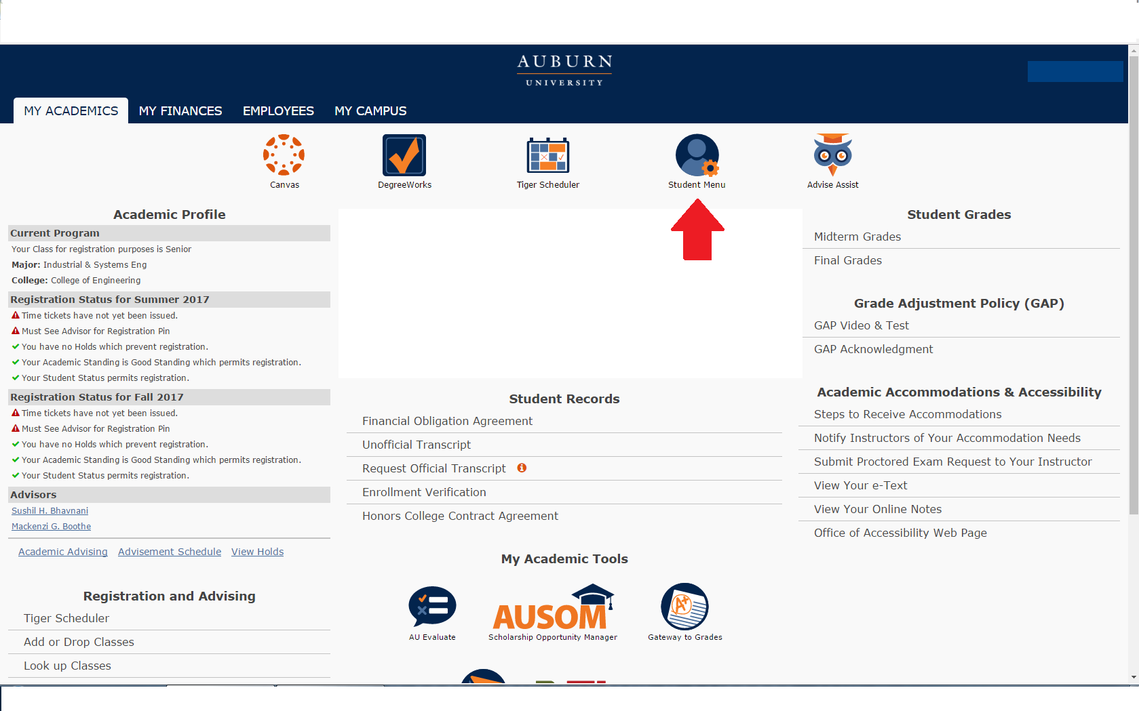

**2. Near the bottom, students will see an All Access tab. Select it to view classes.**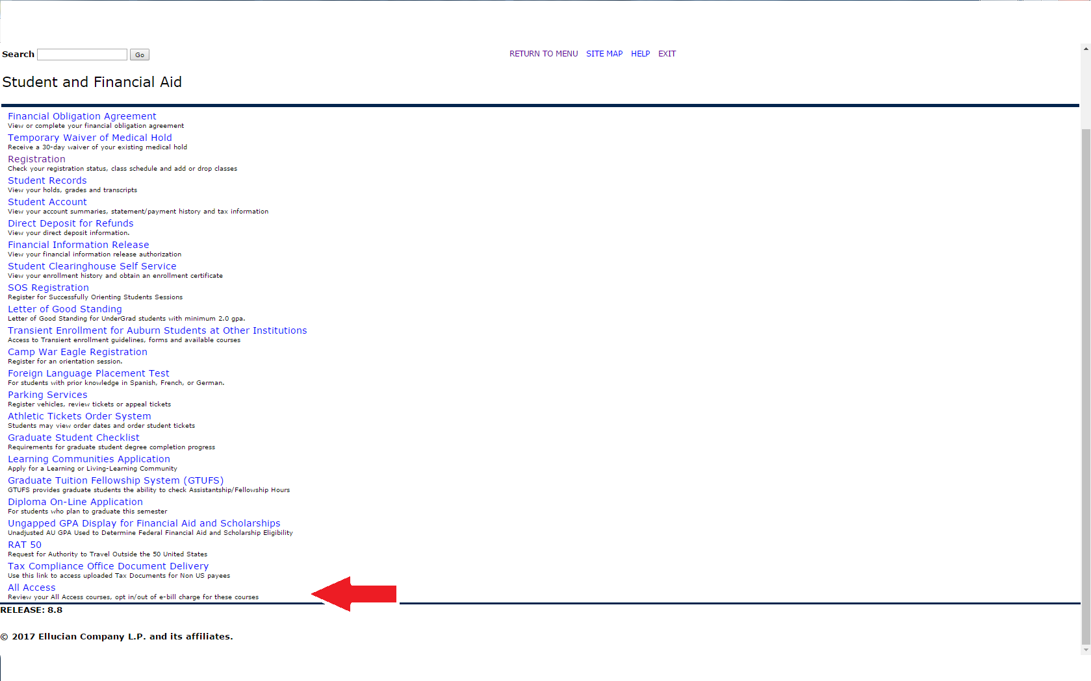

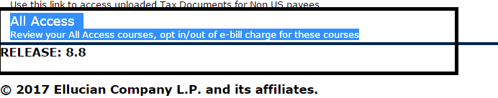

**3. Once in here, they will select their the current term:**

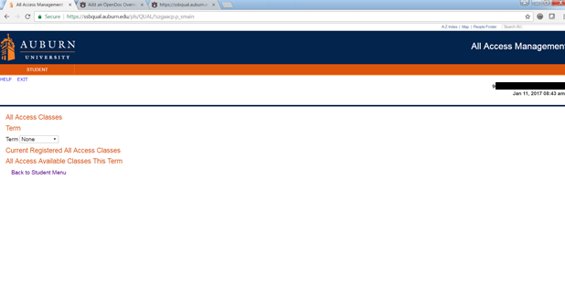

**4. Once the current term is selected, All Access courses will populate with options to change out to the right.**

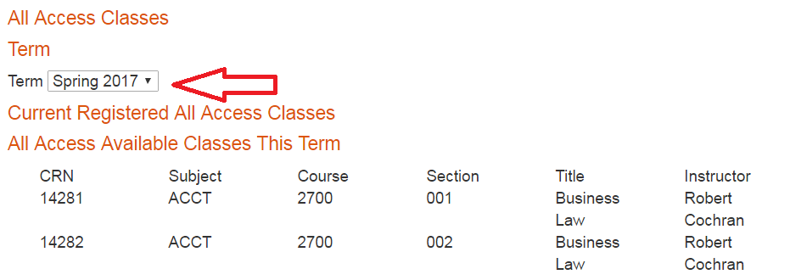

**5. Students can click the change button to opt in or out of the All Access material. NOTE: This does not change your registration in the class, just your purchase option for the course materials.**

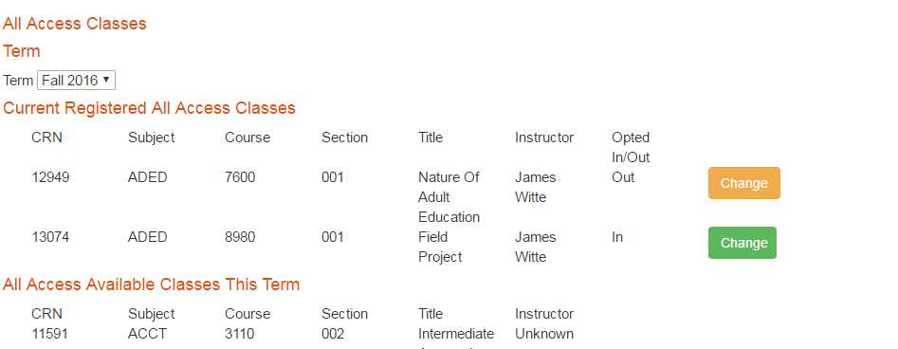

**6. You will be prompted to provide a reason for opting out of the class.**

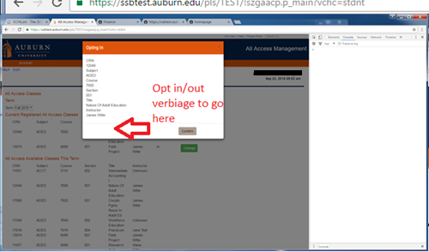

**7. If completed correctly, there will be a green ‘Success’ near the middle of the page.**

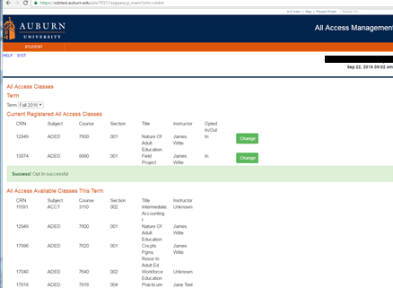

**You may opt in or out at any time before the fifteenth class day. After that day, charges are sent to the Bursar to be applied to your e-bill. We may not be able to reverse the charge after that date.**

**We are able to apply All Access charges for course materials to scholarships that are normally handled through our scholarship counter in store. We will also apply charges for student athletes to the Athletic Department if a student’s scholarship covers course materials.**

**ProctorU Instructions**

## **Online Exam Proctoring with ProctorU**

For your convenience, this course will utilize ProctorU to proctor your online exams. You will access this through the AU Canvas site for this course.

### What is ProctorU?

ProctorU is a service that monitors you while you’re taking your exams online to ensure that no cheating takes place, and to help you be successful. Using this service allows you the convenience of testing from home, in your dorm, or in a private room at the library. They are available 24/7, so you can take your test whenever it’s most convenient for you.

Go to [go.proctoru.com](https://go.proctoru.com/) to create your free ProctorU account.

### How does it work?

After you set up your account, you can schedule your test (or you can even take it on-demand for an additional fee). I strongly recommend that you schedule your exam as soon as possible so you get a time that works well for your schedule and fits within the exam window.

At the time of your exam, you’ll log into your account and be guided through a 10- to 15-minute start-up process that will verify your identity, review the rules of your exam, and get you into your exam. You will be monitored and recorded during your exam to make sure that no one has any unfair advantages while testing. If cheating is suspected, I’ll be notified and will have video evidence of your session.

If you experience any technical issues during the start-up process, ProctorU technicians will work with you until the problem is resolved. In extreme cases when you cannot connect due to technical problems, you may have to reschedule.

All you need is a computer with a strong internet connection, a microphone, a web camera, and a cellphone or mirror. Laptops work, but you cannot use a tablet, Chromebook or mobile device. You will also need to have a valid government-issued photo ID (not a photo or copy of your ID). You’ll need to be in a well-lit, quiet area with a clear workspace and no one else can be in the room with you.

Be sure to schedule each exam at least 72 hours in advance to avoid premium scheduling fees.

### Basic technical requirements:

You may review all equipment and technology requirements [here](https://support.proctoru.com/hc/en-us/sections/115003555488-Equipment-Requirements-and-Help). Please test your equipment with ProctorU’s free helpdesk service by clicking on “Test Your Equipment” on your ProctorU account homepage. If any of your equipment does not pass the check, which will be indicated with an X, click on the chat icon at the bottom right corner of that page. There you can speak with a representative to troubleshoot any issues. I suggest you test your equipment at least one day prior to your exam so they can resolve any problems that may be detected.

### Do you need special accommodations?

If you require special testing accommodations, I will need to let ProctorU know. Please work with me prior to your exam to make sure your accommodations are noted in their system.

### Does it negatively interfere with my computer?

ProctorU does not permanently impact your computer in any way. The only time they will go into your computer settings is to secure your testing environment or troubleshoot issues that may cause you to not be able to connect to their proctoring system. You will be able to see everything they are doing while they are working on your machine. Their proctors and technicians are right there with you every step of the way to provide free basic troubleshooting for common tech issues that can occur during your session, such as a slow connection or a high CPU. Depending on the requirements of your exam, your proctor may need to disable some settings and close any open programs. After your exam is over, you can ask the proctor to turn those settings back on for you. Once your exam is over and you have closed out of your chat session and video page with ProctorU, it completely removes the screen sharing client from your computer. You may also uninstall the browser extension after each exam session if you choose to do so.

### Does ProctorU breach my privacy rights?

Absolutely not! ProctorU takes your privacy very seriously. They stringently adhere to all [Family Educational Rights and Privacy Act (FERPA)](https://studentprivacy.ed.gov/faq/what-ferpa) guidelines. No student information can be shared without your direct approval. If you have any privacy concerns, you can visit ProctorU’s [Privacy Policy](https://www.proctoru.com/privacy-policy) page.

### FAQs:

More questions? Please view ProctorU’s test-taker support FAQ page [here](https://support.proctoru.com/hc/en-us/categories/115001818507).

### Still have questions or concerns?

ProctorU wants you to know that they are always available to help! You can always [start a live chat](https://go.proctoru.com/) by logging into your ProctorU account and clicking the chat icon in the lower right side of your screen, [open a support ticket](https://support.proctoru.com/hc/en-us/requests/new), or call (855) 772-8678.