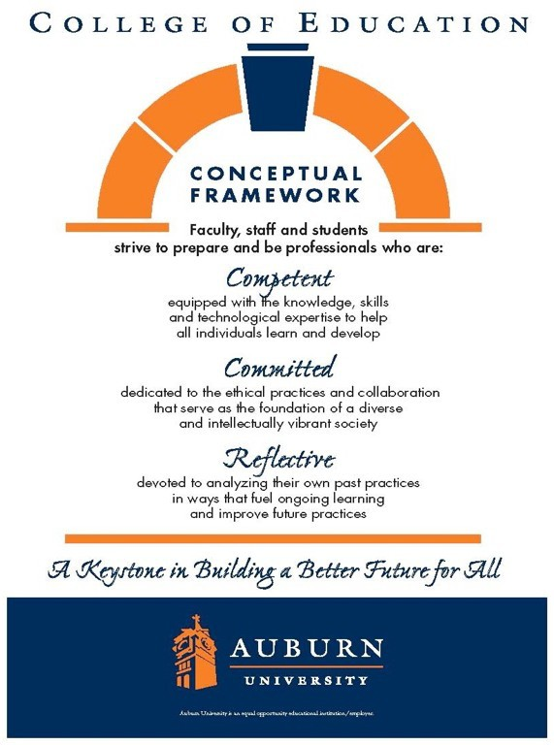CTEE 7420/7426 Auburn University

# Date Syllabus

**Prepared:** August 2024

**Department**: Department of Curriculum & Teaching

Elementary Education

**Program**: Elementary Education

**Course Title:** Curriculum and Teaching Language Arts

**Credit Hours**: 3-semester credit **Prerequisites**: Graduate standing **Course Number**: CTEE 7420/7426 **Course Credit**: Fall 2024

# Instructor:

**Dr. Victoria Cardullo** [**vmc0004@auburn.edu**](mailto:vmc0004@auburn.edu) **386-295-9346**

**Office Hours**: Virtually upon request

**Schedule**: See Calendar

# Texts or Major Resources

**Required Texts:** All readings will be provided in Canvas

# Additional Resources:

APA 7 Style Manual- Required

Alabama Course of Study for Language Arts: [https://www.alabamaachieves.org/wp-content/uploads/2021/08/2021-Alabama-](http://www.alabamaachieves.org/wp-content/uploads/2021/08/2021-Alabama-) English-Language-Arts-Course-of-Study.pdf

**Course Description:** Throughout this course, learners will explore age-appropriate content and pedagogical practices that enhance the instruction of children in kindergarten through grade six in the language arts to promote meaningful learning across the elementary school curriculum.

# Course Objectives:

**As a result of participation in this course, students will:**

1. Discuss concepts, principles, theories, and inquiry tools associated with language arts
2. read, reflect, and discuss assigned readings
3. discuss the role of the following in the language arts: reading, writing, listening, speaking
4. design and assess learner-centered lessons that use appropriate and effective learner- centered lessons that integrate technology and address identified ACOS and NCTE guidelines
5. select and support the use of instructional strategies that meet the needs of diverse learners
6. demonstrate effective oral and written communication
7. identify the resources for enhancing professional growth using technology
8. utilize culturally responsive pedagogy in developing student-centered learning activities
9. demonstrate reflection and self-evaluation as a basis for professional growth
10. demonstrate knowledge of safe, responsible, legal and ethical uses of technologies including fair-use and copyright guidelines and Internet user protection policies

**Course Assignments:**

**All assignments are due by 11:59 p.m. on the due date identified in Canvas.**

**Note: all assignments and due dates are subject to change. Please check canvas announcements and email for updates.**

**Module 1**

* + Perusal- Unpacking the Science of Reading Annotation and Discussion- 10 Points
  + Discussion Prompt- Introduction using Funds of Knowledge Framework-5 Points
  + Discussion Prompt- Evidence-Based Reading Instruction-10 Points

# Module 2

* Critical Issues in Literacy Education – 100 Points
* Discussion Post- Area of Interest in Research Discussion-5 Points
* Individual Zoom Conference-Assignment-10 points
* Brief Outline-Assignment- 10 Points

# Module 3

* Library Tutorial Assignment- 13 Points

# Module 4

* Annotated Bibliography/Sources-Assignment- 20 Points
* The Integration of Reading and Writing Instruction- 10 Points

# Module 5

* Research Topic Writing Assignment- 12 Points

# Module 6

* Group Work- Peer Summary Chart(s)-10 Points
* Group Work- Data Analysis Project- 50 Points

# Module 7

* Literature Review Part I-Assignment- 15 Points

# Module 8

* Discussion Prompt- Culturally Relevant Pedagogy and Multicultural Literature- - 10 Points
* Multicultural Book Review-Assignment- 10 points

# Module 9

* Theory and Action Research-Assignment- 10 points
* Reflective Journal- 10 Points

# Module 10

* Writing Curriculum and Instruction-Assignment- 27 Points
* Peer Assignment- Literature Review/Peer Review-Assignment- 25 Points

# Module 11

* ZOOM Presentation- Theory Presentation-Assignment- 20 Points
* Discussion Prompt- Curriculum Design and Inclusive Practices- 10 Points

# Module 12

* + No Assignments – Work on Final Literature Review

# Module 13

* Reflective Journal: End-of-Course Reflection- 10 Points
* Final Literature Review-Assignment- 70 Points

# Course Policy Statements:

1. Attendance: Students are expected to attend all classes and will be held responsible for any content covered in the event of an absence.
2. Excused Absences: Students are granted excused absences from class for the following reasons: illness of the student or serious illness of a member of the student’s immediate family, the death of a member of the student’s immediate family, trips for student organizations sponsored by an academic unit, trips for university classes, trips for participation in intercollegiate athletic events, subpoena for a court appearance, and religious holidays. Students who wish to have an excused absence from class for any other reason must contact the instructor in advance of the absence to request permission. The instructor will weigh the merits of the request and render a decision. When feasible, the student must notify the instructor prior to the occurrence of any excused absences, but in no case shall such notification occur more than one week after the absence. Appropriate documentation for all excused absences is required. Please see the *Tiger Cub* for more information on excused absences.
3. Make-Up Policy: Arrangement to make up a missed major examination (e.g., hour exams, mid-term exams) due to properly authorized excused absences must be initiated by the student within one week of the end of the period of the excused absences(s). Except in unusual circumstances, such as the continued absence of the student or the advent of university holidays, a make-up exam will take place within two weeks of the date that the student initiates arrangements for it. Except in extraordinary circumstance, no make-up exams will be arranged during the last three days before the final exam period begins.
4. Academic Honesty Policy: The University Student Academic Honesty Code on the University Policies site (https://sites.auburn.edu/admin/universitypolicies/default.aspx) pertaining to cheating apply to this class.
5. Disability Accommodations: Students who need special accommodations in class, as provided by the Americans with Disabilities Act, should arrange for a confidential meeting with the instructor during office hours in the first week of classes (or as soon as possible if accommodations are needed immediately). The student must bring a copy of their Accommodations Letter and an Instructor Verification Form to the meeting. If the student does not have these forms, they should make an appointment with the Program for Students with Disabilities, 1288 Haley Center, 844-2096 (V/TT).
6. Course contingency: If normal class and/or lab activities are disrupted due to illness, emergency, or crisis situation, the syllabus and other course plans and assignments may be modified to allow completion of the course. If this occurs, an addendum to your syllabus and/or course assignments will replace the original materials.
7. Cell Phones/Electronic Devices: Students are expected to keep all cell phones on vibrate/silent ring during class time.
8. Professionalism: As faculty, staff, and students interact in professional settings, they are expected to demonstrate professional behaviors as defined in the College’s conceptual framework. These professional commitments or dispositions are listed below:
   * Engage in responsible and ethical professional practices
   * Contribute to collaborative learning communities
   * Demonstrate a commitment to diversity
   * Model and nurture intellectual vitality
9. Late Work: Grades on late work are reduced at a rate of 10% of overall eligible points per day the assignment is submitted late. Work will only be accepted within 48 hours past the posted due date in Canvas. After 48 hours past the posted due date, the assignment will receive a score of Zero (0). For example, if a 10-point paper is due by 11:59 p.m. Sunday but is submitted Tuesday, 2 points will be deducted for a tardy submission (in addition to any points deducted due to quality of work). If the assignment is submitted at 12:00 a.m. Wednesday, the assignment will not be graded and receive a score of zero. The supervising professor may make exceptions to this policy due to previously communicated emergency situations.
10. Work Quality: If submitted work does not meet quality standards or receives a failing grade, at the professor’s discretion, students may be allowed to resubmit work to earn up to half of the deducted points. For example, if a 10-point assignment receives a score of 5/10, the instructor may allow/request a resubmission. The assignment will be assessed a second time and up to half of the deducted points (5) can be earned, meaning a final score of 7.5/10.

**Grading Plan:**

The final grade for the course is based on the following:

90%-100%= A

80%-89% = B

70%-79% = C

60%-69% = D

Below 60% = F

Please note that this is only a plan; point totals for the course may change during the semester if assignments are added or deleted. Detailed instructions will be available in Canvas.

**Course Schedule**

|  |  |  |
| --- | --- | --- |
| Week | Topic | Assignments |
| Week 1 | Foundation of the Science of Readings | Perusal Unpacking the Science of Reading Funds of Knowledge Introduction Letter- Discussion  Evidence Based Reading Instruction- Discussion |
| Week 2 | Critical Issues in Literacy Education | Critical Issues in Literacy Writing Assignment Area of Action Research Interest  ZOOM Conference Sign- up Brief Outline Assignment |
| Week 3 | Action Research Unit | ZOOM Meetings Library Tutorial |
| Week 4 | Writing Instruction and Integration with Reading | Annotated Bibliography |
| Week 5 | Differentiated Instruction | Spring Placement Required Research Topic Writing Assignment |
| Week 6 | Assessment and Data Drive Decision Making | Peer Summary Chart- Group Assignment Data Analysis Project- Group Assignment |
| Week 7 | Literature Review | Literature Review Part 1 |
| Week 8 | Children’s Literature and Text Selection | Culturally Relevant Pedagogy- Discussion Multicultural Book Review-Assignment |
| Week 9 | Professional Development and Reflective Practices | Theory and Action Research Writing Assignment  Midpoint reflective Journal |
| Week 10 | Theorist and Language Arts | Writing Curriculum and Instruction-Assignment Literature Review/Peer Review-Assignment |
| Week 11 | Curriculum Design and Inclusive Practices | *Theory Presentation-Assignment- ZOOM Meeting*  *Curriculum Design and Inclusive Practices-*  *Discussion* |
| Week 12 | Family and Community Engagement | Work on Literature Assignment |
| Week 13 | Final Literature Review | *Reflective Journal: End-of-Course Reflection Final Literature Review-Assignment* |
| Thanksgiving Break | | |
| Week 15 | Any Make up Work |  |