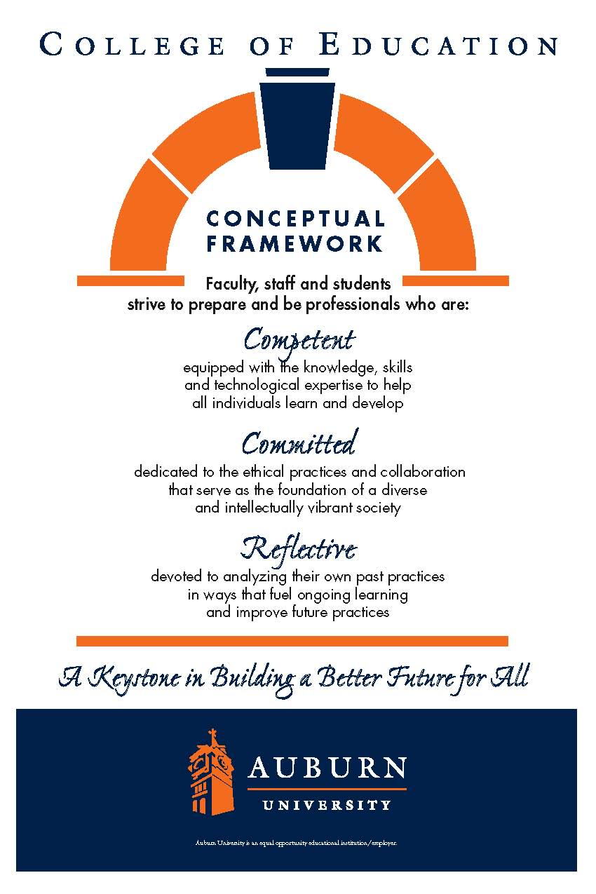**CTEC 4210**

**The Constructivisit Teacher: Growing Professionally**

**Spring 2011**

*Credit Hours*: 3 semester hours

*Prerequisite***:** Admission to Teacher Education, CTEC 4200

*Corequisite*: CTEC 4920

*Schedule:* Tues, 5:00 pm 7:50 pm, HC TBA

*Instructor*: Sandra Little

Graduate Teaching Assistant

Early Childhood Education

Departmental secretary: 844-4434. Fax: 844-6789.

E-mail: [littlsj@auburn.edu](mailto:littlsj@auburn.edu)

*Office hours*: by appointment. I hope you'll feel welcome to e-mail or drop by the office to pursue ideas from the course.

**Date Syllabus Prepared:** August 1998; Reviewed January 2007

**Required Readings: *Specified readings and websites on Blackboard**

**Recommended Texts:**

DeVries, R. and Zan, B. (1994) *Moral Classrooms, Moral Children: Creating a Constructivist Atmosphere in Early Education*. NY, New York: Teachers College Press.

Jackson, Margaret (1993). *Creative Display & Environment*. Portsmouth, NH: Heinemann.

Wilson, J. & Jan, L. (1993). *Thinking for Themselves, Developing Strategies for Reflective Learning*. Portsmouth, NH: Heinemann.

**\*Additional readings may be required**

**Course Description**

Students will construct an operational understanding of the roles and responsibilities of being an early childhood professional and will develop the knowledge necessary to make wise decisions related to professional ethics with children, families and colleagues, as well as those related to classroom management, organization and administration of early childhood programs.

**Course Objectives[1]1**

This course provides students the opportunity to construct knowledge of:

1. How to accommodate to individual learners needs by adapting teaching techniques and strategies to individual and cultural learning styles in a multi-cultural learning environment. [PS 2.b.2(i),(ii), & (iii)] [PS 2.c.2(x)] NAEYC 1.2.2 & 2.3]
2. How to plan, organize, implement, and manage a constructivist program in relation to the total school program. [ECE 2.a.1] [PS 2.c.2(iv) & (vii)] [PS 2.d.2(ii)] [NAEYC 2.4.1 & 5.1] [ECE 2.a.8]
3. What it means to be a professional in terms of the responsibilities to children and their families, as well as awareness of the need for continuous growth and avenues for that growth. [ECE 2.a.9 and 2.b.4]
4. Cultural values, issues, and the existence of codes of ethics in professional life. [ECE 2.a.6] [NAEYC 2.4.2, 2.4.5 & 5.4]
5. Family life and multicultural patterns which exist in homes, schools, and communities, as well as techniques for working with families and for involving family members in the education of young children. [ECE 2.a.5, ECE 2.a.6, & ECE 2.a.7] [NAEYC 3.3, 5.2, 5.6 & 5.7] [ECE 2.a.9]
6. Current trends and research and their applications to early childhood education as well as techniques for creating and maintaining a wholesome environment that meets individual needs and fosters the development of interpersonal relationship skills with emphasis on the use of manipulative materials and play as instruments for enhancing development and learning. [PS 2.c.2(xi)] [NAEYC 2.1.1]
7. Criteria to be used in selecting, organizing, and evaluating available space, resources, textbooks, experiences, and equipment appropriate to the divergent components of the early childhood curriculum [PS 2.c.2(ix)] [NAEYC 2.1.7] [ECE 2.a.8]
8. Techniques and instruments for observing, recording and assessing behavior and development. [PS 2.c.2(ix)]
9. The impact of federal and state laws and regulations, as well as local policies and procedures, on the work of the teacher and curriculum development.
10. The role and use of paraprofessionals [NAEYC 2.2]
11. How to use appropriate classroom management and discipline techniques [PS 2.d.2(iv)] [NAEYC 2.2]

**AUBURN COLLEGE OF EDUCATION-CONCEPTUAL FRAMEWORK**

*Competent*

Competent professionals demonstrate the knowledge and skills needed to facilitate the learning of the individuals they serve. Their competence enables them to model and promote active, collaborative, and ongoing learning. Their efforts are enhanced by their abilities to foster learning communities that are safe, stimulating, and enriched with diversity; engage in reasoned and purposeful decision making; and implement their professional practices in proactive, flexible, and self-regulating ways. We recognize that the development of professional competence is linked to levels of preparation and experience. We also acknowledge that competence continues to develop over the course of an entire career.

*Committed*

Committed professionals make reasoned decisions based on thoughtfully constructed values. As a College, we strive to nurture values that support the learning of all people, honor diversity, protect the integrity of learning, and expand the scholarship of our professions. We view these values as professional dispositions, and we define them as filters for responsible decision making. Our College emphasizes the conscious development of commitments related to professional responsibilities and ethics, collaboration, diversity, and intellectual vitality.

*Reflective*

We choose to frame reflection as a critical and pervasive habit of mind that permeates and fuels the ongoing expansion of competence and the continued development of reasoned commitments. Reflective professionals subject their own competencies and commitments to continuous scrutiny as they systematically monitor the impact of their professional practices on the individuals they serve and make adjustments as needed. Thoughtful reflection emphasizes reviewing and analyzing past practices in ways that influence and improve future practices. This stance inspires self-initiated professional growth and results in increased capacities for addressing the complexities and dilemmas situated within the work of educational and human services professionals.

**Course Content and Proposed Schedule Outline [see attached for full proposed course schedule & assignments]**

Week 1 Introduction and Overview – class, school, & community

Week 2 **Mandatory attendance:** **Intern orientation Meeting**

Week 3 Your role as an Intern

Week 4 Professional responsibilities to

* + 1. children
    2. parents
    3. other teachers
    4. school administrators
    5. paraprofessionals
    6. community

Week 5 School system requirements for teacher applicants

1. Preparing for a professional interview
2. Preparing for a guest speaker

Week 6 Interviewing for a job – guest speaker

Week 7 Interviewing continued

Week 8 **Mandatory attendance: Interview week**

Week 9 Universal Design for Learning – “minimizing barriers and maximizing learning through flexibility”

Week 10 UDL – focus on autism spectrum and Asperger’s syndrome

Week 11 **Mandatory attendance: Temple Grandin’s lecture & class meeting**

Analyzing discipline problems stemming from disabilities and individual problems

Week 12 Preparing for your PWS & Portfolio

Week 13-14 Professional Work Sample (Guest speaker and mandatory meeting one or both of these weeks)

Week 15 Self-reflection

1. Expectations for yourself as a teacher in training at the outset of this course
2. Progress toward meeting those expectations
3. Summary of achievements during internship and class discussions
4. Self-evaluation

Week 16 Portfolio Evaluation/Final Examination

**Course Requirements/Evaluation**

1. Attend mandatory meetings outlined in proposed course schedule and participate in all discussions online.
2. Complete all assigned readings from posted articles and websites prior to discussions.
3. Complete all assignments on time.
4. Videotape a lesson & answer the following questions (Rubric online)
   1. What do you think went well?
   2. How do you know the students were engaged?
   3. How did you evaluate the students’ understanding?
   4. Include your lesson plan (lesson plan format online)
   5. How would you extend this lesson and/or follow this lesson with additional lessons?
5. Electronic Portfolio
   1. How do I address questions that arise relating to the ethics involved in working with children, parents, paraprofessionals, and school officials? How do I ensure that current research, codes of ethics, school regulations, and my understanding of the family values and cultures of the child guide my relationships?
   2. How do I plan, create and maintain the classroom environment and curriculum necessary to meet the academic, cultural, social/moral, physical and personal needs of the children? How do I ensure that my classroom environment and curriculum value and display children's work? How do I ensure that my classroom environment and curriculum necessary to meet the academic, cultural, social/moral, physical and persona needs of the children? How do I ensure that my classroom environment and curriculum facilitate children's thinking?
   3. How do I manage guidance and discipline in a constructivist classroom, so that children have ownership of their problems, can devise strategies for solving those problems, and can monitor each other according to cooperatively constructed rules?
   4. How do I adapt instruction to meet the needs of the children, parents, and community and still meet the state and local school curriculum standards? How do I evaluate my ability to consider all perspectives as I work with the children?

Portfolio Evaluation Criteria (Rubric online):

1. Evidence of reflection on what you learned through the assigned websites, readings, and discussions.
2. Evidence of use of what you learned in your management decisions with children.

For example, how did you handle setting rules with the children? How did you manage any particular child who presented challenges to you?

1. Competence in handwriting forms, grammar and spelling.
2. Evidence of reflection on and growth in the following areas:
   1. Planning for all curriculum goals
   2. Management of time, materials, space, instruction and people
   3. Observations for assessing, evaluating and advancing thinking
   4. Questioning to facilitate, challenge, provoke or find out
   5. Responding authentically and purposefully
   6. Constructively guiding and disciplining
3. Evidence of the ability to work cooperatively with others
4. Competence in the knowledge base related to the above research questions

Final grades are based on the weight and grade of each of the assignments. The instructor according to the specified criteria evaluates all requirements.

|  |  |
| --- | --- |
| Portfolio | 30% |
| Videotaped lesson and reflection | 15% |
| PWS | 15% |
| Online reflections posted to Bb | 25% |
| Class Attendance when mandated & participation in preparation questions for guest speakers | 15% |
|  |  |

**Grading Plan**. Semester grades ranges are 90-100 = A, 80-89 = B, 70-79 = C, 60-69 = D, 59 and below = F. Note: You must make a “C” or above in this class or retake the class (see Professional Education Services policy).

**Class Policy Statements**

**Participation**: Students are expected to participate in all class discussions and participate in all exercises. It is the student’s responsibility to contact the instructor if assignment deadlines are not met. Students are responsible for initiating arrangements for missed work.

**Excused Absences**: Students are granted excused absences from class for the following reasons: Illness of the student or serious illness of a member of the student’s immediate family, the death of a member of the student’s immediate family, trips for student organizations sponsored by an academic unit, trips for University classes, trips for participation in intercollegiate athletic events, subpoena for a court appearance, and religious holidays. Students who wish to have an excused absence from this class for any other reason must contact the instructor in advance of the absence to request permission. The instructor will weigh the merits of the request and render a decision.

When feasible, the student must notify the instructor prior to the occurrence of any excused absences, but in no case shall such notification occur more than one week after the absence.

Appropriate documentation for all excused absences is required. Please see the *Tiger Cub* for more information on excused absences.

**Make-Up Policy:** Arrangement to make up missed major examination (e.g. hour exams, mid-term exams) due to properly authorized excused absences must be initiated by the student within one week from the end of the period of the excused absences. Except in unusual circumstances, such as continued absence of the student or the advent of University holidays, a make-up exam will take place within two weeks from the time that the student initiates arrangements for it. Except in extraordinary circumstances, no make-up exams will be arranged during the last three days before the final exam period begins. The format of the make-up exam will be *(as specified by instructor).*

**Professionalism**: As faculty, staff, and students interact in professional settings, they are expected to demonstrate professional behaviors as defined in the College’s conceptual framework. These professional commitments or dispositions are listed below:

* Engage in responsible and ethical professional practices
* Contribute to collaborative learning communities
* Demonstrate a commitment to diversity
* Model and nurture intellectual vitality

**Academic Honesty Policy**

All portions of the Auburn University student academic honesty code (Title XII) found in the *Tiger Cub* will apply to this class. All academic honesty violations or alleged violations of the SGA Code of Laws will be reported to the Office of the Provost, which will then refer the case to the Academic Honesty Committee.

**Disability Accommodations**

Students who need special accommodations in class, as provided for by the American Disabilities Act, should arrange a confidential meeting with the instructor during office hours the first week of classes - or as soon as possible if accommodations are needed immediately. You must bring a copy of your Accommodation Memo and an Instructor Verification Form to the meeting. If you do not have these forms but need accommodations, make an appointment with The Program for Students with Disabilities, 1244 Haley Center, 844.2096 (V/TT).

1. 1ECE=Alabama and National Council for the Accreditation of Teacher Education Standards for Early Childhood Education

   PS=Alabama and National Council for the Accreditation of Teacher Education Standards for Professional Studies, Basic Programs

   NAEYC=National Association for the Education of Young Children Standards