Department of the Army
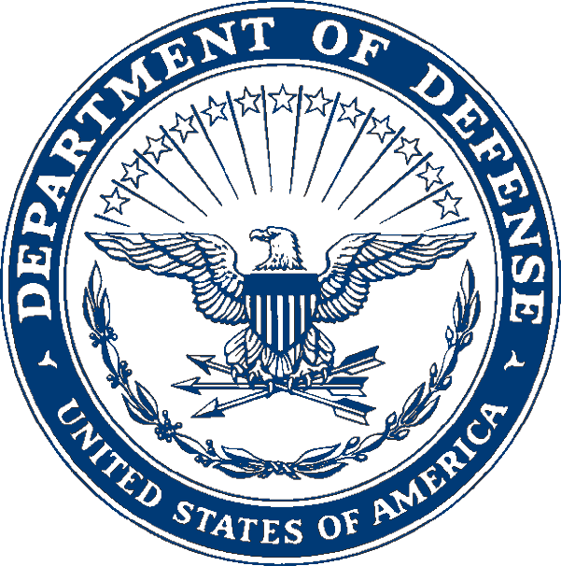
Auburn Army rotc
WAR EAGLE BATTALION
WILLIAM F. NICHOLS CENTER
AUBURN UNIVERSITY, AL 36849-5513

ATCC-FFA-LAU 10 January 2011

MEMORANDUM FOR RECORD

SUBJECT: PHED 1300-001: Fitness and Conditioning Class Syllabus for Spring 2011

- Course Overview: This course will provide an introduction to the US Army Physical Readiness Training (PRT) program and evaluate the students ability to lead small groups in its execution. Understand the fundamental concepts of small unit training – management, operations planning and assessment. Conduct activities of the ROTC cadet organization. Articulate goals; put plans into action to attain them. Assess organizational cohesion and fitness and develop strategies to improve it.

- Evaluation and Grading:
- The PT grade is based on the following:
- APFT Score: The score of the final APFT will be divided by three to figure the PT grade. Example: score a 227 on your final APFT and you receive a 75.6 (C) for your PT grade.
- Attendance: One point will be deducted for every absence from PT. A half point will be deducted if missing equipment and another half point for being late to accountability formation. These points will be deducted from your final grade following the APFT.

- Training Schedule: PT will be held Monday, Wednesday, and Thursday at the Auburn IM fields from 0600 to 0715 and Tuesday at a location to be announced from 0600-0715. Times and locations for PT can change due to event or weather and will be announced thru the Chain of Command and the trainers.

- Credit(s): After successful completion of PHED 1300 you will receive 1 PE credit.

- Uniform. The uniform for the prescribed training will be IAW the battalion-training schedule. However, as a guideline the uniform for PT will be the seasonal Army Physical Fitness Uniform. ACUs may be worn for PT if the event dictates that as the uniform, i.e. ruck marches but they will have all the appropriate patches and the footwear may be either boots or running shoes dependent on the event. All uniforms will be worn IAW with Army AR 670-1(Wear and Appearance of Army Uniforms and Insignia) and the Battalion SOP.

- Changes. Changes will be distributed thru the Chain of Command and also posted on the MS III bulletin board, ROTC Blackboard, your Auburn email, and the Auburn University ROTC website.

- Administrative Suspensions: Cadets that fail to maintain the standard will be subject to administrative suspension. Any cadets that fail to meet the requirements during the semester will be placed on temporary administrative suspension that may be lifted once the requirements are fulfilled. Those cadets that fail to meet the requirements by the end of the semester must be put on administrative suspension and will not receive any benefits, other than stipend for the current and following semester. They will also be subject to disenrollment from the ROTC program. Administrative suspensions will be used for (not all inclusive):
  - Failure of APFT or height/weight standards
  - Failure to maintain academic/ROTC standards
  - Failure to maintain full-time academic status as determined by the university

- Text and References:
- TC 3-22.20 “Army Physical Readiness Training” (AUG 2010).

- Special needs: The American with Disabilities Act of 1990 requires universities to provide a “reasonable accommodation” to any individual who advises us of a physical or mental disability. If you have a physical or mental limitation that requires an accommodation or an academic adjustment, please arrange a meeting with the cadre at you earliest convenience.

- Open Door Policy: Cadre will be available from 0900 to 1600 at the Nichols Center. Cadets are encouraged to keep the Cadre informed on status of any situation that may change their status as a Cadet (i.e. medical, academic, or legal) or may affect their performance or attendance in the program. SFC Wommack and MAJ Heymann are available to Cadets at times outside the normal office hours thru cell phone, text message, or email. If you feel that neither of them could help with the problem, then the PMS or SMI are available by scheduling an appointment with Ms. Ledford.

////ORIGINAL SIGNED////
ANDREW HEYMANN
MAJ, IN
Assistant Professor of Military Science

