**CTCT 7730/7736**

Program Evaluation

*Spring 2013*

Business Education

College of Education

Dr. Leane Skinner

(334) 844-3823

Haley 0348

skinnal@auburn.edu

Office Hours:

By Appointment

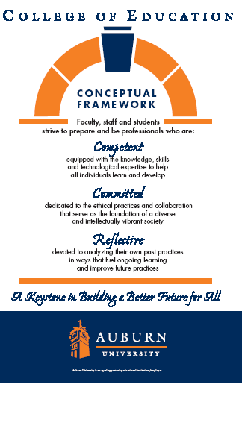

**Syllabus   
CTCT 7730/7736 – Program Evaluation**

**SYLLABUS PREPARED: Spring 2013**

**TEXTS, RESOURCES and SUPPLIES:**

Journal articles and Internet resources

**COURSE DESRIPTION:**

Principles and procedures used in evaluation vocational, technical, extension, and training programs. Alternative approaches to evaluation and practical guidelines for conducting evaluations.

**COURSE OBJECTIVES:**

Upon completion of this course, students will be able to project themselves as competent, committed, and reflective professionals through their ability to:

1. Explain evaluation concepts as applied to education programs
2. Describe the purposes of evaluation
3. Compare and contrast alternative approaches to evaluation
4. Develop an evaluation plan
5. Collect evaluative information
6. Analyze evaluation information
7. Report evaluation results

**COURSE CONTENT:**

**See “Modules” in Canvas**

**COURSE REQUIREMENTS/EVALUATION**:

1. Participate in all class discussions in Canvas
2. Submit all assignments by due date
3. Develop an evaluation plan for a program with which you are working.
   1. The plan will be 11-16 pages in length and contain the following:
      1. Contextual description – This section should describe the context of the program for which you will be designing the evaluation. I should briefly describe the program in terms of location, purpose, goals, objectives, content of the program, characteristics of the clients, and the purposes of the evaluation. It should be 1-2 pages in length.
      2. Evaluation questions - This section should identify and describe the purposes of the evaluation. It should also identify the major stakeholders and four or five evaluation questions to be addressed. It should be 1-2 pages in length.
      3. Information r required and methods of data collection - This section should be the information required. Information source(s), method(s) for collecting information and information collection arrangements (i.e. by whom, conditions, and when). It should be 3-4 pages in length.
      4. Analysis and interpretation procedures – This section should present the analysis procedures, interpretation procedures, and criteria. This section should be 3-4 pages in length.
      5. Evaluation Report – The topics to be included in this section should include how the reporting of information will be done (i.e.to whom, how and when) . This section should eb 3-4 pages in length.

The final grade will be based on the following:

Discussions 25%

Weekly Assignments 25%

Evaluation Report/Presentation 50%

90-100% A

80-89% B

70-79% C

60-69% D

Below 60% F

Participation: Students are expected to participate in all class discussions and participate in all exercises. It is the student’s responsibility to contact the instructor if assignment deadlines are not met. Students are responsible for initiating arrangements for missed work.

Attendance/Absences: For on campus students, attendance is required at each class meeting. Distance learning students must log on and participate in Canvas weekly. If an exam is missed, a make-up exam will be given only for University-approved excuses as outlined in the Student Policy ebook. Arrangement to take the make-up exam must be made in advance. Students who miss an exam because of illness need a doctor’s statement for verification of sickness and should clear the absence with the instructor the day they return to class. Other unavoidable absences from campus must be documented and cleared with the instructor in advance.

Unannounced quizzes: There will be no unannounced quizzes.

Accommodations: Students who need accommodations are asked to electronically submit their approved accommodations through AU Access and to arrange a meeting during office hours the first week of classes, or as soon as possible if accommodations are needed immediately. If you have a conflict with my office hours, an alternate time can be arranged. To set up this meeting, please contact me by e-mail. If you have not established accommodations through the Office of Accessibility, but need accommodations, make an appointment with the Office of Accessibility, 1228 Haley Center, 844-2096 (V/TT)."

Honesty Code: See the Student Policy eBook - http://www.auburn.edu/student_info/student_policies/

All policies and guidelines apply to this class.

Professionalism: As faculty, staff, and students interact in professional settings, they are expected to demonstrate professional behaviors as defined in the College’s conceptual framework. These professional commitments or dispositions are listed below:

• Engage in responsible and ethical professional practices

• Contribute to collaborative learning communities

• Demonstrate a commitment to diversity

• Model and nurture intellectual vitality

Distance Learning Students: Unless specific instructions have been given for a designated course, students in distance education courses shall take all closed resource examinations under the supervision of an approved proctor. Examples of approved proctors include a school superintendent, a principal of a high school, or a dean or department head of a college. Proctors shall be verified and exams shall be sent directly to the proctor who will manage the examination in a secure manner, requiring students to present a picture ID.

The instructor reserves the right to make changes to the syllabus, class requirements, and schedule.

Incompletes are not given except in extenuating and documented circumstances. This is determined by the instructor.

**Writing Center:** The Miller Writing Center provides free support on any writing you are doing while at Auburn, whether for a course or not. Trained consultants are available to work with you as you plan, draft, and revise your writing. For students in distance courses and students temporarily away from Auburn’s campus, the Miller Writing Center offers synchronous online consultations. Please check the Miller Writing Center website ([www.auburn.edu/writingcenter](http://www.auburn.edu/writingcenter)) for instructions and information about scheduling online appointments. If you have questions about the Miller Writing Center, please email [writctr@auburn.edu](mailto:writctr@auburn.edu) or call 334-844-7475 M-F  7:45am-4:45pm.