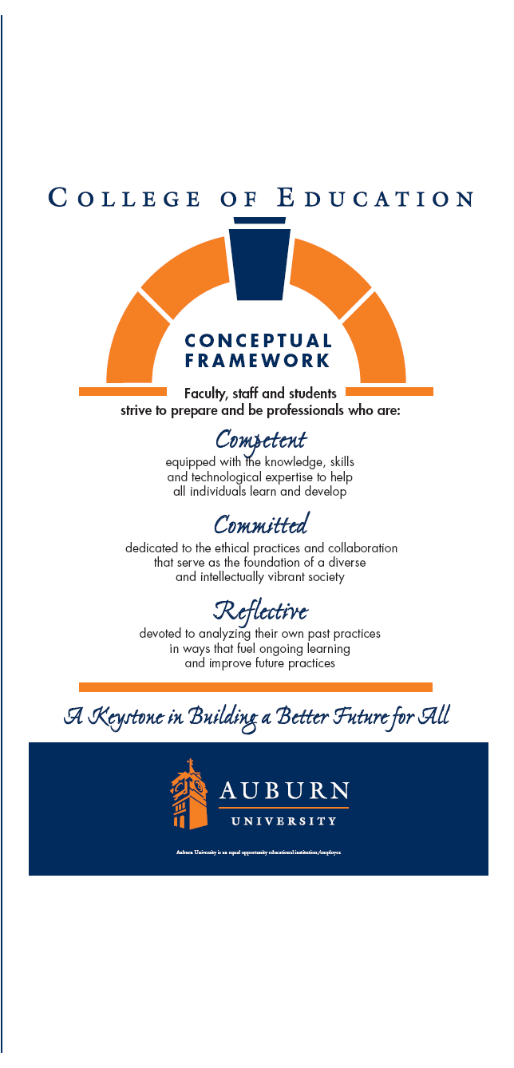

Course and number
HIED 7260
Course Title
Counseling and Advising in Higher Education
Semester and Year
Spring 2013
Department
EFLT
College of Education

Elizabeth Mueller, PhD
Work#: 844-5972
Fax: 334-844-3856
E-Mail: muelleh@auburn.edu
Office Hours: By Appointment

Tamara Miller Bowden, M.Ed.
Work#: 844-4388
E-Mail: bowdetm@auburn.edu
Office Hours: By Appointment

AUBURN UNIVERSITY
SYLLABUS

1. Course Number: HIED 7260
Course Title: Counseling and Advising in Higher Education
Credit Hours: 3 semester hours
Prerequisites: HEID 7250
Corequisites: None

2. Date Syllabus Prepared: December 17, 2012

3. Texts or Major Resources:

Dunkel, N.W. & Schuh, J. H. (1998). Advising student groups and organizations. San
Francisco, CA: Jossey-Bass. ISBN 0787910333

Parsons, R. D. (2004). Fundamentals of the helping process. Long Grove, IL: Waveland
Press, Inc. ISBN 1577663381

Reynolds, A. L. (2009). Helping college students: Developing essential support skills for
student affairs practice. San Francisco, CA: Jossey-Bass. ISBN 978-07979-8645-2

4. Course Description:

This course is designed to introduce counseling and advising theory and
application to professionals in higher education. This course is NOT for those
seeking a credential or degree in counseling.

5. Student Learning Outcomes:

Upon completion of this course, students will be able to:

- Describe how college students are changing and what that means for counseling and advising practices;
- Apply a theoretical approach to assessing counseling and advising needs;
- Discuss what it means to advise at the individual, team, and organizational level;
- Describe the multiple roles that campus professionals play with respect to students and student organizations;
- Describe a model of helping which can be utilized in a variety of settings;
- Demonstrate fundamental helping skills;
- Identify personal attitudes, biases and expectations and their impact on the helping relationship;
- Describe differences between types of counseling and advising; and
- Write a comprehensive report about relevant aspect(s) of counseling and/or advising in higher education.
6. Course Content Outline

WEEK 1: Wednesday, January 9: Introduction of course; syllabus; discussion re knowledge of counseling, counseling theory, active listening skills, student advising; assign theories for re-cap.

WEEK 2: January 16: Re-cap of CSD/Adult Development theory (student presentations and discussion); today’s student

WEEK 3: January 23: Helping College Students Forward, Chapters 1-3; ACPA and NASPA Ethical Codes. Five (5) discussion questions due 8:00 am via email.

WEEK 4: January 30: Helping College Students Chapters 4 & 5; Fundamentals of the Helping Process Chapter 13. Five (5) discussion questions due 8:00 am via email. College Counseling - Dr. Doug Hankes, Director AU Student Counseling Services; College Counseling Center Benchmarking due.

WEEK 5: February 6: Helping College Students Chapter 7; Fundamentals of the Helping Process Chapter 12. Five (5) discussion questions due 8:00 am via email.

WEEK 6: February 13: Advising Student Groups and Organizations Chapter 5, pp. 107-133. Lauren Kume and Nicole Gaillard, Academic Counseling and Advising Center. Five (5) discussion questions due 8:00 am via email. Career Center Benchmarking due.

WEEK 7: February 20: Helping College Students pp. 131-148; Fundamentals of the Helping Process Chapters 3 & 4.

WEEK 8: February 27: Helping College Students pp. 148-155; Fundamentals of the Helping Process Chapters 5 & 6.

WEEK 9: March 6: Helping College Students pp. 145-167; Fundamentals of the Helping Process Chapters 7-11, 14.

WEEK 10: Spring Break!!

WEEK 11: March 20: Research Papers due and presentations

WEEK 12: March 27: Helping College Students Chapter 8; Advising Student Groups and Organizations Chapters 1-4. Five (5) discussion questions due 8:00 am via email.

WEEK 13: April 3: Helping College Students Chapter 7; Advising Student Groups and Organizations Chapters 6-9. Five (5) discussion questions due 8:00 am via email.

WEEK 14: April 10: Advising Student Groups and Organizations Chapters 10, 11. Five (5) discussion questions due 8:00 am via email.

WEEK 15: April 17: Student Advisor Panel. Helping College Students Chapter 9, 10. Five (5) discussion questions due 8:00 am via email.

WEEK 16: April 24: Individual Student Involvement Advisor Presentations; Final Exam

7. Assignments/Projects:

A. Class participation is essential for successful completion of the course. Active and mature participation includes asking questions, sharing experiences, and contributing to the class community. You are part of a classroom community and the total learning environment depends upon the contributions of each individual. A successful student demonstrates initiative in the area of participation. You are responsible for adding to the knowledge base during class by discussing input prepared and gained from your readings and coursework. The quality (not the quantity) of participation is important.

B. Theory Presentations: Each student will prepare a twenty (20) minute presentation on one of the following theorists: Erikson, Sanford, Chickering, Josselson, Marcia, Baxter Magolda, Schlossburg, Kegan, or Jones & McEwen using the following format:
Introduction of Theorist
Basic Philosophy
Key Concepts
Cross-Cultural Contributions
Cross-Cultural Limitations
General Contributions of Approach
General Limitations of Approach
Application of Approach with College Students
- Include handout for classmates and instructors - Name of theory, name of theorist, key concepts, references

Due January 16.

C. Counseling Center and Career Center “Benchmarking”:

Each student will select three colleges/universities: one small (fewer than 5,000 students); one medium (between 5,000 and 15,000 students); and one large (more than 15,000 students) and create a report about the services and staffing of the Counseling Center and the Career Center at each institution. Additionally, you will summarize what you have learned about the similarities and differences among the counseling centers and the similarities and differences among the career centers. While you will be able to find a great deal of information on websites, you may need to call to get all the information you need to complete this assignment.

Counseling Centers: Due January 30.

Career Centers: Due February 13.

D. Research Paper. Each students will prepare a research paper and a 20 minute presentation on a sub-group of college students, e.g. First Generation, International, Minority, Over-Traditionally Aged, Disabled (physical and/or learning), Student Athletes, Academically At-Risk, Veterans, etc., focusing on the challenges they face adjusting to and negotiating the college environment. No sources prior to 2005 may be used. All papers will be prepared according to the APA Style Manual (6th edition). Significant points will be deducted for mechanical sloppiness, including, but not limited to: grammar, punctuation, syntax, format, and spelling as well as inconsistent use of APA formatting.

Students are required to submit their work as hard copy and electronically to turnitin.com. Papers must be turned in directly to me and submitted to turnitin.com; papers left under my office door, given to someone in my office, faxed, or emailed will not be accepted. BOTH the hard copy and the electronic copy must be received to be considered on time. Late papers will not be accepted under any circumstances. If you have never used turnitin.com before, you will need to create a user profile. The class ID is 5943159 and the password is counseling. Due March 20.

E. Student Involvement Advisor: Each student will be assigned a specific size and type of institution, and is responsible for identifying one targetcollege or university to research. Students are required to interview (on the phone or in person) a minimum of one student involvement advisor from that institution to gather information on at least three functional areas (see below); turn in a transcript (questions and answers) of the interview, and develop a 20 minute presentation on that institution, the person interviewed, and how the functional areas compare to Auburn University’s organizational structure, advisor make-up, and fiscal support/funding. Due April 24.

Functional Areas:
Community Service
Freshman Year Programs
General Student Organizations
Greek Life (Panhellenic, IFC, and National Pan-Hellenic)
Minority/International Programming
Recreational Services
Residence Life Programming
Student Alumni Association/Organization
Student Government Association
Student Publications/Media Programming
Student Programming Board (UPC equivalent)

8. Rubric and Grading Scale:

The final grade for the course will be based on the following:

Class Participation in
Discussion/Class Meetings 150 pts. (10 points per week)
Theory Presentation 50 pts.
Benchmarking (2 @ 100 pts each) 200 pts.
Literature Review 200 pts.
Student Advisor Presentations 200 pts.
Final Exam 200 pts.
Total……………………………… 1000 points

The following grading scale will be used:
900 - 1000 points = A
800 – 890 points = B
700 – 790 points = C
600 – 690 points = D
Below 600 points = F

9. Class Policy Statements:

- Attendance: Students are expected to attend all classes, and will be held responsible for any content covered in the event of an absence. Attendance is taken at the beginning of each class period. The student is expected to attend all classes, except in the case of a University-approved excused absence (see the AU Bulletin). In the case of an expected absence, advance notice should be provided to the instructor as soon as such absence is known. Except in the case of a University-excused absence, it is the instructor’s prerogative to deem an absence excused or unexcused. In the case of a University-excused absence, all assignments will be due at the beginning of the next class attended.

- Make-Up Policy: Arrangement to make up a missed major examinations (e.g., hour exams, mid-term exams) due to properly authorized excused absences must be initiated by the student within one week of the end of the period of the excused absences(s). Except in unusual circumstances, such as the continued absence of the student or the advent of university holidays, a make-up exam will take place within two weeks of the date that the student initiates arrangements for it. Except in extraordinary circumstance, no make-up exams will be arranged during the last three days before the final exam period begins.

- Academic Honesty Policy: Auburn University expects students to pursue their academic work with honesty and integrity. The Academic Honesty Code is available at www.auburn.edu/academicpolicy and contains a list of those actions that are considered cheating and the possible consequences they carry. Violations of the Academic Honesty Code will NOT be tolerated in this course.

- Disability Accommodations: Any student needing special accommodations should inform the instructors and/or The Office of Accessibility (1228 Haley Center, phone: 334.844.2096) as soon as possible.

- Course contingency: If normal class and/or lab activities are disrupted due to illness, emergency, or crisis situation, the syllabus and other course plans and assignments may be modified to allow completion of the course. If this occurs, an addendum to your syllabus and/or course assignments will replace the original materials.

F. Professionalism: As faculty, staff, and students interact in professional settings, they are expected to demonstrate professional behaviors as defined in the College’s conceptual framework. These professional commitments or dispositions are listed below:
  - Engage in responsible and ethical professional practices
  - Contribute to collaborative learning communities
  - Demonstrate a commitment to diversity
  - Model and nurture intellectual vitality

10. Justification for Graduate Credit:
This course requires critical thinking skills, excellent writing skills and a high level of exploration of student affairs related counseling and advising practices. Students will be asked to make in-depth analyses of issues and comprehensive integration of theory and practice.

