AUBURN UNIVERSITY
SYLLABUS

1. Course Number: CTSE 4090
Course Title: Curriculum and Teaching I: Science
Credit Hours: 4 Semester Hours (LEC 2 LAB 4.5)
Prerequisites: Admission to the College of Education: Secondary
Science Education Program
Corequisites: None

2. Term: Spring 2014
Day/Time: Tuesdays 6:00pm – 7:50pm with 4.5 hours of lab each week
Instructor: Dr. Christine Schnittka
Office Address: 5072 Haley Center
Contact Information: schnittka@auburn.edu or (334) 844-8277
Office Hours: Mondays 11am -3pm, Tuesdays 2pm – 6pm, and by appointment

3. Texts: None required. Readings will be provided through Canvas.

This course will require the use of the learning management system, Canvas which can be accessed from the Auburn University website (www.auburn.edu). An orientation can be provided if necessary by the Secondary Education Program.

- Course Description:

The prospective science teacher will develop or deepen the skills of planning, teaching, management and evaluation necessary for successfully teaching diverse learners in the secondary science classroom. The course will include a hands-on lab to be undertaken in local area schools. Students will select, plan, and demonstrate various teaching strategies in the field under the guidance of mentor teachers. In addition to planning and teaching, students will apply concepts related to: learning in science, STEM integration, classroom management, assessment, diversity/equity, lab safety, and inquiry-based science.

- Student Learning Objectives:

The course has been organized into five standards that roughly correspond to categories of teacher competencies outlined in AU EDUCATEAlabama. These five strands include: content knowledge, teaching & learning, literacy, diversity, and professionalism. I have translated a portion of AU EDUCATEAlabama Standards into specific lessons and learning objectives for this course. On completion of this course, you will be able to:

Standard 1: Content Knowledge
1.1 Demonstrate deep knowledge of subject-matter content and an ability to organize related facts, concepts, and skills
1.2 Use learners’ prior knowledge, experience, and interests to plan content and to help individual students attain learning goals
1.3 Connect the curriculum to other content areas and real-life settings to promote retention and relevance
1.4 Design instructional activities based on state content standards
1.5 Provide instructional accommodations, modifications, and adaptations to meet the needs of each individual learner
Standard 2: Teaching and Learning
2.1 Design a classroom organization and management system
2.2 Create a positive climate that promotes respect and responsibility
2.3 Create a safe, orderly, and stimulating learning environment and nurtures responsibility, motivation, and engagement of learners
2.4 Develop challenging, standards-based academic goals for each learner
2.5 Engage learners in developing and monitoring goals
2.6 Design coherent lessons that integrate a variety of instructional strategies
2.7 Create learning activities that optimize each individual’s growth and achievement within a supportive environment
2.8 Use formative assessments to adjust instruction
2.9 Use summative assessments to measure learner attainment of specified learning targets
2.10 Maintain evidence and records of learning performance to communicate progress
2.11 Analyze and use disaggregated standardized assessment results for planning
Standard 3: Literacy
3.1 Demonstrate standard oral and written communications
3.2 Foster and respond to effective verbal and nonverbal communication during instruction.
3.3 Use age-appropriate instructional strategies to improve learners’ skills in critical literacy components
3.4 Integrate narrative and expository reading strategies across the curriculum
3.5 Develop skills to solve math problems across subject areas using a variety of strategies to verify and interpret results and to draw conclusions
3.6 Communicate mathematical concepts, processes, and symbols
3.7 Identify and integrate available emerging technologies into the teaching of all content areas
3.8 Facilitate learners' individual and collaborative use of technology
Standard 4: Diversity
4.1 Develop culturally responsive curriculum and instruction in response to individual differences
4.2 Communicate in ways that show sensitivity to diverse populations and respond appropriately to cultural, ethnic, and social differences.
4.3 Demonstrate and apply to own practice an understanding of how biases can affect teaching
4.4 Support learners to accelerate language acquisition
4.5 Guide second-language acquisition and utilize English Language Development Strategies
4.6 Differentiate between learner difficulties and related to cognitive or skill development and difficulties related to language learning
4.7 Understand and recognize the characteristics of exceptionality
4.8 Facilitate inclusive learning environments that support and address the needs of learners with learning differences and disabilities
4.9 Help students assess their own learning styles
4.10 Design learning experiences that engage all learning preferences
Standard 5: Professionalism
5.1 Work in partnership with cooperating teacher to facilitate student learning and well-being
5.2 Participate in professional growth opportunities to improve teaching practice
5.3 Perform as a leader at the program level and within the school
5.4 Promote professional ethics and integrity
5.5 Comply with local, state, and federal regulations and policies

- Course Content:

Week | Date | Topic
1 | 1/14 | Orientation and overview on the art of teaching science. Discrepant events. Demonstrations.
2 | 1/21 | Lesson plans and objectives. ACOS. 5E Learning Cycle
3 | 1/28 | Inquiry in the classroom. ExploreLearning
4 | 2/4 | Nature of Science and Safety in Science. First lesson plan due.
5 | 2/11 | Theories of learning. Assessment to guide learning.
6 | 2/18 | Next Generation Science Standards. A taste of engineering.
7 | 2/25 | Engagement and motivation (MUSIC Model)
8 | 3/4 | Argumentation and Modeling. Second lesson plan due
9 | 3/11 | AU Spring Break—NO CLASS Tuesday. Attend lab if at all possible.
10 | 3/18 | Differentiation and math/reading integration
11 | 3/25 | (Reminder: No Lab this week- Spring Break in Schools) Formative and Summative assessment
12 | 4/1 | Discipline and classroom management. Third lesson plan due.
13 | 4/8 | Rubrics and Test Measurement
14 | 4/15 | Current issues in science education
15 | 4/22 | Last day of class- Review for Final. Outreach Experience due
16 | 4/28 | Final Exam
*** Always check Canvas for the current topics and assignments.
- Assignments/Projects

A. Outreach experience (10 points)- In keeping with the outreach spirit of our university, you are required to complete a minimum of four hours of service with a school-based or campus-based science program. Some options include: AMSTI, GUTS, DAMES, Spring YES camp, or activities going on at the school where you are doing your placement (see COSAM outreach activities on AU website). You will type up your own documentation sheet, indicating the name of the program, the dates and times of attendance, and what you did. The coordinator or leader of the program needs to sign this form. Add these hours to your field experience document. Outreach documentation forms due on April 22.

B. Reflective journal (20 points)- You will write a reflective journal entry for each day you spend out in your field placement, starting with the first day. Each entry should be a couple of good paragraphs, or about 300-400 words. Rather than recount each thing you did during the placement day, you should pick one or more incidents and reflect on their meaning. We will discuss what constitutes “reflection” in class. Sample guiding questions will be provided. Reflective journals will be graded on the criteria of effort, depth of reflection, evidence of problem solving and analysis. Reflective journals are due each week on Canvas and feedback will be provided.

C. Lesson Plans (15 points) Three lesson plans will be graded during the course of the semester. The dates for turning these in are flexible, but should be spaced out during February, March, and
April if possible. A rubric for grading lesson plans will be provided.

D. Reflections on Reading Assignments (15 points) Most weeks, a reflection will be required on the assigned reading. Rubrics will be provided on Canvas for each of these assignments.

E. Final Exam (15 pts.)- There will be an essay final exam due via Canvas on the designated final exam day for this class (April 28). The questions will consist of the following: (1) What have been your greatest accomplishments this term in learning to teach science? (2) Describe your emerging teaching style or teaching identity. (3) What are 3 areas and/or goals for specific improvement as you go on into your internship or forward in your career. Additional questions based on course content will be included. The final exam will be graded based on a rubric containing elements for depth of reflection, clear and logical presentation, accurate content, and evidence of problem solving.

F. Final Lab Field Placement Evaluation (15 pts.) - Total points accumulate on your evaluations for the lab portion of the course and will be numerically translated into 15 points of the course grade.

G. Professionalism and Participation (10 points). Attending class, attending lab sessions, dressing appropriately, and behaving as a professional teacher in these settings is a very important aspect of this course. You are expected to keep your cell phones out of sight, contribute constructively to class discussions and activities, plan with your cooperating teacher, and use your lab time to its fullest potential. Points will be deducted from 10 possible points for every missed class, missed lab session, or unprofessional incident.

H. Field experience hours in this course are linked to certification standards. You must complete a minimum of 60 field experience hours to receive credit for this course.

8. Rubric and Grading Scale:

Any assignment presented or turned in late will be penalized 10% for each day late. Late assignments presented or turned in late after two days will not be accepted without prior approval of the instructor.
The final grade will be determined by the following grading scale:
A = 90 -100, B = 80-89, C = 70-79, D = 60-69, F = below 60%

Note: Although it is possible to make a grade of “D” in this class, a student receiving any grade below “C” must retake the class to matriculate through the program and gain certification.

9. Class Policy Statements:

A. Participation: Students are expected to participate in all class discussions and participate in all exercises. It is the student’s responsibility to contact the instructor if assignment deadlines are not met. Students are responsible for initiating arrangements for missed work.

B. Excused Absences: Attendance is required at each class meeting. Students are granted excused absences from class for the following reasons: Illness of the student or serious illness of a member of the student’s immediate family, the death of a member of the student’s immediate family, trips for student organizations sponsored by an academic unit, trips for University classes, trips for participation in intercollegiate athletic events, subpoena for a court appearance, and religious holidays. Students who wish to have an excused absence from this class for any other reason must contact the instructor in advance of the absence to request permission. The instructor will weigh the merits of the request and render a decision. When feasible, the student must notify the instructor prior to the occurrence of any excused absences, but in no case shall such notification occur more than one week after the absence. Appropriate documentation for all excused absences is required. Please see the Student Policy eHandbook for more information on excused absences (http://www.auburn.edu/student_info/student_policies/).

C. Make-Up Policy: If an exam is missed, a make-up exam will be given only for university-approved excuses as outlined in the Student Policy Handbook www.auburn.edu/studentpolicies . Arrangement to take the make-up exam must be made in advance. Students who miss an exam because of illness need a doctor’s statement for verification of sickness and should clear the absence with the instructor the day they return to class. Other unavoidable absences from campus must be documented and cleared with the instructor in advance.

Unannounced quizzes: There may be unannounced quizzes on the reading assignments. Quiz scores will be averaged in with Reflections on Reading Assignments.

D. Disability Accommodations: Students who need accommodations are asked to electronically submit their approved accommodations through AU Access and to arrange a meeting during office hours the first week of classes, or as soon as possible if accommodations are needed immediately. If you have a conflict with my office hours, an alternate time can be arranged. To set up this meeting, please contact me by e-mail. If you have not established accommodations through the Office of Accessibility, but need accommodations, make an appointment with the Office of Accessibility, 1228 Haley Center, 844-2096 (V/TT).

E. Honesty Code: All portions of the Auburn University student academic honesty code (Title XII) found in the Student Policy eHandbook will apply to this class. All academic honesty violations or alleged violations of the SGA Code of Laws will be reported to the Office of the Provost, which will then refer the case to the Academic Honesty Committee.

F. Course contingency: If normal class and/or lab activities are disrupted due to illness, emergency, or crisis situation, the syllabus and other course plans and assignments may be modified to allow completion of the course. If this occurs, and addendum to your syllabus and/or course assignments will replace the original materials.

G. Professionalism: As faculty, staff, and students interact in professional settings, they are expected to demonstrate professional behaviors as defined in the College’s conceptual framework. These professional commitments or dispositions are listed below:
    - Engage in responsible and ethical professional practices
    - Contribute to collaborative learning communities
    - Demonstrate a commitment to diversity
    - Model and nurture intellectual vitality

DISCLAIMER: ***THE CONTENTS OF THIS SYLLABUS ARE SUBJECT TO CHANGE.***
Module 1: Lesson plans and objectives (Due 1/22/13)
This module is about lesson plans, writing learning objectives, using the Alabama Course of Study for lesson planning, and using the 5-E Learning Cycle for lesson planning. Several readings are required for this module which can be accessed online You may have to use the library online journals. I will upload here what cannot be accessed online.
Read:
Bowen, L. (n.d.) The 5E model of instruction. Lexington, KY: Fayette County Public Schools.
Arreola, R. A. (1998). Writing learning objectives: A teaching resource provided from the Office of the Vice Chancellor for Planning and Academic Support. Available from http://www.uwo.ca/tsc/pdf/LearningObjectivesArreola.pdf
Access and review:
Alabama Course of Study: http://alex.state.al.us/browseSC.php
Sample Lesson Plan with Comments
Lesson Plan Rubric

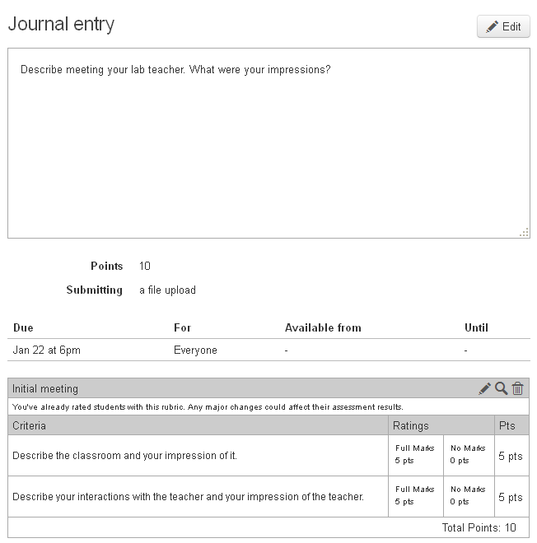
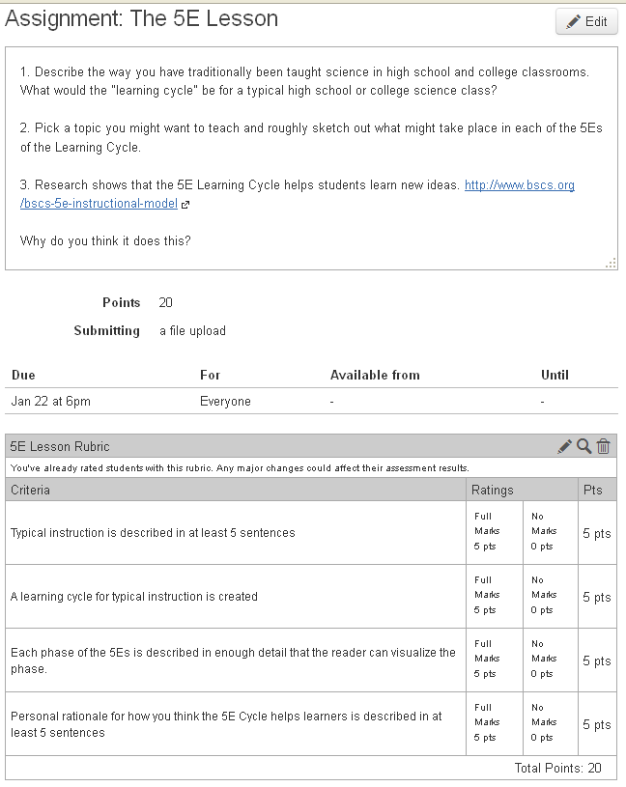
Module 2: Inquiry (Due 1/29/13)
A major theme this semester will be teaching through inquiry. For this module, I want you to write out what you think inquiry teaching is, then read an article from The Science Teacher, and then write about how your ideas of inquiry have changed.
The article:
Bell, R., Smetana, L, & Binns, I. (2005). Simplifying inquiry instruction. The Science Teacher, 72(7)30-33.
can be found by going to the library online: http://www.lib.auburn.edu/ and then clicking on e-Journals and searching for The Science Teacher.
You will get a choice: Education Research Complete. Click on it and use the + signs at the right to find volume 72 issue 7 of The Science Teacher from 2005.
This past week you went to your lab placement with the goal of observing and helping. See assignment (due Friday January 25 if possible).
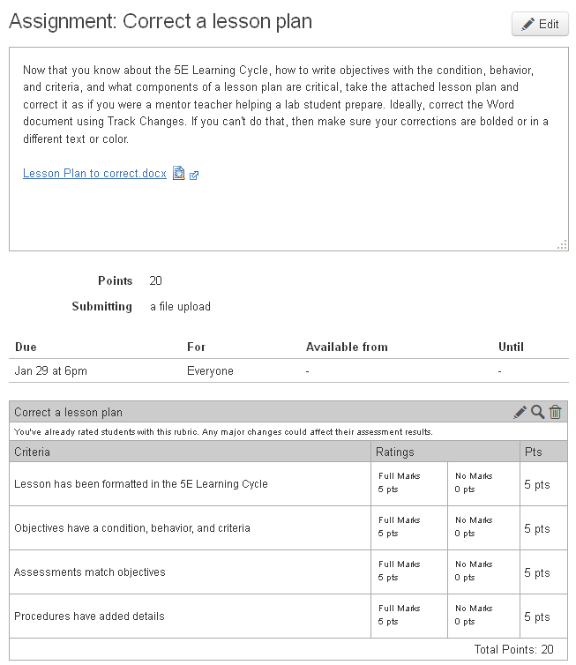
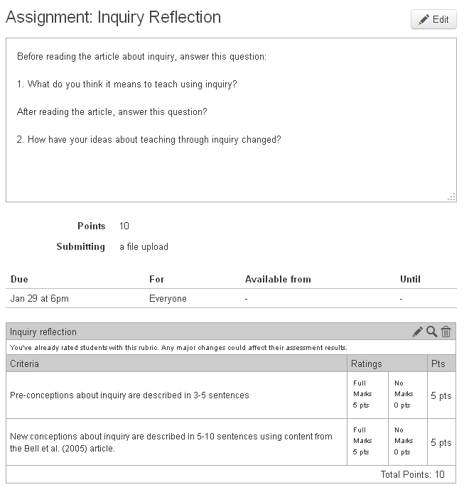
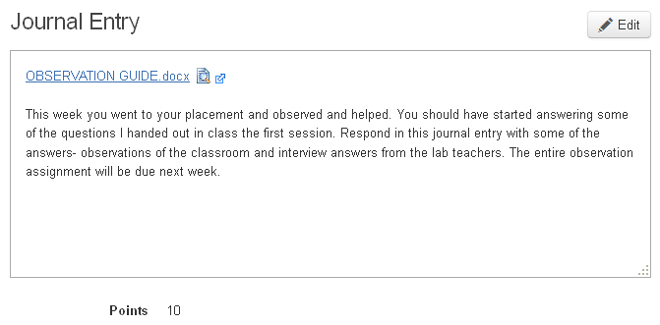
Module 3: Nature of Science (Due 2/5/13)
This week's module is on teaching with the Nature of Science in mind.
Here are the readings:
McComas, W. F. (1996). Ten myths of science: Reexamining what we think we know about the nature of science. School Science and Mathematics, 96, 10-16.
National Academy of Science (1998). Teaching about evolution and the nature of science. Washington, D.C.: National Academy Press. (hardcopy at bookstore) Online at: http://books.nap.edu/books/0309063647/html/1.html
Read Chapter 1 (pages 1-9) very carefully.
(You can try to get a free copy of the book from the Alabama Academy of Science: http://alabamaacademyofscience.org/teaching%20about%20evolution.php)
After reading these two important pieces, I want you to plan a fictional dialog with a student who says to you, "I don't want to learn about evolution. It's against my religion." This will happen and you need to be prepared with a discussion and not just ignore this statement. It's a ripe teachable moment to address so many facets of the nature of science. The NAS book gives you an example, but use your own background knowledge, your own opinions, and your own way of communicating to craft this narrative. A rubric is attached to the assignment to guide you.
Also this week, turn in your observation/interview assignment.
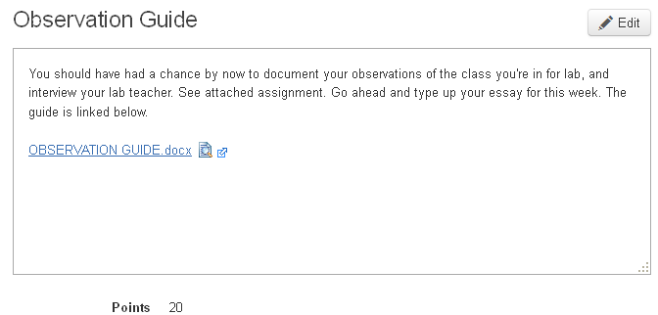
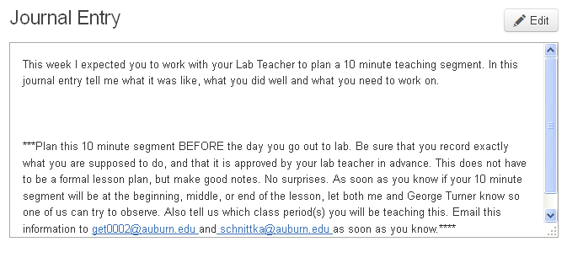
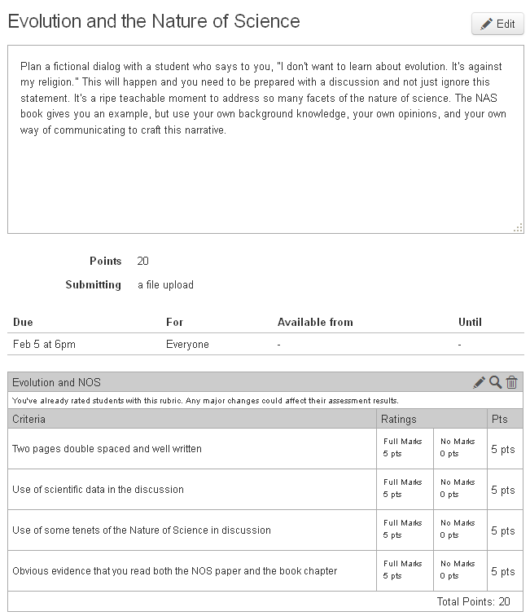
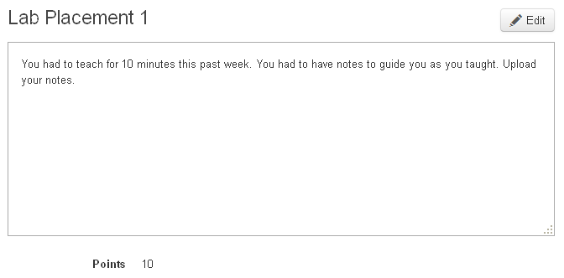
Module 4: Constructivism and conceptual change (Due 2/12/13)
This module is about constructivism and conceptual change. I want you to read three short articles first. They are each from The Science Teacher. I'll just attach them here:
Colburn 2007 Constructivism part 1.pdf
Colburn 2007 Constructivism part 2.pdf
Metz 2008 Constructivism and PBS.pdf
What does it mean to teach in a constructivist manner? After reading these article you should have a pretty good sense. So, imagine your principal stops you in the hall and says, "I heard you teach in a construtivist manner. What is that? Why do you do that?" You have two minutes to answer. Your answer should teach the principal what it is that you do and why you do it. You can record your answer on any device you want and upload an audio file. Alternatively, there is a way to record on Canvas and upload an audio file. Either way, write out your "speech" first but don't sound like you're reading a speech. Sound authentic. Convince me that you know what you're talking about!
Also, this week upload a journal entry in which you describe specific strategies you have seen your Lab teacher use to promote positive relationships with students. Then describe specific strategies YOU want to use to promote positive relationships with students.
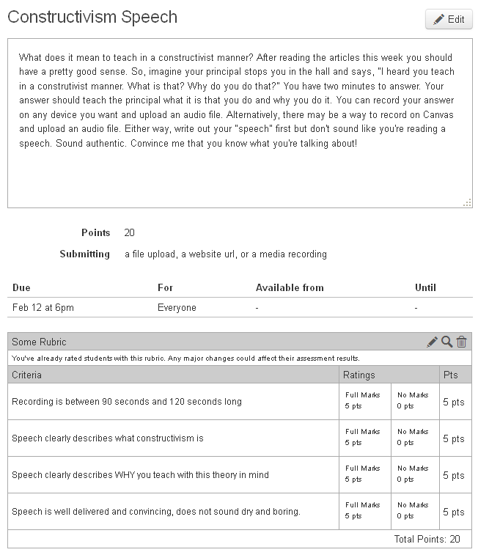
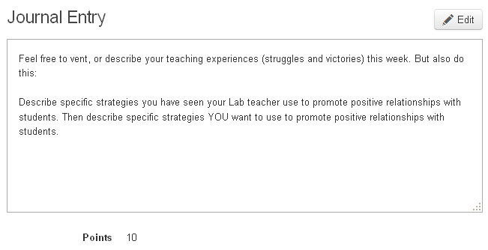
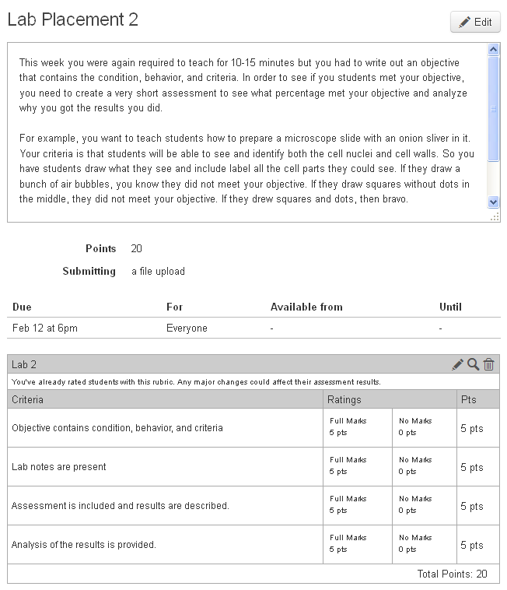
Module 5: Engineering in STEM education (Due 2/19/13)
This module is about integrating engineering into science teaching and learning. Also, I want you to be familiar with my work and think about how to assess for learning when you use design or project-based lessons.
First, I want you to read this article:
Schnittka, C., Bell, R., & Richards, L. (2010). Save the penguins: Teaching the science of heat transfer through engineering design. Science Scope, 34(3), 82-91.
As you know, you can find it in the library e-Journals.
Then, I want you to read this article that I have submitted to Science Scope, and it is under review. I hope it gets accepted.
proof for peer review.pdf
Here are a few videos you can watch to understand these two curriculum modules: http://youtu.be/5xQ5yxt7BSM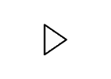 http://youtu.be/iYXpyTEYlhs
The full versions of these curricula can be found on my website in the Engineering tab. Go to www.auburn.edu/~cgs0013 and you may find additional assessments linked there.
Your written assignment is to document all the ways I embed assessment into the engineering design curriculum (Penguins and Sea Birds) and whether you think it measures learning. Sometimes I have students do performance assessments, sometimes it's drawing or such. This satisfies Objective Strand 4.2, "Explain the relationship between assessment and learning and show how to integrate assessment into various stages of the learning process."
Finally, don't forget to create a journal entry this week.
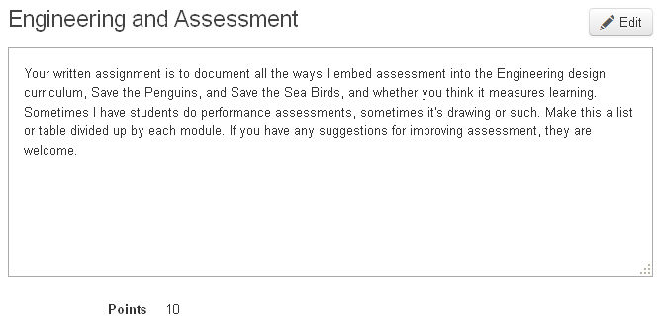
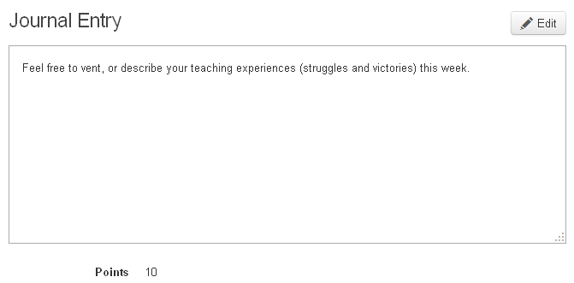
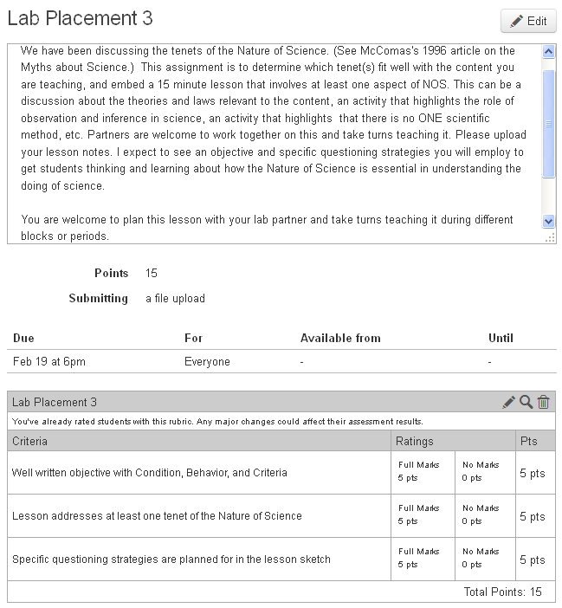
Module 6: Motivation (Due 2/26/13)
This module is about motivation. How can you motivate your students to learn and work in your class?
For some ideas, read the following:
Jones, B. D. (2009). Motivating students to engage in learning: The MUSIC model of academic motivation. International Journal of Teaching and Learning in Higher Education, 21(2), 272-285. Downloaded from http://www.isetl.org/ijtlhe/pdf/IJTLHE774.pdf
I want you to create something useful with the information in this article, and I want to give you some power over how you create a useful product. It could be a foldable (see http://www.catawba.k12.nc.us/C_i_resources/Foldables.htm) or a song or an essay or a Prezi (see www.prezi.com) or a mind map (see https://bubbl.us) or any other way you would like to create a useful way to remember and use what you have learned.
This week your lab assignment is to use a probe to assess student conceptions. If you did not find a published probe in one of Page Keeley's books, you need to find or create your own. It must be based on research on children's' ideas about a science topic.
As usual, create a journal entry about your work in your placement this week. Perhaps you can watch for ways your cooperating teacher does things to motive students, and things you think might back fire...
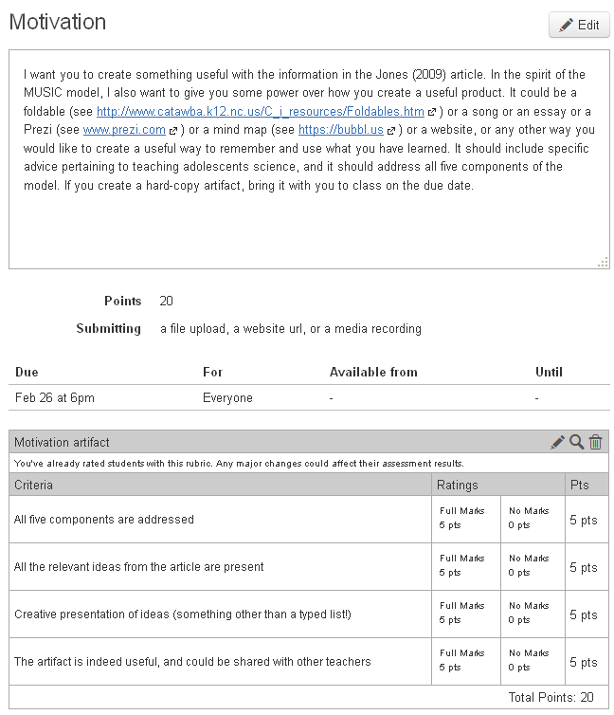
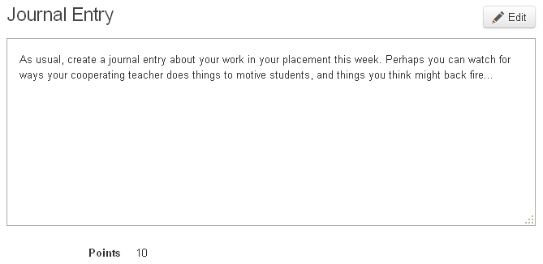
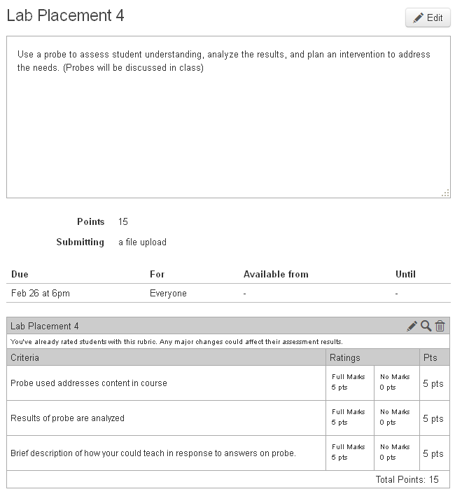
Module 7: Different teaching techniques (Due 3/5/13)
This module is about different techniques to teach science.
One popular technique is "The Field Trip."
Read:
Schnittka, C.G. (2006). Learning lessons from estuaries. The Science Teacher, 73(1), 31-35.
This was my first publication. You will find it in the library e-Journals.
Another popular technique is "The Lecture."
While this is my least favorite technique, sometimes it cannot be avoided. Read some ways to make the lecture interactive:
Millis Active Learning.pdf
Another popular technique is called "The Lab."
Labs can be described as "cook book" or "inquiry" or somewhere in between. Pick three labs that your cooperating teacher has used-- get the handouts, the directions, everything that accompanies the "labs." Analyze them using the following rubric to find out where they fall on the cook-book to inquiry spectrum.
Lab Assessment.doc
For your assessment of different techniques to teach science, create a document that lists everything you read or learned that you think is interesting, and that you will want to remember in the future when you teach science.
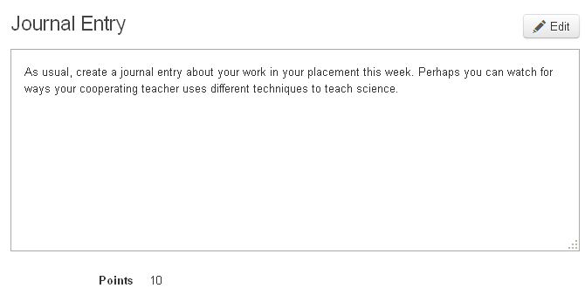
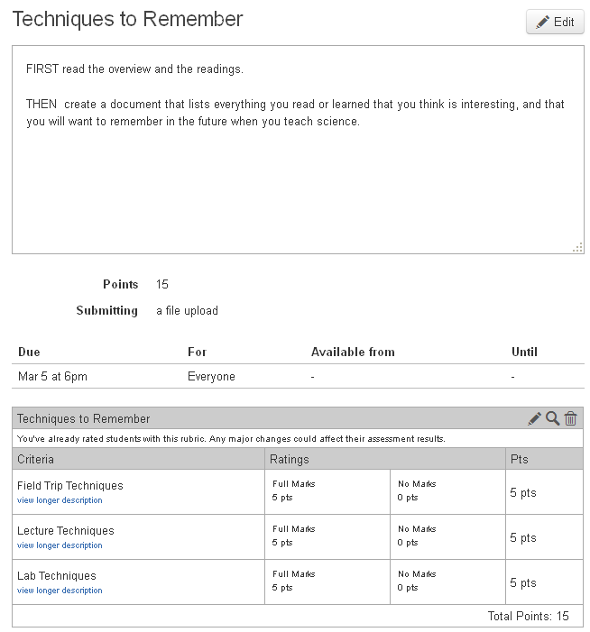
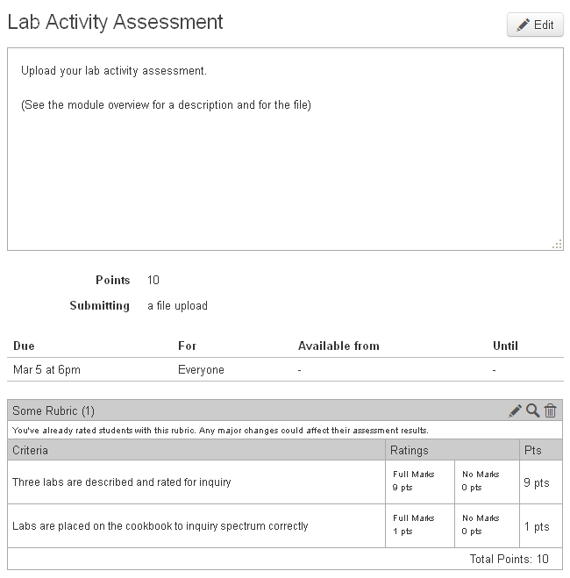
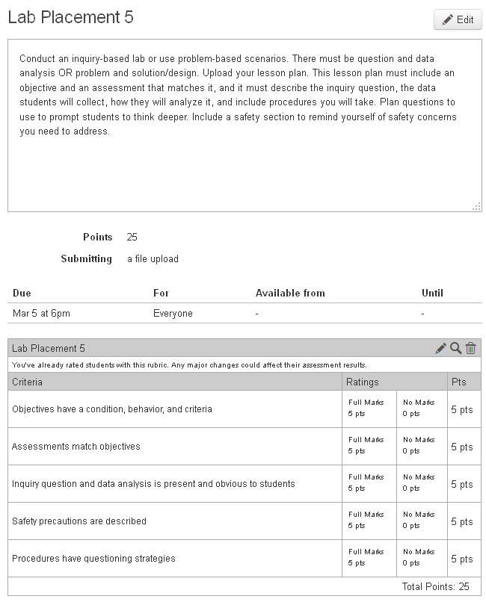
Module 8: Differentiated Instruction (Due 3/19/13)
This module is about teaching with differentiation in mind.
Read: Science Differentiation Brief.pdf for an overview of what differentiation means.
Then, read: Dotger, S., & Causton-Theoharis, J. (2010). Differentiation through choice: Using a think-tac-toe for science content. Science Scope, 77(2), 18-23.
(You can find this article through the library e-Journals or download Dotger 2010.pdf .) This article will give you a specific technique idea that we will try in class, so be prepared.
We use differentiation to reach all types of learners. Read the following article to specifically learn a strategy to reach underrepresented groups of learners:
Behm, C. (2001). Big picture science: Uncovering teaching strategies for underrepresented groups. The Science Teacher, 68(3), 36-39.
(Download it here Behm 2001.pdf)
Teaching with the philosophy of differentiation can be overwhelming to a new teacher and should be planned for in advance. Reflect on the three articles you have just read, and think about the lessons you have taught this semester in your lab placement. Pick one lesson and write an essay about what you could have done differently to incorporate differentiation. If you can't think of a lesson YOU taught, reflect on one that your coopering teacher taught that you observed.
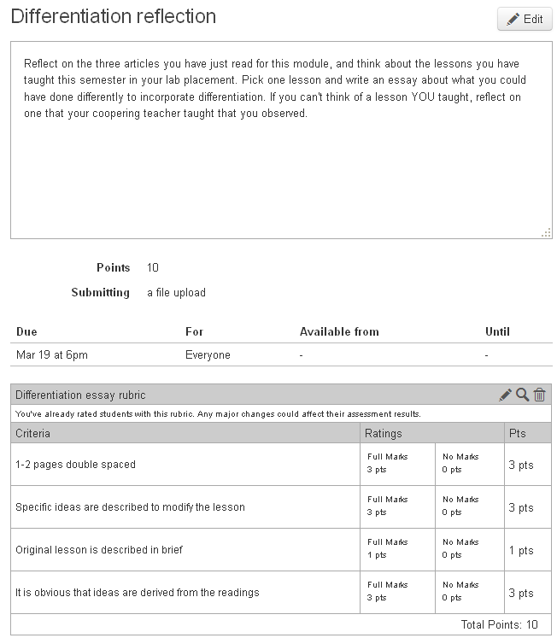
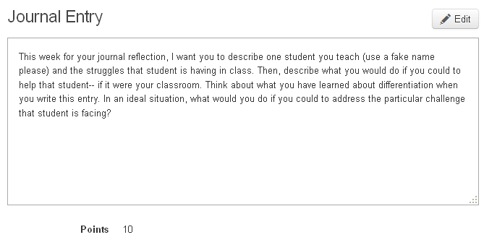
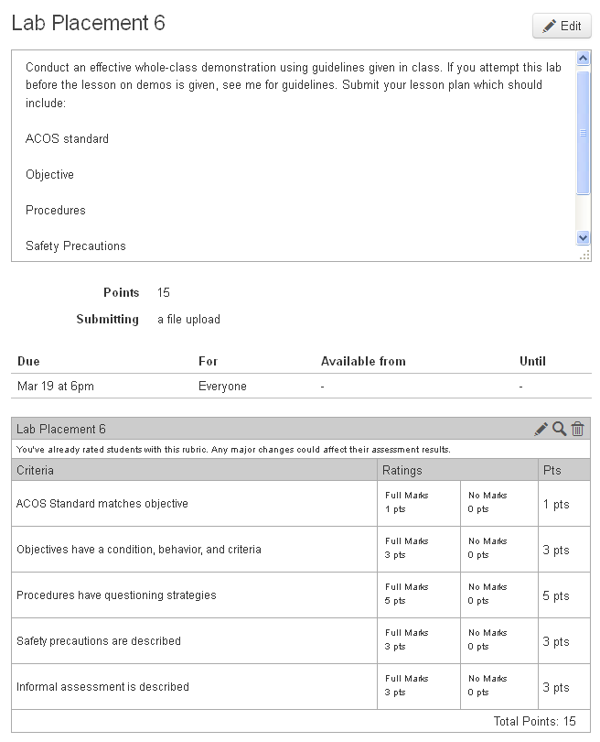
Module 9: Assessment (Due 3/26/13)
This module is on assessment-- formative and summative assessment.
Read:
Go to www.nsta.org and click on HIGH SCHOOL on the left. Then scroll down to the journal archives and do a search on the word, "assessment." You will find that it brings up 72 articles. Find a few that look good and then get them from the library eJournals (if you are an NSTA member you can click and read). Read what you need to in order to answer the following questions:
Reflect:
1. What are the purposes, strengths, and limitations of formative and summative assessment?
2. What is the relationship between assessment and learning?
3. Give examples of how you would use assessments at different stages of the learning process (think of the 5E model and how you might use assessment each of the Es).
4. What articles did you read? Please format them in APA format.
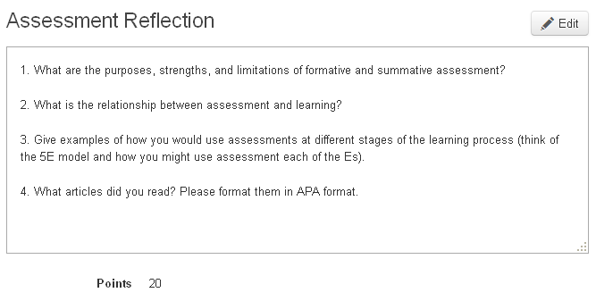
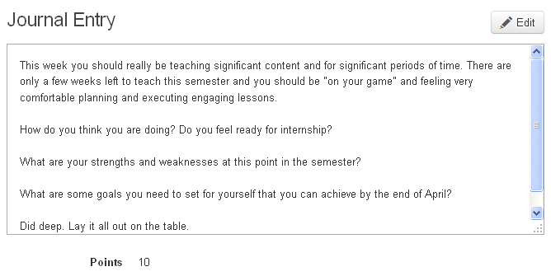
Module 10: Next Generation Science Standards (Due 4/2/13)

This module is about the National Research Council’s Framework for K-12 Science Education and what is happening with the development of the Next Generation Science Standards.
You will read part of the “Framework” online, and come to class prepared to discuss the latest NGSS standards draft.

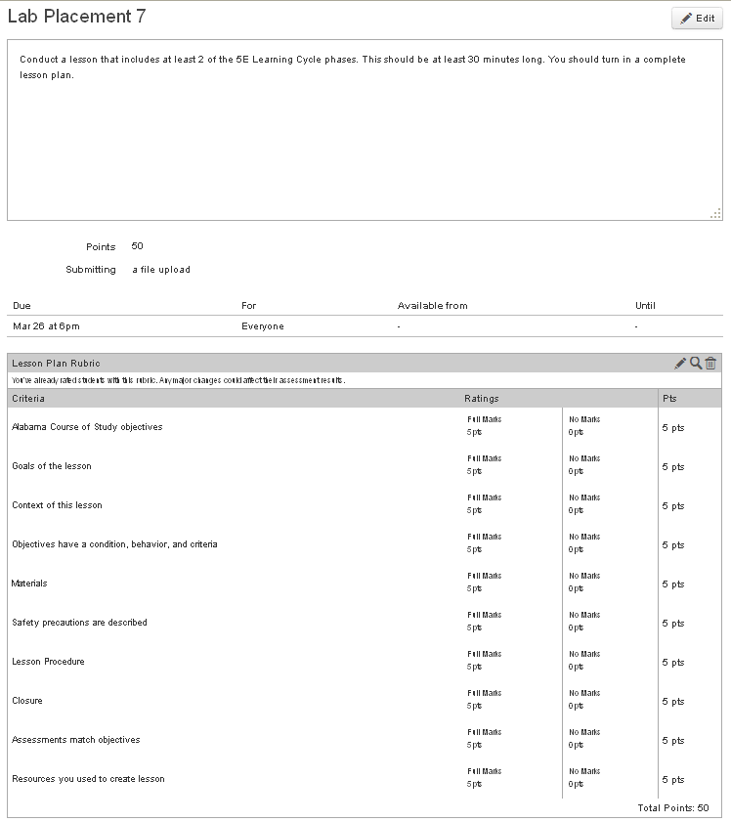
Module 11: Alabama Science in Motion (Due 4/9/13)

Do you know about ASIM? If not, get ready because we will be taking a trip in class tonight to visit some of the ASIM teachers and find out what it’s all about.

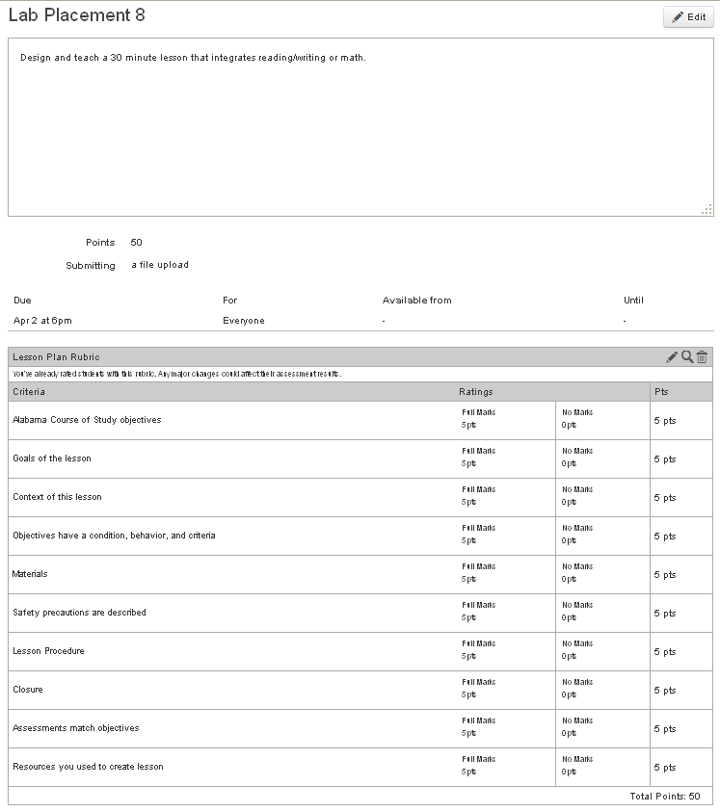
Module 12: Semester review (Due 4/16/13)
For this module, review the semester and get ready for the final exam.

