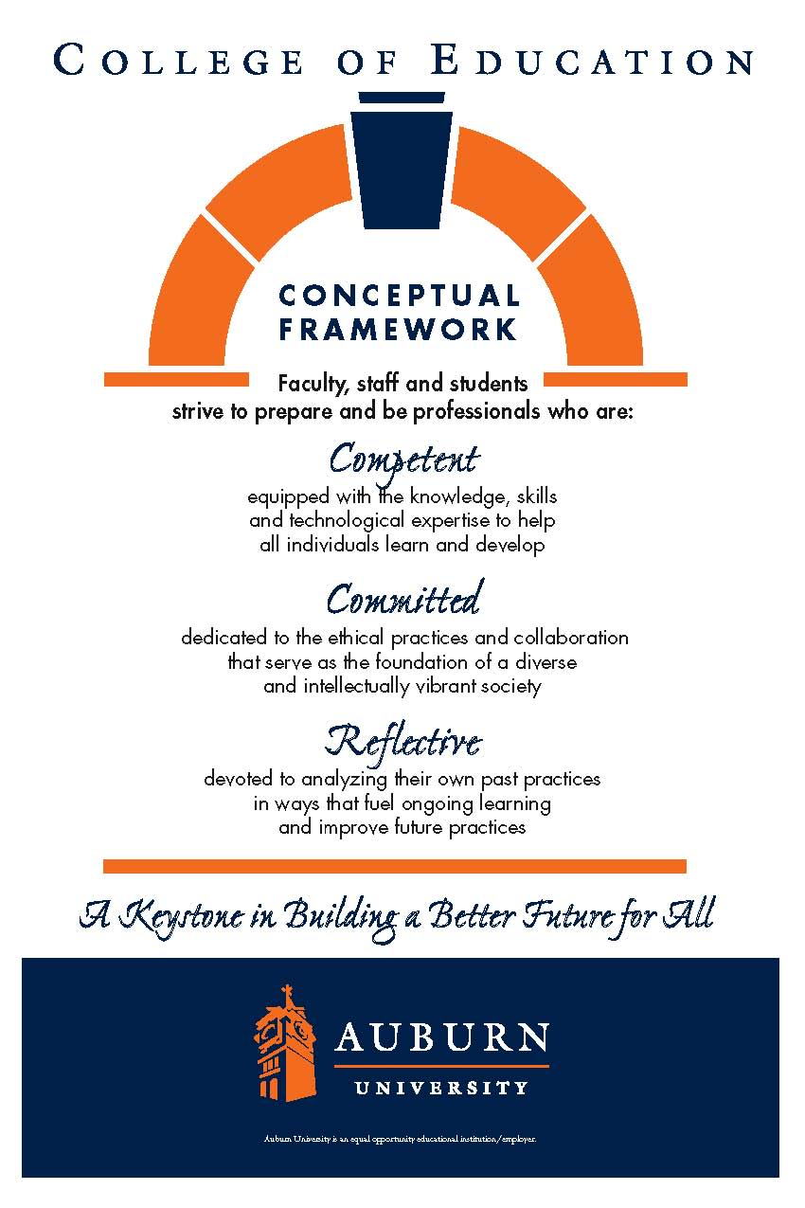**CTES 7470**

**Auburn University**

Department: Department of Curriculum & Teaching

Program: English to Speakers of Other Languages Education

Course Title: Issues in English for Speakers of Other Languages Education

Course Number: CTES 7460

Course Credit: 3 hours

Semester: Spring 2017

Instructor: Gwendolyn M. Williams, PhD

Email Address: gmw0015@auburn.edu

Phone Number: Office: 334-844-6775

Office: 5078 Haley Center

Office Hours: 1:30-3:30 PM T/TH

Schedule:

Classroom:

**1. COURSE DESCRIPTION**

**Catalog Description:** Examination of central issues in the teaching and learning of ESOL including language policy, language diversity and multiculturalism

**Course Description:** This course enables participants to develop awareness and understanding of the cultures represented by different language minorities within the state and the nation. It also provides an emphasis on research that will enable participants to address the special needs of linguistically and culturally diverse students.

**Attendance:**

Class attendance and engaged participation are essential to achieving the goals of this course. Missing class is like skipping a chapter in a book—what follows is harder to understand. Excused absences are defined in the *AU Bulletin*: You may be excused for personal illness, a serious illness or death of someone in your immediate family, a field trip, a religious holiday (one week notice required), or a subpoena. For a provisional excuse, please notify me before the day you miss by leaving a message by e-mail or telephone (no documentation is necessary). For a fully excused absence (and full attendance/participation points), you will need to provide documentation for your absence.

You will earn points by attending class and arriving on time (see grading plan below). Quizzes missed because of unexcused absences may not be made up. Late assignments lose 10% credit per day. If your absence is excused, any assignment will be due the following day and will begin to incur late penalties on the second day unless you provide daily updates of continuing excusing information. Assignments may be sent by course e-mail to avoid late penalties. If you do send work by e-mail, address it carefully and watch for error messages or for my acknowledgement. Note: *E-mail errors will not negate late penalties.*

**Grading Plan:**

The final grade for the course is based on the following:

90%-100%= A

80%-89% = B

70%-79% = C

60%-69% = D

Below 60% = F

*Please note that this is only a plan; point totals for the course may change during the semester if assignments are added or deleted. Detailed instructions will be available in Canvas.

Grades will be weighted the following ways:

**Classroom Expectations and Group Norms:**

* + Be respectful of yourself and others. Talking while others are addressing the class (including the instructor) is not appropriate.
  + The class will start and end at the instructor’s designated time. If you arrive late or leave early, points will be deducted from your attendance and participation.
  + No unauthorized guests.
  + Cell phones, beepers, and pagers must be turned off or placed on vibrate mode. Inappropriate use of cell phones and other technology during class time will result in loss of points.

**Assignment Requirements:**

All assignments must be typed unless otherwise noted by the instructor. If your assignment contains excessive writing errors *it will not be accepted*. Make sure to proof read any submitted work before turning it in. Typographical and grammar errors will result in the lowering of an assignment grade. All assignments will be submitted via Canvas. Only use PDF or Word files when uploading to Canvas.

**3. University and College Policies**

**Participation**:

All students are expected to participate in all class discussions and participate in all exercises. It is the student’s responsibility to contact the instructor if assignment deadlines are not met and for initiating arrangements for missed work.

**Unannounced Quizzes:**

There will be no unannounced quizzes.

**Accommodations:**

Students who need special accommodations in class, as provided for by the American Disabilities Act, should arrange a confidential meeting with the instructor during office hours the first week of classes – or as soon as possible if accommodations are needed immediately. You must bring a copy of your Accommodation Memo and an Instructor Verification Form to the meeting. If you do not have these forms but need accommodations, make an appointment with the Program for Students with Disabilities, 1244 Haley Center, 844-2096.

**Academic Honesty Policy:**

All portions of the Auburn University student [Academic Honesty Code](https://sites.auburn.edu/admin/universitypolicies/Policies/AcademicHonestyCode.pdf) (Title XII) will apply to this class. All academic honesty violations or alleged violations will be reported to the Office of the Provost, which will then refer the case to the Academic Honesty Committee.

**Professionalism:**

Faculty, staff, and students in professional settings are expected to demonstrate professional behaviors as defined in the College’s conceptual framework. These professional commitments or dispositions are as follows: Engage in responsible and ethical professional practices; contribute to collaborative learning communities; demonstrate a commitment to diversity; model and nurture intellectual vitality.

**Writing Center:**

The Miller Writing Center provides free support on any writing you are doing while at Auburn, whether for a course or not. Trained consultants are available to work with you as you plan, draft, and revise your writing. For students in distance courses and students temporarily away from Auburn’s campus, the Miller Writing Center offers synchronous online consultations. Please check the Miller Writing Center website ([www.auburn.edu/writingcenter](http://www.auburn.edu/writingcenter)) for instructions and information about scheduling online appointments. If you have questions about the Miller Writing Center, please email [writctr@auburn.edu](mailto:writctr@auburn.edu) or call 334-844-7475 M-F  7:45am-4:45pm.

**Student eHandbook:**

Please refer to <http://www.auburn.edu/student_info/student_policies/> for all AU student policies.

**4. Tentative Schedule**

|  |  |  |  |
| --- | --- | --- | --- |
| Date | Topic for the Week | Readings | Assignment Due |
| 1/12 | Introduction to Culture |  |  |
| 1/19 | Culture & Communication | Samovar pp. 17- 67  H: Min |  |
| 1/26 | Culture & Families | Samovar Chapter 3  Guo  H: Cavilcante |  |
| 2/2 | Culture & History | Martin & Nakayama  Herrera 2015 Chapter 2  H: PerezFirmat |  |
| 2/9 | Culture & Values | Samovar Chapter 6  H: Ihedigbo | Engagement Plan Due |
| 2/16 | Culture & Identity | Samovar Chapter 7  Igoa Chapter 2  H: Ansary |  |
| 2/23 | Culture & Gender | Lu & Luk  Samovar pp. 81-88  Berger  H: Hayslip | Reaction Paper 1 Due |
| 3/2 | Culture & Language | Samovar Chapter 8 DeCapua & Wintergerst  H: Reyes |  |
| 3/9 | Culture and Non-verbal Communication | Samovar Chapter 9 Gregersen  H: Samuelsson | Exam Due |
| 3/16 | Spring Break | | |
| 3/23 | Culture in Contexts | Samovar Chapter 10  Neuliep  H: Yang |  |
| 3/30 | Culture & Racism | Nieto Chapter 4  Ting-Toomey & Chung ch. 8  H: Dumas |  |
| 4/6 | Culture & Power Issues | Samovar Chapter 11  Malsbary  Vandrick  H: Narayan | Cultural Miscommunication Paper Due |
| 4/13 | Integrating Culture into Instruction | Wintergerst & McVeigh  Herrera et al, 2013  H: Marafioti |  |
| 4/20 | Cultural Competence for Teachers | Gay Chapter 2  Cervantes & Shelby  H: Ung | Reaction Paper 2 Due |
| 4/27 | Wrap-up Discussions & Activities |  | Border Crossing Activity Due |

**Required texts:**

**Samovar, L.A., Porter, R.E., McDaniel, E. R. & Roy, C. S. (2017). *Communications between Cultures*, 9th edition. Boston: Wadsworth Cengage Learning. ISBN-10: 1285444620**

**Hutner, G. (Ed). (2015*). Immigrant Voices Volume II*. New York: New American Library. ISBN-10: 0451472810**

**Required Readings that will be provided on-line**

Berger, R. (2011). Chapter 7 Major themes in women’s narratives. In *Immigrant women tell their stories* (pp. 177-210). New York: Routledge.

Cervantes, R. C. & Shelby, T. M. (2013). Chapter 9 Mental health issues for immigrant adolescents: Research & practice. In E. L Grigorienko (ed.) *US immigration and education: Cultural and policy issues across the lifespan* (pp. 163-178). New York: Springer.

DeCapua, A. & Wintergerst, A. C. (2016). Pragmatics and communication. In *Crossing cultures in the second language classroom* (pp 257-285). Ann Arbor: University 8 of Michigan Press.

Gay, G. (2010). Chapter 2. Pedagogical potential of cultural responsiveness. In *Culturally Responsive Teaching, 2nd ed* (pp. 22-46). New York: Teacher’s College Press.

Gregerson, T. (2007). Language learning beyond words: Incorporating body language into classroom activities. *Reflections on English Language Teaching, 6* (1), 51-64

Guo, Y. (2011). Beyond deficit paradigms: Exploring informal learning of immigrant parents. *The Canadian Journal for the Study of Adult Education, 24* (1), 45-59.

Herrera, S., Cabral,R. M., & Murry, K.G. (2013). Assessment of acculturation. In *Assessment accommodations for classroom teachers of culturally and linguistically diverse students.* (2nd ed.) (pp. 90-129). New York: Pearson.

Herrera, S. G. (2015). Chapter 2 Biography driven instruction. In Biography driven culturally responsive teaching (pp. 16-28). New York: Teacher’s College Press.

Lu, H., & Luk, J. (2014). “I would study harder if I was a girl.” Gendered narratives of low-achieving male and high-achieving female EFL learners. *Journal of Language, Identity and Education, 13*, 1-15.

Igoa, C. (1995). Chapter 2: The phenomenon of uprooting. In *The inner world of the immigrant child* (pp. 37-69). New York: Routledge.

Malsbary, C. B. (2014). “It’s not just learning English, it’s learning other cultures”: belonging, power, and possibility in an immigrant contact zone. *International Journal of Qualitative Studies in Education* (QSE), 27(10), 1312-1336. doi:10.1080/09518398.2013.837210

Martin, J. N., & Nakayama, T. K. (2013). Chapter 4 History and intercultural communication. In *Intercultural Communication in Contexts* (pp. 126-166). New York: McGraw-Hill.

Neuliep, J. W. (2015). Chapter 10 Cultural conflict. In *Intercultural communication: A contextual approach* (pp. 373-398). Thousand Oaks, CA: Sage.

Nieto, S., & Bode, P. (2012). Chapter 3 Racism, discrimination, and expectations of student achievement. In *Affirming diversity: The Sociopolitical context of Multicultural Education 6th ed*.(pp. 62-84). New York: Pearson

Ting-Toomey, S. & Chung, L.L. (2011). Chapter 8: What causes us to hold biases against outgroups? In *Understanding Intercultural Communication* (pp.157-178). New York: Oxford University Press.

Vandrick, S. (2015). No “knapsack of Invisible privilege” for ESL university students. *Journal of Language, Identity & Education, 14*(1), 54-59

Wintergerst, A. & McVeigh, J. (2012). Chapter 6 Traditional ways of teaching culture. In *Tips for teaching culture: Practical approaches to intercultural communication* (pp. 119-142). New York: Pearson Longman.

5. Course Student Learning Outcomes

Upon completion of this course, students will be able to:

1. Explain the role of cultural competence to a classroom teacher.
2. Identify the dynamics of institutional and cultural racism in schools.
3. Describe the role of racial identity on teacher development.
4. Define the different components of culture and cultural paradigms, and then explain their impact on classroom instruction. .
5. Use a range of resources in learning about the cultural experiences of ELLs and their families to guide curriculum development and instruction.
6. Define assimilation and acculturation.
7. Provide psychological and emotional support for ELLs in the classroom.
8. Understand and apply knowledge about the effects of racism, stereotyping, and discrimination in teaching and learning of ELLs from diverse backgrounds and at varying English proficiency levels.
9. Explain the cultural influences on classroom management and interaction.
10. Understand and apply knowledge about home/school connections to build partnerships with ELLs’ families (e.g., Parent Leadership Councils (PLC).
11. Understand and apply knowledge about concepts related to the interrelationship between language and culture for students from diverse backgrounds and at varying English proficiency levels.

6. Teacher Education Standards Addressed

**TESOL Teacher Education Standards**

**2.a.** Understand and apply knowledge about cultural values and beliefs in the context of teaching and learning.

**2.b.** Understand and apply knowledge about the effects of racism, stereotyping, and discrimination to teaching and learning.

**2.c.** Understand and apply knowledge about cultural conflicts and home events that can have an impact on ELLs’ learning.

**2.d.** Understand and apply knowledge about communication between home and school to enhance ESL teaching and build partnerships with ESOL families.

**2.e.** Understand and apply concepts about the interrelationship between language and culture.

**2.f.** Use a range of resources, including the Internet, to learn about world cultures and specifically the cultures of students in their classrooms and apply that learning to instruction.

**2.g.** Understand and apply concepts of cultural competency, particularly knowledge about how an individual’s cultural identity affects their learning and academic progress and how levels of cultural identity will vary widely among students

Alabama State Teacher Education Standards

**(b) Culture**. Candidates know, understand, and use in their instruction, the major theories and research related to the nature and role of culture, and how cultural groups and individual cultural identities affect language development and academic achievement. This domain consists of two parts: nature and role of culture and cultural groups and identity.

1. **Nature and role of culture.** Candidates know, understand, and use the major concepts, principles, theories, and research related to the nature and role of culture and cultural groups to construct learning environments that support the cultural identities, language and literacy development, and content-area achievement of ELLs. Prior to program completion, prospective teachers of English for speakers of other languages shall demonstrate:

(i) Knowledge of:

(I) The wide range of cultural values and beliefs represented by the ELLs

cultures in the context of teaching and learning.

(II) The effects of racism, stereotyping, and discrimination in the context of teaching ESL.

(III) The importance of home/school communication with ESOL families and appropriate techniques for fostering communication.

(IV) The interrelationship between language and culture and the roles of language and ethnicity in a multicultural society.

(ii) Ability to:

(I) Maintain a climate of respect for all cultures.

(II) Help ELLs deal with discrimination.

(III) Support ELLs and families in valuing their own cultures.

(IV) Locate resources for communicating with families.

2. **Cultural groups and identity**. Candidates know, understand, and use knowledge of how cultural identities, both group and individual, affect language learning and school achievement. Prior to program completion, prospective teachers of English for speakers of other languages shall demonstrate:

(i) Knowledge of:

(I) How an individual’s cultural identify affects their ESL learning and how levels of cultural identify will vary widely among students.

(II) Cultural conflicts and home-area events that can have an impact on ELLs’ learning.

(ii) Ability to:

(I) Use a range of resources, including the Internet, to learn about world cultures and apply that learning to instruction.

(II) Implement activities and/or cultural events that promote the ELLs’ cultures and foster their learning.

(III) Include ELLs’ cultural experience when building background for instruction.

**Details on Assignments**

**Course Requirements**.

1. **Engagement Plan**

**OPTION 1: Family Engagement Plan**

You will select and explain how to implement 5 different strategies to engage the families of English learners in a ESOL child’s education in a K-12 school context. Each of the 5 strategies must be explained what the strategy is, and the theoretical reasons on how this strategy would benefit the parent, the teacher, and the student.

Page length- 4 pages

**OR**

**OPTION 2: Community Engagement Plan**

You will select and explain how to implement five strategies that would help adult English learners become more integrated into their community. You will describe how you would communicate this strategy to adult ESOL students, and explain how the theoretical reasons that this strategy would benefit the long-term development of the students in terms of their language development and community engagement.

Page length 4 pages

1. **Boundary Crossing Assignment-**

You will select a cultural group or event(s) to work with, attend, and/or investigate, individually or in a small group, outside of the in-school context. This might involve volunteering at a community center for a particular ethnic/language group; conducting home visits with families of a particular culture; attending a religious, cultural, or community event for a cultural group other than your own; etc. You will provide a written summary and analysis (min. 3 pages, typed and double-spaced) providing your thoughtful reflections on what you did, what you learned, how it relates to what we have discussed in class, and what conclusions of relevance to teaching ELL students that you can draw.

1. **Cultural Miscommunication Paper**

You will be required to research one specific aspect about how cultural differences create misunderstanding. The key here is to be specific, such as eye contact or intonation patterns. Don’t pick a topic that is too large, such as gestures because you will not have time to research and discuss all the elements of such a broad category. The sequence of your paper should look like this:

1. Provide a description of the cultural phenomenon.
2. What would be the consequences of miscommunication of this phenomenon?
3. Offer at least two ways to minimize cultural misunderstanding of this phenomenon.
4. Conclude the paper with a description of how the knowledge that you have gained from this assignment will influence the way that you interact with ELLs in the classroom.

Expected length of this paper is 8 pages.

1. **Participation**

Participation in weekly assignments is your way of demonstrating your completion of reading assignments and your ability to apply what you have read to the field of education. Keeping up with weekly reading assignments is vital to your ability to learn course content and participate in class discussions (3 points per class).

1. Response Papers*:*

These commentaries have three purposes. First, they show me that you are keeping up with the readings. They also allow you the opportunity to reflect on them and to apply the information from the readings to your own experiences and prior knowledge. Finally, it provides me with a way to dialogue about the readings to ask questions that you may not feel comfortable asking in class. You should NOT simply summarize the readings. If you’re unsure about how to go about this, a good way to start is to select a couple ideas or excerpts from different readings and compare the ideas in them, then tie these ideas in with examples from your own experience, but be careful that your examples stay on point. **The paper should be 3 pages long and be double spaced**. Papers must be handed in on the day that that particular reading is discussed. One paper should cover a reading from the first half of the semester, and the second paper should cover content from the second half of the semester. Please submit to Canvas. The due dates for the papers (2 of them) have been spaced throughout the semester to prevent procrastination until the end of the semester. You cannot submit two papers on the same day

1. **Semester Exam**

The exam will be a cumulative essay exam that assesses the standards and content taught in this course.