ADED 7056  Methods of Teaching in Adult Education  Spring 2018  Department of EFLT  College of Education  Dr. Xi Lin  E-mail: xilin@auburn.edu  Office hours:  By appointment  Course Room: Virtual on Canvas | 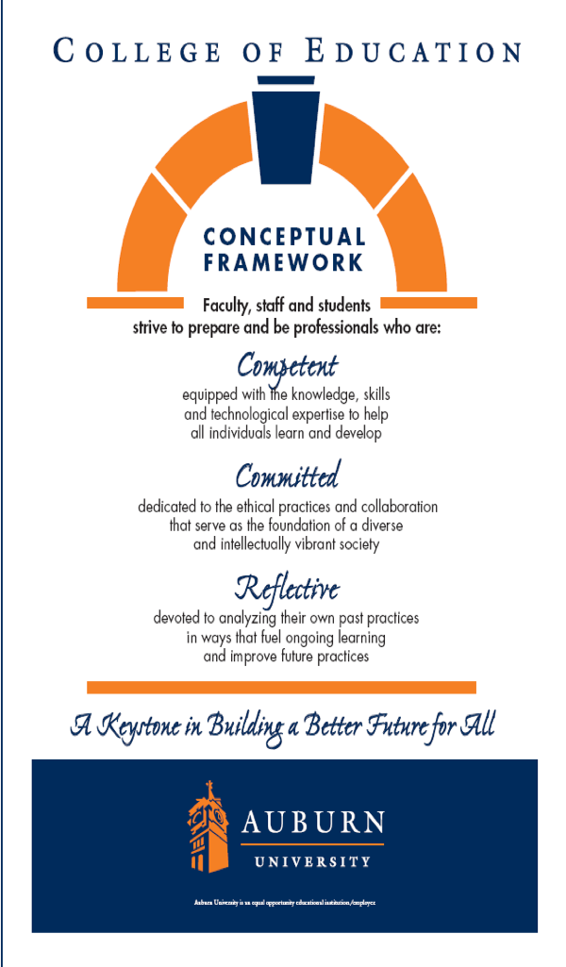

Methods of Teaching in Adult Education
ADED 7056
Auburn University
Department of Educational Foundations, Leadership, and Technology
College of Education
Spring 2017

Class Time: Online
Location: Virtual
Professor: Dr. Xi Lin
Office – Haley Center 2320
Email: xilin@auburn.edu
Office Hours: Scheduled by Appointment

1. Course Number: ADED 7056
Course Title: Methods of Teaching in Adult Education
Credit Hours: 3 semester hours
Pre/Corequisites: None

- Recommended Texts: Older versions of these texts will work sufficiently (match the chapter titles) and some of this information is available free online through various sources.

- Galbraith, M.W. (Ed.) (2004). Adult Learning Methods: A Guide for Effective Instruction (3rd Ed.). Robert E. Krieger Publishing (Required)

- Ko, S., & Rossen, S. (2017). Teaching online: A practical guide (4 ed.). Routledge. (Optional)

Other Required Readings will be posted online or made available through eReserves and the Library.

- Course Description:
Methods and techniques of instruction using appropriate instructional materials; planning and evaluation of instruction for adult education programs.

- Course Objectives:

Upon completion of this course, students will be able to:

- evaluate principles of teaching and learning.
- evaluate effective teaching behaviors.
- prepare and give a demonstration on how to perform a skill to a group of learners.
- create an environment conducive to learning.
- describe the relationship between the learning process and the problem-solving approach to teaching.
- develop performance objectives for units of instruction.
- describe how learning styles affects individuals’ teaching styles.
- select and incorporate teaching strategies into your teaching style that will reach a culturally diverse group of learners.
- determine the appropriate method to evaluate the learners.
- develop an instructional strategy that utilizes the most effective teaching technique for the topic.
- use a variety of instructional strategies in learning.
- organize, allocate, and manage resources of time, space, and activities.
- analyze and synthesize teaching techniques used in instructional settings.

Course Philosophy:

There are approximately 16 sessions with a variety of topics related to workplace education and development. There will be online lectures and group activities and discussions. You are expected to read the assigned readings, participate and contribute to lecture presentations, collaborate in discussions, and submit assignments. A variety of media provided by the LMS (Canvas) are used for communication among class members and the instructor, along with additional resources.

This is a professional online education course in adult education. All participants are considered adults and are expected to not only study but also practice andragogy by taking responsibility for their learning. Thus, the participant is expected to participate regularly, contribute to the class setting by participating in online discussions and activities, and to be collaborative and supportive of all members of the learning setting. Adult education is not a place for passive learning but a place to explore, take risks and grow.

Additional course materials are made available through the university’s learning management system (LMS). Interactivity is possible through the LMS, which allows for online discussions, email, web conferencing and chats with the instructor, along with testing and submission of assignments. A student taking the online version of the course will need a reliable computer and will need to decide if online learning is a good option for them (for an assessment of the proper skills. If you have questions on this, please ask me the first week of class.

Please see Academic Calendar for Important Dates http://www.auburn.edu/main/auweb_calendar.html

6. Tentative - Course Content/Schedule: Online Weekly Sessions run from Mondays to Sundays.

Session | Week | Topic
1 | Week 1 | Overview and Introduction
2 | Week 2 | Qualities of Effective Adult Educators
3 | Week 3 | Adult Learners and Teaching Styles
4 | Week 4 | Philosophy and Ethics
5 | Week 5 | Learning Styles
6 | Week 6 | Motivation
7 | Week 7 | Active Learning and Learning Contracts
8 | Week 8 | Evaluation of Learning
9 | Week 9 | Online Teaching
10 | Week 10 | Spring Break – Have FUN!
11 | Week 11 | Instructional Design
12 | Week 12 | Critical Thinking
13 | Week 13 | Teaching Diverse populations
14 | Week 14 | Blended Learning
15 | Week 15 | Last Week of Classes – Wrap Up and Summary – Last Week for Assignments. No Assignments accepted after April 27th.
16 | Week 16 | Final Exam/Projects Week – No Classes Scheduled

7. Course Requirements/Evaluation (General Information – more details provided in the Assignments area in Canvas):

- Presentation of an Instructional Session (Team Assignment if possible – 30 points)
Each group (at most 2 people) will lead one instructional session in which the team will demonstrate how to facilitate learning using a method or technique of their choice (lecture, illustrated talk, demonstration, discussion, questioning techniques, collaborative learning, etc.) to the members of the class. This will be assigned starting week 3. This assignment will be evaluated on how well you implement the method and engage the learners. As this is an online class, please make sure to adapt the session to both the F2F (face-to-face) and online/blended format. This assignment will be recorded.
As presenter(s), you need to design 3 to 5 short questions (fill in blank or/and multiple choice) with answers and explanations based on your presentation and send them to me along with your presentation.

* **NOTE: The presentation (PowerPoint/Handouts/Agenda/Supporting Materials) is due to the instructor every Saturday at 11:59pm or earlier prior to scheduled class week for these Presentations. See Late Assignments for more information.

For example: If you are schedule to present on Week 3 (1/22-1/28), you must send your presentation to me by Saturday (1/20) or earlier, and I will post your presentation on Canvas on or before the following Tuesday (1/23).

Students will be provided a variety of options in terms of recording their presentations for the online class. This information will be discussed posted in the course. The resources to complete these presentations are available through the University’s LMS.

- Peer Evaluations of Presentations (10 points)
You need to provide peer evaluations for at least 2 presentations for the entire course. Providing the comments to the student is an important task for an adult education as a means of feedback.

- Quiz Participation (10 points)
You need to participate at least 5 weekly quizzes for the entire course. Thus, you need to provide a short reflective report for each quiz, as self-evaluation is important for adult learners. *Please note that your quiz grade will NOT influence your final grade, only your quiz participation will be counted in your final grade.

- Discussion Participation (10 points)
Participate in the required class discussions and online activities. You will need to respond to a majority of weekly questions and discussions. Overall, discussions will be graded based upon the quantity and quality of the discussions posted as determined by the instructor. More information to follow in Canvas. *Two optional discussions will make up for one missed required discussion.

- Research Paper – Instructional Method (team assignment if possible – 40 points)
Each team will develop a 5 to 8-page APA format report on their chosen Instructional Method Session. Along with describing the key aspects of the method, you should include the following:
  - Each strategy should be described in detail and academic literature review should be supported and referenced.
  - Detail how this strategy could be used to increase the retention of information and skills (long-term memory) among adult learners; discuss the techniques that should enhance the learners’ retention of information and skills.
  - Discuss how the instructor or facilitator would incorporate the strategy into the teaching/learning process.
Overall evaluation of the paper will look at the appropriateness of strategy and method related to the teaching/learning process; supporting information describing how each strategy would be implemented; and the strength of references and citations (academic, research, date, adult learning sources; etc.) that are provided in the literature review.
Evaluation of Assignments:
Assignment | Points | Due date
Presentation + Quiz Questions | 30 | Every Saturday at 11:59pm
Quiz + Required Discussion Participations | 10 + 10 | Every Sunday at 11:59pm
Peer Evaluations of Weekly Presentations | 10 | Every Sunday at 11:59pm
Research Paper | 40 | 4/30/2018 at 11:59pm
Total Points | 100

The following grading scale will be used:

90% - 100% / 90-100 points = A
80% - 89% / 80-89 points = B
70% - 79% / 70-79 points = C
60% - 69% / 60-69 points = D
Below 60% / Below 60 points = F

8. Class Policy Statements:

- Absences/Inactivity in Class - You are expected to participate regularly in the weekly course discussions and readings, including an ad hoc exercises and requirements as scheduled. Login access is regularly monitored. It is your responsibility to contact me if assignment deadlines are not met and responsible for initiating arrangements for missed work. Attendance and participation in the online discussions will affect your grade as this is graduate learning course. Your participation is part of the course design and is directly correlated to academic success. THIS IS NOT A SELF-PACED COURSE and requires participation weekly. If you cannot participate regularly, please consider another course.

Students are granted excused absences from class for the following reasons: Illness of the student or serious illness of a member of the student’s immediate family, the death of a member of the student’s immediate family, trips for student organizations sponsored by an academic unit, trips for University classes, trips for participation in intercollegiate athletic events, subpoena for a court appearance, and religious holidays. Students who wish to have an excused absence from this class for any other reason must contact the instructor in advance of the absence to request permission. If feasible, the student must notify the instructor prior to the occurrence of any excused absences, but in no case shall such notification occur more than one week after the absence.

Appropriate documentation for all excused absences is required. Please see the Student Policy eHandbook for more information on excused absences.

- Late/Make-up Assignments:

Assignments will not be accepted late. Some make-up assignments will be posted on Canvas. A student who has an excused absence or illness will have the opportunity to earn credit for any missed assignments that are submitted late. Assignments turned in late due to a documented excused absence will be graded as initially assigned.

Late assignments due to unexcused absence may not be accepted. In some cases, there will be a make-up assignment required in addition to the regular assignment.

Again, appropriate documentation for all excused absences is required. Please see the Student Policy eHandbook for more information on excused absences.

- Team Assignments

Team assignments receive grades based on group and individual work. It is possible that unsatisfactory participation in team assignments will result in a lower participation grade or a lower grade on the team assignment itself. You may be called upon to evaluate your own or your team members' performance on group assignments.

- Accommodations: Students who need accommodations are asked to electronically submit their approved accommodations through AU Access and to arrange a meeting during office hours the first week of classes, or as soon as possible if accommodations are needed immediately. If you have a conflict with my office hours, an alternate time can be arranged. To set up this meeting, please contact me by e-mail. If you have not established accommodations through the Office of Accessibility, but need accommodations, make an appointment with the Office of Accessibility, 1228 Haley Center, 844-2096 (V/TT). Please visit their web site at: http://accessibility.auburn.edu/

- The Student Policy eHandbook rules and regulations pertaining to Academic Honesty will apply to this class. All coursework should be properly cited using APA format. Coursework from other classes cannot be used unless FIRST discussed with the professor and substantially revised or updated for the class.

- Professional Classroom Behavior: As faculty, staff, and students interact in professional settings, they are expected to demonstrate professional behaviors as defined in the College’s conceptual framework. These professional commitments or dispositions are listed below:

- Engage in responsible and ethical professional practices
- Contribute to collaborative learning communities
- Demonstrate a commitment to diversity
- Model and nurture intellectual vitality

These behaviors are especially important in terms of our graduate classroom and online discussions.

9. Justification for Graduate Credit:

Participants in this class must have an advanced knowledge level of the clientele for workforce education as provided in the required prerequisites. Participants will be required to demonstrate their ability to evaluate the completeness and appropriateness of a workplace basic skills education program based upon application and synthesis of principles associated with this course.

