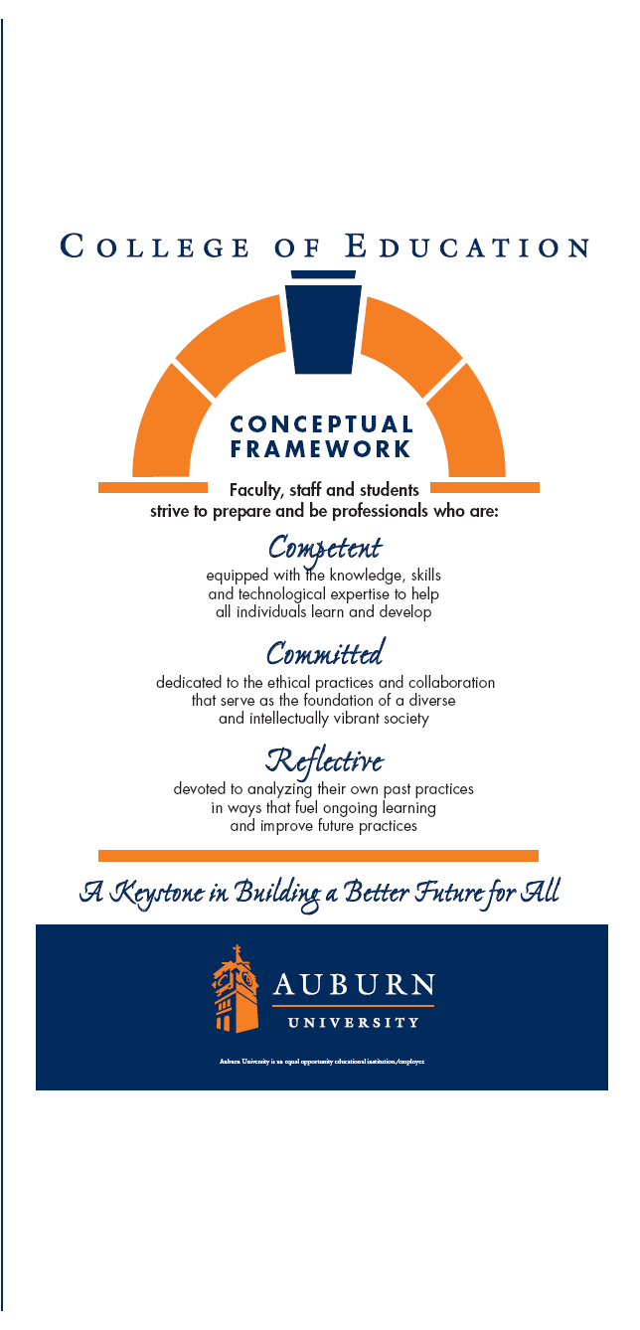

**ADED 7680**

**Learning Styles in Adult Education**

**Spring 2018**

**Educational Foundations, Leadership and Technology**

College of Education

Dr. Maria M. Witte

Work: 334-844-3078

Home: 334-887-3934

E-Mail: [wittemm@auburn.edu](mailto:wittemm@auburn.edu)

Office located: Haley 3068

|  |
| --- |
| **Learning Styles in Adult Education**  ADED 7680-001  Department of Educational Foundations, Leadership, and Technology  College of Education ▪ Auburn University  Spring 2018 |

1. **Course Number:** ADED 7680-001

**Course Title:** Learning Styles in Adult Education

**Credit:** 3 semester hours

1. **Term: Spring 2018**

**Day/Time:** Thursdays ▪ 5:00-7:50 p.m ▪ Haley 2435

**Instructor:**  Dr. Maria Martinez Witte

**Office Address:** Haley Center, Room 3068

**Contact Information:** (334) 844-3078 Work / (334) 887-3934 Home [wittemm@auburn.edu](mailto:wittemm@auburn.edu)

**Office Hours:** Mon, Tues, or Wed by Appointment

1. **Texts or Major Resources:**

Optional:

American Psychological Association. (2009). *Publication manual* (6th ed.).

Washington, DC: Author.

1. **Course Description:**

Current or advanced topics within area of specialization.

1. **Student Learning Outcomes:**

Learning Styles in Adult Education provides participants an opportunity to apply adult education principles to their specific area of interest and study. Topics to be presented include adult education principles, learning styles, and instructional processes for the teaching and learning environment. In this course, participants will be invited to research and assess their own learning preferences, problem-solving abilities, values and beliefs, and apply that information through presentation, group discussions, and written reflections.

Based on classroom instruction and activities, self-assessments, reading assignments

and related activities, each participant should be able to do the following upon

completion of this course:

a. Analyze and interpret personal learning styles assessment and techniques for effective interpersonal communication.

1. Interpret and synthesize research and other literature on identified special topic.
2. Describe topic-related research as applied to adult education principles and differences in learning methods.
3. Demonstrate special topic content knowledge, application, and synthesis through formal presentation.
4. **Course Content Outline**

Jan 11 - Session 1

Brief Overview

Jan 18 - Session 2

Introductions

Review syllabus and course requirements

Jan 25 – Session 3

**Bring an article to class related to the following topics and be prepared to discuss in a small group:**

Introduction to the field of Adult Education

Definition of Adult Education

Andragogy vs Pedagogy

Feb 1 - Session 4

Learning Styles: Overview

Articles on Canvas

Feb 8 - Session 5

Learning Styles Assessment: Gregorc Style Delineator

Feb 15 - Session 6

No Class – Work on Learning Styles Presentation

Feb 22 - Session 7

Learning Styles Presentations

Mar 1 - Session 8

Learning Styles Presentations

Mar 8 - Session 9

Learning Styles Presentations

Mar 15 - Session 10

**Spring Break!**

Mar 22– Session 11

Learning Styles Presentations

Mar 29 - Session 12

Learning Styles Presentations

Apr 5– Session 13

Learning Styles Presentations

Apr 12 - Session 14

Learning Styles Presentations

Apr 19 - Session 15

Learning Styles Presentations

Apr 26 – Session 16

*Assignment Deadline: Learning Styles Self Analysis*

Review and Evaluation

1. **Assignments/Projects:**

Illustrative participant experiences will include: active participation; individual reflection; group discussions; participant presentations; and review of topic-related literature. The experiences will include:

**Course Requirements:**

* Present and facilitate a Learning Styles Instrument session.

**Learning Styles Instrument Assessment Presentation.** Class members will present and facilitate a learning styles instrument assessment to class participants. This will include development of a technical sheet and appropriate explanation of assessment results including implications for leadership and working with others.

* Complete a Reflection paper on Learning Styles Information.

**Self-Analysis Reflection on Learning Styles Information**. This reflection should be based on your results of several learning styles instruments (e.g., preferences, strengths, developmental areas, application–e.g., What does this information mean to you in terms of your personal experience and knowledge? How does this information apply to your current situation? What key insights did you have when applying this information to your everyday life?)

* Prepare an Article Review, related to Learning Styles or a learning-related topic.

**Article Review.** Summarize a research article describing the results of a learning styles instrument administration (use a different learning styles instrument than you administered in our class) or related application of learning principle. Provide a copy for each class member. The review should include the APA citation and summary. The following questions can be answered in addition to the brief summary:

* What was the purpose of the research and research questions (if applicable)?
* Who was sampled in the research? How were they selected?
* What type of data was collected? What methods were used to analyze the data?
* What was the researcher’s interpretation or conclusion?

**OPTIONAL** – This paper can be used for a presentation at the American Association for Adult and Continuing Education Conference, October 2-5, 2018, Myrtle Beach, South Carolina. Abstract submission due: April, 2018.

* Prepare a research paper on a self-selected topic.

**Research Paper**. The topic should be self-selected, explored, grounded in literature, and presented in a way that reflects the participant’s understanding and skills in analysis and synthesis of professional material. The finished product should include references, in APA format, and be in the form of a professional prepared journal article.

* Solicit and incorporate (if appropriate) 3 peer evaluations based on the research paper.

**Peer Evaluations of Research Paper (3)**. Research papers should be evaluated by three peers/class members. Feedback should be incorporated within the research paper, if appropriate. Evaluation forms should be included with the research paper.

1. **Rubric and Grading Scale:**

The final class grade will be based on the following:

Learning Styles Information Reflection - 40% (40 points)

Learning Styles Instrument Presentation - 40% (40 points)

Article Review - 20% (20 points)

The following grading scale will be used:

90 - 100 points = A

80 - 89 points = B

70 - 79 points = C

60 - 69 points = D

Below 60 point = F

1. **Class Policy Statements**
2. Attendance: Although attendance is not required, students are expected to attend all classes, and will be held responsible for any content covered in the event of an absence.
3. Excused absences: Students are granted excused absences from class for the following reasons: illness of the student or serious illness of a member of the student’s immediate family, the death of a member of the student’s immediate family, trips for student organizations sponsored by an academic unit, trips for university classes, trips for participation in intercollegiate athletic events, subpoena for a court appearance, and religious holidays. Students who wish to have an excused absence from class for any other reason must contact the instructor in advance of the absence to request permission. The instructor will weigh the merits of the request and render a decision. When feasible, the student must notify the instructor prior to the occurrence of any excused absences, but in no case shall such notification occur more than one week after the absence. Appropriate documentation for all excused absences is required. Please see the *Tiger Cub* for more information on excused absences.

C. Make-Up Policy: Arrangement to make up a missed major examination (e.g., hour exams, mid-term exams) due to properly authorized excused absences must be initiated by the student within one week of the end of the period of the excused absences(s). Except in unusual circumstances, such as the continued absence of the student or the advent of university holidays, a make-up exam will take place within two weeks of the date that the student initiates arrangements for it. Except in extraordinary circumstance, no make-up exams will be arranged during the last three days before the final exam period begins.

1. Academic Honesty Policy: All portions of the Auburn University student academic honesty code (Title XII) found in the *Tiger Cub* will apply to university courses. All academic honesty violations or alleged violations of the SGA Code of Laws will be reported to the Office of the Provost, which will then refer the case to the Academic Honesty Committee.

E. Disability Accommodations: Students who need special accommodations in class, as provided by the Americans with Disabilities Act, should arrange for a confidential meeting with the instructor during office hours in the first week of classes (or as soon as possible if accommodations are needed immediately). The student must bring a copy of their Accommodations Letter and an Instructor Verification Form to the meeting. If the student does not have these forms, they should make an appointment with the Program for Students with Disabilities, 1288 Haley Center, 844-2096 (V/TT).

F. Course contingency: If normal class and/or lab activities are disrupted due to illness, emergency, or crisis situation, the syllabus and other course plans and assignments may be modified to allow completion of the course. If this occurs, and addendum to your syllabus and/or course assignments will replace the original materials.

G. Professionalism: As faculty, staff, and students interact in professional settings, they are expected to demonstrate professional behaviors as defined in the College’s conceptual framework. These professional commitments or dispositions are listed below:

o Engage in responsible and ethical professional practices

o Contribute to collaborative learning communities

o Demonstrate a commitment to diversity

o Model and nurture intellectual vitality

A variety of teaching techniques and strategies are employed in the instruction of this course. The principal methods to be utilized include, but may not be limited to lectures, video tapes, visual aids, development experiences, and group discussion. This is a professional education course in adult education. All participants are considered adults and are expected to not only study but also practice andragogy – to take responsibility for their learning. Thus the participant is expected to contribute to the class setting by participating and to be collaborative and supportive of all members of the learning setting. Adult education is not a place for passive learning but a place to explore, take risks and grow. Ignorance is not vested in the participants while knowledge is vested in the instructor. Both are learners and have contributions to make to each other. Both are responsible for their own learning.

**Learning Styles Instrument Technical Summary Sheet**

Name of Instrument

Source (company, address, phone)

Cost - Per instrument, package/kit, scoring, etc.

Format/Administration - Length of test, etc.

Target Audience

Purpose/Intent

Development (background, history, when developed)

Description of Evidence of: Norms, Validity, Reliability

Summary Statistics

Strengths

Weaknesses

Implications for Practice

Research Uses

Personal Recommendation for Instrument Use

References

**Peer Research Paper Evaluation – OPTIONAL**

Research Paper Title:

Please evaluate the attached research paper, provide comments, and return to the author.

Thank you.

Circle the appropriate rating:

|  |  |  |  |  |  |
| --- | --- | --- | --- | --- | --- |
|  | Low |  |  |  | High |
| Adequacy of sources | 1 | 2 | 3 | 4 | 5 |
| Comprehensiveness | 1 | 2 | 3 | 4 | 5 |
| Clarity of ideas and expression | 1 | 2 | 3 | 4 | 5 |
| Organization and logical development of material | 1 | 2 | 3 | 4 | 5 |

Comments: