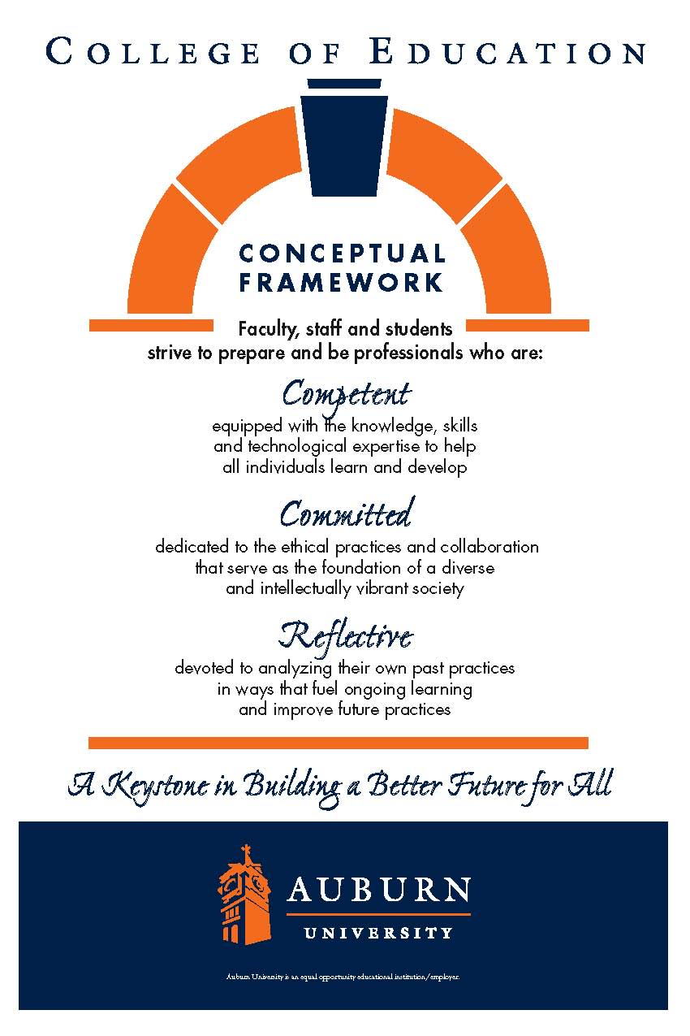**CTRD 7910: Practicum in Reading Education**

**Spring 2018**

*Schedule:* Tuesdays and Thursdays, 2423 Haley Center

Class: 8:00-9:50 am.

Lab Richland Elementary (Sept 1-Nov 17): 7:50–8:20 am.

*Classroom*: 2423 Haley Center.

*Instructor*: Bruce A. Murray, Ph.D.

Associate Professor, Dept of Curriculum & Teaching

Coordinator of Reading Education

Office: 5066 Haley Center. Office phone: 844-6934.

Departmental secretary: 844-4434. Fax: 844-6789.

Cell: 334-524-2476.

E-mail: [murraba@auburn.edu](mailto:murraba@auburn.edu).

*Reading Genie* site: <http://www.auburn.edu/rdggenie> (please bookmark—many course materials are here).

*Office hours*: Mon, Tues, & Thurs, 4:00-4:50 pm and by appointment. I hope you'll feel welcome to e-mail, telephone, or drop by the office to pursue ideas from the course.

**Catalog description.** Practicum. S/U grading. Prerequisite: Departmental approval. Experience relating theory and practice, usually in a school setting.

CTRD 7910 provides practical experience in teaching reading education to undergraduate education majors. Students are expected to attend class, supervise labs, grade papers, and serve as an informal advisor to students in reflecting and planning tutoring lessons. Some teaching presentations may be invited.

**Texts.** Students will be expected to develop familiarity with course readings. One book is required:

Murray, Bruce (2012). *Making sight words: Teaching word recognition from phoneme awareness to fluency*. Ronkonkoma, NY: Linus.

**Course goals.** Upon completion of this course, students will be able to:

* Supervise and assist students in their academic work and laboratory teaching.
* Evaluate tests and quizzes in both objective and essay format, lesson reflections and plans, lesson design projects, and tutoring reports.
* Record observation data on laboratory teaching to provide feedback and for statistical analysis.
* Develop plans and confidence for teaching undergraduate courses in Reading Education.

**COURSE REQUIREMENTS**

**Attendance.** Class attendance and engaged participation are essential to achieving the goals of this course. Missing class is like skipping a chapter in a book—what follows is harder to understand. Excused absences are defined in the *AU Bulletin*: You may be excused for personal illness, a serious illness or death of someone in your immediate family, a field trip, a religious holiday, or a subpoena. For a provisional excuse, please notify me on or before the day you miss by leaving a message by e-mail or telephone (no documentation is necessary). For a fully excused absence, you will need to provide documentation for your absence.

**Grading Plan.** This course is graded satisfactory or unsatisfactory. Formative and summative evaluations will be qualitative, based on holistic evidence of achieving the goals of the course.

**University and College Policies**

**Participation**. All students are expected to participate in all class discussions and participate in all exercises. It is the student’s responsibility to contact the instructor if assignment deadlines are not met and for initiating arrangements for missed work.

**Unannounced Quizzes**. There will be no unannounced quizzes.

**Accommodations**. Students who need special accommodations in class, as provided for by the American Disabilities Act, should arrange a confidential meeting with the instructor during office hours the first week of classes – or as soon as possible if accommodations are needed immediately. You must bring a copy of your Accommodation Memo and an Instructor Verification Form to the meeting. If you do not have these forms but need accommodations, make an appointment with the Program for Students with Disabilities, 1244 Haley Center, 844-2096.

**Academic Honesty Policy**. All portions of the Auburn University student academic honesty code (Title XII) found in the Tiger Cub will apply to this class. All academic honesty violations or alleged violations of the SGA Code of Laws will be reported to the Office of the Provost, which will then refer the case to the Academic Honesty Committee.

**Professionalism**. Faculty, staff, and students in professional settings are expected to demonstrate professional behaviors as defined in the College’s conceptual framework. These professional commitments or dispositions are as follows: Engage in responsible and ethical professional practices; contribute to collaborative learning communities; demonstrate a commitment to diversity; model and nurture intellectual vitality.