**CTES7400_7406 Spring 2019**

**Auburn University**

Department: Curriculum & Teaching

Course Title/Credit: Techn & Media in ESL Education; 3 hrs

Room and Schedule: Mell 3520; Thur 4:00 – 6:50 p.m.

Instructor: Dr. Jamie Harrison [jlh0069@auburn.edu](mailto:jlh0069@auburn.edu)

Phone Number: 334-844-8278

Office: Haley Center 5080

Office Hours: Tu/Th 1 – 3 p.m.

**1. COURSE DESCRIPTION**

This course is a study of technology and media applications for teaching English to Speakers of Other Languages (ESOL). Students will examine ways to effectively incorporate technology and media into the ESL/EFL classroom.

You will come away from this course with a better understanding of yourself as a user of technology, the ways techonolgy enhances the language learning process, and a battery of techonological resources to support teaching and learning.

**Text:**

Walker, A. & White, G. (2013). *Technology enhanced language learning: Connecting theory and practice.* Oxford, United Kingdom: Oxford University Press.

Other readings as provided by instructor.

**Course Objectives:**

Engaged learners in this course can look forward to:

* Identifying and utilizing Internet-based and software resources for teaching ESL/EFL.
* Evaluating the effectiveness and appropriateness of a variety of technologies for teaching the English language student.
* Using computer and media technologies to address the ESL/EFL language domains of listening, speaking, reading and writing.
* Selecting and integrating appropriate instructional materials, media, and technology for ELL students at various language proficiency and age levels.
* Reflecting on the way technology can enhance the learning experience of ELLs of variety of levels in multiple contexts.
* Documenting your own growth as a user of technology in the classroom. You wil gain online group interaction skills, increasing your comfort in both areas.
* Developing a positive relationship with technology from the perspective of a language instructor.

Active Learning Environment

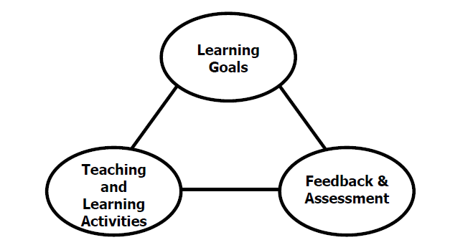

Figure 1. The key components of an integrated course design. (Fink, 2003).

This course has been designed with an active learning framework intended to integrate learning goals, teaching & learning activities, and feedback & assessment. This means you should expect to see a direct relationship between course goals, what we do in class, and how you are assessed. My hope is that you can use this course as a guide for developing your own English language courses.

A variety of teaching and learning experiences have been designed for this course to support the six key dimensions of significant learning (Fink, 2003).

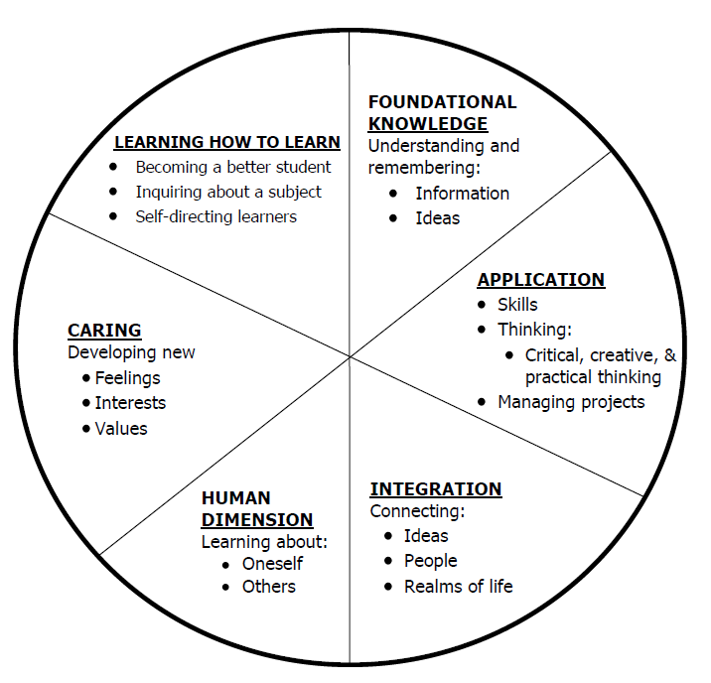

Figure 2. The taxonomy of significant learning (Fink, 2003).

Fink, L.D. 2003. A Self Directed Guide to Designing Courses for Significant Learning. San Fransisco: Jossey-Bass, pp. 37.

**2. COURSE REQUIREMENTS**

**A. Preparation and Participation (40%)**

**1. Weekly Discussions:**

a. Attendance and *active participation* in discussions and activities weekly in the F2F session will constitute excellent participation. As graduate students, this should be a ‘given’ and I don’t plan to make tally marks based on participation. I will consult individually with those who don’t seem to be actively participating.

b. Online discussions will be available on a weekly basis for all students (F2F and online). Distance students will be required to participate unless you plan to Zoom synchronously with the F2F class on Thursdays from 4 – 6:50. If a F2F student is absent, they must participate in the weekly discussion to make up participation points. 10 pts per week.

**2. Weekly Perusall Article Reading:** Students will participate in active reading via the Perusall app in Canvas. Articles will be chosen by students. Please see Perusall document information about how to effectively participate in these interactive reading sessions. We will also do a practice round together during the first class session. 10 points per week.

**3. Weekly Nearpod Lesson:** Partners will work together to prepare a Nearpod lesson of the technology topic assigned for the week. The lesson will be based on the course text reading and should be interactive and include a variety of Nearpod features (poll, open-ended questions, quiz, video, etc.). The Nearpod lesson will be delivered in class either F2F or online. 25 points.

**B. Assignments (30%)**

**1. Technology Tasks:**

Tasks will be shared weekly in class in small groups and also in Tech Groups online. For each technology task, upload a link to your work along with any other materials. Also upload a reflection based on these questions:

*What was your overall impression of this task? What challenged you? What went as expected?

*How would you use this task in a language learning classroom?

Tech Task 1: Voki Introduction

Tech Task 2: Perusall reflection

Tech Task 3: Listening – task choices: 1, 2 or 3, pages 34 - 36

Tech Task 4: Speaking – task choice: meet with your Tech Group via Zoom to discuss topic (TBA)

Tech Task 5: Reading – task choices: 3, 4, or 5, pages 54 - 56

Tech Task 6: Writing – task 5, p. 67 (with Tech Group)

Tech Task 7: Writing – task 8, p. 75

Tech Task 8: Multimodal literacies – task choices: 6, 7, 8 pages 88 - 90

Tech Task 9: Study skills & EAP – task 1, p. 97

Tech Task 10: Video creation – information to be given at later date

15 points per task + 5 points per reflection

**2.** **Technology, Media, Website Evaluation:**

Students will collectively create/develop a rubric for technology, media, website evaluation. Individually students will identify 20 different language learning apps, software, websites, etc. for evaluation and review.

50 points

**3. Technology Demonstration//Technology Expo:**

Students will demonstrate the uses of a variety of web applications in general and also specifically as they relate to language learning. How would you use the technology in your classroom to facilitate language learning in at least one domain (listening, speaking, reading, writing)? Design an interactive activity to teach a language learning objective via the chosen tech/digital resource. Align the activity with a language learning objective. We will present these in class and also at an invited event: “Technology in Language Learning Expo”. 70 points; 30 points Expo Preparation and Participation

**C. Final Exam (20%)**

**1.** ePortfolio and reflection:

Students will develop a portfolio of work showcasing their growth in course objectives during the semester. More details to be given at a later date. 100 points

Grading and Evaluation:

The grading scale will be:

**A = 100 – 90 average**

**B = 89 – 80 average**

**C = 79 – 70 average**

**D = 69 – 60 average**

**F = 59 or below average**

Attendance and Participation: Active learning experiences are only as powerful as you, the students in class, make them. Therefore, it is really important that you come to class each week and that you come prepared for group interactions and class discussions. As graduate level students, you should be able to prepare outside of class up to three hours per hour in class. That is up to nine hours of preparation. So, as part of this weekly preparation, please be sure to read and view any required material prior to class each week, participate in online discussions, and spend time delving into the variety of technology resources we will be discovering together.

*\*Special note: anyone absent from the F2F session will be allowed to make up their participation points by joining in with the distance discussion board during the week of absence.*

Distance Student Requirements: The distance section is "asynchronous" for distance students. The following will be available to distance students:

- opportunity to participate live via Zoom during F2F course

- full Panopto recording of weekly F2F class sessions

- Canvas modules that outline weekly expectations

- Canvas distance discussion boards

- 3 set 1 hour live "drop in" office hours via Zoom (details will be sent later)

- other Zoom chat sessions as requested

Distance students follow the same weekly schedule as F2F students, and adhere to all assignment due dates as listed in the syllabus or outlined in Canvas as the course proceeds.*Attendance and participation: distance students will be expected to either Zoom in live with us during the F2F class session or participate weekly in Distance Discussion Boards.*

Late Assignments: Late assignments lose 10% credit per unexcused day late to a maximum of 30% lost credit.

Assigned Readings: Beyond the required textbooks, some additional readings will be available in Canvas. Readings will be discussed in various manners ranging from course Canvas discussions to embedded in class assignments. These readings contain information that will be included in the group quizzes, reflections, projects, examinations, and other course requirements.

Justification for Graduate Credit: CTES 7400 is a comprehensive course of study in technology and media applications for teaching English to Speakers of Other Languages (ESOL). Students will examine ways to effectively incorporate technology and media into the ESL/EFL classroom. You will come away from this course with a better understanding of yourself as a user of technology, the ways techonolgy enhances the language learning process, and a battery of techonological resources to support teaching and learning. The rigorous examination of technology and its implications for teaching and learning English as a second language justify the placement of this course at the graduate level.

.

**2. COLLEGE AND UNIVERSITY POLICIES**

**Participation:** Students are expected to attend class and participate in all class discussions, exercises, and activities.

It is the student’s responsibility to contact the instructor if assignment deadlines are not met. Students are responsible

for initiating arrangements for missed work.

**Attendance/Absences:** **Excused Absences**: Students are granted excused absences from class for the following reasons: Illness of the student or serious illness of a member of the student’s immediate family, death of a member of the student’s immediate family, trips for student organizations sponsored by an academic unit, trips for University classes, trips for participation in intercollegiate athletic events, subpoena for a court appearance and religious holidays. Students who wish to have an excused absence from this class for any other reason must contact the instructor in advance of the absence to request permission. The instructor will weigh the merits of the request and render a decision. When feasible, the student must notify the instructor prior to the occurrence of any excused absences, but in no case shall such notification occur more than one week after the absence. Appropriate documentation for all excused absences is required.

**Make-Up Policy:** Arrangements to make up missed major examination (e.g. hour exams, mid-term exams) due to properly authorized excused absences. Except in unusual circumstances, such as continued absence of the student or the advent of University holidays, a make-up exam will take place within two weeks from the time the student initiates arrangements for it. Except in extraordinary circumstance, no make-up exams will be arranged during the last three days before the final exam period begins. The format of the make-up exam will be (as specific by the instructor).

**Late Assignments:** Late assignments lose 10% credit per unexcused day late to a maximum of 30% lost credit.

**Unannounced Quizzes:** There will be no unannounced quizzes.

**Accommodations:** Students who need special accommodations in class, as provided for by the American Disabilities Act, should arrange a confidential meeting with the instructor during office hours the first week of classes – or as soon as possible if accommodations are needed immediately. You must bring a copy of your Accommodation Memo and an Instructor Verification Form to the meeting. If you do not have these forms but need accommodations, make an appointment with the Program for Students with Disabilities, 1244 Haley Center, 844-2096.

**Academic Honesty Policy:** All portions of the Auburn University student [Academic Honesty Code](https://sites.auburn.edu/admin/universitypolicies/Policies/AcademicHonestyCode.pdf) (Title XII) will apply to this class. All academic honesty violations or alleged violations will be reported to the Office of the Provost, which will then refer the case to the Academic Honesty Committee.

**Professionalism:** Faculty, staff, and students in professional settings are expected to demonstrate professional behaviors as defined in the College’s conceptual framework. These professional commitments or dispositions are as follows: Engage in responsible and ethical professional practices; contribute to collaborative learning communities; demonstrate a commitment to diversity; model and nurture intellectual vitality.

**Writing Center:** The Miller Writing Center provides free support on any writing you are doing while at Auburn, whether for a course or not. Trained consultants are available to work with you as you plan, draft, and revise your writing. For students in distance courses and students temporarily away from Auburn’s campus, the Miller Writing Center offers synchronous online consultations. Please check the Miller Writing Center website ([www.auburn.edu/writingcenter](http://www.auburn.edu/writingcenter)) for instructions and information about scheduling online appointments. If you have questions about the Miller Writing Center, please email [writctr@auburn.edu](mailto:writctr@auburn.edu) or call 334-844-7475 M-F  7:45am-4:45pm.

**Student eHandbook:** Please refer to <http://www.auburn.edu/student_info/student_policies/> for all AU student policies.

**Distance Learning Students**: Unless specific instructions have been given for a designated course, students in distance education courses shall take all closed resource examinations under the supervision of an approved proctor. Examples of approved proctors include a school superintendent, a principal of a high school, or a dean or department head of a college. Proctors shall be verified and exams shall be sent directly to the proctor who will manage the examination in a secure manner, requiring students to present a picture ID.

**Additional Resources:**

***Student Policy eHandbook:*** <http://www.auburn.edu/student_info/student_policies/>

***Health and Wellness Resources*** <https://cws.auburn.edu/studentAffairs/healthAndWellness/>

***Academic Support Services:*** <http://www.auburn.edu/academic/provost/undergrad_studies/support/>

4. TENTATIVE SCHEDULE

Please note that this is a tentative summary of the schedule and activities/due dates may change during the semester. Follow the assignments as posted on the weekly modules in Canvas.

**Weeks marked with asterisk (*) will be online only. There might be others held online due to unforeseen circumstances as well.**

|  |  |  |  |  |
| --- | --- | --- | --- | --- |
| Week | Topics | Prior to Class Meeting | In Class Plan | Assignments |
| **1: 1/10** | Digital Introduction  SYLLABUS  Tech Standard Questionnaires  EASL Room intro | Download and read syllabus  Order textbook | Perusall Demo  Nearpod Demo  Article choices  Tech Demo choices | Digital competencies survey and reflection 10/13  Tech Task 1: Voki introduction 10/13  Online Discussion 1 10/13 |
| **2: 1/17** | Chapter 1& 2  Learning + Communication | Read chapter 1&2  Read Article 1 | Article 1 Discussion  Technology Demonstration Overview  e-Portfolio Overview  Nearpod Demo | Online discussion 2  Tech task 2: TBA |
| **3: 1/24\*** | Chapter 3  Listening+ Speaking | Read Chapter 3  Read Article 2 | Listening Nearpod 1  Zoom or Asynchronous Class Session* | Online discussion 3  Tech task 3: TBA |
| **4: 1/31\*** | Chapter 3  Listening+ Speaking | Read  Read Article 3 | Speaking Nearpod 2  Zoom or Asynchronous Class Session* | Online discussion 4  Tech task 4: TBA |
| **5: 2/7** | Chapter 4 & 5 Reading & Writing | Read chapters 4 & 5  Read Article 4 | Reading Nearpod 3  Tech Demonstration 1 & 2 | Online discussion 5 Tech task 5: TBA  Article synthesis 1 |
| **6: 2/14** | Chapter 4 & 5 Reading & Writing | Read chapters 4 & 5  Read Article 5 | Writing Nearpod 4  Tech Demonstration 3 & 4 | Online discussion 6  Tech task 6: TBA |
| **7: 2/21** | Chapter 6 Multimodal | Read chapter 6  Read Article 6 | Multimodal Nearpod 5  Tech Demonstration 5 & 6 | Online discussion 7  Tech task 7: TBA |
| **8: 2/28** | Chapter 7 Study Skills | Read chapter 7  Read Article 7 | Study Skills Nearpod 6  Tech Demonstration 7 & 8 | Online discussion 8  Tech task 8: TBA |
| **9: 3/7** | Chapter 8 Young Learners | Read chapter 8  Read Article 8 | Young learners Nearpod 7  Tech Demonstration 9 & 10 | Online discussion 9  Tech task 9: TBA |
| **SPRING BREAK Mar 11 – 15 (TESOL Conference, Atlanta, GA)** | | | | |  | Task 7  Article 9 | Article 9  Demonstration 8 |
| **10: 3/21** | Chapter 10 Teaching using Technology | Read chapter 10  Read Article 9 | Teaching Nearpod 8  Tech Demonstration 11 & 12 | Online discussion 10 |
| **11: 3/28** | Chapter 11 Choosing Teaching Material | Read chapter 11  Read Article 10 | Teaching Nearpod 9  Tech task 10: language learning video | Online discussion 11 |
| **12: 4/4** | Chapter 12 | Read Chapter 12  Read Article 11 | Article 11 discussion  Tech task 10: language learning video | Online discussion 12 |
| **13: 4/11** | e-Portfolio  TBA | Prepare for Technology EXPO  Read Article 12 | Article 12 discussion | Online discussion 13  Tech task 10 due Sunday |
| **14: 4/18** | e-Portfolio  TBA | TECHNOLOGY EXPO: CALL & TELL |  | Online discussion 14 |
| **15: 4/25** |  |  |  | Online discussion 15  ePortfolio due |
| **FINAL EXAMS**  **Apr 29 – May 3** | TBA |  |  |  |
|  |  |  |  |  |