**CTES7480_7486 Spring 2019**

**Auburn University**

Department: Curriculum & Teaching

Course Title: Assessment in ESL 3 hrs

Room and Schedule: MELL 3520; Tue 4:00 – 6:50 p.m.

Instructor: Dr. Jamie Harrison [jlh0069@auburn.edu](mailto:jlh0069@auburn.edu)

Phone Number: 334-844-8278

Office: Haley Center 5080

Office Hours: Tu/Th 1 – 3 p.m.; others made by appt.

**1. COURSE DESCRIPTION**

This course focuses on language assessment theory and practice. The content of the course includes purposes for assessment, types of assessment including alternative assessment and construction of assessment instruments. Central issues in the assessment of language will be presented and analyzed.

**Text:**

Brown, H. D. (2010). Language assessment: principles and classroom practices (2nd ed.). White Plains, NY: Pearson Education. ISBN: 978-0-13-814931-4

**Course Objectives:**

Engaged learners in this course can look forward to:

* Identifying and utilizing a variety of language assessment instruments and classroom assessment tools that support ELLs.
* Evaluating assessment instruments and supporting evaluations with research
* Analyzing key issues in assessment for ELLs
* Creating assessments for listening, speaking, reading, writing, vocabulary and grammar
* Engaging in small group and partner work that provides opportunities for collaboration and leadership
* Documenting language proficiency among a targeted group of ELLs
* Feeling more comfortable with creating and using assessments in multiple contexts

Active Learning Environment

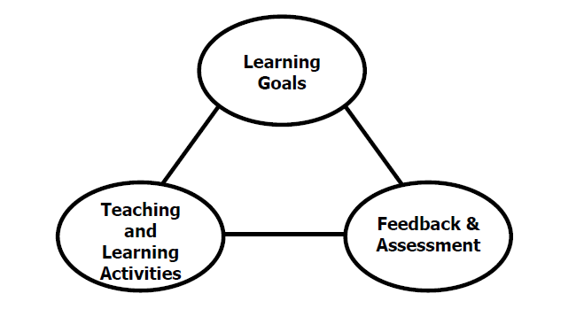

Figure 1. The key components of an integrated course design. (Fink, 2003).

This course has been designed with an active learning framework intended to integrate learning goals, teaching & learning activities, and feedback & assessment. This means you should expect to see a direct relationship between course goals, what we do in class, and how you are assessed. My hope is that you can use this course as a guide for developing your own English language courses.

A variety of teaching and learning experiences have been designed for this course to support the six key dimensions of significant learning (Fink, 2003).

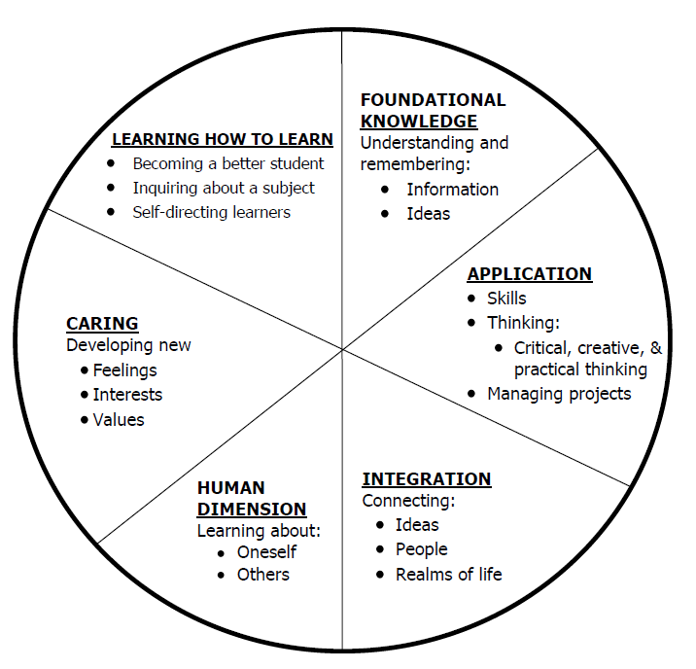

Figure 2. The taxonomy of significant learning (Fink, 2003).

Fink, L.D. 2003. A Self Directed Guide to Designing Courses for Significant Learning. San Fransisco: Jossey-Bass, pp. 37.

**2. COURSE REQUIREMENTS**

**Course Requirements**

**A. Preparation and Participation (40%)**

**Reading Formative Assessments**

**Perusall Reading Participation**

**Discussion Leads**

**B. Academic Writing and Skills (10%)**

**Article Synthesis + APA reference**

**C. Assignments (30%)**

**Content Area Test Creation**

**ELP Instrument and Report**

**Authentic Assessment Demonstration**

**Issues of Assessment Presentation**

**D. Final Exam (20%)**

**Eportfolio/Reflective paper**

**A. Preparation and Participation.**

* **Formative Assessments:** Students will participate in syllabus development by determining a preparation indicator (formative assessment) to be used during the semester. This could be a reading or vocabulary quiz, a graphic organizer of key ideas, or a reading guide (more suggestions will be provided). This will be uploaded to Canvas prior to class each week. **Distance students (and any absent F2F students) will also participate in discussion boards each week based on class discussion topics or activities. These will be posted weekly.**
* **Perusall and Student-led Discussions:** Students will participate in weekly article reading, synthesis, and leadership. Class discussions will be led by teams of students weekly.

**B. Content Area Test Creation.** Students will create a scaffolded test suitable for a range of NNES/ELL in a mainstream classroom.

**C. ELP Assessment Instrument & Report.** Students will develop an assessment instrument that will be used for screening ELs/NNESs in the four language domains of listening, speaking, reading and writing. The assessment instrument will include the actual test and all evaluation materials. Students will administer their Original Assessment Instrument and report the results according to assignment details.

**D. Authentic Assessment Demonstration.** Students will create and demonstrate one type of authentic assessment.

**E**. **Issues of Assessment Presentation.** Students will read, research, and present an issue of assessment for ELs or NNESs.

**F. Final Exam: ePortfolio and reflection paper**

**Evaluation:**

All assignments are graded according to the specific assignment criteria and returned to students by the next class meeting after submission unless noted otherwise. I adhere firmly to the University’s statement on academic conduct/plagiarism. Based on these evaluation criteria, your final grade will be based on the following:

A = 100-90 B = 89-80 C = 79-70 D = 69-60 F = 59-0

Attendance and Participation: Active learning experiences are only as powerful as you, the students in class, make them. Therefore, it is really important that you come to class each week and that you come prepared for group interactions and class discussions. As graduate level students, you should be able to prepare outside of class up to three hours per hour in class. That is up to nine hours of preparation. So, as part of this weekly preparation, please be sure to read and view any required material prior to class each week, participate in online discussions, and spend time delving into the variety of technology resources we will be discovering together.

*\*Special note: anyone absent from the F2F session will be allowed to make up their participation points by joining in with the distance discussion board during the week of absence.*

Distance Student Requirements: The distance section is "asynchronous" for distance students. The following will be available to distance students:

- opportunity to participate live via Zoom during F2F course

- full Panopto recording of weekly F2F class sessions

- Canvas modules that outline weekly expectations

- Canvas distance discussion boards

- 3 set 1 hour live "drop in" office hours via Zoom (details will be sent later)

- other Zoom chat sessions as requested

Distance students follow the same weekly schedule as F2F students, and adhere to all assignment due dates as listed in the syllabus or outlined in Canvas as the course proceeds.*Attendance and participation: distance students will be expected to either Zoom in live with us during the F2F class session or participate weekly in Distance Discussion Boards.*

Late Assignments: Late assignments lose 10% credit per unexcused day late to a maximum of 30% lost credit.

Assigned Readings: Beyond the required textbooks, some additional readings will be available in Canvas. Readings will be discussed in various manners ranging from course Canvas discussions to embedded in class assignments. These readings contain information that will be included in the group quizzes, reflections, projects, examinations, and other course requirements.

Justification for Graduate Credit: CTES 7420 is a comprehensive study of theories of second language acquisition. The course covers SLA from three perspectives: psycholinguistics, sociolinguistics and neurolinguistics. The course requires students not only to interpret and analyze theoretical models of SLA, it requires students to make clear the connections between research and effective practice in SLA programs. Crucial to the success of second language teaching and learning is educators’ in-depth understanding of how processes of second language acquisition are theorized and researched. The rigorous examination of SLA and its implications for teaching and learning English as a second language justify the placement of this course at the graduate level.

.

**3. COLLEGE AND UNIVERSITY POLICIES**

**Participation:** Students are expected to attend class and participate in all class discussions, exercises, and activities.

It is the student’s responsibility to contact the instructor if assignment deadlines are not met. Students are responsible

for initiating arrangements for missed work.

**Attendance/Absences:** **Excused Absences**: Students are granted excused absences from class for the following reasons: Illness of the student or serious illness of a member of the student’s immediate family, death of a member of the student’s immediate family, trips for student organizations sponsored by an academic unit, trips for University classes, trips for participation in intercollegiate athletic events, subpoena for a court appearance and religious holidays. Students who wish to have an excused absence from this class for any other reason must contact the instructor in advance of the absence to request permission. The instructor will weigh the merits of the request and render a decision. When feasible, the student must notify the instructor prior to the occurrence of any excused absences, but in no case shall such notification occur more than one week after the absence. Appropriate documentation for all excused absences is required.

**Make-Up Policy:** Arrangements to make up missed major examination (e.g. hour exams, mid-term exams) due to properly authorized excused absences. Except in unusual circumstances, such as continued absence of the student or the advent of University holidays, a make-up exam will take place within two weeks from the time the student initiates arrangements for it. Except in extraordinary circumstance, no make-up exams will be arranged during the last three days before the final exam period begins. The format of the make-up exam will be (as specific by the instructor).

**Late Assignments:** Late assignments lose 10% credit per unexcused day late to a maximum of 30% lost credit.

**Unannounced Quizzes:** There will be no unannounced quizzes.

**Accommodations:** Students who need special accommodations in class, as provided for by the American Disabilities Act, should arrange a confidential meeting with the instructor during office hours the first week of classes – or as soon as possible if accommodations are needed immediately. You must bring a copy of your Accommodation Memo and an Instructor Verification Form to the meeting. If you do not have these forms but need accommodations, make an appointment with the Program for Students with Disabilities, 1244 Haley Center, 844-2096.

**Academic Honesty Policy:** All portions of the Auburn University student [Academic Honesty Code](https://sites.auburn.edu/admin/universitypolicies/Policies/AcademicHonestyCode.pdf) (Title XII) will apply to this class. All academic honesty violations or alleged violations will be reported to the Office of the Provost, which will then refer the case to the Academic Honesty Committee.

**Professionalism:** Faculty, staff, and students in professional settings are expected to demonstrate professional behaviors as defined in the College’s conceptual framework. These professional commitments or dispositions are as follows: Engage in responsible and ethical professional practices; contribute to collaborative learning communities; demonstrate a commitment to diversity; model and nurture intellectual vitality.

**Writing Center:** The Miller Writing Center provides free support on any writing you are doing while at Auburn, whether for a course or not. Trained consultants are available to work with you as you plan, draft, and revise your writing. For students in distance courses and students temporarily away from Auburn’s campus, the Miller Writing Center offers synchronous online consultations. Please check the Miller Writing Center website ([www.auburn.edu/writingcenter](http://www.auburn.edu/writingcenter)) for instructions and information about scheduling online appointments. If you have questions about the Miller Writing Center, please email [writctr@auburn.edu](mailto:writctr@auburn.edu) or call 334-844-7475 M-F  7:45am-4:45pm.

**Student eHandbook:** Please refer to <http://www.auburn.edu/student_info/student_policies/> for all AU student policies.

**Distance Learning Students**: Unless specific instructions have been given for a designated course, students in distance education courses shall take all closed resource examinations under the supervision of an approved proctor. Examples of approved proctors include a school superintendent, a principal of a high school, or a dean or department head of a college. Proctors shall be verified and exams shall be sent directly to the proctor who will manage the examination in a secure manner, requiring students to present a picture ID.

**Additional Resources:**

***Student Policy eHandbook:*** <http://www.auburn.edu/student_info/student_policies/>

***Health and Wellness Resources*** <https://cws.auburn.edu/studentAffairs/healthAndWellness/>

***Academic Support Services:*** <http://www.auburn.edu/academic/provost/undergrad_studies/support/>

4. TENTATIVE SCHEDULE

Please note that this is a tentative summary of the schedule and activities/due dates may change during the semester. Follow the assignments as posted on the weekly modules in Canvas.

|  |  |  |  |  |
| --- | --- | --- | --- | --- |
| Week | Topics | Prior to Class Meeting | In Class Plan | Assignments |
| **1: 1/8 – First week of classes. Classes begin on 1/9, so no class meeting this week. Please read the syllabus and post an online introductory post in your assessment work group.** | | | | |
| **2: 1/15** | Assessment concepts and issues | Chapter 1, Brown & Abeywickrama  Chapter 1, McNamara (pdf) | TBA – please see Canvas for Agenda   * Article choices * Authentic assessment choices * Issue choices | Please identify 3 – 5 ELLs/NNES for practice assessments this semester. Submit names & email addresses. *school age children will need parent permission |
| **3: 1/22\*** | Principles of Language Assessment  Major Assessments review | Chapter 2, Brown & Abeywickrama  Chapter 2, McNamara (pdf)  ACCUPLACER  KITE  MTELP | TBA – please see Canvas for Agenda |  |
| **4: 1/29\*** | Designing Classroom Language Tests  Content Area Assessment | Chapter 3, Brown & Abeywickrama  Article 1 & 2 | TBA – please see Canvas for Agenda |  |
| **5: 2/5** | Assessing Listening | Chapter 7, Brown & Abeywickrama  Article 3 & 4 | TBA – please see Canvas for Agenda  Auth assessment demo 1  Auth assessment demo 2  Auth assessment demo 3 |  |
| **6: 2/12** |  | Article 5 & 6 | TBA – please see Canvas for Agenda  Auth assessment demo 4  Auth assessment demo 5  Auth assessment demo 6 | Classroom content area assessment due |
| **7: 2/19** | Assessing Speaking | Chapter 8, Brown & Abeywickrama  Article 7 & 8 | TBA – please see Canvas for Agenda  Auth assessment demo 7  Auth assessment demo 8  Auth assessment demo 9 | Article synthesis 1 |
| **8: 2/26** |  | Article 9 & 10 | TBA – please see Canvas for Agenda  Auth assessment demo 10  Auth assessment demo 11  Auth assessment demo 12 |  |
| **9: 3/5** | Assessing Reading | Chapter 9, Brown & Abeywickrama  Article 11 & 12 | TBA – please see Canvas for Agenda  Auth assessment demo 13  Auth assessment demo 14  Auth assessment demo 15 |  |
| **SPRING BREAK 3/11 – 3/15** | | | | |
| **10: 3/19** |  | Article 13 & 14 | TBA – please see Canvas for Agenda  Auth assessment demo 16  Auth assessment demo 17  Auth assessment demo 18 | Assessment Issue Online Pres A |
| **11: 3/26** | Assessing Writing | Chapter 10, Brown & Abeywickrama  Article 15 & 16 | TBA – please see Canvas for Agenda  Auth assessment demo 19  Auth assessment demo 20  Auth assessment demo 21 | Assessment Issue Online Pres B |
| **12: 4/2** |  | Article 17 & 18 | TBA – please see Canvas for Agenda  Auth assessment demo 22  Auth assessment demo 23  Auth assessment demo 24 | Assessment Issue Online Pres C |
| **13: 4/9** | Assessing Grammar and Vocabulary | Chapter 11, Brown & Abeywickrama  Article 19 & 20 | TBA – please see Canvas for Agenda | Assessment Issue Online Pres D |
| **14: 4/16** | Standards-based assessment;  Standardized Assessment | Chapter 4, Brown & Abeywickrama  Chapter 5, Brown & Abeywickrama  Article 21 & 22 | TBA – please see Canvas for Agenda | Article Synthesis 2 |
| **15: 4/23** | Alternatives in Assessment; Grading & Student Evaluation | Chapter 6, Brown & Abeywickrama  Chapter 12, Brown & Abeywickrama  Article 23 & 24 | TBA – please see Canvas for Agenda | ELP Instrument & Report due |
| **FINAL EXAM** | Assessment portfolio & reflection |  |  |  |
|  |  |  |  |  |

Alignment of objectives with the Alabama Quality Teaching Standards (AQTS 290-3-3-.45) is noted.

Upon completion of this course students will be able to demonstrate knowledge of:

* a variety of standards-based and performance-based classroom assessment tools to inform language and content instruction for the ELL’s language proficiency level. (2)(d)1.(i)
* a variety of standards-based language proficiency instruments & their uses for identification, placement, and demonstration of language growth of ELLs. (2)(d)2.(i)(I)
* issues of assessment. (2)(d)2.(i)(II)
* the purposes of assessment as they are related to ESOL learners and how to use results appropriately. (2)(d)3.(i)(I)
* the key indicators of good assessment instruments. (2)(d)3.(i)(II)
* a variety of assessment procedures for ESOL students. (2)(d)3.(i)(III)
* the advantages and limitations of assessment, including accommodations for ELLs. (2)(d)3.(i)(IV)
* the impact of English language proficiency on the consideration for referral for special education services, including gifted programming. (2)(d)3.(i)(V)
* state requirements for identification, reclassification, and exit of ELLs from language support programs. (2)(d)3.(i)(VI)
* norm-referenced and criterion-referenced assessments **that are appropriate for ELLs.** (2)(d)3.(i)(VII)
* assessment measures used for a variety of purposes in serving ELLs. (2)(d)3.(i)(VIII)
* How to determine ELLs’ language skills and communicative competence using multiple sources of information. (2)(d)3.(i)(IX)
* performance-based assessment tools and tasks that measure ELLs’ progress toward state standards. (2)(d)3.(i)(X)
* a variety of instruments and techniques to assess content-area learning (e.g., math, science, social studies) for ELLs at varying levels of language and literacy development. (2)(d)3.(i)(XI)