AUBURN UNIVERSITY

SYLLABUS

Spring 2020

# Course Details:

Course Number: PHED 1410-004

Course Title: Team Sports Basketball

Day/Time: TR 11:00am-12:15pm

Location: Student Activity Center 142 (NOT AUBURN REC)

Credit Hours: 2 credit hours

Prerequisites: None

# Contact Information:

Instructor: Mr. Michael Morris

Office Address: 301 Wire Road, Kinesiology Research Facility, Rm # 106

Email: mam0222@auburn.edu

Office Hours: By appointment

Secondary Contact: thornr1@auburn.edu

# Texts or Major Resources:

This PHED course will utilize an e-book version of the textbook that will be made available to you in the Canvas site associated with your course. Since you use an e-book in your class, there are a few important things to know up-front:

DO NOT BUY OR ORDER A TEXTBOOK FOR THIS CLASS. It will be provided to you in Canvas.

You will be charged $ 39.50 for the e-book by the AU Bookstore. The charge will be made to your AU e-bill on September 10, 2019 and will appear as "Bookstore Charges" on the e-bill issued following that date.

No charge will be made to your account if you drop the class before the 15th class

day September 9, 2019 .

You will be able to view the course text in Canvas, and will also be able to view it using the Canvas mobile application.

For billing questions/concerns, contact Rusty Weldon, Assistant Director of the AU Bookstore, [weldora@auburn.edu](mailto:weldora@auburn.edu).

Please note if you “opt out” of eBook charges, you will not have access to the materials you need to complete the course.

# Course Description:

Basic concepts and physical activities associated with basketball. Phase I of the course will home in the essential fundamentals of honoring diversity, fair play/sportsmanship, passing, shooting, and dribbling. True mastery of these skills does not consist of individual success of these skills, but how one can apply these concepts through teaching one another and gameplay. Phase II of the curriculum entails offensive and defensive strategies. There will be an emphasis on overload games, pass, and cut, pick and rolls, off-ball screens, and man to man defensive principles. The Sport Education model guides phase III of the curriculum. The preparation of phases I and II will help ready students for the game experiences of Sport Education. Siedentop (1984) developed the Sport Education model, which is a curriculum instruction model designed for delivery in physical education programs at the primary and secondary levels. Curtner-Smith, Hastie, and Kinchin (2008) noted that the goals of SE are to produce sportspeople who are enthusiastic, competent, and literate. Through the Sport Education model, students serve in varied and genuine roles that are in traditional sports settings such as captains, coaches, trainers, statisticians, officials, publicists, and members of a sports council.

I will attempt to group students by experience during the small-sided invasion games. However, each class, I will task several students that have much experience with the sport to participate with those that do not have a lot of experience. The goal of the more experienced students is not to take over the games (i.e., scoring) but merely, facilitate, motivate, and encourage.

# Course Objectives:

After taking this course you will have a working knowledge of skill and techniques used in basketball from a cognitive, affective, and psychomotor standpoint.

# Course Content: (assignment due dates/exams are in bold and in Canvas)

# Course Content: (assignment due dates/exams are in bold and in Canvas)

Week 1: Classes Begin – 1/8/20

**Phase I: Honoring Diversity, Fair Play/Sportsmanship, and Passing**

Week 2: **Syllabus Quiz – 1/17/20**

**Dribbling**

Week 3: **Canvas Module #1- Exercise Vocabulary – 1/24/20**

**Shooting**

**-Last day to drop a course with no grade assignment – 1/29/20**

Week 4: **Canvas Module #2- Health Benefits of Engaging in Regular Physical Activity**

– **1/31/20**

**Not your typical 3 v 3**

**Skills Test 1 Development**

Week 5: **Canvas Module #3 - FITT Principles – 2/7/20**

**Skills Test I**

Week 6: **Phase II Offensive and Defensive Strategies**

Week 7: **Canvas Module #4 - Behavioral Change Strategies – 2/21/20**

**Offensive and Defensive Strategies**

Week 8: **Phase III Sport Education Season** **(Skills Test II)**

Week 9: **Canvas Module #5 - Preparing and Recovering from Exercise – 3/6/20**

**Phase III Sport Education Season (Skills Test II)**

*Spring Break 3/8/20-3/14/20*

Week 10: **Phase III Sport Education Season (Skills Test II)**

***NOTE: Last day to withdraw from course with no grade penalty. "W" assigned* – 11/2/18**

Week 11: **Canvas Module #6 – Conceptual Core (if applicable)– 3/27/20**

**Phase III Sport Education Season (Skills Test II)**

Week 12: **Phase III Sport Education Season (Skills Test II)**

Week 13: **Phase III Sport Education Season (Skills Test II)**

Week 14: **Phase III Sport Education Season (Skills Test II)**

Week 15: **Final Exam (NOT AU EVALUATE) –** 4/6/20-4/24/20(**FRIDAY**- last scheduled

day of classes)

**Award Ceremony**

# Course Requirements / Evaluation:

Item Percentage

Participation 35%

2 Skills Exams 20%

Syllabus Quiz 5%

5-6 Canvas Modules 30%

Final Exam (NOT AU-Evaluate) 10%

Total 100%

**Extra Credit – SONA

Participation - requires students be dressed appropriately and fully take part in daily activities and exercises from beginning to the end of class. Participation will be graded based on instructor observation. Students are required to behave in an orderly fashion and exhibit quality sportsmanship throughout the semester. Mature behavior consists of respecting both the teacher and peers. Students are not required to engage in altercations with one another, use profane or ugly language, and make obscene gestures. During instruction, students are required to give the instructor their undivided attention. Unruly behavior will result in an initial warning, and the student will sit out for a period. However, if the behavior problem persists the student will have to exit the class and I will nullify their participation points for the day.

Skills Tests – See Course Content.

Syllabus Quiz - Week 1 posted on Canvas.

Canvas Modules – see schedule of Course Content for due dates.

Final Exam – A comprehensive written assessment of concepts and techniques used in the course. (NOT AU-Evaluate)

## Grading Scale:

A = 100 – 90%

B = 89 – 80%

C = 79 – 70%

D = 69 – 60%

F = Below 60%

## **College of Education SONA EXTRA CREDIT OPPORTUNITY

Your class has the opportunity to participate in the online research participation system, College of Education SONA. You will receive an email from SONA that enables you to sign up for research solicitations. If you do not receive this email by the third week of classes, please email [**sona@auburn.edu**](mailto:sona@auburn.edu). If you are under 19 years of age you must get your parents’ consent to participate in each study. Forms are available online. It is your job to make sure that your earned extra credit goes to the correct course. You can modify this in your student SONA account. If you sign up for a study that has appointments, you are expected to attend. If you need to cancel, follow the directions for cancelling an appointment for that study. Please pay attention to cancellation deadlines for that study. If you fail to do so you will be marked as a “no-show” in SONA. Two “no-show” designations will result in you being locked out of SONA for the semester and you will not be able to receive extra credit through research participation for that semester.

Your instructor is not affiliated with SONA, so participation or non-participation will not influence your status in this course, other than the extra credit points you can earn. SONA will report the number of credits you have earned to the instructor of the course you select when registering for research solicitations.

There are several SONA systems on campus. To receive credit in this course you must participate in the College of Education SONA.

The School of Kinesiology or your instructor is not responsible for the availability or lack of availability of SONA extra credit.

½ points will not be credited to final grade.

1 30-minute session = 1 credit

2 credits = 1 point added to final grade

4 credits = 2 points added to final grade

6 credits = 3 points added to final grade

8 credits = 4 points added to final grade

10 credits = 5 points added to final grade (maximum allowed)

# Course Policy Statements:

## A. Attendance:

Physical Activity and Wellness Program Attendance Policy

The material and experiences in this class are important and if you are not in class, you cannot take an active role as a student. Class attendance and appropriate participation is paramount to your success as a student. Participation is defined as, but not limited to, “fully engaging in the course content and activities at a level that is deemed appropriate by the instructor.” Once a student has accrued five unexcused absences he/she will not be permitted to take the final examination and will receive a grade of FA (as stipulated by the Physical Activity and Wellness Program guidelines). Moreover, students who accrue eight (8) absences (excused, unexcused and/or combination of each type) will not be permitted to take the final examination and will receive a grade of FA.

Unexcused absences result in the loss of participation points for the day and cannot be made up. Be responsible.

Students are required to sign in before the start of class. There will be a five-minute grace period for all students to sign in. Furthermore, there will be days that I require students to sign out. Signing out will be done using exit slips. Students who fail to sign in will be marked absent. Students who fail to sign in but complete an exit slip will be marked absent. Students who sign in and sneak out of class will be marked absent. The sign in sheet will be placed on a chair directly in front of the gymnasium doors. Remember it is your responsibility to sign in. Students will lose one point towards your final grade if you are not present following the completion of my set induction. Students that arrive 15 minutes after the official start of class will be marked absent from the roll. Students are only permitted to exit class early when injured, sick or any other emergency. In the event of an emergency that causes one to exit early, students will only earn half of their allotted participation points (only if students left prior to the halfway mark). Students will not receive the other half until they provide me with an official excuse. In the event of an injury, you must exit class and seek medical attention immediately. There will be no scenarios where students will sit out if injured. Therefore, sitting out is not an option. Either you go to the medical clinic or I give you an alternative work out.

## B. Excused Absences:

Students are granted excused absences from class for the following reasons: illness of the student or serious illness of a member of the student’s immediate family, the death of a member of the student’s immediate family, trips for student organizations sponsored by an academic unit, trips for university classes, trips for participation in intercollegiate athletic events, subpoena for a court appearance, and religious holidays. Appropriate documentation for all excused absences is required. Please refer to the [Auburn University Student Policy eHandbook](http://www.auburn.edu/studentpolicies) at the following link www.auburn.edu/studentpolicies for more information on excused absences.

## C. Make-Up Policy:

Arrangement to make up missed examinations due to properly authorized excused absences must be initiated by the student within one week from the end of the period of the excused absences. The format of the make-up exam will be as specified by the instructor. If the student fails to follow these instructions the excused absence in question will be calculated as an unexcused absence.

Course Contingency: If normal class and/or lab activities are disrupted due to illness, emergency, or crisis situation, the syllabus and other course plans and assignments may be modified to allow completion of the course. If this occurs, an addendum will be made to your syllabus and/or course assignments will replace the original material.

Inclement Weather: In case of inclement weather, check your Auburn email account for alternative class location and/or assignments.

# 9. Academic Honesty Policy:

All portions of the Auburn University student academic honesty code (Title XII) found in the [Auburn University Student Policy eHandbook](http://www.auburn.edu/studentpolicies) www.auburn.edu/studentpolicies will apply to this class. All academic honesty violations or alleged violations of the SGA Code of Laws will be reported to the Office of the Provost, which will then refer the case to the Academic Honesty Committee.

# 10. Disability Accommodations:

Students who need accommodations are asked to electronically submit their approved accommodations through AU Access and to arrange a meeting during office hours the first week of classes, or as soon as possible if accommodations are needed immediately. If you have a conflict with my office hours, an alternate time can be arranged. To set up this meeting, please contact me by e-mail. If you have not established accommodations through the Office of Accessibility, but need accommodations, make an appointment with the Office of Accessibility, 1228 Haley Center, 844-2096 (V/TT).

Please note that accommodations are not retroactive. Accommodations begin after: (1) a meeting with the Office of Accessibility to determine appropriate accommodations; and (2) a meeting with the Instructor arranged by the student.

**Skill Test 1**

**Objective:** Students will form into groups and create a skill-based game utilizing any of the three fundamental elements (passing, shooting, or dribbling). The game must be creative and *A SMALL SIDED INVASION GAME*. An invasion game is a term used for any game where the aim is to attack an opponent's territory and score a goal or point. Usually consisting of teams of equal players, these fast-paced games focus on teamwork, keeping possession, scoring, and defending. Games that involve relay races or stationary shooting (i.e., around the world, knockout), stationary passing, or stable dribbling games are not allowed. You can modify games I used in the class or search the web for some creative basketball games that utilize the fundamentals of passing, shooting, or dribbling. I will provide equipment as needed for your games. Each game must require the participation of all group members present on the court. You will do a write up of the game on a poster board and submit it during class. The elements I need to see in the write up are space, organization, gameplay, equipment, and fair play. Here is an example.

**4 Goal Score w/ Dribbling**

**Space:** Full Court

**Organization:** 4v4/5v5

**Gameplay:** The object of the game is to pass the ball facing each other in between each goal. There is a goal in each corner, and both teams can score from any target. Once a team scores, then both oppositions will swap possessions. This time you can dribble, but each player can only dribble three times. There are no cross-court passes to score a goal, and you must score within the three-point line. The first team to 25 wins. Let’s demonstrate.

Equipment: one Ball, eight cones

**Fair Play**

1. Do not slap the ball when an opponent has the ball
2. Do not take any steps when you have the ball. That is called traveling.
3. While defending stand 1 yard away.
4. Do not make body contact
5. When a dispute arises, do rock paper scissors.
6. No running with the ball is allowed.
7. Shake hands with the other team when the game is over.
8. No goal guarding

For the skills test, groups will teach and play their games with each other for the duration of the class period. Groups will have 3 minutes to instruct their games and 15 minutes to perform. Teams will use their poster boards to help them teach the game. Then the lead group will demonstrate an example of their game. Following both demonstrations, the lead group will check for understanding. Once everyone signals that they have an agreement, then both teams will compete.

I will evaluate students game based on the criteria below. Instructor evaluation is 50% of the skills test I grade. Then groups will assess each other on fair play after the game. Student evaluation of fair play will constitute the additional 50% of their skills test I grade. Students must get all perfect scores on their fair play evaluation to get full credit. Anything less will result in partial credit.

**Instructor Evaluation:**

|  |  |  |
| --- | --- | --- |
|  | MEET | DOES NOT MEET |
| Game Creation: 4 points | 4 | 2.0 |
|  | The game created uses one or two of the three elements; school equipment is utilized appropriately at all the time. The game has all required components within the description. The game is creative and has a unique aspect. | The game created uses other elements not discussed, school equipment is not utilized appropriately. None or some of the required components are present. The game is not creative and is commonly used (i.e. 21, Knockout, Horse, 3-man weave, etc.) |
| Teaching: 4 points | 4 | 2.0 |
|  | Teaching of the created game maximizes student learning. Class can effectively participate and play game incorporating all the elements. | Presentation of the created game is ineffective and hard to follow, forcing students to improvise during game play. |

**Student Evaluation:**

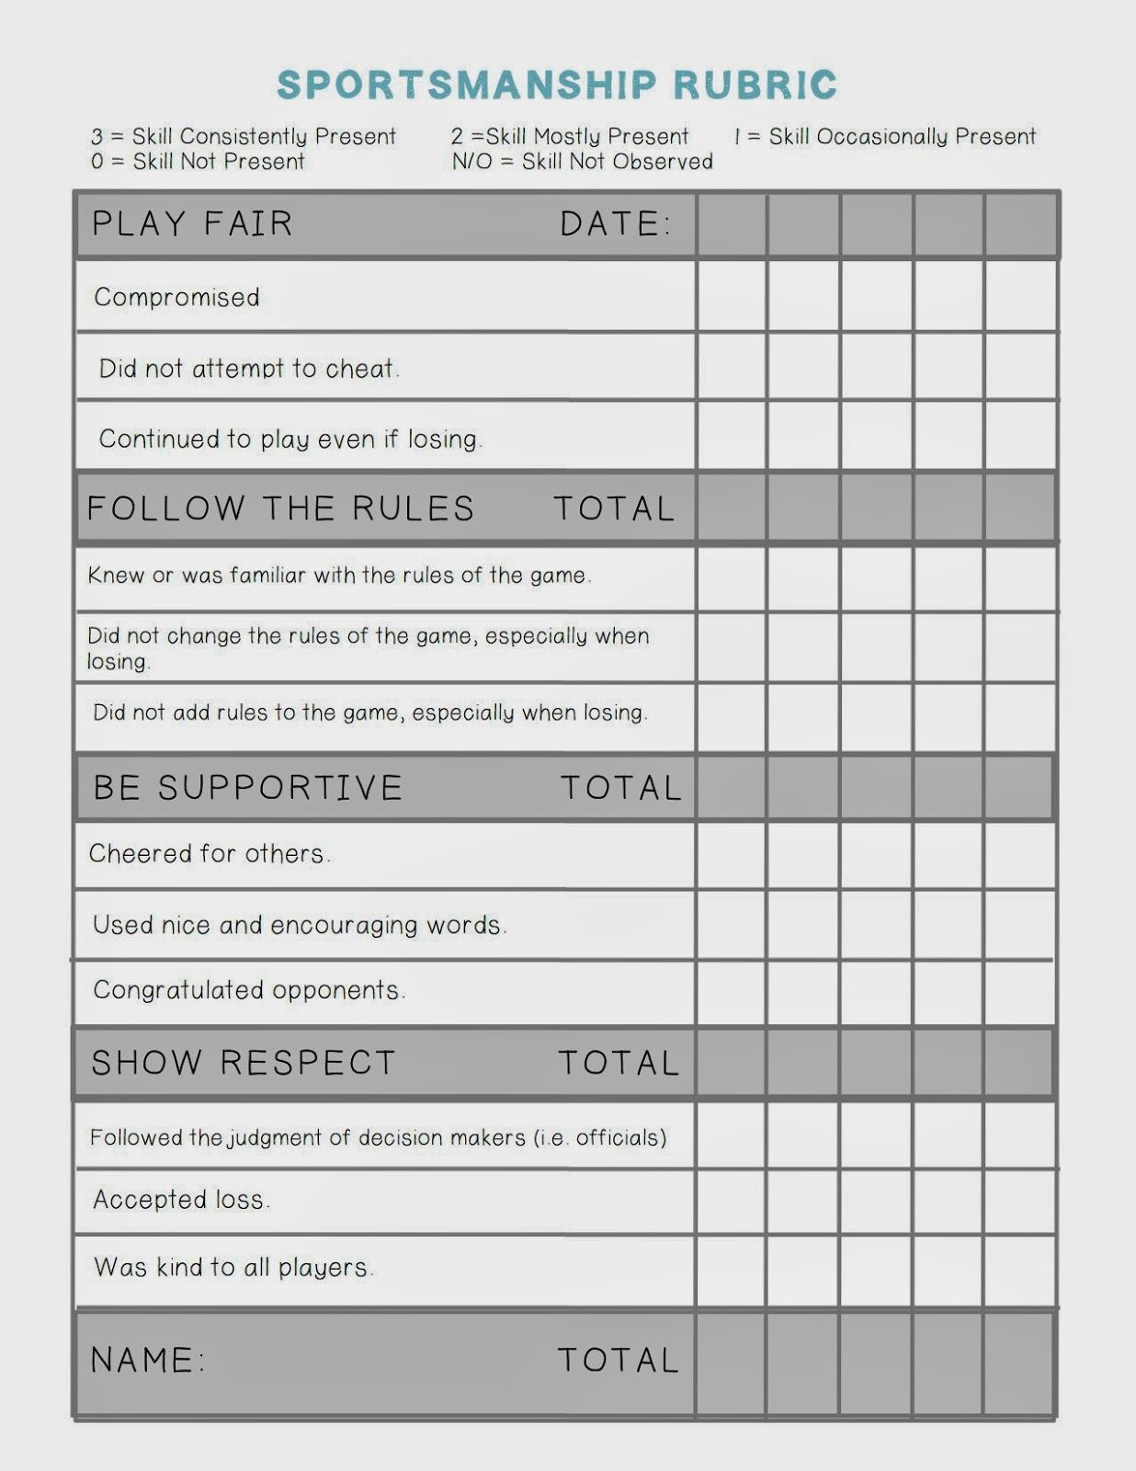

**Skills Test 2**

Skills Test 2 will be your participation during the sport education tournament. Students are required to complete three journal entries, a Sport Education Quiz. I will assess team gameplay. Furthermore, students will formally assess each other on fair play and duty team roles. However, duty team roles will not be in the graded criteria.

Journal Entries 30 points

Gameplay Assessment 30 points

Fair Play Assessment 30 points

Sport Education Quiz 10 points

Total: 100 points

**Journal Entries**

Only three Journal entries. Entry prompts are in Canvas. Each entry is worth 10 points. Each day your journal entry is late you lose half credit (10 – 5 – 0).

**Gameplay Assessment**

|  |  |  |  |
| --- | --- | --- | --- |
| Gameplay Outcomes | Often  6 points | Sometimes  5 points | Not Present  4 points |
| Use of Offensive/Defensive strategies |  |  |  |
| Proper Spacing on Floor |  |  |  |
| The frequency of uncontested shots |  |  |  |
| Multiple teammates receiving passes during each possession |  |  |  |
| The occurrence of turnovers |  |  |  |
| Consistency and/or improvement of towards each gameplay outcome. |  |  |  |

**Fair Play Assessment: Same rubric as skill test 1**

Teams must exhibit good sportsmanship throughout the sport education season to receive full credit. If teams exhibit quality sportsmanship sometimes then their team score would be a 15/30. If sportsmanship is not present, then no credit will be given.

**Sport Education Quiz: Quiz from the handbook provided by the instructor.**