**CTSE 7970_76 Special Topics:**

**Teaching ESL Listening & Speaking**

**Auburn University**

Department: Curriculum & Teaching

Course Title & Credit: Methods in ESL List/Spkg; 3 hrs

Room and Schedule: TBA; **Tue 4:00 – 6:50 p.m.**

Instructor: Dr. Jamie Harrison [jlh0069@auburn.edu](mailto:jlh0069@auburn.edu)

Phone Number: 334-844-8278

Office: Haley Center 5080

Office Hours: Tues and Thurs 1 – 3 p.m.

**1. COURSE DESCRIPTION**

This course will prepare ESL/EFL teachers to develop engaging and effective listening and speaking lessons in a variety of contexts. Students will design and implement effective listening and speaking lessons for a variety of proficiency levels.

**Text:**

**Required Texts:**

Newton, J. & Nation, I.S.P. (2021). 2nd Edition. *Teaching ESL/EFL listening and speaking*. New York: Routledge.

Other readings as required and provided via Canvas

**Recommended texts:**

Students in M.Ed track: *WIDA PK – 12 ELP Standards /CAN DO Standards*

<https://wida.wisc.edu/sites/default/files/resource/2012-ELD-Standards.pdf>

Students in the M.S. track: *Standards for ESL-EFL Teachers of Adults* (2008). Alexandria, VA: TESOL.

<https://sites.tesol.org/bookstore/ItemDetail?iProductCode=509E&Category=EBOOK>

Bleistein, T., Lewis, M., & Smith, M. (2020). *Teaching speaking*. Alexandria, VA: TESOL

Bolen, J. (2020). *ESL listening activities for teenagers and adults.* Author.

Bolen, J. (2015). *39 non-prep/low-prep ESL speaking activities.* Author.

Nemtchinova, E. (2020). *Teaching listening*. Alexandria, VA: TESOL

**Course Objectives**

Engaged learners in this course can look forward to:

* Demonstrating high level of competence in methods and strategies for teaching listening and speaking
* Developing and utilizing active-learning listening and speaking mini-lessons for an authentic audience
* Analyzing authentic speech samples and providing authentic feedback
* Conducting research in an area of interest related to listening and speaking
* Demonstrating advanced critical thinking skills, interpersonal and leadership skills in group work

Active Learning Environment

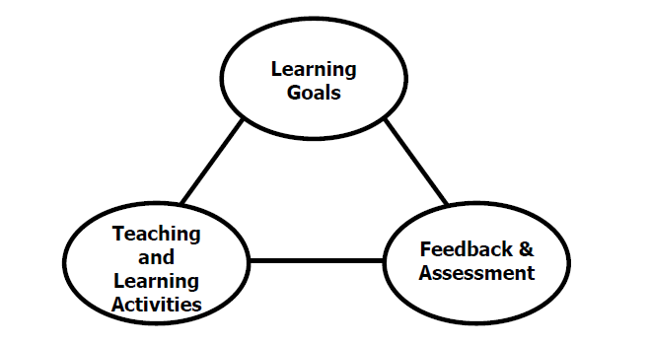

Figure 1. The key components of an integrated course design. (Fink, 2003).

This course has been designed with an active learning framework intended to integrate learning goals, teaching & learning activities, and feedback & assessment. This means you should expect to see a direct relationship between course goals, what we do in class, and how you are assessed. My hope is that you can use this course as a guide for developing your own English language courses.

A variety of teaching and learning experiences have been designed for this course to support the six key dimensions of significant learning (Fink, 2003).

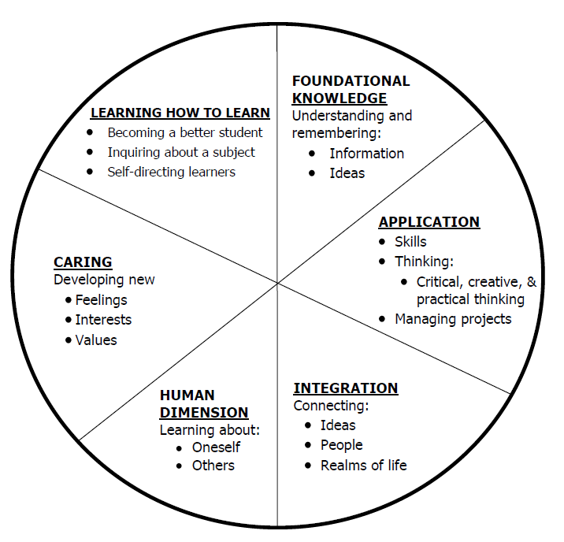

Figure 2. The taxonomy of significant learning (Fink, 2003).

Fink, L.D. 2003. A Self Directed Guide to Designing Courses for Significant Learning. San Fransisco: Jossey-Bass, pp. 37.

**2. COURSE REQUIREMENTS**

**A. Assignments**

**Attendance (10%)** Your active participation in this course is essential to getting the most out of it and attending the actual class (F2F or virtually) is imperative. Attendance per class session will be awarded 5 points per class. All class sessions will be recorded. If you are a distance student if will be most effective for you to attend synchronously via Zoom. If you are not able to do this, please contact me so that I am aware of your intentions to participate asynchronously. If you do not attend the F2F session or participate synchronously via Zoom (for whatever reason) you will be expected to submit a summary of the class session that you view. There will be an assignment portal created for this and you will have one week after the missed class to submit the summary. A template will be provided.

**Participation: Preparation/Discussion Posts/In-class activities (20%)**  Attending class is just one aspect of being successful in this course and your active participation is vital to your success in and benefit from the course. Participation will include: preparing prior to class, contributing to discussions (or discussion posts) before, during, and after class, and participating in in-class activities. You will be asked to get started with the weekly discussion by posting some of your thoughts about the reading each week. The format for your responses will vary. Topics will come from the reading.

**Issues in Listening and Speaking Presentation and Discussion Lead (30%)** You will research an issue related to teaching listening and speaking English. You will identify a relevant article for shared reading, conduct a brief literature review, present on the topic, and lead a discussion about the topic.

**Major Project (30%)**

**Option 1: Listening and Speaking Course Design**

You will work with other classmates to develop a listening and speaking course that can be offered to the community. Through this experience, you will design the course, recruit the online participants, write three lessons on the chosen topic, and prepare for and deliver 3 lessons to an online small group.

**Option 2: Case Study**

You will individually identify one ESL student (any age) with whom you will participate in a variety of interview protocols to assess skills and needs. You will design the interview protocols with Dr. Harrison based on the unique student factors of your participant. You will design an independent skill tutoring plan for the tutee and use formative assessments to guide your work with the student from session to session. You will conduct 8 – 10 tutoring sessions (30 minutes each).

**Final Exam –Portfolio and Reflection (10%) –** details to be provided

Grading and Evaluation:

The grading scale will be:

**A = 100 – 90 average**

**B = 89 – 80 average**

**C = 79 – 70 average**

**D = 69 – 60 average**

**F = 59 or below average**

Attendance and Participation: Active learning experiences are only as powerful as you, the students in class, make them. Therefore, it is really important that you come to class each week and that you come prepared for group interactions and class discussions. As graduate level students, you should be able to prepare outside of class up to three hours per hour in class. That is up to nine hours of preparation. So, as part of this weekly preparation, please be sure to read and view any required material prior to class each week, complete all assigned grammar homework, do extra grammar practice as you feel necessary to master the topics, and prepare for all group and individual assignments. **More than two unrequested and/or unexcused absences will result in a 10% reduction on your final average.**

Distance Student Requirements: The distance section is "asynchronous" for distance students. The following will be available to distance students:

- full Panopto recording of weekly F2F class sessions

- Canvas modules that outline weekly expectations

- Canvas distance discussion boards

- 3 set 1 hour live "drop in" office hours via Zoom (details will be sent later)

- other Zoom chat sessions as requested

Distance students follow the same weekly schedule as F2F students, and adhere to all assignment due dates as listed in the syllabus or outlined in Canvas as the course proceeds.*Attendance and participation: distance students will be required to participate weekly in Distance Discussion Boards. Lack of participation in more than 2 discussion boards will result in a 10% reduction on your final average.*

Late Assignments: Late assignments lose 10% credit per unexcused day late to a maximum of 30% lost credit.

Assigned Readings: Beyond the required textbooks, some additional readings will be available in Canvas. Readings will be discussed in various manners ranging from course Canvas discussions to embedded in class assignments. These readings contain information that will be included in the group quizzes, reflections, projects, examinations, and other course requirements.

Justification for Graduate Credit: CTSE 6010 is a comprehensive study of language for teachers of ESOL. The course requires students to master English grammar as well as to synthesize and analyze grammar theory and grammar instruction from multiple perspectives. The rigorous examination of grammar, its place in the instruction of ESL students, and its implications for teaching and learning English as a second language justify the placement of this course at the graduate level.

.

**3. COLLEGE AND UNIVERSITY POLICIES**

**Participation:** Students are expected to attend class and participate in all class discussions, exercises, and activities.

It is the student’s responsibility to contact the instructor if assignment deadlines are not met. Students are responsible

for initiating arrangements for missed work.

**Attendance/Absences:** **Excused Absences**: Students are granted excused absences from class for the following reasons: Illness of the student or serious illness of a member of the student’s immediate family, death of a member of the student’s immediate family, trips for student organizations sponsored by an academic unit, trips for University classes, trips for participation in intercollegiate athletic events, subpoena for a court appearance and religious holidays. Students who wish to have an excused absence from this class for any other reason must contact the instructor in advance of the absence to request permission. The instructor will weigh the merits of the request and render a decision. When feasible, the student must notify the instructor prior to the occurrence of any excused absences, but in no case shall such notification occur more than one week after the absence. Appropriate documentation for all excused absences is required.

**Make-Up Policy:** Arrangements to make up missed major examination (e.g. hour exams, mid-term exams) due to properly authorized excused absences. Except in unusual circumstances, such as continued absence of the student or the advent of University holidays, a make-up exam will take place within two weeks from the time the student initiates arrangements for it. Except in extraordinary circumstance, no make-up exams will be arranged during the last three days before the final exam period begins. The format of the make-up exam will be (as specific by the instructor).

**Late Assignments:** Late assignments lose 10% credit per unexcused day late to a maximum of 30% lost credit.

**Unannounced Quizzes:** There will be no unannounced quizzes.

**Accommodations:** Students who need special accommodations in class, as provided for by the American Disabilities Act, should arrange a confidential meeting with the instructor during office hours the first week of classes – or as soon as possible if accommodations are needed immediately. You must bring a copy of your Accommodation Memo and an Instructor Verification Form to the meeting. If you do not have these forms but need accommodations, make an appointment with the Program for Students with Disabilities, 1244 Haley Center, 844-2096.

**Academic Honesty Policy:** All portions of the Auburn University student [Academic Honesty Code](https://sites.auburn.edu/admin/universitypolicies/Policies/AcademicHonestyCode.pdf) (Title XII) will apply to this class. All academic honesty violations or alleged violations will be reported to the Office of the Provost, which will then refer the case to the Academic Honesty Committee.

**Professionalism:** Faculty, staff, and students in professional settings are expected to demonstrate professional behaviors as defined in the College’s conceptual framework. These professional commitments or dispositions are as follows: Engage in responsible and ethical professional practices; contribute to collaborative learning communities; demonstrate a commitment to diversity; model and nurture intellectual vitality.

**Writing Center:** The Miller Writing Center provides free support on any writing you are doing while at Auburn, whether for a course or not. Trained consultants are available to work with you as you plan, draft, and revise your writing. For students in distance courses and students temporarily away from Auburn’s campus, the Miller Writing Center offers synchronous online consultations. Please check the Miller Writing Center website ([www.auburn.edu/writingcenter](http://www.auburn.edu/writingcenter)) for instructions and information about scheduling online appointments. If you have questions about the Miller Writing Center, please email [writctr@auburn.edu](mailto:writctr@auburn.edu) or call 334-844-7475 M-F  7:45am-4:45pm.

**Student eHandbook:** Please refer to <http://www.auburn.edu/student_info/student_policies/> for all AU student policies.

**Distance Learning Students**: See section 2.

**Additional Resources:**

***Student Policy eHandbook:*** <http://www.auburn.edu/student_info/student_policies/>

***Health and Wellness Resources*** <https://cws.auburn.edu/studentAffairs/healthAndWellness/>

***Academic Support Services:*** <http://www.auburn.edu/academic/provost/undergrad_studies/support/>

## COVID Policies

**Physical Distancing**

Face coverings are not a substitute for physical distancing. Students shall observe physical distancing guidelines where possible in the classroom, laboratory, studio, creative space setting and in public spaces.

Students should avoid congregating around doorways before or after class sessions. If the instructional space has designated entrance and exit doors students are required to use them. Students should exit the instructional space immediately after the end of instruction to help ensure social distancing and allow for the persons attending the next scheduled class session to enter.

**Face Covering Policy**

In response to COVID-19, and in alignment with Auburn University's Presidential directives, and local, state, and national health official guidelines face coverings are required at all times while on campus, except when alone in a private office. This includes the classroom, laboratory, studio, creative space, or any type of in-person instructional activity, and public spaces. "A “face covering” is defined as a “covering that fully covers a person’s nose and mouth, including without limitation, cloth face mask, surgical mask, towels, scarves, and bandanas.

If a student has a medical exception to the face covering requirement, please contact the Office of Accessibility to obtain appropriate documentation.

**Possibility of Going Remote**

In the event that the University is forced to move to fully online instruction, please be assured that the learning goals and outcomes of the course will not change; however, some aspects of the course will change in terms of the mode of delivery, participation, and testing methods. Those details will be shared via a Canvas Announcement within 24 hours of the announcement that we are going remote. Please be prepared for this contingency by ensuring that you have access to a computer and Internet.

**In the Event that a Student in the Class Tests Positive**Students must conduct daily health checks in accordance with [CDC guidelines (Links to an external site.)](https://www.cdc.gov/coronavirus/2019-ncov/symptoms-testing/symptoms.html). Students testing positive for COVID-19, exhibiting COVID-19 symptoms or who have been in direct contact with someone testing positive for COVID-19 will not be allowed to attend in-person instructional activities and must leave the venue immediately. Students should contact the [Student Health Center (Links to an external site.)](https://cws.auburn.edu/aumc/) or their health care provider to receive care and who can provide the latest direction on quarantine and self-isolation. Contact your instructor immediately to make instructional and learning arrangements.

**In the Event that the Instructor Tests Positive**If I am unable to attend our F2F portions of the class, we will transition to a fully online course until I am allowed to return. If I become ill or unable to lead the class, a backup instructor will be identified and they will communicate any changes or updates to the course schedule or mode of instruction as soon as possible.

**Zoom Policies**

When we meet on Zoom, your attendance, attention, and participation are expected. Zoom participation requires you to keep your video on and your microphone muted when you are not speaking. Although you may be participating from your residence, our Zoom meetings are professional interactions. To the extent possible, please minimize distractions in the background. I reserve the right to dismiss anyone from a Zoom meeting whose environment or behavior is distracting or problematic. If you have any issues with sharing your video feed, adhering to this policy, or anything else related to your use of Zoom please notify me via email in the first week of class. I’m happy to consider and provide accommodations, but you will need to be in communication with me.

4. TENTATIVE SCHEDULE

*Please note that this is a tentative summary of the schedule and activities/due dates may change during the semester. Follow the assignments as posted on the weekly modules in Canvas. Pay attention to Announcements as I often clarify assignments & due dates that way.

**If normal class and/or lab activities are disrupted due to illness, emergency, or crisis situation, the syllabus and other course plans and assignments may be modified to allow completion of the course. If this occurs, an addendum to your syllabus and/or course assignments will replace the original materials.

Here is a link to the official AU academic calendar: <http://www.auburn.edu/main/auweb_calendar.php>

And a link to the revised calendar based on Covid 19: <https://ocm.auburn.edu/newsroom/news_articles/2020/06/221634-academic-calendar.php>

|  |  |  |  |  |
| --- | --- | --- | --- | --- |
| Week | Topics | Prior to Class Meeting | In Class Activities | Assignments |
| 1: 1/11 – 1/17*  Class held on 1/12 | Introduction & Course Overview | Download and read course syllabus  Order required textbook  Introductory Post: Funds of Knowledge | **Research issues in Listening and Speaking, bring ideas and topics to class in week 3 to share** |  |
| 2: 1/18 – 1/24*  Class held on 1/19 | Parts and goals of a listening and speaking course | Newton & Nation, ch. 1  Discussion post 1: 4-3-2 topic preparation | *Activity: 4-3-2* |  |
| 3: 1/25 – 1/31  Class held on 1/26 | Beginning to listen and speak in another language | Newton & Nation, ch. 2  Discussion post 2: 5 principles  **Research issues in Listening and Speaking, bring ideas and topics to class in week 3 to share; sign up for presentation date** | *Activity: Spot the Difference* |  |
| 4: 2/1 – 2/7  Class held on 2/2 | Listening | Newton & Nation, ch. 3  Discussion post 3: Table 3.1 Conditions for learning through input | *Activity: Listen and Draw* |  |
| 5: 2/8 – 2/14  Class held on 2/9 | Extensive listening | Newton & Nation, ch 4  Discussion post 4: Authentic extensive listening – the college lecture | *Activity: Watching a Movie* |  |
| **6: 2/15 – 2/21**  **~~Class held on 2/16~~**  **Wellness day: 2/16** | Language-focused learning through dictation and related activities | Newton & Nation, ch 5  Discussion post 5: Dictation try-out and reflection | *Activity: Dictation* |  |
| 7: 2/22 – 2/28  Class held on 2/23 | Pronunciation | Newton & Nation, ch 6  Discussion post 6: pronunciation difficulties | *Activity: Pronunciation Pairs* | Issue Presentation and Discussion Lead |
| 8: 3/1 – 3/7  Class held on ¾=2 | Learning through task-based interaction | Newton & Nation, ch. 7  Discussion post 7: Create a problem-solving task to share | *Activity: Split information* | Issue Presentation and Discussion Lead |
| 9: 3/8 – 3/14  Class held on 3/9  Wellness day: 3/10 | Learning through pushed output | Newton & Nation, ch. 8  Discussion post 8: list of topics and TED talk | *Activity: TBA* | Issue Presentation and Discussion Lead |
| 10: 3/15 – 3/21  Class held on 3/16 | Teaching using a course book | Newton & Nation, ch. 9  Discussion post 9: extensive listening resources (end of ch 9) | *Activity: TBA* | Issue Presentation and Discussion Lead |
| 11: 3/22 – 3/28  Class held on 3/23 | Language-focused learning: Deliberate teaching | Newton & Nation, ch. 10  Discussion post 10: feedback types (end of ch 10) | *Activity: TBA* | Issue Presentation and Discussion Lead |
| 12: 3/29 – 4/4  Class held on 3/30  Wellness day: 4/1 | Developing fluency | Newton & Nation, ch. 11 | *Activity: TBA* | Issue Presentation and Discussion Lead |
| 13: 4/5 – 4/11  Class held on 4/6 |  | ESL Listening and Speaking Community Course Week 1 |  | Issue Presentation and Discussion Lead |
| 14: 4/12 – 4/18  Class held on 4/13 |  | ESL Listening and Speaking Community Course Week 2 |  | Issue Presentation and Discussion Lead |
| 15: 4/19 – 4/25  Class held on 4/20 |  | ESL Listening and Speaking Community Course Week 3 |  |  |
| FINAL EXAMS  Apr 26 – Apr 30 | FINAL EXAM - Online |  |  |  |
|  |  |  |  |  |