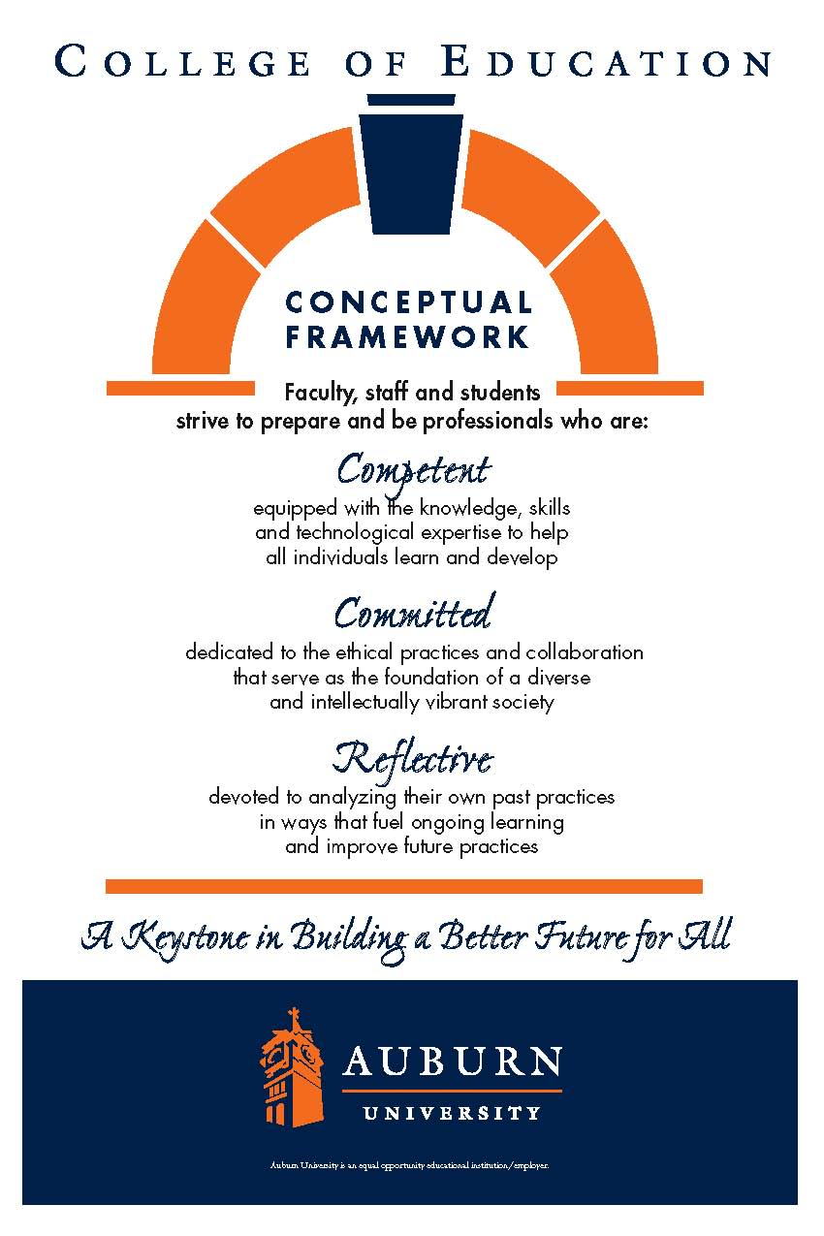

**CTES 7920**

**Auburn University**

Department: Curriculum & Teaching

Program: English to Speakers of Other Languages Education

Course Title: cLINICAL rESIDENCY IN esol education

Course Number: CTES 7920

Course Credit: 3 hours

Semester: Spring 2023

|  |  |
| --- | --- |
| Instructor | Gwendolyn M. Williams |
| Email Address | Gmw0015@auburn.edu | |
| Phone number | (Office) 334-844-6775 | |
| Office | 5078 Haley Center | |
| Office Hours | By appointment | | |
| Schedule | In the classrooms | | |

**1.COURSE DESCRIPTION**

**Catalog Description:**

Supervised on-the-job experience in a school, college, or other appropriate setting, accompanied by regularly scheduled, on-campus discussion periods.

**Overview**

The Clinical Residency in ESOL education (certification track) may be completed by working with students in a public school setting, the Summer English School setting, and/or private tutoring sessions. The non-certification track may utilize Auburn Global or another adult education setting to fulfill requirements. On-the-job experiences are accompanied by scheduled observations and discussions that allow the university supervisor and the interning teacher to analyze and evaluate teaching experiences and abilities to apply research-based practices and knowledge base addressed in objectives and content for courses in the reading program.

The Clinical Residency experience is set up in three unique stages. 1) observations in ESL classes that encompass the wide range of language levels and language domains 2) shadowing/assisting practicing teachers with all aspects of ESL teaching, and/or tutoring one-on-one in class and private settings 3) small group teaching and full time teaching of at least one class of students for the duration of at least one unit. Each stage is comprised of at least 100 hours, but may be split up throughout the entire course of study.

Students working toward Alabama’s Class A ESOL Education certification must complete all three options. Students wishing to develop expertise in other areas of reading education may work with a university supervisor to create additional Clinical Residency options (e.g., teaching reading to children with special needs; working with adult readers).

**Required Text-**none required

**Student Learning Outcomes:** Course objectives include a subset of key indicators from the Alabama Quality Teaching Standards and program-specific indicators. Indicators assigned to CTES 7920 are highlighted on the performance assessment templates included in the attachments. [Or noted below.]

Alignment of objectives with the Alabama Quality Teaching Standards (AQTS) is noted.

1. Students will be introduced to the ethical standards for professionalism.
2. Students will demonstrate the ability to apply course material (to improve thinking, problem solving, and decisions); related to the principles and methods of teaching and learning of English language.
3. Students will develop and demonstrate skills, competencies, and points of view needed by professionals; related to lesson planning, classroom management, and student peer relationships
4. Students will develop an appreciation for the breadth of the field in terms of the four language modalities + grammar, pronunciation, and vocabulary teaching, as well as integrated approaches.
5. Students will use the practicum to gain competence in the field and use course work to support the development of effective teaching as well as the ability to reflect critically about their own teaching techniques and the teaching of others

**2. COURSE REQUIREMENTS**

Students will work with the university supervisor to develop weekly plans for addressing and demonstrating competence in the objectives listed above.

The entire clinical residency will consist of 3 credit hours, with 100 clock hours per stage. Additional clock hour configurations can be made on individual basis in consultation with university supervisor. Requirements for each option include weekly entries in a professional journal that includes annotations to standards or theory, self-evaluations completed at midterm and at the end of the term, and participation in professional conversations about the Clinical Residency.

**Course Requirements**

**Goal Statement**-

1. By the end of week 2, please make a list of at least three personal goals for this stage of the internship that you hope to accomplish by the end of the current semester. These goals can focus on teaching skills, classroom management skills, lesson planning, facilitating student interaction, etc. Just make sure the goals are important to you and are areas that you haven’t already mastered. Please be realistic and set goals that can reasonably be met in the prescribed time frame. **Please email them to your advisor by January 27, 2023.**This way she can work with you to help you move towards accomplishing your goals by the end of the semester.

**Formal Classroom Observations (9/9, 10/7, 11/4, 12/2)**

Each intern will be observed by your advisor **four** times throughout the course of the semester. Each of the four lessons must address at least one language domain (listening, speaking, reading, writing) and all domains must be represented among the lessons. Lessons could address multiple domains, but you must address all four domains. The lesson should be a complete lesson that can be evaluated as a stand-alone lesson or activity. Each observation must be scheduled and confirmed with your supervisor at least 48 hours before the lesson is actually taught. On the day of the observation, each intern should provide the supervisor with a copy of the lesson plan that is being taught, and the completed pre-observation report with a blank copy of the evaluation rubric. Please see the rubric on Canvas. After the observation, a time must be scheduled shortly thereafter to discuss the observation with your supervisor. The observations are designed to help you analyze and improve your teaching skills. The observations will be spaced throughout the semester, so it is important to make sure that you meet your deadlines.

**B: Reflective Teaching Journal**

Write this journal entry each week during your student teaching experiences. It provides a way for you to summarize your weekly written reflections about insights, new understandings, acquired skills, problems, and successes during the previous week. Be specific since this is an opportunity to practice self-analysis in such areas as relationships with students and relationships with your supervising teacher and other school personnel. It also demonstrates your planning and how you are working toward personal goals. The journal entries will be submitted three times throughout the course of the semester. (This means that 4-5 weeks of journal entries will be submitted per time.)

You should answer the following questions each week with a different paragraph for each question:

1. I am currently teaching and/or my activities were…
2. My schedule next week… (include a detailed teaching / activity schedule)
3. Overall, this week went… (provide professional, insightful reflections)
4. I achieved success this week…
5. My challenges this week…
6. I have learned that…

See rubric on Canvas.

**C: Professional Work Sample- This assignment is for M.Ed. students ONLY.**

The focus of this professional work sample is on comprehensive planning of instruction for multilingual learners that incorporates best practices in sheltered instruction and technology infused instruction, while supporting the acquisition of English in multiple environments. Responses must be well-written, clear, well-organized and free of major grammatical and usage errors. Use APA format when citing any research.

**Planning for Multiple Instructional Interactions**

Complete your plans for multiple instructional interactions with your English language learners. Then respond to the following questions. Attach your plans to your responses.

1. What is the setting for which these plans are designed? Describe the school setting and the student characteristics.

2. What are your learning outcomes and why did you choose them? Describe how they integrate more than one of the language domains of listening, speaking, reading or writing.

3. How will you determine if all students made progress toward achieving the learning

outcomes? Be sure to discuss multiple assessments.

4. How do your plans address the diverse linguistic and cultural backgrounds of your students? Be sure to include a variety of effective instructional strategies you plan to use that are based on recent relevant research. Explain how your plans accommodate the various differences in your student population.

5. Select one or two students that you would like your observer to focus on during the

observation of one of your instructional interactions. Discuss these students’ learning

needs and how you will scaffold instruction to meet the students’ proficiency levels and content knowledge levels.

6. How do your unit plan and/or the learning environment promote student engagement and

encourage supportive interactions that will facilitate their language development?

7. How do you plan to integrate technology into your unit plan? How does technology enhance the instructional effectiveness in this lesson sequence?

**Implementation and Discussion of One Instructional Interaction**

Arrange for your internship supervisor and/or your cooperating teacher to observe one of your multiple instructional interactions. Conduct a brief pre-conference with the observer(s) and share an overview of your instructional plans including the learning outcome(s). After the observation, facilitate a discussion with your observer(s) that focuses on the classroom observation instrument.

1. Did all students make progress toward achieving the language and content outcome(s)?

What evidence did you observe during the instructional interaction to support your response?

2. Discuss the one or two focus students you selected during your planning. How did

these students engage with your lesson? Did you believe you met their needs? Why or

why not? If not, what were the obstacles that prevented the student from achieving the outcomes and what strategies did you implement to address these challenges?

**Reflection on Multiple Instructional Interactions**

1. Reflect on how your *planning* and *instruction* changed over the multiple instructional

interactions and explain what changes you made and why you made the changes you

did.

2. How has your experience teaching this unit changed how you approach lesson planning for English learners? How do you feel that this change will affect the student learning outcomes for your English learner students?

3. Did all students make progress toward achieving the language and content learning outcomes for the unit? What evidence did you observe while teaching the unit that supports your response?

4. What parts of the unit were effective? What parts of the unit were less effective? Utilize

current research about English language teaching to support your answer.

5. In what ways was technology useful as you planned, implemented, or reflected on the unit. Describe how technology extended your instructional capabilities to address the linguistic or sociocultural needs of your students.

**Assessment and Analysis of Student Learning**

Your analysis of student learning should consist of multiple assessments that were included in your unit plan of instruction. Assessments should be both formal and informal. Carefully analyze the assessment data.

1. What formal and informal assessments did you include in your analysis? Why did you choose

these measures? Identify each assessment as formative or summative.

2. How did the assessments match the student’s WIDA language proficiency levels or how were the mainstream assessments adapted to meet the student’s WIDA language proficiency levels?

3. What did the assessment data reveal about the learning of all students? Attach the data

and supporting artifacts such as samples of the assessment(s), rubrics, and student

work samples. Be sure to include a table for each formal assessment that includes a breakdown

of grades. Create a chart based on the table(s).

4. What feedback did you provide to the student to respond to their linguistic or content mastery? How was the feedback understood and incorporated into the student’s subsequent work?

**Items to be Included in Appendices**

1. Unit Plan

2. Course from Alabama Course of Study

3. All supplemental unit materials (PowerPoints, handouts, assessments and rubrics, answer keys, etc.)

4. Student work samples (do not include identifying information)

5. Completed observation tools

6. APA style reference list

**For PWS rubric see Canvas.**

**Professional Growth Paper due 4/28/2023**

In this paper you will reflect on the professional growth in reflective teaching that you have achieved throughout the semester. Please connect your reflections back to theory or standards. This paper should be 3-4 pages long. Questions that should be answered are:

1. Describe the journey that you have taken towards the goals that you set at the beginning of the semester. How did you meet these goals, or what challenges prevented you from meeting these goals?
2. What did you learn from this internship that surprised you the most?
3. Describe a critical incident that occurred in your EL classroom this semester and explain how this event changed your views on teaching ELs.
4. Describe how your connection with the institution and community in which you were teaching has influenced your professional growth.

**See the rubric on Canvas.**

**Grading and Evaluation Procedures:**

A grade of Satisfactory or Unsatisfactory is assigned. Students must satisfy all objectives to receive a satisfactory grade.

Evaluation:

The Alabama State Board of Education requires all students completing teacher certification programs to be assessed using the Alabama Quality Teaching Standards and program-specific standards. Assessments used during Clinical Residency to assess these standards are (1) the Professional Work Sample and (2) the Inventory of Candidate Proficiencies. Information regarding the following is provided in the attachments:

* alignment of state standards with the College’s 15 candidate proficiencies – performance assessment templates
* alignment of candidate proficiencies with the key assessments

The final Clinical Residency grade (S, U) is determined by the university supervisor and the cooperating teacher based on the key assessments which include a holistic evaluation of the student’s performance throughout the semester (e.g., Inventory of Candidate Proficiencies).

**3. University and College Policies**

1. Attendance: Attendance is required for all classes unless excused prior to class meeting.
   1. Excused absences: Students are granted excused absences from class for the following reasons: illness of the student or serious illness of a member of the student’s immediate family, the death of a member of the student’s immediate family, trips for student organizations sponsored by an academic unit, trips for university classes, trips for participation in intercollegiate athletic events, subpoena for a court appearance, and religious holidays. Students who wish to have an excused absence from class for any other reason must contact the instructor in advance of the absence to request permission. The instructor will weigh the merits of the request and render a decision. When feasible, the student must notify the instructor prior to the occurrence of any excused absences, but in no case shall such notification occur more than one week after the absence. Appropriate documentation for all excused absences is required. Please see the *Tiger Cub* for more information on excused absences. It is the student’s responsibility to notify the cooperating teacher of the absence.
   2. Make-Up Policy: Arrangement to make up missed work due to properly authorized excused absences must be initiated by the student within one week of the end of the period of the excused absences(s). Except in unusual circumstances, such as the continued absence of the student or the advent of university holidays, make-up work will be completed within two weeks of the date that the student initiates arrangements for it. Except in extraordinary circumstance, no make-up work will be arranged during the last three days before the final exam period begins.
2. Academic Honesty Policy: All portions of the Auburn University student academic honesty code found in University Policies (<https://sites.auburn.edu/admin/universitypolicies/default.aspx>)will apply to university courses. All academic honesty violations or alleged violations of the SGA Code of Laws will be reported to the Office of the Provost, which will then refer the case to the Academic Honesty Committee
3. Disability Accommodations: Students who need accommodations are asked to arrange a meeting during office hours the first week of classes, or as soon as possible if accommodations are needed immediately. If you have a conflict with my office hours, an alternate time can be arranged. To set up this meeting, please contact me by e-mail. If you have not established accommodations through the PSD office, but need accommodations, make an appointment with The Program for Students with Disabilities, 1228 Haley Center, 844-2096 (V/TT).
4. Course contingency : If normal class and/or lab activities are disrupted due to illness, emergency, or crisis situation, the syllabus and other course plans and assignments may be modified to allow completion of the course. If this occurs, and addendum to your syllabus and/or course assignments will replace the original materials.
5. As faculty, staff, and students interact in professional settings, they are expected to demonstrate professional behaviors as defined in the College’s conceptual framework. These professional commitments or dispositions are listed below:
   1. Engage in responsible and ethical professional practices
   2. Contribute to collaborative learning communities
   3. Demonstrate a commitment to diversity
   4. Model and nurture intellectual vitality
6. Professionalism Conduct Code
   1. Clothing should be neat and professional. Men should wear pants (not jeans) and a shirt/sweater- T-shirts and sweat shirts are inappropriate. Women can wear pants or skirts, however, they should not be really tight or short. T-Shirts, and spaghetti strap shirts are not appropriate for the classroom. Wear clothing that is not too low-cut.
   2. You should take off your coat during classroom teaching and observations.
   3. You should be punctual in arriving at the placement, in getting to the class for your lessons, and in the discharge of all professional duties. If you are running late, you should notify your cooperating teacher. You are not allowed to leave early as this disrupts the students’ learning.
   4. You must notify the instructor if you are ill and unable to report to class. If you are scheduled to teach on a particular day and are unable to attend, you still must submit lesson plans so that the instructor can teach the class in your absence.
   5. Please remember you are a guest at your placement. You are to treat the faculty and students with the utmost respect and not interfere with the daily learning practices that the school has set in place. If a difficulty arises, you may be reassigned to a different placement.
   6. You are to be actively engaged in the classroom either through observation or interacting with students or faculty throughout your time in the classroom. Your hours in the classroom are not to be spent doing outside assignments or computer work. This is not a study period.

**Justification for Graduate Credit:**

CTES 7920 provides students with the opportunity to develop graduate-level skills in a professional context through supervised experience. The Clinical Residency promotes the integration of theory, research, and practice in a professional context and fosters self-directed professional development.