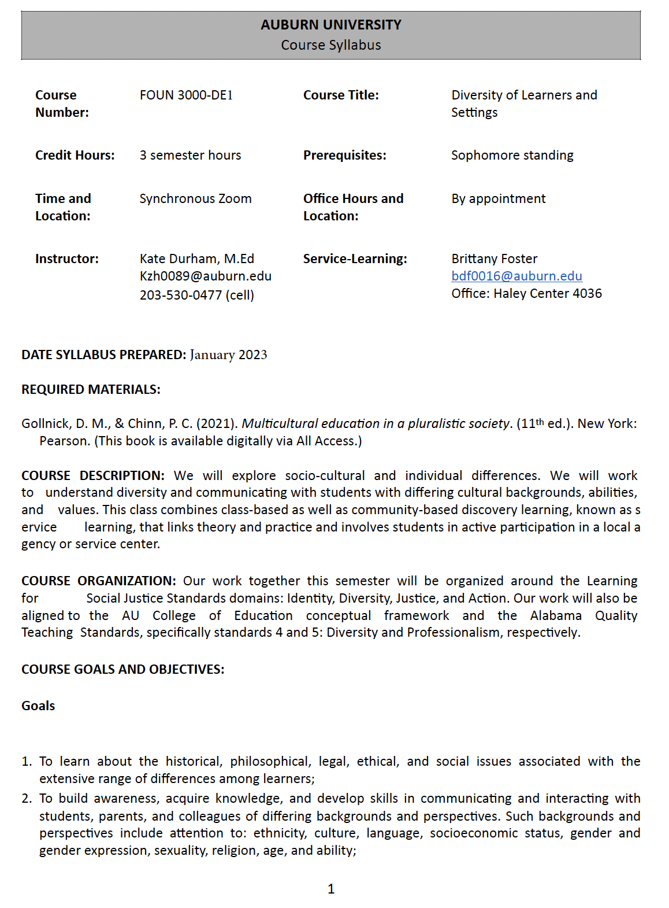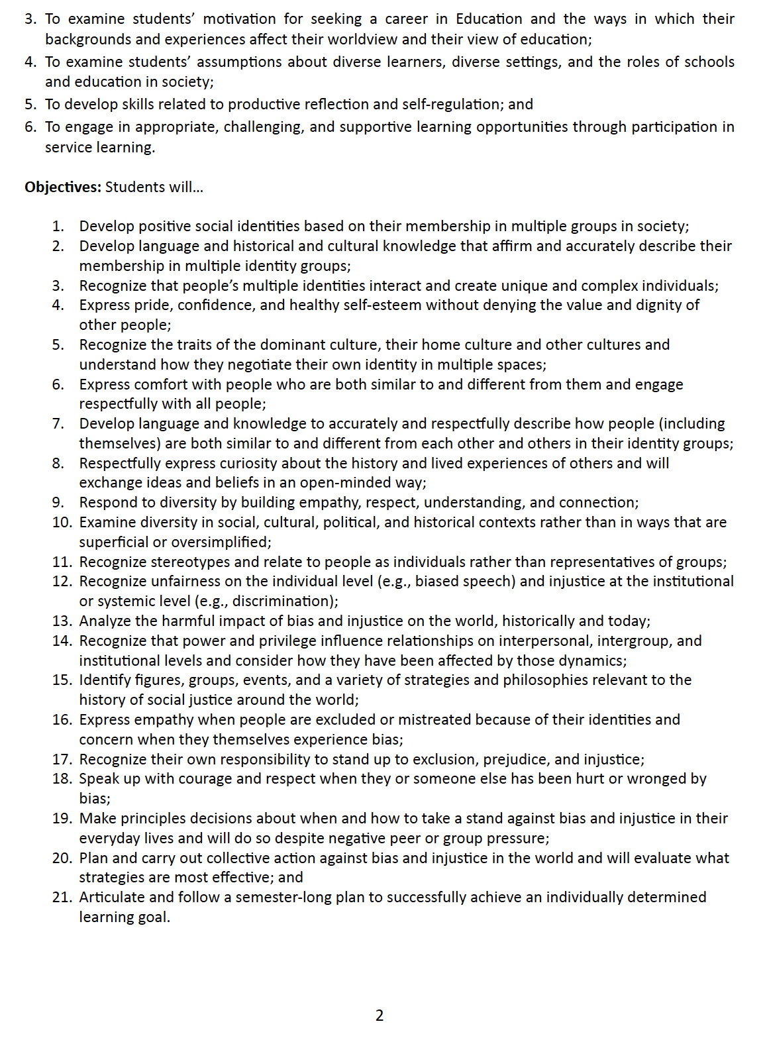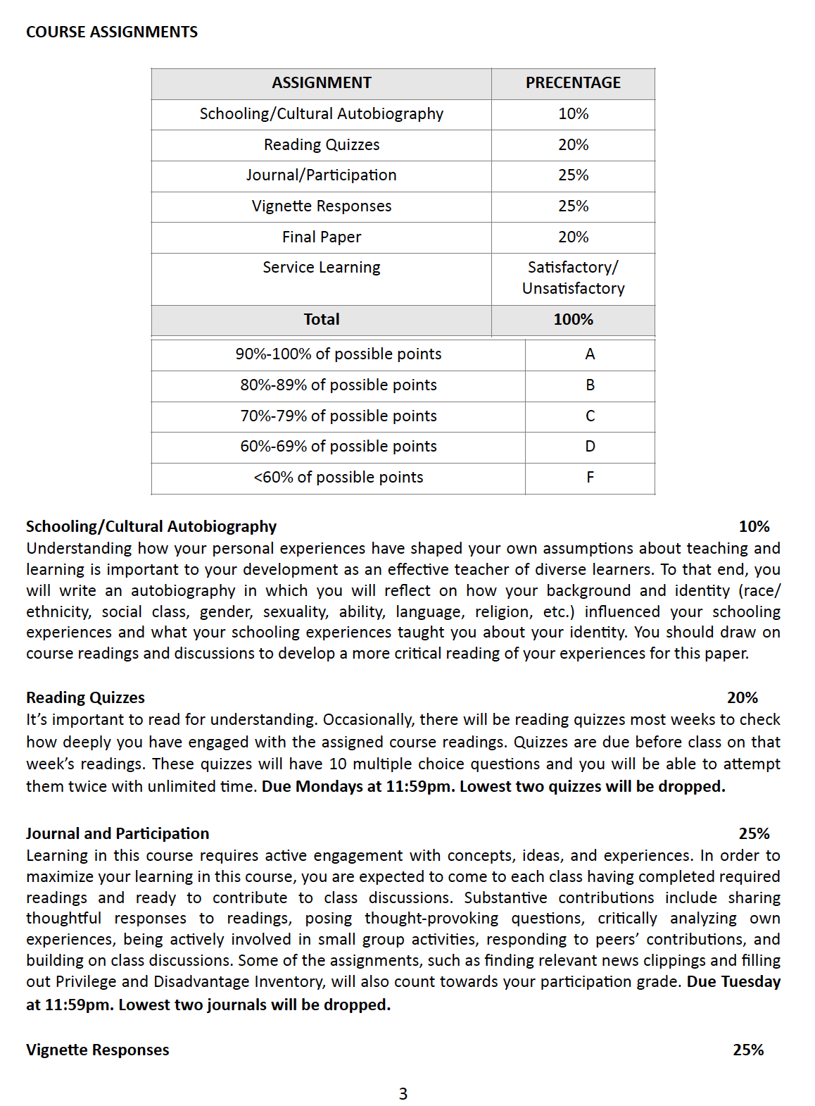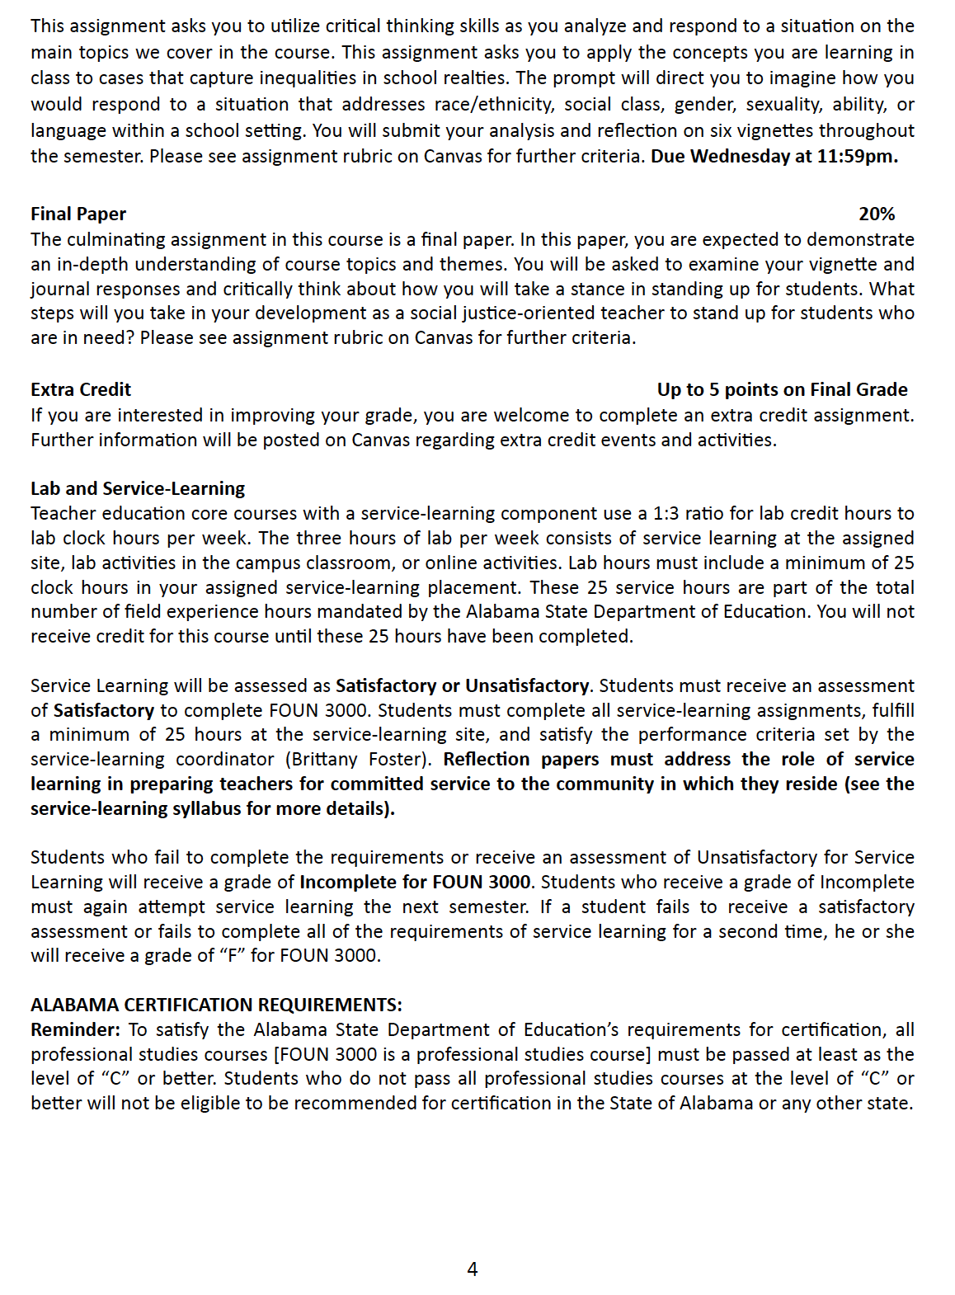**COURSE CALENDAR**

| **TOPIC & WEEK** | **READINGS** | **ASSIGNMENTS DUE** |
| --- | --- | --- |
| **Week 1**  **January 17th**  Orientation & Naming | Kohli & Solórzano (2012) in Canvas |  |
| **Week 2**  **January 24th**  Identity | Chapter 1 in ME | * Week 2 Reading Quiz * Journal Entry 1 |
| **Week 3**  **January 31st**  Intersectionality | Chapter 4 in ME | * Week 3 Reading Quiz * Journal Entry 2 |
| **February 1st Last day to drop with the possibility of a refund and no grade assignment** | | |
| **Week 4**  **February 7th**  Privilege & (Implicit) Bias | See Canvas for various readings | * Schooling/Cultural Autobiography Paper * Journal Entry 3 |
| **Week 5**  **February 14th**  Exploitation & Powerlessness | Chapter 5 in ME | * Week 5 Reading Quiz * Journal Entry 4 * Vignette Response 1 |
| **Week 6**  **February 21st**  Marginalization & Cultural Imperialism | Chapter 8 in ME | * Journal Entry 5 |
| **Week 7**  **February 28th**  (Micro) Aggression & Violence | Chapter 10 in ME | * Week 7 Reading Quiz * Journal Entry 6 * Vignette Response 2 |
| **Week 8**  **March 7th**  No Class Spring Break |  | * Watch Precious Knowledge * Journal Entry 7 |
| **Week 9**  **March 14th**  Curriculum | Chapter 11 in ME | * Week 9 Reading Quiz * Journal Entry 8 |
| **Week 10**  **March 21st**  Achievement, Discipline, & Opportunity Gaps | Chapter 6 ME  Ladson-Billings, G. (2006) in Canvas | * Week 10 Reading Quiz * Journal Entry 9 * Vignette Response 3 |
| **Week 11**  **March 28th**  School Integration & Inclusion | Chapter 2 in ME | * Week 11 Reading Quiz * Journal Entry 10 * Vignette Response 4 |

| **TOPIC & WEEK** | **READINGS** | **ASSIGNMENTS DUE** |
| --- | --- | --- |
| **Week 12**  **April 4th**  School Funding & Zoning | Chapter 3 in ME | * Week 12 Reading Quiz * Vignette Response 5 * Journal Entry 11 |
| **Week 13**  **April 11th**  Policy Barriers | Chapter 9 in ME | * Week 13 Reading Quiz * Journal Entry 12 * Vignette Response 6 |
| **Week 14**  **April 18th**  Work for Teachers | Grantham, T.C. (2011)  Grantham & Biddle (2014) | * Week 14 Reading Quiz * Journal Entry 13 |
| **April 21st Last day to withdraw from course with no grade penalty** | | |
| **Week 15**  **April 25th**  No Class |  | * Final Paper Due by 11:59pm |

