**CTES 7430 Teaching ESL**

**Listening and Speaking**

**Spring 2025**

Department: Curriculum & Teaching

Course Title & Credit: Teaching ESL List/Spkg; 3 hrs

Room and Schedule: 2406; **Tue 4:00 – 6:50 p.m.\***

Instructor: Dr. Jamie Harrison [jlh0069@auburn.edu](mailto:jlh0069@auburn.edu)

Phone Number: 334-844-8278

Office: Haley Center 5080

Office Hours: Tues and Thurs 1 – 3 p.m.

*Community English Class: T 6:30 – 7:30 p.m.

**1. COURSE DESCRIPTION**

This course will prepare ESL/EFL teachers to develop engaging and effective listening and speaking lessons in a variety of contexts. Students will learn current theory and research related to teaching English listening and speaking skills. Students will design and implement effective listening and speaking lessons for a variety of proficiency levels.

**Text:**

**Required Texts:**

Newton, J. & Nation, I.S.P. (2021). 2nd Edition. *Teaching ESL/EFL listening and speaking*. New York: Routledge.

**Required Resources:**

Students in M.Ed track: *WIDA PK – 12 ELP Standards /CAN DO Standards*

<https://wida.wisc.edu/sites/default/files/resource/2012-ELD-Standards.pdf>

Students in the M.S. track: *Standards for ESL-EFL Teachers of Adults* (2008). Alexandria, VA: TESOL.

<https://sites.tesol.org/bookstore/ItemDetail?iProductCode=509E&Category=EBOOK>

**Recommended texts:**

Bolen, J. (2020). *ESL listening activities for teenagers and adults.* Author.

Bolen, J. (2015). *39 non-prep/low-prep ESL speaking activities.* Author.

Nemtchinova, E. (2020). *Teaching listening.* Alexandria, VA: TESOL Press.

Bleistein, T., Lewis, M., & Smith, M. (2020). *Teaching speaking.* Alexandria, VA: TESOL Press.

**Course Objectives**

Engaged learners in this course can look forward to:

* Demonstrating high level of competence in methods and strategies for teaching listening and speaking
* Developing and utilizing active-learning listening and speaking mini-lessons for an authentic audience
* Analyzing academic lessons and integrating listening and speaking activities to support English language growth
* Conducting research in an area of interest related to listening and speaking
* Demonstrating advanced critical thinking skills, interpersonal and leadership skills in group work

Active Learning Environment

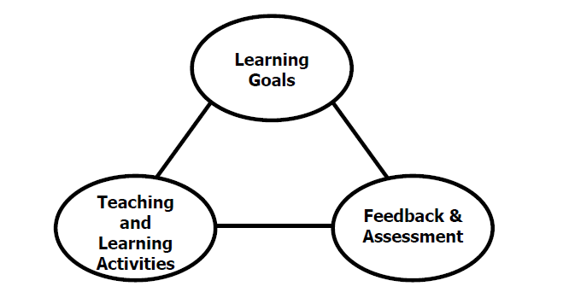

Figure 1. The key components of an integrated course design. (Fink, 2003).

This course has been designed with an active learning framework intended to integrate learning goals, teaching & learning activities, and feedback & assessment. This means you should expect to see a direct relationship between course goals, what we do in class, and how you are assessed. My hope is that you can use this course as a guide for developing your own English language courses.

A variety of teaching and learning experiences have been designed for this course to support the six key dimensions of significant learning (Fink, 2003).

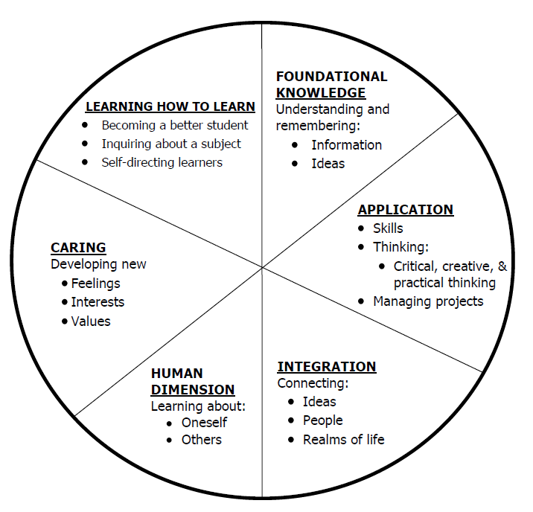

Figure 2. The taxonomy of significant learning (Fink, 2003).

Fink, L.D. 2003. A Self Directed Guide to Designing Courses for Significant Learning. San Fransisco: Jossey-Bass, pp. 3.

**2. COURSE REQUIREMENTS**

**ASSIGNMENTS**

**Discussion Boards (10 @ 10 points each = 100 points)**  Online discussion boards are required of all students in both online and in-person sections. Discussion boards will help solidify key course concepts in the reading, try out various techniques, help us make connections to our own teaching and learning experiences, and provide baseline preparation for in-class discussions as needed. **Discussion boards will be closed one week after the final due date.**

**Listening/Speaking (L/S) Activity (150 pts)** You will choose a listening/speaking activity to demonstrate to the class and then practice teach with the CEC. The demonstration will include a description of the activity, its features and uses at various levels, and a hands-on demonstration of the activity. Follow up reflection will be included as part of this assignment.

**Community English Class (CEC) Observations (50 points) and Reflection Log (100 points)** You will observe lessons in English listening and speaking and reflect on various aspects of the lessons. *Note: If you have another setting accessible to observe, you may consult with me regarding substituting this context for observation.

**CEC Sustainability Unit Teaching (200 points) and Online Package (200)**

You will design, develop and implement a unit for the Community English Class. Details of the unit and CEC change from semester to semester and details will be provided in class. *Note: If you have another setting accessible in which to teach you may consult with me regarding substituting this context for practice teaching of your designed unit.

**Listening and/or Speaking Research and Presentation (100 points)**

You will research a topic related to the topic of ESL listening and speaking. You will research and access at least 5 relevant and timely (within the past 5 years) academic research articles about an aspect of listening and/or speaking English (teaching or learning/acquiring). You will write a 3 page summary of key findings from the research and prepare a presentation for the class that includes practical application to current instruction.

**Final Exam: Unit Reflection and Teaching Reflection using GoReact (100 points) –** details to be provided

Grading and Evaluation:

**A = 1000 - 900**

**B = 899 – 800**

**C = 799 – 700**

**D = 699 – 600**

**F = 599 or below**

Attendance and Participation: Active learning experiences are only as powerful as you, the students in class, make them. Therefore, it is really important that you come to class each week and that you come prepared for group interactions and class discussions. As graduate level students, you should be able to prepare outside of class up to three hours per hour in class. That is up to nine hours of preparation. So, as part of this weekly preparation, please be sure to read and view any required material prior to class each week, complete all assigned discussion posts, and prepare for all group and individual assignments. **More than two unrequested and/or unexcused absences will result in a 10% reduction on your final average.**

Distance Student Requirements: The distance section is "synchronous - flexible" for distance students. My preference is that you join us synchronously as this will give you the optimum access to the active learning experiences designed for the course. **Please email me if you are not able to attend the in-person sessions due to scheduling conflict.** The following will be available to distance students:

- full Panopto or Zoom recording of weekly F2F class sessions

- Canvas modules that outline weekly expectations

- Canvas discussion boards

- flexible office hours

Distance students follow the same weekly schedule as F2F students, and adhere to all assignment due dates as listed in the syllabus or outlined in Canvas as the course proceeds.

Late Assignments: Late assignments lose 10% credit per unexcused day late to a maximum of 30% lost credit. Assignments will not be accepted beyond 2 weeks past the original due date without a doctor’s note.

Assigned Readings: Beyond the required textbooks, some additional readings will be available in Canvas. Readings will be discussed in various manners ranging from course Canvas discussions to embedded in class assignments. These readings contain information that will be included in the group quizzes, reflections, projects, examinations, and other course requirements.

Justification for Graduate Credit: CTSE7970 is a course designed to explore the various skills needed to teach English listening and speaking to students of varying grade and English skill levels. The course requires students to synthesize theory about language learning with practical application.

**3. COLLEGE AND UNIVERSITY POLICIES**

**Participation:** Students are expected to attend class and participate in all class discussions, exercises, and activities.

It is the student’s responsibility to contact the instructor if assignment deadlines are not met. Students are responsible

for initiating arrangements for missed work.

**Attendance/Absences:** **Excused Absences**: Students are granted excused absences from class for the following reasons: Illness of the student or serious illness of a member of the student’s immediate family, death of a member of the student’s immediate family, trips for student organizations sponsored by an academic unit, trips for University classes, trips for participation in intercollegiate athletic events, subpoena for a court appearance and religious holidays. Students who wish to have an excused absence from this class for any other reason must contact the instructor in advance of the absence to request permission. The instructor will weigh the merits of the request and render a decision. When feasible, the student must notify the instructor prior to the occurrence of any excused absences, but in no case shall such notification occur more than one week after the absence. Appropriate documentation for all excused absences is required.

**Make-Up Policy:** Arrangements to make up missed major examination (e.g. hour exams, mid-term exams) due to properly authorized excused absences. Except in unusual circumstances, such as continued absence of the student or the advent of University holidays, a make-up exam will take place within two weeks from the time the student initiates arrangements for it. Except in extraordinary circumstance, no make-up exams will be arranged during the last three days before the final exam period begins. The format of the make-up exam will be (as specific by the instructor).

**Late Assignments:** Late assignments lose 10% credit per unexcused day late to a maximum of 30% lost credit.

**Unannounced Quizzes:** There will be no unannounced quizzes.

**Accommodations:** Students who need special accommodations in class, as provided for by the American Disabilities Act, should arrange a confidential meeting with the instructor during office hours the first week of classes – or as soon as possible if accommodations are needed immediately. You must bring a copy of your Accommodation Memo and an Instructor Verification Form to the meeting. If you do not have these forms but need accommodations, make an appointment with the Program for Students with Disabilities, 1244 Haley Center, 844-2096.

**Academic Honesty Policy:** All portions of the Auburn University student [Academic Honesty Code](https://sites.auburn.edu/admin/universitypolicies/Policies/AcademicHonestyCode.pdf) (Title XII) will apply to this class. All academic honesty violations or alleged violations will be reported to the Office of the Provost, which will then refer the case to the Academic Honesty Committee.

**Professionalism:** Faculty, staff, and students in professional settings are expected to demonstrate professional behaviors as defined in the College’s conceptual framework. These professional commitments or dispositions are as follows: Engage in responsible and ethical professional practices; contribute to collaborative learning communities; demonstrate a commitment to diversity; model and nurture intellectual vitality.

**Writing Center:** The Miller Writing Center provides free support on any writing you are doing while at Auburn, whether for a course or not. Trained consultants are available to work with you as you plan, draft, and revise your writing. For students in distance courses and students temporarily away from Auburn’s campus, the Miller Writing Center offers synchronous online consultations. Please check the Miller Writing Center website ([www.auburn.edu/writingcenter](http://www.auburn.edu/writingcenter)) for instructions and information about scheduling online appointments. If you have questions about the Miller Writing Center, please email [writctr@auburn.edu](mailto:writctr@auburn.edu) or call 334-844-7475 M-F  7:45am-4:45pm.

**Student eHandbook:** Please refer to <http://www.auburn.edu/student_info/student_policies/> for all AU student policies.

**Distance Learning Students**: See section 2.

**Additional Resources:**

***Student Policy eHandbook:*** <http://www.auburn.edu/student_info/student_policies/>

***Health and Wellness Resources*** <https://cws.auburn.edu/studentAffairs/healthAndWellness/>

***Academic Support Services:*** <http://www.auburn.edu/academic/provost/undergrad_studies/support/>

**Note on course effort:** In an effort to understand how much is expected of a graduate student outside of classtime, I have utilized the “Course Workload Estimator” at <https://cte.rice.edu/blogarchive/2016/07/11/workload> I have used 30 pages of reading per week (450 word density, many new concepts, engage level); 15 pages of writing (250 words; reflection; no drafting); 1 exam (no study hours); 4 assignments (10 hours per assignment); class duration (15 weeks). The results indicate approximately 7 hours of outside class time should be sufficient for you to spend with course material. I believe this is an overestimate as the reading will not be 30 pages each week, and the writing will not be 15 full pages. Furthermore, some weeks will be heavier than others depending upon the schedule for presentations and teaching. My reasonable expectation of effort will be approximately 5 hours outside of class. I welcome feedback on my estimates at the end of the course.

4. TENTATIVE SCHEDULE

*Please note that this is a tentative summary of the schedule and activities/due dates may change during the semester. Follow the assignments as posted on the weekly modules in Canvas. Pay attention to Announcements as I often clarify assignments & due dates that way.

**If normal class and/or lab activities are disrupted due to illness, emergency, or crisis situation, the syllabus and other course plans and assignments may be modified to allow completion of the course. If this occurs, an addendum to your syllabus and/or course assignments will replace the original materials.

Here is a link to the official AU academic calendar: <http://www.auburn.edu/main/auweb_calendar.php>

|  |  |  |  |
| --- | --- | --- | --- |
| Week | Topics | Prior to Class Meeting | Assignments |
| 1: 1/14 | Introduction & Course Overview | Download and read course syllabus  Order required textbooks | Discussion post 1  **Sustainability Topic Brainstorm**  L/S Activity: Harrison  L/S Activity: Harrison |
| 2: 1/21 | Parts and goals of a listening and speaking course | N&N ch 1 | Discussion post 2  **Sustainability Topic Sign Up**  L/S Activity: Harrison  L/S Activity: Harrison |
| 3: 1/28 | Beginning to listen and speak in another language | N&N ch. 2 | Discussion post 3  L/S Activity: Harrison  L/S Activity: Harrison |
| 4: 2/4 | Listening | N&N ch. 3 | Discussion post 4  L/S Activity: Ainsley  L/S Activity: Maryssa  Community English Class (CEC) Observation ALL |
| 5: 2/11 | Dictation as a Technique | N&N ch 4 | Discussion post 5  L/S Activity: Katie  L/S Activity: Anna Poole  L/S Activity: Zadie  L/S Activity: Marsha  Community English Class (CEC) Observation ALL |
| 6: 2/18 | Pronunciation | N&N ch 5 | Discussion post 6  L/S Activity: Sarah  L/S Activity: Xuehui  L/S Activity: Yuan  L/S Activity: Megan  Community English Class (CEC) Observation   * Grad Stu L/S activity * Grad Stu L/S activity * Grad Stu L/S activity * Grad Stu L/S activity |
| 7: 2/25 | Task-focused interaction | N&N ch 6 | Discussion post 7  L/S Activity: Sunyoung  L/S Activity: Anna Posey  L/S Activity: Carolina  L/S Activity: Carley  Community English Class (CEC) Observation   * Grad Stu L/S activity * Grad Stu L/S activity * Grad Stu L/S activity * Grad Stu L/S activity   CEC Unit Rough Drafts DUE |
| 8: 3/4 | Pushed output | N&N ch 7 | Discussion post 8  Community English Class (CEC) Observation   * Grad Stu L/S activity * Grad Stu L/S activity * Grad Stu L/S activity * Grad Stu L/S activity |
| **Spring Break – 3/10 – 3/14** | | | |
| 9: 3/18*  *TESOL Conference – class *may* meet online or asynchronously this week | Language-focused learning: Deliberate teaching | N&N ch. 8 | CEC Sustainability Unit Week 1 |
| 10: 3/25 | Developing fluency | N&N ch. 9 | CEC Sustainability Unit Week 2 |
| 11: 4/1 | Monitoring and testing progress | N&N ch. 10 | CEC Sustainability Unit Week 3 |
| 12: 4/8 |  |  | CEC Sustainability Unit Week 4 |
| 13: 4/15 | Listening and Speaking Research Presentations | 1.  2.  3. | CEC Sustainability Unit Week 5 |
| 14: 4/22 | Listening and Speaking Research Presentations | 1.  2.  3. | CEC Sustainability Unit Week 6 |
| 15: 4/29 | Listening and Speaking Research Presentations | 1.  2.  3. |  |
| **Final Exam** | | | |
|  |  |  |  |

**Important Dates**

|  |  |  |
| --- | --- | --- |
| **1/13 Classes begin (Monday)**  **1/20 MLK Jr. Holiday – no classes**  **3/10 – 3/14 Spring Break** | **4/30 Last day of class**  **5/1 – 5/2 Study days** | **5/5 – 5/9 Final exams**  **5/9 – 5/12 Commencement** |