CTCT 7970/7976
Special Topics: Advanced Internet Projects

Summer 2011

Business Education
College of Education

Elisha Wohleb
wohleec@auburn.edu
334-844-3800

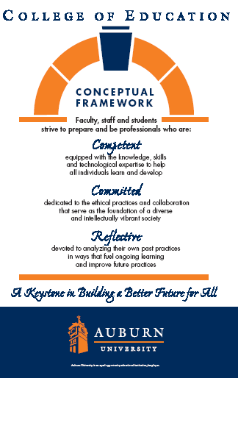

Syllabus - CTCT 7970/7976
Special Topics

 | INSTRUCTOR: Elisha Wohleb  E-mail: wohleec@auburn.edu  Credit Hours: 3 Semester Hours  Office:  108 Wallace Building  Auburn University  Phone: (334) 844-3800  Shipping Address:  108 Wallace Building  Auburn University, AL 36849

1. Course Number: CTCT 7970/7976
Course Title: Special Topics: Advanced Internet Projects for Business Educators
Credit Hours: 3 semester hours
Prerequisites:
Corequisites: None

2. Date Syllabus Prepared: Summer 2011

- Texts and Equipment:

Hartman, K. & Ackerman, E. (2005). Searching and researching on the Internet & World Wide Web. Franklin, Beedle, & Associates. (1-59028-036-9)

Headphones and a Microphone

4. Course Description:

New and emerging technologies in business education and their application to educational settings.

5. Course Objectives:

Upon completion of this course, students will:

• Develop an understanding and appreciation of the vast uses of the Internet in today’s offices.
• Develop the ability to analyze information needs and apply critical thinking skills in designing search strategies.
• Develop the ability to employ the Internet to complete office tasks in a much more efficient and effective manner.
- Use the internet as a research tool for gathering information.

- Course Content:

See assignments in BlackBoard

7. Course Requirements:
A. Complete all weekly assignment by due date

B. Complete all discussion topics

C. Complete a portfolio of the course assignments. Portfolio may be hard copy in a binder or electronic. An electronic portfolio should be in website form on a server with appropriate links to all work. Organization of the portfolio should be neat and clearly labeled.

D. In order to pass the course, all requirements must be met.

8. Grading and Evaluation Procedures:

Late assignments will not be accepted

The following grading scale will be used:
90 – 100% = A
80% - 89.9% = B
70% - 79.9% = C
60% - 69.9% = D
Below 60% = F

The final grade for the course will be based on the following:
Projects: 80 percent

Notebook/Electronic Portfolio: 10 percent

Discussion Board (Articles): 10 percent

End of Term: A HARD COPY/LINK OF ALL ASSIGNMENTS IS DUE TO THE FOLOWING OFFICE NO LATER THAN JULY 27, 2011:

Elisha Wohleb
Auburn University
108 Wallace Building
Auburn, AL 36849

- Class Policy Statements:

Participation: Students are expected to participate in all class discussions and participate in all exercises. It is the student’s responsibility to contact the instructor if assignment deadlines are not met. Students are responsible for initiating arrangements for missed work.

Attendance/Absences: Attendance is required at each class meeting. If an exam is missed, a make-up exam will be given only for University-approved excuses as outlined in the Tiger Cub. Arrangement to take the make-up exam must be made in advance. Students who miss an exam because of illness need a doctor’s statement for verification of sickness and should clear the absence with the instructor the day they return to class. Other unavoidable absences from campus must be documented and cleared with the instructor in advance.

Unannounced quizzes: There will be no unannounced quizzes.

Accommodations: Students who need accommodations are asked to arrange a meeting during office hours the first week of classes, or as soon as possible if accommodations are needed immediately. If you have a conflict with my office hours, an alternative time can be arranged. To set up this meeting, please contact me by e-mail. Bring a copy of your Accommodation Memo and an Instructor Verification Form to the meeting. If you do not have an Accommodation Memo but need accommodations, make an appointment with the Program for Students with Disabilities at 1244 Haley Center, 844-2096 (V/TT).

Honesty Code: The University Academic Honesty Code and the Tiger Cub Rules and Regulations pertaining to Cheating will apply to this class.

Professionalism: As faculty, staff, and students interact in professional settings, they are expected to demonstrate professional behaviors as defined in the College’s conceptual framework. These professional commitments or dispositions are listed below:

- Engage in responsible and ethical professional practices
- Contribute to collaborative learning communities
- Demonstrate a commitment to diversity
- Model and nurture intellectual vitality

Distance Learning Students: Unless specific instructions have been given for a designated course, students in distance education courses shall take all closed resource examinations under the supervision of an approved proctor. Examples of approved proctors include a school superintendent, a principal of a high school, or a dean or department head of a college. Proctors shall be verified and exams shall be sent directly to the proctor who will manage the examination in a secure manner, requiring students to present a picture ID.

9. Justification for Graduate Credit:

The course will be taught at an advanced level and require extensive student participation. Students will be required to review, interpret, and analyze current literature related to the study topic. The course will contain some examination material; however, most graded material will come from student synthesis of the topic through papers and presentations.

