CTCT 7970/7976
Special Topics: Advanced Technology Applications

Summer 2012

Business Education
College of Education

Dr. Elisha Wohleb
wohleec@auburn.edu
334-844-8724

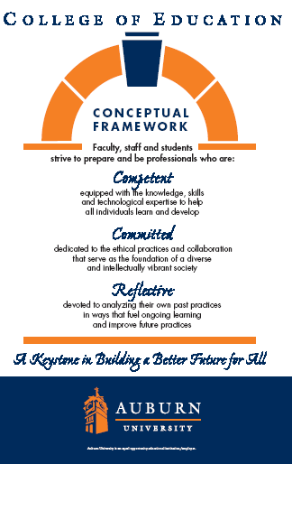

Syllabus - CTCT 7970/7976
Special Topics

 | INSTRUCTOR: Elisha Wohleb  E-mail: wohleec@auburn.edu  Credit Hours: 3 Semester Hours  Office:  108 Wallace Building  Auburn University  Phone: (334) 844-3800  Shipping Address:  108 Wallace Building  Auburn University, AL 36849
TEXTS, RESOURCES and SUPPLIES:
Please choose two of the following books:
Shelly, G., and Vermaat, M. (2012). Microsoft Word 2010: Comprehensive. Boston, MA: Course Technology, Inc. (Required) ISBN 10: 1-4390-7900-5

Shelly, G., & Sebok, S.. (2012). Microsoft PowerPoint 2010: Comprehensive. Boston, MA: Course Technology. ISBN: 978-1-4390-7903-4. (Required)

Microsoft Office Suite 2010

COURSE DESCRIPTION:
Decision making and business problem solving using microcomputer software applications to include spreadsheets, presentation software, database software and operating systems. Students will prepare for MOS exams in two of the following application areas: Excel 2010, Access 2010, PowerPoint 2010, or Word 2010.Students will write a position paper on the subject of integrating certification testing into the secondary level classroom.
COURSE OBJECTIVES:
- Upon completion of this course, students will be able to:
  - Explore and analyze specific, complex concepts and issues within the topic area.
  - Apply course information to solve problems, update expertise in current or emerging topics, and/or develop research areas related to their area of specialization.
  - Pass MOS exams for two of the following applications: Excel, Access, PowerPoint, or Word
COURSE OUTLINE:
See Course Outline on Blackboard for MCAS Assignments

Position Paper: Write a 2-3 page position paper describing why certification exams (such as IC3, MCAS, Adobe, A+) should/should not be included into the secondary business education classroom. Provide support for your position. Find at least 2 reference articles to support your position. Use APA 6th edition guidelines. Some things to consider: cost, administration, benefits or lack thereof, etc. You may use www.certiport.com to help with your topic.
COURSE REQUIREMENTS:
- Complete and turn in assignments at the assigned time – Tuesday by 11:30 pm electronically through canvas (https://auburn.instructure.com/login). This is a very fast-paced course. You must stay on schedule with assignments. Late assignments will not be accepted.
- Complete problem-solving applications and project based assignments. Students will apply learned skills and concepts to business document formatting and preparation. The case problem method will be used to present realistic and unstructured scenarios, which require learners to appraise, develop, and apply appropriate solutions. (Part of weekly assignments)
- Obtain and utilize practice software for each of the applications the student is testing for. An additional cost of $20 per exam is required for practice software.
- Complete the Microsoft Office Specialist (MOS) Certification Exam for the two applications chosen. There is an additional cost of $90 per exam – fee includes one retake per exam. Money for exams will be due on Wednesday, June 13, 2012. Checks should be made payable to Auburn University. Off-campus students are welcome to come to campus and test. If you plan on testing off campus please check with the testing center now to make sure they have 2010 testing available – then email me with the testing center information. I generally give Distance students an option of an 9:00 test time or a 1:00 test time (for those that have to travel a distance). You may also purchase a voucher from us and test at a closer location. Check with the testing facility for additional administrative costs.

GRADING:
ITEM | Percentage | DUE DATE
Certification Exams | 25%
Weekly Assignments | 60%
Position Paper | 15%
Total Possible Percentage | 100%

The following grading scale will be used:
90% - 100 % | = A
80% - 89.9% | = B
70% - 79.9% | = C
60% - 69.9% | = D
Below 60% | = F
Course Policy Statements:
Participation: Students are expected to participate in all class discussions and participate in all exercises. It is the student’s responsibility to contact the instructor if assignment deadlines are not met. Students are responsible for initiating arrangements for missed work.

Unannounced quizzes: There will be no unannounced quizzes.

Accommodations: Students who need accommodations are asked to arrange a meeting during the first week of classes, or as soon as possible if accommodations are needed immediately. If you have a conflict with my office hours, an alternative time can be arranged. To set up this meeting, please contact me by email. Bring a copy of your accommodation memo and an Instructor Verification Form to the meeting. If you do not have an Accommodation memo but need accommodations, make an appointment with the program for students with disabilities at 1244 Haley Center, 844-2096 (V/TT).

Honesty Code: The University Honesty Code and the Tiger Cub rules and regulations pertaining to cheating will apply to this class.

Professionalism: As faculty, staff, and students interact in professional setting, they are expected to demonstrate professional behaviors as defined in the College’s conceptual framework. These professional commitments or dispositions are listed below:]
- Engage in responsible and ethical professional practices
- Contribute to collaborative learning communities
- Demonstrate a commitment to diversity
- Model and nurture intellectual vitality

Distance Learning Students: Unless specific instructions have been given for a designated course, students in distance education courses shall take all closed resource examinations under the supervision of an approved proctor. Examples of an approved proctor include a school superintendent, a principal of a high school, or a dean or department head of a college. Proctors shall be verified and exams shall be sent directly to the proctor who will manage the examination is a secure manner, requiring students to present a picture ID.

Justification for Graduate Credit: The course will be taught at an advanced level and require extensive student participation. Students will be required to review, interpret, and analyze current literature related to the study topic. The course will contain some examination material.

