**CTCT 7730/7736**

Program Evaluation

*Summer 2014*

Business Education

College of Education

Dr. Geana Mitchell

[mitchgw@auburn.edu](mailto:mitchgw@auburn.edu) or

[geanamitchell@hotmail.com](mailto:geanamitchell@hotmail.com)

Office Hours:

By Appointment

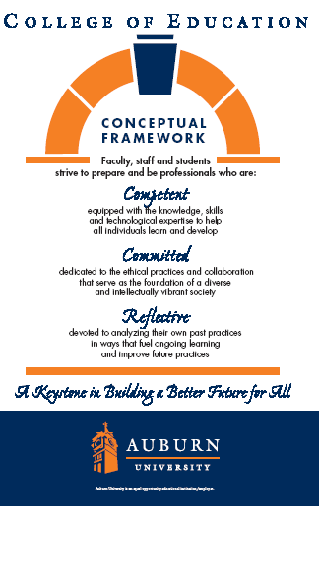

**Syllabus   
CTCT 7730/7736 – Program Evaluation**

**SYLLABUS PREPARED: Summer 2014**

**TEXTS, RESOURCES and SUPPLIES:**

Journal articles and Internet resources

**COURSE DESRIPTION:**

Principles and procedures used in evaluation vocational, technical, extension, and training programs. Alternative approaches to evaluation and practical guidelines for conducting evaluations.

**COURSE OBJECTIVES:**

Upon completion of this course, students will be able to project themselves as competent, committed, and reflective professionals through their ability to:

1. Explain evaluation concepts as applied to education programs
2. Describe the purposes of evaluation
3. Compare and contrast alternative approaches to evaluation
4. Develop an evaluation plan
5. Collect evaluative information
6. Analyze evaluation information
7. Report evaluation results

**COURSE CONTENT:**

In a age of accountability, it is important for educators to be able to discuss the effectiveness of his/her program and how it benefits the students. Effective program evaluation is a carefully planned and systematic approach to documenting the nature and results of program implementation. The best program evaluations are performed by those who care about the program and its affects on students. In this course you will pick a program and conduct the following nine steps to evaluate the program:

1. Define the Purpose and Scope of the Evaluation
2. Specify the Evaluation Questions-- What do you want to know?
3. Specify Evaluation Design
4. Create the Data Collection Action Plan
5. Collect Data
6. Analyze Data
7. Document Findings
8. Disseminate Findings
9. Feedback to Program Improvement

**COURSE REQUIREMENTS/EVALUATION**:

1. Participate in all class discussions in Canvas
2. Submit all assignments by due date
3. Develop an evaluation plan for a program with which you are working.

The final grade will be based on the following:

Discussions 25%

Weekly Assignments 25%

Evaluation Report/Presentation 50%

90-100% A

80-89% B

70-79% C

60-69% D

Below 60% F

**Class Policy Statements:**

1. Participation: Students are expected to participate in all class discussions and participate in all exercises. It is the student’s responsibility to contact the instructor if assignment deadlines are not met. Students are responsible for initiating arrangements for missed work.
2. Attendance/Absences: Distance learning students must log on and participate in Canvas weekly. If an exam is missed, a make-up exam will be given only for University-approved excuses as outlined in the Student Policy ebook. Arrangement to take the make-up exam must be made in advance. Students who miss an exam because of illness need a doctor’s statement for verification of sickness and should clear the absence with the instructor the day they return to class. Other unavoidable absences must be documented and cleared with the instructor in advance.
3. Academic Honesty Policy: All portions of the Auburn University student academic honesty code found in University Policies (<https://sites.auburn.edu/admin/universitypolicies/default.aspx>)will apply to university courses. All academic honesty violations or alleged violations of the SGA Code of Laws will be reported to the Office of the Provost, which will then refer the case to the Academic Honesty Committee
4. Disability Accommodations: Students who need accommodations are asked to arrange a meeting during office hours the first week of classes, or as soon as possible if accommodations are needed immediately. If you have a conflict with my office hours, an alternate time can be arranged. To set up this meeting, please contact me by e-mail. If you have not established accommodations through the PSD office, but need accommodations, make an appointment with The Program for Students with Disabilities, 1228 Haley Center, 844-2096 (V/TT).
5. Course contingency : If normal class and/or lab activities are disrupted due to illness, emergency, or crisis situation, the syllabus and other course plans and assignments may be modified to allow completion of the course. If this occurs, and addendum to your syllabus and/or course assignments will replace the original materials.
6. As faculty, staff, and students interact in professional settings, they are expected to demonstrate professional behaviors as defined in the College’s conceptual framework. These professional commitments or dispositions are listed below:
   1. Engage in responsible and ethical professional practices
   2. Contribute to collaborative learning communities
   3. Demonstrate a commitment to diversity
   4. Model and nurture intellectual vitality
7. Distance Learning Students: Unless specific instructions have been given for a designated course, students in distance education courses shall take all closed resource examinations under the supervision of an approved proctor. Examples of approved proctors include a school superintendent, a principal of a high school, or a dean or department head of a college. Proctors shall be verified and exams shall be sent directly to the proctor who will manage the examination in a secure manner, requiring students to present a picture ID.
8. The instructor reserves the right to make changes to the syllabus, class requirements, and schedule.
9. Incompletes are not given except in extenuating and documented circumstances. This is determined by the instructor.
10. **Writing Center:** The Miller Writing Center provides free support on any writing you are doing while at Auburn, whether for a course or not. Trained consultants are available to work with you as you plan, draft, and revise your writing. For students in distance courses and students temporarily away from Auburn’s campus, the Miller Writing Center offers synchronous online consultations. Please check the Miller Writing Center website ([www.auburn.edu/writingcenter](http://www.auburn.edu/writingcenter)) for instructions and information about scheduling online appointments. If you have questions about the Miller Writing Center, please email [writctr@auburn.edu](mailto:writctr@auburn.edu) or call 334-844-7475 M-F  7:45am-4:45pm.