AUBURN UNIVERSITY
COURSE SYLLABUS

Auburn University

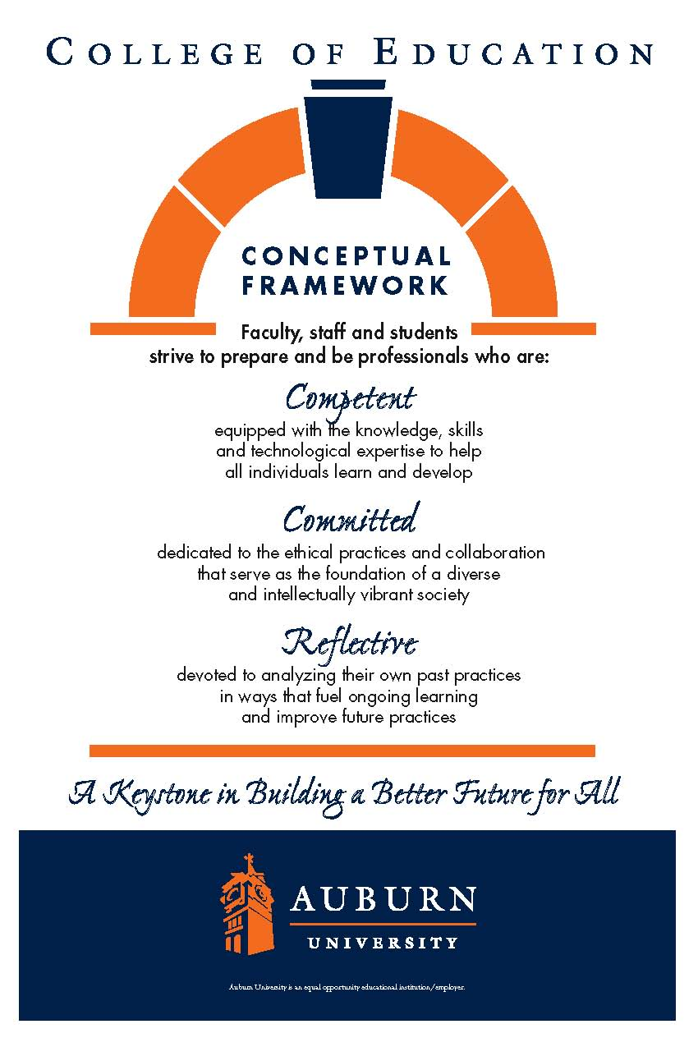
Course Syllabus

1.
Department: Department of Curriculum & Teaching
Reading Education
Course Title: Curriculum and Teaching in Reading Education
Course Number: CTRD 7520
Course Credit: 3 hours
Semester: Summer 2014
Instructor: Dr. Victoria Cardullo
Email Address: Canvas email (Preferred method of contact)
Phone Number: 334-844-6882
Office: 5066 Haley Center 5th floor
Office Hours: by appointment.
Schedule: Asynchronous

Prerequisite: None (2 years of successful teaching and one undergraduate or graduate course in reading are required for admission to the Reading Specialist Certification Master’s Degree Program for which CTRD 7520 is a required course.)
Co-requisite: None (Candidates for the Alabama State Department of Education Reading Specialist Certification Master’s Degree must complete an internship to demonstrate the knowledge and skills included in the objectives and course content for CTRD 7520.)

2. Date Syllabus Prepared: July 1998; Revised 2000, 2004, 2007, 2010, 2013

3. Texts: Students are assigned individualized reading that can be accessed through Canvas or AU Library

- Course Description:
This course focuses on teaching practices and reappraisal of experiences and content for the improvement of literacy curricula. Graduate students taking CTRD 7520 will develop the knowledge and skills necessary for implementing literacy curricula and teaching practices for students in pre-school through grade 12 that are grounded in the Scientifically Based Reading Research (SBRR). Class A Reading Specialist Certification requires a two-credit-hour internship in a school setting to demonstrate knowledge and skills taught in CTRD 7520.

5. Course Objectives:
All of the following course objectives correspond to requirements in the Alabama State Department of Education (ALSDE) Code for teacher certification programs with advanced course work at the graduate level in Reading Education. Numbers and numerals in brackets and parentheses after each objective refer to the specific standards and requirements addressed.
As a result of their work in CTRD 7520, graduate students will demonstrate knowledge and skills related to each of the following course objectives and ALSDE Code items.

- Research including: what methods and materials for teaching reading have been established as effective by the SBRR supporting the explicit, systematic teaching of phoneme awareness, phonics, fluency, vocabulary, and comprehension; how scientifically based research in reading is grounded in theory and conducted; what instructional practices demonstrably improve reading achievement; who past and present prominent reading researchers are and what contributions they have made to theoretical understandings and practical knowledge about the teaching of reading. [(2a): (1.i & 1.ii), (2), (4)]

- The knowledge base for reading including: 1) components of early reading instruction that nurture oral language development (e.g., by reading to students, providing verbal interactions about readings, expanding sentences), develop concepts of print, and foster a love of reading; 2) components of programs for developing readers in all grades that give students ample time and support for reading independently (e.g., help with book selection), emphasize reading for meaning, enhance reading proficiency through daily writing, increase students’ listening comprehension, integrate language arts in all content areas, and develop oral and silent reading fluency. [(2b): (2.i, 2.ii, 2.iii, 2.iv, 2.viii, 2.ix, 2.x, 2.xi, and 2.xii)]

- Reading materials including: classic and contemporary children’s and young adult literature; easy-reading fiction and non-fiction at levels appropriate to individual readers; and the uses and functions of various types of texts (e.g., predictable, decodable, transitional, serial, etc.) in developing effective, fluent readers and comprehenders. [(2c): (1), (2)]

- Comprehension and the impact of: the amount of reading for developing comprehension; teacher-directed, integrated instruction in comprehension strategies for increasing students’ abilities to gain meaning from printed material (strategies include but are not limited to summarizing, retelling, rereading, outlining, note-taking, visualizing, clarifying, and predicting); questioning and discussion for supporting students’ literal, interpretive, and evaluative responses to printed material; vocabulary size for limiting or promoting outcomes of instruction and self-extending reading comprehension. [(2e): (1), (2), (3), (4), and (5)]

- Reading/writing connections including: the influence of students ’writing on learning, understanding, and remembering content; the effectiveness of teaching writing as a process engaging students in prewriting, drafting, revising, editing, and publishing; and the role of writing across the curriculum using all four modes of discourse—descriptive, persuasive, narrative, and expository. [(2f): (2), (3), (4)]

- Intervention and the importance of: ongoing, systematic assessment that informs instruction; intensifying instruction and guided practice for slowly developing readers; accelerating achievement for readers performing below grade level; self-selected, independent reading practice for leading struggling readers to become fluent readers. [(2g): (4)]

- Tentative Sequence for Course Content:

This is an accelerated semester therefore multiple assignments are due within each module
Week 1 Recent Historical Perspectives on Reading Research, Balanced Reading Instruction, and Intervention
Week 2 Research-Based Practices for Conducting Reading Intervention with Differentiated Instruction and Assessing Response to Intervention
Professional Development for Improving Reading Instruction and Achievement

Week 3 The Knowledge Base and Materials for Early Reading Instruction: Oral Language, Emergent Literacy, Phonological Awareness, and Beginning Phonics
The Knowledge Base and Materials for Assessing and Teaching Phonics and Spelling
The Knowledge Base and Materials for Assessing and Teaching Fluency
The Knowledge Base and Materials for Assessing and Teaching Vocabulary
Week 4 Research-Based Practices and Materials for Assessing and Teaching Comprehension
The Knowledge Base and Materials for Assessing and Teaching Writing
Research-Based Practices for Teaching Struggling Readers to Read and Write
Research-Based Practices for Teaching Language Learners to Read and Write English as a Second or Additional Language
Week 5 Manuscript submission
Conference Proposal

7. Course Requirements:
A. Class Participation: You are expected to log in frequently and participate in all assignments and discussions. This is a graduate level class and the expectation is that you will log in frequently, check canvas email often and participate in all assignments and discussion. You will demonstrate through your interactions that you (1) have read the assigned readings carefully and thoughtfully as demonstrated assignments and discussions and (2) can make connections that synthesize information on research-based practices and materials from multiple sources.

B. You will complete all assigned readings on time, you may work ahead but realize all assignments have date stamps; you will still be responsible for weekly discussion if you choose to work ahead
D. Complete the Final manuscript submission and conference presentation.

8. Grading and Evaluation Procedures:
The final grade for the course will be based on the following:
Manuscript Submission 100
Conference Proposal 30
Prezi 30
Histroical perspective 10
Chapter overview 50
RtI 10
RtI interventions 10
RtI Professional Presentation 10
Discussion Posting 25
Interview 60
Class Data 40
Writing 10
Writing 50

Total 435
Any assignment turned in late will result in a 5% grade deduction per calendar day. The following grading scale will be used: 90-100% = A; 80-89.99% = B; 70-79.99% = C; 60-69.99% = D; Below 60% = F.

9. Class Policy Statements:
A. Students are expected to participate in all classroom discussions and exercises (see the Student Handbook). Students are expected to contact the course instructor before missing a class meeting. For each unexcused absence, 5 points will be deducted from the class attendance and participation grade.
B. Students are responsible for initiating arrangements for missed work due to excused absences (see the Student Handbook).
C. Students who need special accommodations should make an appointment to discuss the Accommodation Memo during office hours as soon as possible. If you do not have an Accommodation Memo and need information about how to get one, contact the Director, Program for Students with Disabilities, in 1244 Haley Center as soon as possible. Telephone: 334-844-5943 (Voice T/O)
D. All portions of the Auburn University Honesty Code found in the Student Handbook will apply in this class.
- As faculty, staff, and students interact in professional settings, they are expected to demonstrate professionalism and behaviors defined in the College’s conceptual framework. These professional commitments or
dispositions are described in the College of Education’s Conceptual Framework as Candidate Proficiencies 11
through 14, and they are listed below:
- Engage in responsible and ethical professional practices
- Contribute to collaborative learning communities
- Demonstrate a commitment to diversity
- Model and nurture intellectual vitality

THIS SECTION IS FOR STUDENTS TAKING INTERNSHIP WITH THIS CLASS OR IN THE FALL Checklist for CTRD 7920 Internship: Reading Education- CTRD 7520, Curriculum and Teaching in Reading Education, is a prerequisite or co-requisite for this 2-credit-hour internship which requires a minimum of 100 clock hours in one or more school settings and demonstration of satisfactory to exemplary performance for each of the following abilities or competencies related to Implementing Comprehensive Classroom Literacy Programs.

Directions: Mark each item 0-4 with 4 = Exemplary ability, 3 = Commendable ability, 2 = Satisfactory ability, 1 = Some ability, but needs much improvement, 0 = No evidence of this ability

1. Create a print- and language-rich classroom that fosters all aspects of literacy.
2. Model reading and writing as valuable lifelong activities.
3. Use a variety of literary genres including culturally diverse literature.
4. Implement effective strategies that develop students’ language comprehension and expression.
5. Read to students and lead discussion about what was read.
6. Provide direct instruction in comprehension strategies.
7. Model multiple comprehension strategies appropriate to the text and task including but not limited to summarizing, retelling, rereading, questioning, and deep discussion techniques.
8. Increase the motivation of students to read independently.
9. Adjust reading strategies to the purpose of the reading and the nature of the text.
10. Teach vocabulary through multiple encounters with words in a variety of contexts.
11. Teach students to vary their reading rate according to their purpose and the difficulty of the material.
12. Provide extensive practice in guiding students to choose and read appropriate texts in a variety of genres.

