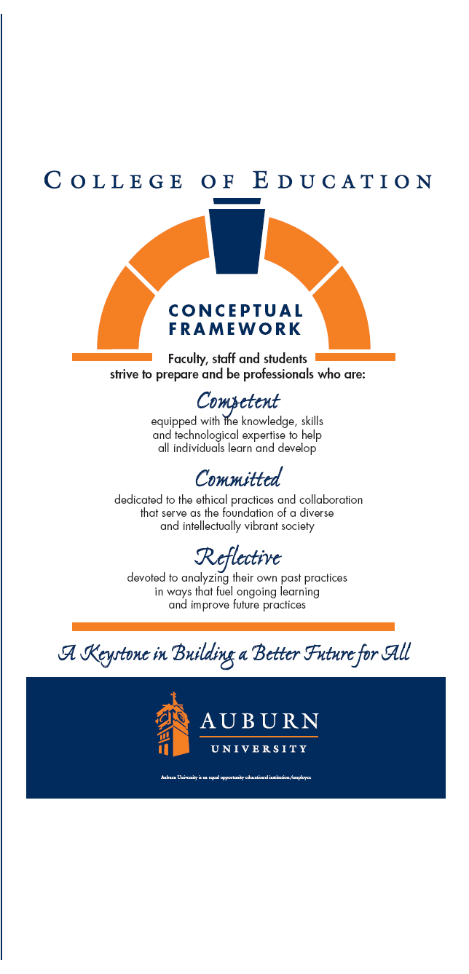
ERMA 7206-002

Basic Research Methods

Summer, 2016

EFLT Department
College of Education

Dr. James E. Witte

Work: 334-844-3054
Fax: 334-844-3072
E-Mail: witteje@auburn.edu
Office Hours: Appointment Preferred

ERMA 7206-002
Basic Methods in Education Research
Auburn University
College of Education
Summer, 2016

Class Time: TBD
Location: TBD
Instructor: Dr. James E. Witte
Haley Center, Rm 4010
334-844-3054
witteje@auburn.edu
Office Hours: by appointment

1. Course Number: ERMA 7206-002

Course Title: Basic Methods in Educational Research

Credit Hours: 3 semester hours

Prerequisites: Departmental approval

2. Date Syllabus Prepared: May 2016

- Text: Wiersma, W., & Jurs, S. (2009) Research methods in education. (9th ed.)
New York, Pearson.

- Course Description: Major modes of inquiry in contemporary educational research including experimental, causal comparative, descriptive, qualitative inquiry and action research models.

- Course Objectives: Upon completion of this course the student will be able to:

1. State a research question amenable to research techniques using empirical methods
2. Develop where appropriate testable hypotheses based on these questions
3. Describe a research design appropriate for investigating each question
4. Choose an appropriate data analysis strategy for each design
5. Develop or choose appropriate measures for each variable
6. Plan for establishing the reliability and validity of each measure
7. Critique the research design of each research situation in terms of threats to internal and external validity of the design
8. Draw appropriate conclusions and interpretations of these analyses
9. Describe the differences and similarities in the assumptions underlying parametric and nonparametric analytical procedures
10. Integrate elements of the research process into a proposal
11. Review and critique articles or papers using these procedures in educational contexts

- Course Content / Requirements:

Research Article Analysis & Evaluation (30 points) Due Not later than July 8. Submissions after July 8 will not be considered for grade.
You will find one original, primary educational research article and analyze it in detail. Your
assignment includes:
- a copy of the original article, which must fit the selection criteria and cite it correctly using APA format for references
- a brief but clearly written summary of the article.
- In addition to the summary, you will answer each of the following questions:
• What is the purpose(s) of the research, the research question(s) or hypothesis(es)?
• What type(s) or class of research is this (e.g. descriptive, experimental, etc.)?
• Who or what is the population and sample being studied and how was the sample selected?
• What type(s) of data were collected? What methods were used to collect data?
• How were the data analyzed? What methods were used and if numeric data were collected, what statistical procedures or analyses were applied?
• What was the researcher's interpretation or conclusion? Do the data and procedures support the interpretation or conclusion?

Thesis/Dissertation Review (30 points) Due Not later than July 22. Submissions after July 22 will not be considered for grade.
You will find at least one (you may need to examine several before making a final selection) Masters thesis or Dissertation. These should align with your possible area of interest:
- Cite the thesis or project in correct APA reference style.\
- Describe the research question to be answered or problem to be solved or need filled.
- List the chapters, including titles, and appendices for the final thesis or project.
- Describe how the need for the project or importance of the research question were established in the first chapter.
- List the sections used to organize the review of literature (typically chapter two).
- Summarize the design of the study or project outlined in the third chapter.
- Describe the data collected, the analysis methods, and the conclusions in some detail and how the findings can be applied to teaching and learning.
- If you were to replicate the study, describe which aspects of the study could be conducted by you and what challenges you would anticipate.

Literature Review (40 points) Due Not later than June 17. Submissions after June 17 will not be considered for grade.
Select a single, focused topic and perform a resource search.
- Find at least 5 different sources of at least two different types (e.g. primary sources, reviews, books, on-line materials, ERIC documents, personal communications, etc.).
- Contact me if your topic doesn’t appear to have a wide range of resources.
- Using these sources write a thematic review emphasizing ideas and trends, rather than dealing with each resource separately.
- The review will be evaluated on the bases of its focus and number and types of resources (5-10), correct and appropriate format, including citations and bibliography, the clarity and thematic nature of the review, and the quality of the writing.

Discussion.
- Post a comment, question, or observation following each weekly class.
- Respond to at least one classmate comment, question, or observation.
- I will monitor your discussions on a weekly basis and respond as needed.

12. Evaluation:

Academic dishonesty is an offense that will be reported to the Academic Honesty Committee). All portions of the Auburn University Honesty Code found in the (Title XII) will apply in this class.

Unexcused absences and tardiness will result in the penalty of one letter grade from the final class average (a “B” instead of an “A”, etc.). It is your responsibility to notify the instructor beforehand or as soon as possible if you anticipate being absent or late for class.

Students are expected to participate in all class sessions and participate in discussion board postings. Should students need to be absent for any reason, please contact the course instructor before missing that class meeting. Students are responsible for initiating arrangements for missed work due to excused absences.

The final grade for the course will be based on the following:

Article Analysis 30pts
Thesis/Diss Review 30pts
Lit Review 10pts
Discussion 30pts
Total 100pts

The following grading scale will be used.

90pts - 100pts= A
80pts - 89pts = B
70pts - 79pts = C
60pts - 69pts = D
Below 60pts = F

13. Methods:

A variety of teaching techniques and strategies are employed in the instruction of this course. The principal methods to be utilized include, but may not be limited to lectures, video tapes, visual aids, peer teaching, experiences, guest lectures and group discussion. This is a professional education course in adult education. All students are considered adults and are expected to not only study but also practice andragogy - to take responsibility for their learning. Thus the student is expected to contribute to the class setting by participating, and to be collaborative and supportive of all members of the learning setting. Adult education is not a place for passive learning but a place to explore, take risks and grow. Ignorance is not vested in the students while knowledge is vested in the instructor. Both are learners and have contributions to make to each other. Both are responsible for their own learning.

- Class Policy Statements:

Students who need special accommodations in class, as provided for by the American Disabilities Act, should arrange a confidential meeting with the instructor during office hours the first week of classes - or as soon as possible if accommodations are needed immediately. You must present a copy of your Accommodation Memo and an Instructor Verification Form to the instructor. If you do not have these forms but need accommodations, make an appointment with the Program for Students with Disabilities, 1244 Haley Center, (334) 844-2096.

Recommended Weekly Schedule
 | Date | Chapter | Activity
Week 1 | May 20 |  | Syllabus discussion & Class Expectations
Week 2 | May 27 | Chapter 1 | Educational Research: Its Nature and Characteristics
Week 3 | June 3 | Chapter 2 | Identification of Research Problem
Week 4 | June 10 | Chapter 3 | The Review of Literature
Week 5 | June 17 | Chapter 4 & 5: | Communicating About Research & Evaluating Research Reports
Week 6 | June 24 | Chapter 6: | Research Design in Quantitative Research
Week 7 | July 2 | Chapter 10: | Research Design in Qualitative Research
Week 8 | July 8 | Chapter 14 & 15: | Sampling Designs & Measurement and Data Collection
Week 9 | July 15 | Chapter 16 & 17: | Data Analysis
Week 10 | July 22 |  | Summary & Turn-in of materials

