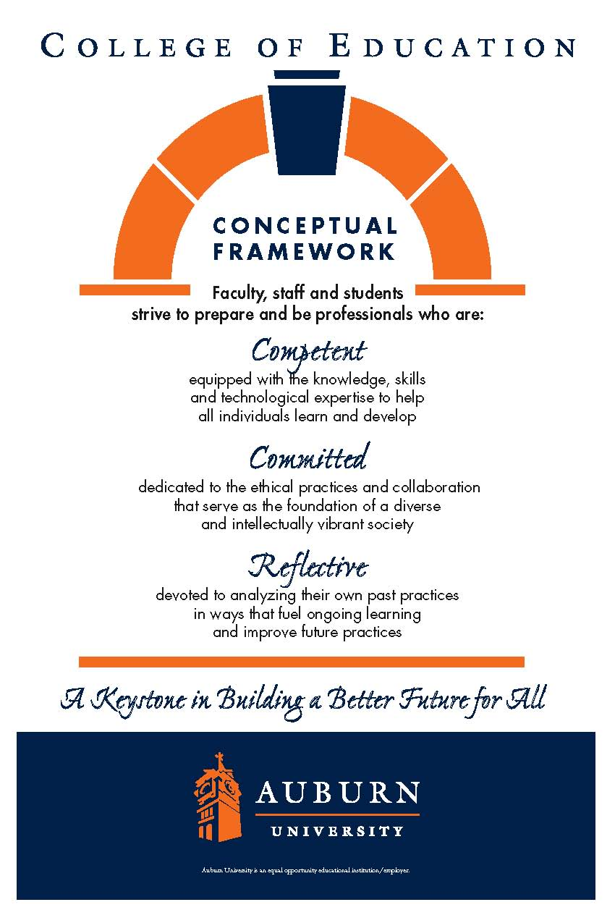
CTEE 7420/7426
Auburn University

Date Syllabus Prepared: May 2017
Department: Department of Curriculum & Teaching
Elementary Education
Program: Elementary Education
Course Title: Curriculum and Teaching
Language Arts
Credit Hours: 3 semester credit
Prerequisites: Graduate standing
Course Number: CTEE 7420/7426
Course Credit: Summer 2017
Instructor: Victoria Cardullo
Email Address: vmc0004@auburn.edu
Phone Number: Office: 334-844-6882 (c)386.295.9346 Text or call
Office: 5022 Haley Center 5th floor
Office Hours: Virtually
Schedule: See Calendar

Texts or Major Resources:
Required Texts:
Readings will be through e-Reserve and on Canvas

Additional Resources:
APA 6 Style Manual-Highly recommended
CCRS available at http://www.corestandards.org/ELA-Literacy/
Alabama Course of Study for Language Arts
International Reading Association (www.reading.org)

Course Description: Throughout this course, learners will explore age-appropriate content and pedagogical practices which enhance the instruction of children in kindergarten through grade six in the language arts to promote meaningful learning across the elementary school curriculum.

Two synchronous sessions will be held during the semester. The first session will occur on May 24. The second will be held on July 11. Both sessions will be held at 4:30 using Zoom.

Course Objectives:
As a result of participation in this course students will:
- discuss concepts, principles, theories, and inquiry tools associated with language arts [
- read, reflect, and discuss assigned readings
- discuss the role of the following in the language arts: reading, writing, listening, speaking
- design and assess learner-centered lessons that use appropriate and effective learner-centered lessons that integrate technology and address identified ACOS and NCTE guidelines
- select and support the use of instructional strategies that meet the needs of divers learners
- demonstrate effective oral and written communication
- identify the resources for enhancing professional growth using technology
- utilize culturally responsive pedagogy in developing student-centered learning activities [
- demonstrate reflection and self-evaluation as a basis for professional growth
- demonstrate knowledge of safe, responsible, legal and ethical uses of technologies including fair-use and copyright guidelines and Internet user protection policies

Course Content and Schedule:
Course Requirements/Evaluation – M. Ed.
The papers and projects will be given in lieu of a midterm and a final exam.
Assignment 1: Book Review (10 points)
Assignment 2: Common Core Paper (25 points)
Assignment 3: Digital Storytelling (30 points)
Assignment 4: Author Study (25 points)
Assignment 5: Literature Review (70 points)
Assignment 6: Online Discussions (40 points)

Course Requirements/Evaluation – Ed.S and Ph.D. students only
All assignments listed above and:
Assignment 7: Handbook Chapter Critique and Research Update (40 points)

Course Assignments:
All assignments are due no later than Friday at 5:00 pm, except for online discussions
as noted below.
Assignment 1: Book Review (10 points total)
This assignment provides an opportunity for you to explore high quality, multicultural children’s literature and consider how it might be utilized in the elementary classroom. You will turn in one copy and upload a copy to the Discussion board for your classmates to download. Assignment and grading criteria will be posted on the class website.

Assignment 2: Common Core and State Standards Paper (25 points)
For this assignment, you review the Common Core standards for grades K-6, as well as state standards for those states that have not adopted Common Core. You will compare and contrast these standards, and support the acceptance or rejection of Common Core in a 4-5 page paper using APA style. Assignment and grading criteria will be posted on the class website.

Assignment 3: Digital Storytelling (30 points)
In this assignment, you will utilize a digital storytelling software package to design a digital documentary. Through the use of technology, you will explore how pictures can be used to prompt elementary students to improve their writing skills. The product you create may be used as a model for implementing the task in an elementary classroom. Assignment and grading criteria will be posted on the class website.

Assignment 4: Author, Author/illustrator Study (25 points)
You will select an author or author/illustrator of books for primary or elementary readers and prepare a paper that provides information on: the author or author/illustrator; their body of work or one genre of their work, and at least three activities that would allow children to explore the work of this individual. Assignment and grading criteria will be posted on the class website.

Assignment 5: Literature Review (70 points)
This assignment provides an opportunity for you to explore extant literature on a topic of your choice related to language arts in a 10-12 page paper written using APA style. Assignment and grading criteria will be posted on the class website.

Assignment 6: Online Discussions (40 points)
As you read the assigned pieces each week, you will reflect on your reading and post to the class discussion board. Your reflections should consider your feelings to the overall article, areas in which you may agree and areas you may disagree, and the possible discussion topics listed in the course schedule. If there is a lecture to accompany the week’s readings, it should be included in the discussion as well. You should post no later than 5 pm on Wednesday of the week the reading is due. Additionally, you will be expected to read others’ posts and comment on at least 2 each week no later than 10 pm on Saturday of that same week. Assignment and grading criteria will be posted on the class website.

Assignment 7: Handbook Chapter Critique and Research Update (40 points) Ed.S. and Ph.D. students only
You will select a chapter from the Handbook of Research on Language Arts. After a careful reading of the chapter you will write a 7-8 page paper that includes a summary of the chapter, a critique, and highlights any research on the topic that has been done since the chapter was written. Assignment and grading criteria will be posted on the class website.

Points Earned/Grade Earned-M.Ed.:
180-200 = A
160-179 = B
140-159 = C
120-139 = D
0-119 = F

Points Earned/Grade Earned-Ed.S. and Ph.D.:
216-240=A
192-215=B
168-191=C
144-167=D
0-167=F

Course Policy Statements:
- Attendance: Students are expected to attend all classes, and will be held responsible for any content covered in the event of an absence.

B. Excused Absences: Students are granted excused absences from class for the following
reasons: illness of the student or serious illness of a member of the student’s immediate family, the death of a member of the student’s immediate family, trips for student organizations sponsored by an academic unit, trips for university classes, trips for participation in intercollegiate athletic events, subpoena for a court appearance, and religious holidays. Students who wish to have an excused absence from class for any other reason must contact the instructor in advance of the absence to request permission. The instructor will weigh the merits of the request and render a decision. When feasible, the student must notify the instructor prior to the occurrence of any excused absences, but in no case shall such notification occur more than one week after the absence. Appropriate documentation for all excused absences is required. Please see the Tiger Cub for more information on excused absences.

- Make-Up Policy: Arrangement to make up a missed major examination (e.g., hour exams, mid-term exams) due to properly authorized excused absences must be initiated by the student within one week of the end of the period of the excused absences(s). Except in unusual circumstances, such as the continued absence of the student or the advent of university holidays, a make-up exam will take place within two weeks of the date that the student initiates arrangements for it. Except in extraordinary circumstance, no make-up exams will be arranged during the last three days before the final exam period begins.

D. Academic Honesty Policy: The University Student Academic Honesty Code on the University Policies site (https://sites.auburn.edu/admin/universitypolicies/default.aspx) pertaining to cheating apply to this class.

E. Disability Accommodations: Students who need special accommodations in class, as provided by the Americans with Disabilities Act, should arrange for a confidential meeting with the instructor during office hours in the first week of classes (or as soon as possible if accommodations are needed immediately). The student must bring a copy of their Accommodations Letter and an Instructor Verification Form to the meeting. If the student does not have these forms, they should make an appointment with the Program for Students with Disabilities, 1288 Haley Center, 844-2096 (V/TT).

F. Course contingency: If normal class and/or lab activities are disrupted due to illness, emergency, or crisis situation, the syllabus and other course plans and assignments may be modified to allow completion of the course. If this occurs, an addendum to your syllabus and/or course assignments will replace the original materials.

G. Cell Phones/Electronic Devices: Students are expected to keep all cell phones on
vibrate/silent ring during class time. No use of electronic devices or text messaging will be permitted.

H. Professionalism: As faculty, staff, and students interact in professional settings, they are
expected
to demonstrate professional behaviors as defined in the College’s conceptual framework. These professional commitments or dispositions are listed below:
o Engage in responsible and ethical professional practices
  - o Contribute to collaborative learning communities
  - o Demonstrate a commitment to diversity
  - o Model and nurture intellectual vitality

Course Schedule

Two synchronous sessions to discuss the literature review assignment will be held during the semester. The sessions are provided as an opportunity for you to ask questions about the major assignment for the semester. They will occur on May 24 and July 11 at 4:30. I anticipate that they will last approximately 15-30 minutes.

Week Of | Topic | Readings | Online Discussion Topics* | Assignment Due
May 18 | Intro to Language Arts | None  Online lecture | Think about which of the frameworks most closely aligns with your thinking and teaching. Describe how your philosophy is manifested in your practice.
May 21 | Culturally Relevant Pedagogy and Multicultural Literature | Gay; Louie; DiNicolo & Franquiz OR Hefflin;  Online Lecture;  Brown Eyes/Blues Eyes video on Canvas (Pages tab) | How may using multicultural literature support or subvert culturally relevant teaching? Relate the theory of culturally relevant pedagogy to multicultural literature and the two examples. How do you see this in relation to your own teaching and beliefs?
May 28 | ESOL | Harper & deJong; Mohr & Mohr; Clark  Online lecture | Many teachers have had limited instruction in teaching ESOL students. What concerns do you have or what difficulties have you faced? What strategies have you employed? What, if any, link do you see between teaching ESOL students and culturally relevant pedagogy and multicultural literature? | Multicultural Children’s Literature Book Review  (Be sure to post your reviews on the Discussion Board as well as submitting to Assignments in Canvas)
June 4 | Common Core  Standards | CCRS for Language Arts (See additional materials above for URL) McDonnell & Weatherford; Center for Public Education; Yatvin | As you read the K-6 standards, what surprised you about them? What do you feel is a strength of the standards? What is missing? Are there valid arguments in favor Common Core? Are there valid arguments against Common Core?  How did/do politics influence Common Core standards?
June 11 | Reading Comprehension | Flood, Lapp, & Fisher; Santoro et al; Piloneta & Medina OR Berne & Clark | In recent years, there has been a focus on fluency in reading. But how can students be good readers if they don’t know what they read? What do you see as critical attributes of reading comprehension? What strategies support these attributes? How does reading comprehension instruction look in practice in the articles and/or in your own practice?
June 18 | Reading and Writing in the Content Areas | Neufield; Moss; Kniper & Dugan  Online lecture | There is an old phrase that in primary grades students learn to read and in the elementary grades students read to learn. However, reading and writing in the content areas should continue past second grade. How can strategies learned in the primary grades be extended and strengthened in the elementary grades? Is this important? Why or why not? Is it occurring in the elementary classroom? Is there any connection between teaching reading and writing in the content areas and Common Core? | Common Core Paper
June 28 | Digital Storytelling | Robin; Manfra & Hammond  Online lecture | Technology use can be a motivating for students in the elementary classroom. How can we use this to enhance reading and writing? What are the strengths and pitfalls of using technology, specifically digital storytelling? What experiences have you had with this medium? Do you see any connection to reading and writing in the content areas?
July 2 | Research Workshop | Video on Canvas (Pages tab) | Although inquiry learning is promoted for young students, rarely is it implemented in the way Paula Rogovin demonstrates. What do you think of her approach? How does this mesh with the assessment issue you addressed last week? Do you see this as a practical tool in a primary classroom? Would you implement it? Why or why not? | Digital Storytelling
July 9 | Writing | Alber-Morgan, Hessler & Konrad; Gibson; Dyson: OR Boyle & Charles | Writing is a critical communication skill that is developed in elementary skills? Does structured writing instruction matter? Why or why not? Do you feel collaboration is an important component of the learning to write process? How do Common Core and assessment impact writing instruction? What success and challenges have you had with writing instruction? | Author Study
July 16 | Literature Review | Literature Review Workshop | No post this week-work on your literature review.
July 23 | Visual Literacy | Avgerinou & Pettersson; Callow; Williams  Online lecture | What is visual literacy and how does it relate to the integrated language arts? How can teachers use visual literacy to advance reading and writing? How might visual literacy advance learning in the content areas? What strategies have you used to teach visual literacy and what were your successes and challenges? | Literature Review
July 30 | Oral Communication | Doddington; Boyce, Alber-Morgan; Bardeen-Listed as Scholastic Instructor in reading materials on Canvas | Children learn to talk before they learn to read, yet many children hate to speak in class. Why is this? What can we, as teachers, do to foster confidence in public speaking? How can we capitalize on the oral communication skills that students bring to school? What strategies are effective in developing speaking skills? How does “speaking” relate to the other areas of language arts? | Handbook Chapter Critique – Ed.S. and Ph.D. students only

