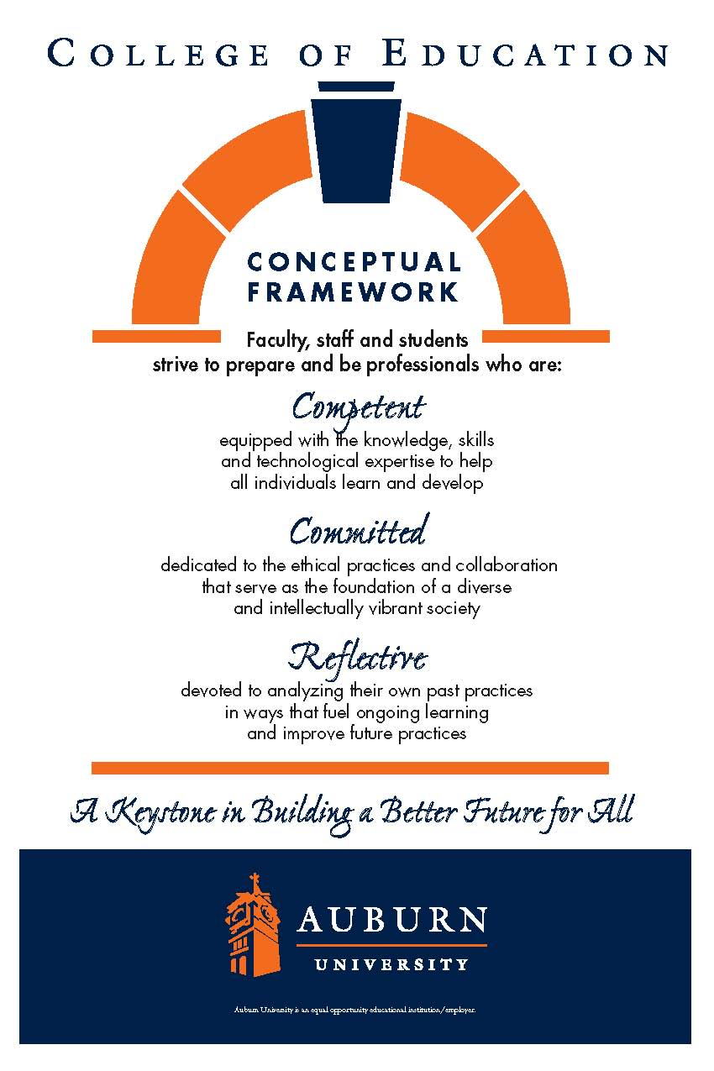**CTRD 5003/6000/6006**

**Auburn University**

Department: Curriculum & Teaching

Program: Reading

Course Title: Language and Literacy in the Content Areas

Course Credit: 3 hours

Semester: Summer 2017

Instructors: Dr. Bruce Murray [murraba@auburn.edu](mailto:murraba@auburn.edu)

Dr. Jamie Harrison [jlh0069@auburn.edu](mailto:jlh0069@auburn.edu)

Phone: Murray: 334-844-6934 C: 334-524-2476                Harrison: 334-844-8278 C: 770-713-8272

Office: Murray: Haley Center 5066

Harrison: Haley Center 5080

Office Hours: By appointment: online/face-to-face options

Schedule: Asynchronous online

Prerequisites: Admission to Teacher Education

(CTRD 5003 Only)

**1. COURSE DESCRIPTION**

**Catalog Description:**

Strategies to help fluent readers and English language learners learn content in the disciplines by strategic reading of texts.

**Text:**

* McKenna, Michael C., & Robinson, Richard D. (2006 or later). *Teaching Through Text: Reading and Writing in the Content Areas*. Boston: Pearson. Used 4th editions are practically free on Amazon.
* Echevarria, J., Vogt, M., & Short. D. (2013). *Making Content Comprehensible for English Learners*. Boston: Peason.

**Course Objectives:**

Course objectives include a subset of key indicators from the Alabama State Department of Education preservice teacher continuum (.03) and English language arts program-specific standards (.10).

**Preservice Teacher Continuum (.03)**

*Literacy*

3.3 Uses age-appropriate instructional strategies to improve learners’ skills in fluency, vocabulary, and comprehension

3.4 Integrates narrative and expository reading strategies across the curriculum

3.7 Identifies and integrates available emerging technology into the teaching of all content areas

3.8 Facilitates learners’ individual and collaborative use of technology and evaluates their technological proficiency

*Diversity*

4.1 Develops culturally responsive curriculum and instruction

4.4 Supports learners to accelerate language acquisition

4.5 Guides second-language acquisition and utilizes English Language Development (ELD) strategies

4.6 Differentiates between learner difficulties related to cognitive or skill development and those that relate to language learning

4.7 Understands and recognizes the characteristics of exceptionality in learning to assist in appropriate identification and interventions

**English Language Arts Program-specific Standards (.13)**

Getting ideas from texts and using them for comprehension, interpretation, evaluation, and appreciation. (2) (a)3. (ii)(i)

Select appropriate research-based strategies and materials to meet the needs of struggling readers, including those identified in the Alabama Reading Initiative publication *Essential Skills of Teaching Reading*. (2) (a) 3. (ii) (lll)

**2. COURSE REQUIREMENTS**

A. Participate in all class activities.

1. Complete all assigned readings.
2. Complete all required class activities, quizzes, and tests on Canvas.

D. Maintain a professional presence in the online environment for this course.

E. Frequently check the course website for announcements, updates, email, and assignments.

Attendance and Participation: Class content and processes related to literacy and inquiry are based on social interaction, applications of cooperative learning activities, shared reader responses, and collaboration. Due to the participatory nature of learning experiences in this class, students are expected to have an *active* online presence and adhere to all course requirements explained in class policies.

Late Assignments: Late assignments lose 10% credit per unexcused weekday late to a maximum of 30% lost credit. For example, a 20-point assignment due Monday would be worth at most 14 points by Thursday. Discussion board postings will *not* be accepted late.

Assigned Readings: Beyond the two required textbooks, some additional readings will be available in Canvas. Readings will be discussed in Canvas discussions or in optional face-to-face sessions. One of us will try to schedule a live session each week Mondays at 4:00 PM on Zoom, in which students can log on and participate with comments and questions. Live participants will earn 2 points extra credit. The assigned readings contain information that will be included in the reflections, projects, examinations, and other course requirements.

Activities: Class activities can be found in the “Agenda” section of each weekly module.

GRADUATE STUDENTS ONLY: Graduate students will be expected to take a leading role in discussion postings (see calendar). Students will choose professional learning communities for discussions. Tentative groups are STEM, the arts, applied sciences, and language and literacy. In addition to their own responses, they will respond to each posting by members of their learning community by asking questions, elaborating ideas based on their teaching experience, or linking useful resources.

**Grading and Evaluation:**

Late assignments will result in a 10% grade deduction per weekday, to a maximum 30% lost points. The grading scale will be:  90-100%  = A; 80-89  = B; 70-79  = C; 60-69  = D; 0-59  = F

**2. COLLEGE AND UNIVERSITY POLICIES**

**Participation**:

Students are expected to participate in all assignments. It is the student’s responsibility to contact the instructor if deadlines for exercises and assignments cannot be met. Students are responsible for initiating arrangements for submitting missed work.

You will need to log in and participate each week. Points will be awarded based on your activities in the course and your participation on the discussion boards, quizzes, and assignments.

**Unannounced Quizzes:**

There will be no unannounced quizzes.

**Accommodations:**

Students who need special accommodations in class, as provided for by the American Disabilities Act, should arrange a confidential meeting with the instructor during office hours the first week of classes – or as soon as possible if accommodations are needed immediately. You must bring a copy of your Accommodation Memo and an Instructor Verification Form to the meeting. If you do not have these forms but need accommodations, make an appointment with the Program for Students with Disabilities, 1244 Haley Center, 844-2096.

**Academic Honesty Policy:**

All portions of the Auburn University student [Academic Honesty Code](https://sites.auburn.edu/admin/universitypolicies/Policies/AcademicHonestyCode.pdf) (Title XII) will apply to this class. All academic honesty violations or alleged violations will be reported to the Office of the Provost, which will then refer the case to the Academic Honesty Committee.

**Professionalism:**

Faculty, staff, and students in professional settings are expected to demonstrate professional behaviors as defined in the College’s conceptual framework. These professional commitments or dispositions are as follows: Engage in responsible and ethical professional practices; contribute to collaborative learning communities; demonstrate a commitment to diversity; model and nurture intellectual vitality.

**Writing Center:**

The Miller Writing Center provides free support on any writing you are doing while at Auburn, whether for a course or not. Trained consultants are available to work with you as you plan, draft, and revise your writing. For students in distance courses and students temporarily away from Auburn’s campus, the Miller Writing Center offers synchronous online consultations. Please check the Miller Writing Center website ([www.auburn.edu/writingcenter](http://www.auburn.edu/writingcenter)) for instructions and information about scheduling online appointments. If you have questions about the Miller Writing Center, please email [writctr@auburn.edu](mailto:writctr@auburn.edu) or call 334-844-7475 M-F  7:45am-4:45pm.

**Student eHandbook:**

Please refer to <http://www.auburn.edu/student_info/student_policies/> for all AU student policies.

4. TENTATIVE SCHEDULE

*Please note that this is a tentative summary of the schedule and may change during the semester. Follow the assignments on the weekly modules in Canvas.

|  |  |  |  |  |
| --- | --- | --- | --- | --- |
| Week | Topics | Reading/Viewing | Assignments | Point Value |
| Week 1  May 18 - 27 | ELLs in the Content Areas: SIOP  Why study reading in the content areas? | McKenna Ch 1: Importance of literacy in content areas  Echevarria Ch. 1: Introducing the SIOP Model  Funds of Knowledge Readings (posted on Canvas)  **Course Intro Panopto** | Funds of Knowledge YouTube video introduction  Discussion Posting: Lesson objective  McKenna Ch 1 & ELL Quiz | 5  5  15 |
| Week 2  May 28 –June 3 | SIOP  Preparing students to read.  Second language acquisition | McKenna Ch 5: Building background knowledge  Echevarria:  Ch. 2: Lesson Preparation  Ch. 3: Building Background  Model as Brilliant Beginner Panopto | McKenna Ch 5 & ELL Quiz  Building background knowledge | 15  25 |
| Week 3  June  4-10 | SIOP  Teaching vocabulary. | McKenna Ch 6: Introducing technical vocabulary  Echevarria:  Ch. 4: Comprehensible Input | McKenna Ch 6 & ELL Quiz  Vocabulary activities | 15  25 |
| Week 4  June  11 - 17 | SIOP  Setting purposes for reading. Language objectives. | McKenna Ch 7: Making reading purposeful  Echevarria:  Ch. 5: Strategies  Ch. 6: Interaction | McKenna Ch 7 & ELL Quiz  Purpose-setting activity  Discussion Posting: Prereading scaffolds | 15  25  5 |
| Week 5  June 18 - 24 | SIOP  Guiding reading. | McKenna Ch 8: Reading guides  Echevarria:  Ch. 7: Practice & Application  Ch. 8: Lesson Delivery | McKenna Ch 8 & ELL Quiz  Content literacy guide | 15  25 |
| Week 6  June 25 - July 1 | Planning for instruction.  Second language acquisition | McKenna Ch 9: Scheduling reading  Reading: Second-language acquisition | McKenna Ch 9 & ELL Quiz  Exemplary lesson plan  Discussion posting: SIOP video view and SIOP instrument critique | 15  25  10 |
| Week 7  July 2-8 | Strategies to enhance learning.  The art of questioning.  Encouraging ELL oral participation. | McKenna Ch 10: Effective questioning  Echevarria Ch 10: Issues of reading, RTI, and Special Education | McKenna Ch 10 & ELL Quiz  Discussion plan | 15  25 |
| Week 8  July 9-15 | Consolidating new content-area knowledge.  Writing to learn.  Supporting ELL writing. | McKenna Ch 11: Extending content knowledge  Reading: Supporting ELLs with writing | McKenna Ch 11 & ELL Quiz  Reflection activities OR writing to learn activity.  Discussion Posting: Considering culture in content-area reading | 15  25  15 |
| Week 9  July 16–22 | Teaching students how to study.  Study issues for ELLs. | McKenna Ch 12: Study skills  Eschevarria Ch 9: Review and assessment | McKenna Ch 12 & ELL Quiz  Unit test | 15  30 |
| Week 10  July 23-28 | Trade books in the content areas |  | PDF Portfolio with unit plan, including extra activity appropriate to the content area | 30 |
| July 31 –  August 4 | FINAL EXAM | Final Exam |  | 100 |
|  |  |  |  |  |