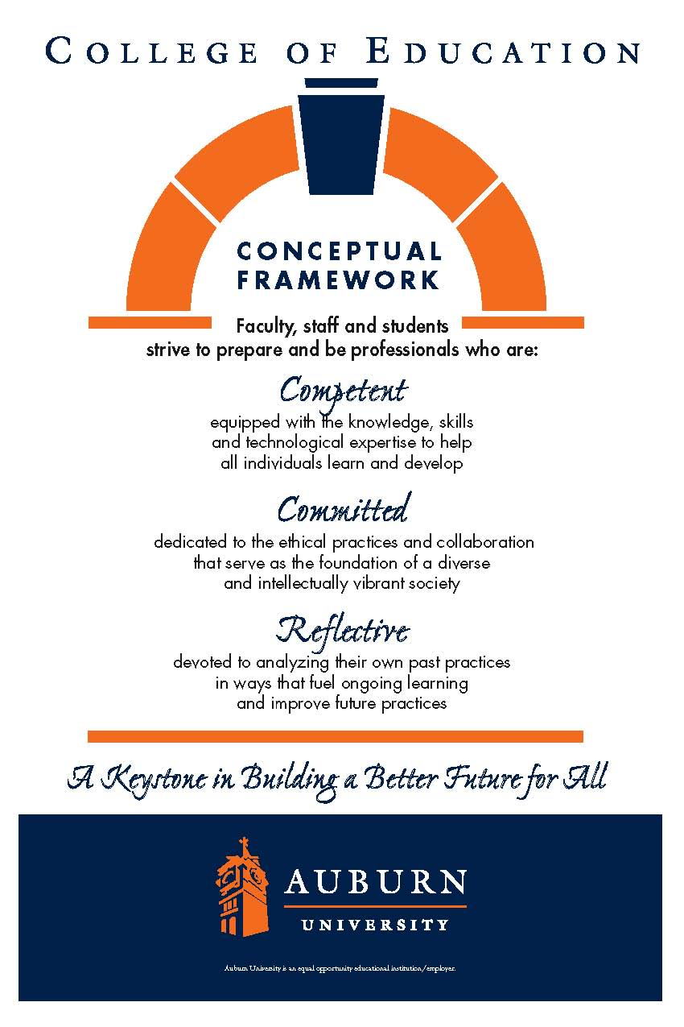**Language and Literacy in the Content Areas**

**CTRD 5003/6000/6006**

**Auburn University**

Department: Curriculum & Teaching

Program: Reading

Course Title: Literacy and Inquiry in the Content Areas

Credit: 3 hours

Semester: Summer 2018

Instructors: Dr. Bruce Murray [murraba@auburn.edu](mailto:murraba@auburn.edu)

Dr. Jamie Harrison [jlh0069@auburn.edu](mailto:jlh0069@auburn.edu)

Phone: Murray: 334-844-6934 C:334-524-2476

Harrison: 334-844-8278 C:770-713-8272

Office: Murray: Haley Center 5066

Harrison: Haley Center 5080

Office Hours: By appointment: online/F2F options

Schedule: Asynchronous/Synchronous Online

Prerequisites: Admission to Teacher Education

(CTRD 5003 Only)

**1. COURSE DESCRIPTION**

**Catalog Description:** Strategies to enhance literacy and inquiry for students' content area learning in the middle and secondary school.

**Texts:**

* McKenna, Michael C., & Robinson, Richard D. (2006 or later). *Teaching Through Text: Reading and Writing in the Content Areas*. Boston: Pearson. Used 4th editions are cheap on Amazon.
* Echevarria, J., Vogt, M., & Short. D. (2013). *Making Content Comprehensible for English Learners*. Boston: Pearson.
* Other readings as posted & provided in Canvas

**Course Objectives:** Course objectives include a subset of key indicators from the Alabama State Department of Education preservice teacher continuum (.03), English language arts program-specific standards (.10), and advanced technology standards (.42). Final assessment of the advanced technology standards (.42) are in this course.

**Preservice Teacher Continuum (.03)**

*Literacy*

3.3 Uses age-appropriate instructional strategies to improve learners’ skills in fluency, vocabulary, and comprehension

3.4 Integrates narrative and expository reading strategies across the curriculum

3.7 Identifies and integrates available emerging technology into the teaching of all content areas

3.8 Facilitates learners’ individual and collaborative use of technology and evaluates their technological proficiency

*Diversity*

4.1 Develops culturally responsive curriculum and instruction

4.4 Supports learners to accelerate language acquisition

4.5 Guides 2nd language acquisition and utilizes English Language Development (ELD) strategies

4.6 Differentiates between learner difficulties related to cognitive or skill development and those that relate to language learning

4.7 Understands and recognizes the characteristics of exceptionality in learning to assist in appropriate identification and interventions

**English Language Arts Program-specific Standards (.13)**

Create meaning-including comprehension, interpretation, evaluation and appreciation-from texts. (2) (a)3. (ii)(i)

Select Appropriate research based strategies and materials to meet the needs of struggling readers, including those identified in the Alabama Reading Initiative publication, Essential Skills of Teaching Reading. (2) (a) 3. (ii) (lll)

**2. COURSE REQUIREMENTS**

A. Participate in all asynchronous and synchronous class activities.

B. Complete all assigned readings.

C. Complete all class activities and tests on Canvas.

D. Maintain a professional presence in the online environment for this course.

E. Frequently check the course website for updates, email, and assignments.

Attendance and Participation: Class content and processes related to literacy and inquiry are based on social interaction, applications of cooperative learning activities, shared reader responses, and collaboration. Due to the participatory nature of learning experiences in this class, students are expected to have an ACTIVE online presence and adhere to all course requirements explained in class policies.

Late Assignments: Late assignments lose 10% credit per unexcused day late to a maximum of 30% lost credit. For example, a 20-point assignment due Monday would be worth at most 14 points by Thursday. Work will not be accepted if more than a week late (without prior permission from the professor). Discussion Board postings will NOT be accepted late and will earn a 0.

Assigned Readings: All assigned texts and course materials will be available in Canvas Course Content for this class. Readings will be discussed in various manners ranging from course Canvas discussions to embedded in-class assignments. These readings contain information that will be included in the reflections, projects, examinations, and other course requirements.

Activities: Class activities can be found in the “Student Responsibilities” section of each weekly module. ALL assignments are expected to be complete.

GRADUATE STUDENTS ONLY: Graduate students will be expected to take a leading role in discussion postings (see calendar). Students will choose professional learning communities for discussions. Tentative groups are STEM, the arts, applied sciences, and language and literacy. In addition to their own responses, they will respond to each posting by members of their learning community by asking questions, elaborating ideas based on their teaching experience, or linking useful resources.

**Grading and Evaluation.** The final grade for the course will be based on the following:

The grading scale will be: 90-100% = A; 80-89.9% = B; 70-79.9% = C; 60-69.9% = D; 0-59.9% = F.

Late assignments will result in a 10% grade deduction per calendar day with a 30% maximum loss of points.

**3. University and College Policies**

**Participation**:

Students are expected to participate in all asynchronous, synchronous assignments. It is the student’s responsibility to contact the instructor if deadlines for exercises and assignments are not met. Students are responsible for initiating arrangements for submitting missed work.

You will need to log in and participate each week. There will be four "real-time" meetings scattered throughout the semester in which you must participate. You will be notified of these dates as soon as possible, so you can make arrangements. Points will be awarded based on your activities in the course and your participation on the Discussion boards and assignments.

**Unannounced Quizzes:**

There will be no unannounced quizzes.

**Accommodations:**

Students who need special accommodations in class, as provided for by the American Disabilities Act, should arrange a confidential meeting with the instructor during office hours the first week of classes – or as soon as possible if accommodations are needed immediately. You must bring a copy of your Accommodation Memo and an Instructor Verification Form to the meeting. If you do not have these forms but need accommodations, make an appointment with the Program for Students with Disabilities, 1244 Haley Center, 844-2096.

**Academic Honesty Policy:**

All portions of the Auburn University student [Academic Honesty Code](https://sites.auburn.edu/admin/universitypolicies/Policies/AcademicHonestyCode.pdf) (Title XII) will apply to this class. All academic honesty violations or alleged violations will be reported to the Office of the Provost, which will then refer the case to the Academic Honesty Committee.

**Professionalism:**

Faculty, staff, and students in professional settings are expected to demonstrate professional behaviors as defined in the College’s conceptual framework. These professional commitments or dispositions are as follows: Engage in responsible and ethical professional practices; contribute to collaborative learning communities; demonstrate a commitment to diversity; model and nurture intellectual vitality.

**Writing Center:**

The Miller Writing Center provides free support on any writing you are doing while at Auburn, whether for a course or not. Trained consultants are available to work with you as you plan, draft, and revise your writing. For students in distance courses and students temporarily away from Auburn’s campus, the Miller Writing Center offers synchronous online consultations. Please check the Miller Writing Center website ([www.auburn.edu/writingcenter](http://www.auburn.edu/writingcenter)) for instructions and information about scheduling online appointments. If you have questions about the Miller Writing Center, please email [writctr@auburn.edu](mailto:writctr@auburn.edu) or call 334-844-7475 M-F  7:45am-4:45pm.

**Student eHandbook:**

Please refer to <http://www.auburn.edu/student_info/student_policies/> for all AU student policies.

**CTRD 5003/6000/6006 Summer 2018**

TENTATIVE SCHEDULE

*Please note that this is a tentative summary of the schedule and may change during the semester. Follow the assignments on the weekly modules in Canvas.

|  |  |  |  |  |
| --- | --- | --- | --- | --- |
| Week | Topics | Reading/Viewing | Assignments | Point Value |
| Week 1  May 17 - 26 | Why study reading in the content areas?  ELLs in the Content Areas: Overview & SIOP | McKenna Ch 1: Importance of literacy in content areas  Echevarria, Vogt & Short Ch. 1: Introducing the SIOP Model  Funds of Knowledge Readings (posted on Canvas)  **View: Course Intro Panopto** | PLC Discussion Posting: Funds of Knowledge YouTube video introduction  McKenna Ch 1 & ELL Quiz | 5  15 |
| Week 2  May 27 –June 2 | Preparing students to read.  SIOP | McKenna Ch 5: Building background knowledge  Echevarria, Vogt & Short  Ch. 2: Lesson Preparation  Ch. 3: Building Background  View: Model as Brilliant Beginner  View: Panopto recorded lectures | McKenna Ch 5 & ELL Quiz  Activity: Building background knowledge  PLC Discussion Posting: Lesson objective & building background for ELLs | 15  25  5 |
| Week 3  June  3-9 | Teaching vocabulary.  SIOP | McKenna Ch 6: Introducing technical vocabulary  Calderon, Ch 3: Vocabulary Development (pdf upload in Canvas)  Echevarria, Vogt & Short Ch. 4: Comprehensible Input  View: Panopto recorded lectures | McKenna Ch 6 & ELL Quiz  Activity: Vocabulary activities | 15  25 |
| Week 4  June  10 - 16 | Setting purposes for reading.  SIOP | McKenna Ch 7: Making reading purposeful  Echevarria, Vogt & Short Ch. 5: Strategies; Ch. 6: Interaction  View: Panopto recorded lectures | McKenna Ch 7 & ELL Quiz  Activity: Purpose-setting activity  PLC Discussion Posting: Immersion Experience | 15  25  5 |
| Week 5  June 17 - 23 | Guiding reading.  SIOP | McKenna Ch 8: Reading guides  Echevarria, Vogt & Short Ch. 7:  Practice & Application; Ch. 8: Lesson Delivery  View: Panopto recorded lectures | McKenna Ch 8 & ELL Quiz  Activity: Content literacy guide | 15  25 |
| Week 6  June 24 - 30 | Planning for instruction. | McKenna Ch 9: Scheduling reading  Echevarria, Vogt & Short  Ch 10: Issues of reading, RTI & Special Education  View SIOP Lesson (recording in Panopto)  View: Panopto recorded lectures | McKenna Ch 9 & ELL Quiz  Activity: Exemplary lesson plan  PLC Discussion Posting: SIOP noticings | 15  25  5 |
| Week 7  July 1-7 | Strategies to enhance learning.  The art of questioning.  ELLs and Higher Order Thinking | McKenna Ch 10: Effective questioning  ELL Reading: TBA and posted in Canvas  View: Panopto recorded lectures | McKenna Ch 10 & ELL Quiz  Activity: Discussion plan | 15  25 |
| Week 8  July 8-14 | Consolidating new content-area knowledge. Writing to learn.  Supporting ELL writing. | McKenna Ch 11: Extending content knowledge  ELL Reading 1: Scaffolding or Rescuing?  View: ELL Scaffolding Resources review  View: Panopto recorded lectures | McKenna Ch 11 & ELL Quiz  Activity: Reflection activities OR writing to learn activity  Discussion Posting: Revisiting funds of knowledge | 15  25  5 |
| Week 9  July 15–21 | Learning with trade books.  Teaching students how to study. | McKenna Ch 12: Study skills  Echevarria, Vogt & Short Ch. 9: Review & Assessment  View: Panopto recorded lectures | McKenna Ch 12 & ELL Quiz  Activity: Unit test | 15  25 |
| Week 10  July 22-28 |  |  | PDF Portfolio with unit plan, including extra activity appropriate to the content area | 30 |
| July 29 –  August 4 | FINAL EXAM | Final Exam |  | 100 |