

**Educational Systems and Communities**

**EDLD 7560**

**3 Credit Hours**

**Summer 2018**

**Dr. Lynn Irwin**

**Cell Phone: 334-494-2280; Home: 334-894-1505**

**Email:** [**lei0001@auburn.edu**](mailto:lei0001@auburn.edu)

**Office Hours: Monday 6-9 PM online or by phone**

**Course Description**

This is a master’s level course focused on addressing systems theory and continuous improvement in school organizations, connections to global communities, diversity, technology, forecasting and future trends analysis. Leaders must think more and more in the space between the present and future. Major shifts, new concepts, and driving forces that will shape our future context of education become the new knowledge base. New modes of work, socializing, and group connectivity and community learning through networking are developing. Media rich and pervasive learning is already occurring. Along with trends, major dilemmas are requiring new strategies that go beyond either-or thinking. This new knowledge economy and globalization will continue to challenge the basic traditional assumptions upon which schools function. Therefore, new frameworks must be created for exploring innovations and new solutions. This course will focus on the directions of change, forecasting, trend analysis, and technology.

**Course Objectives**

Course objectives are based upon the standards for Class A Instructional Leadership [290-3-3-.48 (2)(a)-(h)] as well as reflect the content standards delineated in the Class AA Instructional Leadership analysis form [290-3-3-.53-301 3(c) 5-8 OR 5-9].

|  |
| --- |
| **AL Standards** |
| **a. Demonstrate understanding that are being shaped by the newly-identified social capital of the global community**  (2)(e)1(i-ii); (2)(e)2(i-viii); (2)(h) |
| **b. Demonstrate knowledge of schools as open and living systems characterized by energy flow, diversity, flexibility, interconnectedness, and networks**  (2)(g)1(i-vi); (2)(g)2(i-vi) |
| **c. Demonstrate knowledge of systems change as it relates to school organizational structures and elements**  (2)(b)1(i-iii);(2)(b)2(i-xiii) |
| **d. Understand types and dynamics of systems, living systems, and sustainability**  (2)(g)1(i-vi); (2)(g)2(i-vi) |
| **e. Understand and promote diversity and tolerance in schools as learning organizations**  (2)(d)1(i-v); (2)(d)2(I-v) |
| **f. Understand how systems thinking and planning relate to student achievement and measures of success (e.g., preparedness for the future)**  (2)(a)1; (2)(b)2; (2)(c)2(i-xi) |
| **g. Describe norms of leaders and followers in a learning organization: reflective practice, trust, collegiality, respect, and the valuing of partnerships**  (2)(c)2(I-xi); (2)(h)1(i-v) |
| **h. Understand the need for developing mental models of adaptive schools in a quantum universe**  (2)(a)1(i-v); (2)(a)2(i-xv) |
| **i. Understand the need for developing trend analysis techniques, futures mapping, and scenarios to move towards possible futures**  (2)(a)1(i-v); (2)(a)2(i-xv) |
| **j. Create organizational norms which foster continuous improvement and a widely shared vision or sense of purpose to create students and professionals as global learners**  (2)(a)1; (2)(a)2; (2)(b)1(i-iii) |
| **k. Incorporate collaborative team processes such as democratic governance structures, collective learning, dialogue, empowerment and other group dynamics**  (2)(a)2(i-xv); (2)(e)2(i-viii) |
| **l. Develop and implement a school technology plan**  (2)(f)2(i,ii);(2)(f)1(i,ii) |
| **m. (K, A) provide support for teachers to increase the use of technology already in the school/classroom**  (2)(f)2(vi) |
| **n. (K) respond to legal and ethical concerns of using technology in the school community**  (2)(h)2 |
| **o. (K, A) describe norms of leaders and followers in a learning organization: reflective practice, trust, collegiality, respect, and the valuing of partnerships**  (2)(c)2(i-xi);(2)(h)1(i-v) |
| **p. Develop communication structures and feedback using various technologies to further the organizational mission**  (2)(f)1(i-ii); (2)(f)2(i-vii) |

**Required Texts**

Horn, M.B. and Staker, H. (2014). Blended: Using disruptive innovation to improve schools. San Francisco, CA: Jossey-Bass.

Robinson, K. & Aronica, L. (2015). Creative Schools: The Grassroots Revolution That’s Transforming Education. New York, NY: Viking

**Distance course management** –

When you have a question related to the course you may email me individually or post question/comments/concerns to the Discussion Board in Canvas if you feel everyone would benefit from knowing what questions are asked and how they are answered… Feel free to add, as needed.

Check our course Canvas regularly! You are responsible for knowing what is happening online. I will not necessarily email you outside of Canvas every time I post new information. I will check our Canvas site every morning and respond to posted questions, etc. You may control the way that Canvas communicates with you! See <http://www.auburn.edu/img/canvas/help/index.html> for additional information on setting up personalized notification preferences in Canvas.

**Course Requirements and Assignments**

Measurement of student growth will be assessed using three activities for a total of 100 points.

1. Participation in weekly class discussions and activities (20 points)
2. Technology Plan Analysis and Communicating a Vision (60 points)
3. Grant Writing (20 points)
4. **Participation in class**. You are expected to participate in each class session with the required reading completed and activities posted by midnight each Sunday. During class you are expected to be an active contributor to the discussions and activities in a constructive professional manner.
5. **Technology Plan Analysis and Communicating a Vision.** First,locate and examine your school district’s technology plan and another AL public school’s Technology plan, with a focus on 21st century skills, the ISTE Standards, and the philosophy of transformational change. You will submit a comparison of these plans. Be sure to include specific examples of where each plan addresses the focused items, as well as where the gaps or faults are in each plan. Next, you will create and present a technology vision for your school. Using Animoto, or another dynamic media tool, create a visual that clearly and powerfully communicates your vision for transformational change related to strategic integration of digital technologies and how that will fit into your district’s plan. This visual should be something you could have scrolling in a digital frame in your school lobby.

*Rationale:* As a school leader you will only be able to lead your school to success if you have a vision of what that success looks like. You vision will and should modify as you move along, however you are responsible for effectively and concisely communicating what your vision for the school looks like. Then you can begin to develop a plan for moving toward that vision. As a building principal, your vision must align with the district’s vision. Understanding the districts vision will ensure everyone is working toward a similar goal.

1. **Grant Writing.** Based upon the vision you have established and the technology plan analysis, identify a source of funding to support moving your school toward the vision of integrating technology. Communicate your selection of funding source (grant) with me for approval, then complete and submit the grant application. You may want to contact your district office to connect with a grant specialist for advisement. I would communicate this project with your administration and take the opportunity to actually secure funds for your school.

*Rationale:* One of the biggest hindrances to integrating technology into the schools is the lack of discretionary funds. Seeking external funding to support your vision will be crucial in implementing your plan. Learning how to write and effective grant proposal will help you secure external funds.

**Grant Rubric:**

**Selecting an Appropriate Grant (____/2points)** The first hurtle is finding a grant that is aligned with your vision, in which you meet the eligibility for receiving the grant. Don’t waste your time applying for something you don’t qualify for.

**Building a Case for Need (____/5points)** Persuasively convey your need for the grant, use literature to support your ideas effectiveness, and the impact the grant will have on the students.

**Effectively Address Every Aspect of the Grant Proposal (____/10 points)** Each grant will require specific criteria for the proposal. Be sure to address each section and provide research-based evidence of effectiveness or necessity when appropriate. If a budget or timeline is required, be realistic.

**References (____/3 points)** The paper uses APA citation form (e.g., quotes are accurately quoted and paraphrased ideas are properly cited).

**Total Points: /20**

**Grading**

|  |  |  |
| --- | --- | --- |
| **Assignment** | **Points Possible** | **Due Date (by 9AM on date)** |
| Weekly Participation | 20 | ongoing |
| Grant | 20 | July 25 |
| Technology Plan | 60 | July 18 |
| Part I: Summary and Vision | 5 | May 23 |
| Part II: Mission Statement and Demographics | 5 | May 30 |
| Part III: Current Technology and Integration | 5 | June 6 |
| Part IV: Technology Goals | 10 | June 13 |
| Part V: Evaluation and Budget | 5 | June 20 |
| Part VI: Reflection | 5 | June 27 |
| Peer Review | 5 | July 6 |
| Part VII: Final Technology Plan | 20 | July 18 |
| **TOTAL POINTS** | **100** |  |

Grading Scale:

A = 90-100

B = 80-89

C = 70-79

D = 69-60

F = Below 60 Points

This calendar outlines important due dates and readings. Note: all weeks will have activities and discussions that are considered participation grades.



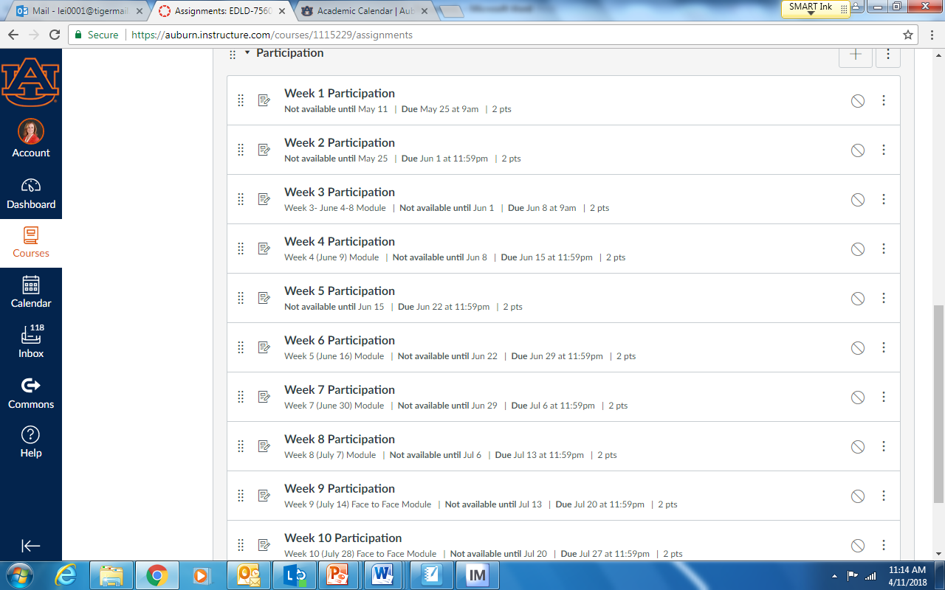

**Class Policy Statements**

Attendance: For EDLD 7560, class attendance and punctuality are expected and required. Students must meet the assignment deadlines described in the syllabus.

Excused absences: Students are granted excused absences (In an asynchronous distance course, absences may translate into submitting late assignment/s to Canvas). Late assignment submission may be excused for the following reasons: illness of the student or serious illness of a member of the student’s immediate family, the death of a member of the student’s immediate family, trips for student organizations sponsored by an academic unit, trips for university classes, trips for participation in intercollegiate athletic events, subpoena for a court appearance, and religious holidays – as detailed in the [Student Policy eHandbook](http://www.auburn.edu/student_info/student_policies/) ([www.auburn.edu/studentpolicies](http://www.auburn.edu/studentpolicies)). Students who wish to have an excused absence (or submit late work) for any other reason must contact the instructor in advance of the absence to request permission. The instructor will weigh the merits of the request and render a decision. When feasible, the student must notify the instructor prior to the occurrence of any excused absences, but in no case shall such notification occur more than one week after the absence. Appropriate documentation for all excused absences is required. Please see the [Student Policy eHandbook](http://www.auburn.edu/student_info/student_policies/) ([www.auburn.edu/studentpolicies](http://www.auburn.edu/studentpolicies)) for more information on excused absences.

Make-Up Policy: Arrangement to make up a missed major examination/assignment (e.g., hour exams, mid-term exams, major papers) due to properly authorized excused absences must be initiated by the student within one week of the end of the period of the excused absences(s). Except in unusual circumstances, such as the continued absence of the student or the advent of university holidays, a make-up exam will take place within two weeks of the date that the student initiates arrangements for it. Except in extraordinary circumstance, no make-up exams will be arranged during the last three days before the final exam period begins.

Accommodations: Students who need accommodations are asked to electronically submit their approved accommodations through AU Access and to arrange a meeting during office hours the first week of classes, or as soon as possible if accommodations are needed immediately. If you have a conflict with my office hours, an alternate time can be arranged. To set up this meeting, please contact me by e-mail. If you have not established accommodations through the Office of Accessibility, but need accommodations, make an appointment with the Office of Accessibility, 1228 Haley Center, 844-2096 (V/TT

Academic Honesty Policy: All portions of the Auburn University student academic honesty code (Title XII) found in the [Student Policy eHandbook](http://www.auburn.edu/student_info/student_policies/) ([www.auburn.edu/studentpolicies](http://www.auburn.edu/studentpolicies)) will apply to university courses. All academic honesty violations or alleged violations of the SGA Code of Laws will be reported to the Office of the Provost, which will then refer the case to the Academic Honesty Committee.

*Please note:*

* *Copying and/or pasting other individuals’ work and then presenting it as your own (intentional or unintentional) is considered plagiarism and is in direct violation of the Honesty Code. Violations of the Honesty Code may result in a zero for the assignment, a failing grade for the course, suspension and/or expulsion from the university.*
* *I expect you to produce original work for this class. You may not submit work for this class that you have previously completed for a different class. If you have any questions, please see me prior to submitting your assignment. You will receive a zero for work that too strongly resembles another course’s work.*

ALL PAPER WRITING Guidelines:

1. You should follow the APA style of writing (6th edition).
   * Your paper should be double-spaced with 1” margins.
   * Please use an APA-approved, 12 pt. font (e.g., Times New Roman).
   * Include a title page and list your references separately. Your reference page is

not included in the expected page limits. No abstract is needed.

* + Direct quotations should be followed by a page number.
  + It’s better to over-cite than under-cite.
  + Ask if you have questions.

1. Your writing style and tone should be scholarly.
   * You should not use a conversational tone. Avoid rhetorical questions and trite phrases/colloquialisms.
   * Exhibit grammar and spelling appropriate to graduate-level study.
   * Do *not* overuse quotations.
   * Turn your paper in on time.
   * Do not use Wikipedia as a reference.
   * Plagiarism Tutorials: http://library.camden.rutgers.edu/EducationalModule/Plagiarism/ http://library.acadiau.ca/tutorials/plagiarism/

Professionalism: As faculty, staff and students interact in professional settings, they are expected to demonstrate professional behaviors as defined in the College’s conceptual framework. These professional commitments or dispositions are listed below:

* + Engage in responsible and ethical professional practices
  + Contribute to collaborative learning communities
  + Demonstrate a commitment to diversity
  + Model and nurture intellectual vitality
* Model and nurture intellectual vitality

Additionally, the following skills, applications, and dispositions are considered important for Accomplished Educational Leaders (National Board Core Propositions from the National Board for Professional Teaching Standards). We expect students fulfilling the expectations for the Ed.S. and/or AA Certification in Instructional Leadership to utilize the course learning opportunities to practice the following:

SKILLS

* Accomplished educational leaders continuously cultivate their understanding of leadership and the change process to meet high levels of performance.
* Accomplished educational leaders have a clear vision and inspire and engage stakeholders in developing and realizing the mission.
* Accomplished educational leaders manage and leverage systems and processes to achieve desired results.

APPLICATIONS

* Accomplished educational leaders act with a sense of urgency to foster a cohesive culture of learning.
* Accomplished educational leaders are committed to student and adult learners and to their development.
* Accomplished educational leaders drive, facilitate and monitor the teaching and learning process.

DISPOSITIONS

* Accomplished educational leaders model professional, ethical behavior and expect it from others.
* Accomplished educational leaders ensure equitable learning opportunities and high expectations for all.
* Accomplished educational leaders advocate on behalf of their schools, communities and profession.