# SUMMER 2021 RSED 5140D/6140D/6140 SEVERE DISABILITIES CURRICULUM

Auburn University Department of Special Education, Rehabilitation, & Counseling

# Course Number: RSED 5140D/6140D/6140

**Course Title:** **Severe Disabilities Curriculum**

**Meeting Time/Place:**

For RSED 5140D The course meets Tuesday and Thursdays from 12:30pm to 4:15pm. You will have required online live class ZOOM meetings at 12:30pm on Tuesdays and Thursdays beginning May 20th.

For RSED 6140D this graduate distance education course is asynchronous. Course videos and assignments are posted weekly. However students are welcome to attend synchronous sessions. For RSED 6140 this graduate course is offered in the Hyflex format. For each class meeting students can attend in person, via ZOOM, or asynchronous.

**Office hours:** Weekly ZOOM Office Hours by appointment

**Credit:** 3 semester hours

**Instructor:** Dr. Suzanne Woods-Groves, Ph.D.

**Instructor’s email:** [woodssu@auburn.edu](mailto:woodssu@auburn.edu)

**Instructor’s phone:** 334-844-7621

**Office location:** Haley Center 1232C

1. **Date Syllabus Prepared:** May 2021

**REQUIRED TEXTBOOKS:**

**Obtain your textbooks before the first day of class.**

**ALL ACCESS TEXTBOOKS:**

Please review ALL ACCESS information attached to this syllabus and located in your CANVAS course home page. If you are not using the REDSHELF ALL ACCESS you MUST OPT out. See OPT out material at the end of the syllabus and within the CANVAS course page.

***Instruction of Students with Severe Disabilities,* Freeda Brown, John McDonnell, & Martha E Snell Publisher: Pearson Edition: 9th Published: 2020**

***Systematic Instruction for Students with Moderate and Severe Disabilities* Collins, Belva C., Published by Brookes Publishing, Publication Date: Jan. 1, 2012 ISBN *9781598571936***

**ADDITIONAL READINGS available via CANVAS**

# COURSE DESCRIPTION:

Understanding of a functional/developmental approach to the selection, development, implementation, and evaluation of appropriate curriculum activities for the instruction of students who have severe or profound disabilities, behavior disorders, learning disabilities, intellectual disabilities, and multiple disabilities (physical, sensory, communication, cognitive and behavioral) with concomitant disabilities; emphasis on education grades Pre K-12. Content includes extensive exploration of various curricular theories focusing on individual and group approaches.

1. **Student Learning Outcomes: After completing this course you will:**

***COURSE OBJECTIVES*: This course is designed to teach university students to:**

* 1. Demonstrate knowledge of the characteristics and service needs of individuals of varying ages and a variety of types of severe/profound behavior disorders, learning disabilities, intellectual disabilities, and multiple disabilities.
  2. Demonstrate knowledge of administrative arrangements, service delivery systems, school-care giver relationships, and curricular content bases related to educational services for individuals’ birth through 21 years of age who have severe/profound behavior disorders, learning disabilities, intellectual disabilities, and multiple disabilities.
  3. Describe the impact of cognitive and affective manifestations on learning, curriculum and program development, and needed services and supports for students with

severe/profound behavior disorders, learning disabilities, intellectual disabilities, and multiple disabilities. *Rules 35(1)(a)1, 36(1)(a)1.*

* 1. Identify the array of residential, vocational, and leisure services available for students with severe/profound behavior disorders, learning disabilities, intellectual disabilities, and multiple disabilities.
  2. Demonstrate knowledge of assessment and intervention procedures appropriate for evaluation and educational programming with infant, toddler, preschool children, school- aged children, and youth who have severe/profound behavior disorders, learning disabilities, intellectual disabilities, and multiple disabilities.
  3. Describe technological advances and their impact on individuals with severe/profound levels behavior disorders, learning disabilities, intellectual disabilities, and multiple disabilities. *Rule 34(1)(a)12.*
  4. Identify the mandates of PL 94-142 and other legislation and their impact on services provided to individuals with severe/profound behavior disorders, learning disabilities, intellectual disabilities, and multiple disabilities. *Rule 34(1)(a)1.*
  5. Describe various curricula, teaching techniques/methods, and materials of instruction for students with severe/profound behavior disorders, learning disabilities, intellectual disabilities, and multiple disabilities.
  6. Identify resource agencies that provide personnel and services for improving and strengthening educational programs for individuals with severe/profound behavior disorders, learning disabilities, intellectual disabilities, and multiple disabilities. *Rule 34(1)(a)8.*
  7. Develop and implement appropriate school healthcare plans and specialized instruction and therapeutic techniques including physical and behavior management. *Rules 35(1)(b)9, 36(1)(b)9.*
  8. Supply the most common definitions and characteristics of children with severe/profound affective/social/behavioral disorders as well as how those characteristics impact learning, curriculum development and needed services and supports. *Rule 35(1)(a)1, 36(1)(a)1.*
  9. Describe the most common theories and educational approaches used with children with severe/profound affective/social/behavioral disorders. *Rule 35(1)(a)1, 36(1)(a)1*
  10. Identify cultural and socioeconomic factors and their impact on eligibility and programming. *Rule (1)(a)9.*
  11. Identify resource agencies that provide personnel and services for improving and strengthening educational programs for individuals with severe/profound learning disabilities. *Rule 34(1)(a)8.*
  12. Observe, interact with, and respond to infants, toddlers, preschoolers, elementary-school, middle-school, or high-school individuals who have severe/multiple disabilities.

**5. COURSE CONTENT SCHEDULE This syllabus** is a tentative outline for the course and is **subject to change** with advance notice from the instructor.

**This is a compressed mini-semester course. You will cover the same amount of material you would cover in a traditional semester course.**

|  |  |  |  |
| --- | --- | --- | --- |
| **Dates** | **Topic** | **Assigned Readings** | **Assignments & Due Date**  **Quizzes & Exams will close after due date and will NOT REOPEN** |
| **05/20**  **Thursday**  **Week 1**  **MODULE 1**  **ZOOM CLASS MEETING 12:30pm** | **Module 1:**  Course Introduction  Legislation & FAPE  History of Early Childhood & Special Education  Transition, Families, & IDEA  Supporting learners with ID and DD  Supports Module  Summative & Formative Assessment  Compare & contrast formal vs. informal assessments  Task analytic measurement  Data-Driven decision making  Social Validity  Graphing Data  Foundational Components of Instruction | **Textbook:**  *Instruction of Students with Severe Disabilities*  Chapters 1-5 | **DUE Sunday May 23rd by 11:59pm.**   * Quiz 1 First Day Class Introduction * Quiz 2Instruction of Students with Severe   Disabilities Chapters 1-2   * Quiz 3 (Chapters 3-5) * Application Activity 1 Reflections on IEPs * Application Activity 2 History of ECSE * Application Activity 3 Behavior * **Participation Points**   Watch all Lectures by May 23rd by 11:59pm  **Critical Thinking Activity 1**  RSED 5140 COMPLETE in ZOOM class meeting on Thurs. May 20th  RSED 6140/6140D due May 23rd by 11:59pm |

|  |  |  |  |
| --- | --- | --- | --- |
| **Dates** | **Topic** | **Assigned Readings** | **Assignments & Due Date**  **Quizzes & Exams will close after due date and will NOT REOPEN** |
| **05/25**  **Tuesday**  **Week 2**  **MODULE 2**  **ZOOM CLASS MEETING**  **12:30pm** | **Module 2:**  Theoretical basis for Video Modeling Components of Video Modeling Types of Video Models  Steps in creating video prompting models  Systematic Instruction  **Field Hours Part 1**  **MAST –Task Analysis** | **Readings located in MODULE 2**   * *Implementing Task Analyses Handou*t   **Textbook:**  *Systematic Instruction for Students with Moderate and Severe Disabilities*  Chapters 1-3 | **DUE Sunday May 30th by 11:59pm**   * Quiz 4 Evidence-Based Video Modeling   & Implementing Task Analysis  **&**  **Collins Chapters 1-3**   * Field Hours Part 1 MAST-- Task Analysis   **Participation Points**  Watch all Lectures by May 30th by 11:59pm  **Critical Thinking Activity 2**  RSED 5140 COMPLETE in ZOOM class meeting on Thurs. May 25thth  RSED 6140/6140D due May 30th by 11:59pm |

|  |  |  |  |
| --- | --- | --- | --- |
| **Dates** | **Topic** | **Assigned Readings** | **Assignments & Due Date**  **Quizzes & Exams will close after due date and will NOT REOPEN** |
| **05/27**  **Thursday**  **Week 2**  **MODULE 3**  **ZOOM CLASS MEETING 12:30pm** | **Module 3:**  Theoretical basis for Video Modeling  Components of Video Modeling  Types of Video Models  Steps in creating video prompting models  Create a task analysis  Systematic Instruction  **Instructional Project**  **Part 1 Task Analysis** | **Readings located in MODULE 3**   * *Implementing Task Analyses Handou*t   **Textbook:**  *Systematic Instruction for Students with Moderate and Severe Disabilities*  Chapters 1-3 | **DUE Sunday May 30th by 11:59pm**   * Instructional Project--Task Analysis for CASE STUDY   **Participation Points**  Watch all Lectures by May 30th by 11:59pm  **Critical Thinking Activity 3**  RSED 5140 COMPLETE in ZOOM class meeting on Thurs. May 27thth  RSED 6140/6140D due May 30th by 11:59pm |

|  |  |  |  |
| --- | --- | --- | --- |
| **Dates** | **Topic** | **Assigned Readings** | **Assignments & Due Date**  **Quizzes & Exams will close after due date and will NOT REOPEN** |
| **06/01**  **Tuesday**  **Week 3**  **MODULE 4**  **ZOOM CLASS MEETING 12:30pm** | **Module 4:**  **Instructional Project** Video Prompting Model  Writing IEP Goals & Objectives Progress Monitoring  Graphing & Interpreting Data | **Readings located in MODULE 4**  **Textbook:**  *Systematic Instruction for Students with Moderate and Severe Disabilities*  Chapters 1-3 | **DUE Sunday June 6th by 11:59pm**   * Quiz 5 * Instructional Project—Writing Goals/Obj.   **Participation Points**  Watch all Lectures by June 6th  by 11:59pm  **Critical Thinking Activity 4**  RSED 5140 COMPLETE in ZOOM class meeting on Tues. June 1st  RSED 6140/6140D due June 6th by 11:59pm |
| **06/03**  **Thursday**  **Week 3**  **MODULE 5**  **EXAM 1 via CANVAS** | **Module 5:**  **EXAM 1 OPENS June 3rd** | **Exam 1 covers**  **Modules 1-4 and all material addressed** | **DUE Monday June 7th by 11:59pm**  **Complete EXAM 1 via CANVAS**  **Exam 1 will close after due date and will NOT REOPEN.** |

|  |  |  |  |
| --- | --- | --- | --- |
| **Dates** | **Topic** | **Assigned Readings** | **Assignments & Due Date**  **Quizzes & Exams will close after due date and will NOT REOPEN** |
| **06/08**  **Tuesday**  **Week 4**  **MODULE 6**  **ZOOM CLASS MEETING 12:30pm** | **Module 6**  **Instructional Project**  Video Prompting Model  Teaching Video Prompting Mode  Systematic Instruction  Baseline Data  Graphing & Interpreting Data | **Readings located in MODULE 6**  **Textbook:**  *Systematic Instruction for Students with Moderate and Severe Disabilities*  Chapters 4-6 | **DUE Sunday June 13th by 11:59pm**   * Quiz 6 Systematic Instruction & Graphing Data & IEP goal/obj writing * Instructional Project-- Video Prompting Model * Field Hours Part 2 MAST—Prompting Systems   **Participation Points**  Watch all Lectures by June 13th by 11:59pm  **Critical Thinking Activity 5**  RSED 5140 COMPLETE in ZOOM class meeting on Tues. June 8th  RSED 6140/6140D due June 13th by 11:59pm |

|  |  |  |  |
| --- | --- | --- | --- |
| **Dates** | **Topic** | **Assigned Readings** | **Assignments & Due Date**  **Quizzes & Exams will close after due date and will NOT REOPEN** |
| **06/10**  **Thursday**  **Week 4**  **MODULE 7**  **ZOOM CLASS MEETING 12:30pm** | **Module 7:**  **Exceptionality Project**  **Part 1 ASD Early Childhood**  **Part 2 Visual Supports** | **Textbook:**  *Systematic Instruction for Students with Moderate and Severe Disabilities* Chapters 9-11 | **DUE Sunday June 13th by 11:59pm**  Quiz 7 Visual Supports  Quiz 8 ASD Early Childhood/prenatual  **Participation Points**  Watch all Lectures by June 13th by 11:59pm  **Critical Thinking Activity 6**  RSED 5140 COMPLETE in ZOOM class meeting on Thurs. June 10th  RSED 6140/6140D due June 13th by 11:59pm |

|  |  |  |  |
| --- | --- | --- | --- |
| **Dates** | **Topic** | **Readings** | **Assignments & Due Date** |
| **06/15**  **Tuesday**  **Week 5**  **MODULE 8**  **ZOOM CLASS MEETING 12:30pm** | **Module 8**  List and describe two evidence-based practices to use when teaching reading skills.  Describe the components of the ACCESS model  Describe how to use the ACCESS model when teaching students writing skills  List and explain a method to adapt books.  **Field Hours**  **MAST –Adapting Books**  MAPS  Person Centered Planning Steps in MAPS planning Alternative Standards  AAA Guidance & Program Decision Making  **Field Hours**  **MAST –Adapting Mathematics** | **READINGS in MODULE 8:**  ACCESS Article  Literacy Instruction Chapter  Steps in MAPS Planning  Webinar Handout    University of Vermont MAPS  Alternative Standards  AAA Guidance & Program Decisions | **DUE Sunday June 20th by 11:59pm**   * Quiz 9 ACCESS Article * Quiz 10 MAPS & AAA * Field Hours MAST—Adapting Mathematics   **Participation Points**  Watch all Lectures by June 20th by 11:59pm  **Critical Thinking Activity 7**  COMPLETE in ZOOM class meeting on Tues. June 15th |
| **06/17**  **Thursday**  **Week 5**  **MODULE 9**  **EXAM 2 via CANVAS** | **Module 9:**  **EXAM 2**  **OPENS June 17th** | **Exam 2 covers Modules 6, 7, 8 and all material addressed** | **DUE Monday June 21st by 11:59pm Complete EXAM 2 via CANVAS**  **Exam 2 will close after due date and will NOT REOPEN.** |

* 1. **COURSE REQUIREMENTS/EVALUATION:**

**Students are required to**

a) Successfully complete all required activities, quizzes, and projects and will submit their projects via CANVAS no later than the date designated for each project,

b) Take and pass all required exams,

c) Watch all class lectures,

d) Read assigned materials within the delineated time.

**STRUCTURE/SCHEDULE OF CLASS SESSIONS:**

**This is a compressed mini-semester course. You will cover the same amount of material you would cover in a traditional semester course.**

**For RSED 5140D undergraduate course students are required to attend weekly Tuesday and Thursday live ZOOM class meetings at 12:30pm. For the 6140D graduate course students can complete the course asynchronously and are also welcome to attend ZOOM class meetings. For 6140 Hyflex graduate course students have weekly options to complete the course via ZOOM, in person, or in the asynchronous format.**

**This course is presented in a flipped classroom format**. The majority of lectures are recorded and posted on CANVAS. Weekly course meetings will include critical thinking activities that RSED 5140D students must complete during Tuesday and Thursday ZOOM class. RSED 6140/6140D students will complete their critical thinking activities via CANVAS. The course will include weekly assigned readings, assignments, lectures, activities, and quizzes. The course is not self-paced and you will need to ensure you keep up with the pace of the course and to complete weekly assignments. This course is organized by modules to help with the organization of the information and assignments as you move through the course. Students are required to visit the CANVAS course site regularly to access course material, lectures, activities, assignments, quizzes, and exams

# Exams (600 points)

Another requirement of this course is the completion of **two 50-minute online examinations**. Each exam is 300 points. All Exams will consist 25 items which will include a variety of item times such as multiple choice, true/false, applied activities, and matching questions. All students will access and complete their exams via CANVAS. These exams are timed and must be completed during the allotted time period and due date. All exams must be completed individually and must represent your own work and responses.

# Check for Understanding Quizzes (100 points)

There will be 10 online quizzes each worth **10 points**. The quizzes will focus on the required readings, course materials, and class activities. These Check for Understanding Quizzes are designed for you to evaluate your understanding of course material and assignments. **You can take the Quiz up to 3 times to achieve the 100% score. Your highest grade will be recorded. You should complete these quizzes individually with your answers representing your own work.**

# Undergraduate Level Instructional Planning Project (300 points)

You will complete an instructional planning project. You will identify a skill to assess and teach. First, you will create an assessment instrument (i.e., task analysis, self- monitoring tool) to use to measure pre-requisite skills and to monitor performance for skill acquisition. Second, you will create a long-term measurable Goal with all SMART components. Third, you will create three objectives that include SMART components that use your assessment instrument as a baseline and progress-monitoring tool. Fourth, you will design a systematic instructional plan where you will use a systematic instructional method(s) to teach the target skill and video modeling. The systematic instructional plan will include the following components: AT supports, accommodation supports to develop independence and autonomy, evidence-based steps in systematic instruction including fading supports and promoting generalization of the skill. Fifth, you will graph and interpret data.

# Graduate Level Instructional Planning Project (300 points)

Graduate students will complete ALL COMPONENTS of Instructional Planning Project included in the undergraduate level description above. In addition, graduate students will read two published peer-reviewed articles. The articles will pertain to an experimental study conducted with individuals with severe disabilities that investigated the systematic instructional method that is used in their Instructional Planning Project. Graduate students will complete article discussion questions, synopsis of articles, and deliver a brief presentation of their findings.

# Participation Points Watch Module Lectures (300 points)

You are required to **WATCH ALL LECTURES IN THEIR ENTIRETLY** within each MODULE. There are 7 MODULES with lectures in each MODULE. Each MODULE is worth 42.85 points. Participation points are earned by watching 100% of each lecture and by watching all of the lectures in each MODULE. CANVAS.

# Panopto statistics record individual views and the viewing length times for each lecture. Lectures must be watched by the due date indicated in the syllabus.

1. **Exceptionality Project (200 points)**

You will complete two modules. Module 1 pertains to ASD and early intervention. Module 2 pertains to visual supports. You will need to complete all parts of each of the modules. This will include pre- and post-test assessments and discussion questions for each module.

# Field service 10-hour requirement (200 points)

For your field service 10- hour requirement, you will complete 3 application activities and 4 MAST MODULES. You will complete all parts of each activity and module.

This will include post assessments and discussion questions for respective modules

and activities

# Critical Thinking Activity (10 Critical Thinking Activities = 50 points each) Total Points = 500

You will complete each Critical Thinking Activity during the live weekly ZOOM class meetings and in-person meetings. These activities provide the student with hands-on learning experiences where they will apply concepts learned through lectures, readings, application activities, and other class materials. **Weekly course meetings will include critical thinking activities that RSED 5140 must complete during ZOOM class. RSED 6140 students will complete their critical thinking activities via CANVAS.**

E**VALUATION:** Final grades will be based on points assigned through completion and evaluation of course requirements and grades will be assigned on the basis of number of accumulated points, as follows:

|  |  |  |  |
| --- | --- | --- | --- |
| **ASSIGNMENTS** | **Points per**  **activity** | **Total Points Possible** | **Approximate**  **% of grade** |
| **Check for Understanding Quizzes (10)** | 10 | 100 | 4.5% |
| **Critical Thinking Activities (10)** | 50 | 500 | 22.7% |
| **10 Hour Field Service Requirement** | See below | 200 | 9.1% |
| * **Application Activity 1 Reflections on IEP videos** | 30 |  |  |
| * **Application Activity 2 History of ECSE & SP ED** | 30 |  |  |
| * **Application Activity 3 Behavior** | 10 |  |  |
| * **MAST Module Part 1—Task Analysis** | 35 |  |  |
| * **MAST Module Part 2—Prompting Systems** | 35 |  |  |
| * **MAST Module Part 3—Math Instruction** | 30 |  |  |
| * **MAST Module Part 4 – Adapting Books** | 30 |  |  |
| **Participation Points Watch All Lectures (7 MODULES)** | 42.85 | 300 | 13.6% |
| **Instructional Planning Project Graduate/Undergraduate** | 300 | 300 | 13.6% |
| **Exceptionality Project Parts 1 & 2** | 200 | 200 | 9.1% |
| **Exams (2)** |  | 600 | 27.4% |
| * **Exam 1** | 300 |  |  |
| * **Exam 2** | 300 |  |  |
| **Total Points** |  | **2,200** | **100%** |

# Final Course Grades will be Assigned for Undergraduate or Graduate as follows:

|  |  |  |
| --- | --- | --- |
| **Letter Grade** | **Percentage** | **Points** |
| **A** | **90 - 100** | **1,980 to 2,200** |
| **B** | **80- 89** | **1,760 to 1,979** |
| **C** | **70-79** | **1,540 to 1,759** |
| **D** | **65-69** | **1,430 to 1,539** |
| **F** | **64 and below** | **1,429 and below** |

1. **CLASS POLICY:**

# *Extra Credit:* No extra credit opportunities will be provided. Final grades will be comprised of points earned on the activities, tests, and projects described in the syllabus.

**COVID Related Policies**

Due to the Coronavirus pandemic, public health measures have been implemented across Auburn’s campus. Students should stay current with these practices and expectations through the campus reentry plan, [A Healthier U (Links to an external site.).](https://ahealthieru.auburn.edu/) The sections below provide expectations and conduct related to COVID-19 issues.

Please do the following in the event of an illness or COVID-related absence:

* Notify me in advance of your absence, if possible
* Provide me with medical documentation, if possible
* Keep up with coursework as much as possible
* Participate in class activities and submit assignments remotely as much as possible
* Notify me if you require a modification to the deadline of an assignment or exam
* Finally, if remaining in a class and fulfilling the necessary requirements becomes impossible due to illness or other COVID-related issues, please let me know as soon as possible so we can discuss your options.

Students with questions about COVID-related illnesses should reach out to the COVID Resource Center at (334) 844-6000 or at [ahealthieru@auburn.edu.](mailto:ahealthieru@auburn.edu)

**Health and Well-Being Resources**

These are difficult times, and academic and personal stress is a natural result. Everyone is encouraged to take care of themselves and their peers. If you need additional support, there are several resources on campus to assist you:

* COVID Response Team ([ahealthieru.edu (Links to an external site.)](http://www.ahealthieru.edu/))
* Student counseling and Psychological Services ([http://wp.auburn.edu/scs/ (Links to an](http://wp.auburn.edu/scs/) [external site.)](http://wp.auburn.edu/scs/))
* AU Medical Clinic ([https://cws.auburn.edu/aumc/ (Links to an external site.)](https://cws.auburn.edu/aumc/)

If you or someone you know are experiencing food, housing or financial insecurity, please visit the Auburn Cares Office ([http://aucares.auburn.edu/ (Links to an external site.)](http://aucares.auburn.edu/))

**Course Expectations Related to COVID-19**

* **Face Coverings**: As a member of the Auburn University academic community you are required to follow all university guidelines for personal safety with face coverings, physical distancing, and sanitation. **Face coverings are required in classes including our small in- person group class meetings and in all campus buildings**. Note that face coverings must meet safety specifications, be worn correctly, and be socially appropriate. You are required to wear your face coverings at all times. If you remove your face covering or are non-compliant with the university’s [policy on face coverings (Links to an external site.)](https://ocm.auburn.edu/news/coronavirus/updates/20200618-face-masks-required.php?ref=coronavirus), you will be instructed to leave the classroom and will be held to the protocols outlined in the [Auburn](https://sites.auburn.edu/admin/universitypolicies/Policies/PolicyonClassroomBehavior.pdf) [University Policy on Classroom Behavior (Links to an external site.).](https://sites.auburn.edu/admin/universitypolicies/Policies/PolicyonClassroomBehavior.pdf) Any student who willfully refuses to wear a face covering and does not have a noted accommodation may be subject to disciplinary action.
* **Physical Distancing**: **For the in-person class meetings use** classroom signage/avoid congregating around doorways before or after class for person group class meetings. If the instructional space has designated entrance and exit doors, you should use them. **Students should exit the instructional space immediately after the end of instruction to help ensure social distancing and allow for the persons attending the next scheduled class session to enter.**
* **Course Attendance**: If you are quarantined or otherwise need to miss class because you have been advised that you may have been exposed to COVID-19, you will be expected to develop a plan to keep up with your coursework during any such absences.
* **Technology Requirements:** This course may require particular technologies to complete coursework. If you need access to additional technological support, please contact the AU Bookstore at [aubookstore@auburn.edu.](mailto:aubookstore@auburn.edu)

*Disruptive or concerning classroom behavior involving the failure to wear a face covering, as directed by Auburn University, represents a potential Code of Student Conduct violation and*

*may be reported as a non-academic violation. Please consult the* [*Classroom Behavior*](https://sites.auburn.edu/admin/universitypolicies/Policies/PolicyonClassroomBehavior.pdf)[*Policy* (Links to an external site.)](https://sites.auburn.edu/admin/universitypolicies/Policies/PolicyonClassroomBehavior.pdf)*.*

# Course Delivery Changes Related to COVID-19

Please be aware that the situation regarding COVID-19 is frequently changing, and the delivery mode of this course may adjust accordingly. In the event that the delivery method is altered, please be assured that the learning goals and outcomes of the course will not change; however, some aspects of the course will change in terms of the mode of delivery, participation, and testing methods. Those details will be shared via Canvas as soon as possible. Please be prepared for this contingency by ensuring that you have access to a computer and reliable Internet.

# ACADEMIC INTEGRITY

Auburn University has adopted an Honor System proposed by its students and faculty to promote academic integrity and has enacted the following code:

*“We, the faculty, instructors, and students of the (University course here) pledge to fulfill our mutual responsibilities to each other and the academic community at large with honor and integrity in order to build and maintain a climate of respect and trust that will enhance our research, teaching, and learning. We will support the Honor System of the School, and will not tolerate activities that undermine academic integrity.”*

Academic dishonesty is an offense that will be reported to the Academic Honesty Committee.

Please refer to the following document for further information regarding academic honesty: [Auburn University Student Academic Honesty Code](https://sites.auburn.edu/admin/universitypolicies/policies/academichonestycode.pdf)

**Academic Honesty Policy**: All portions of the Auburn University student academic honesty code (Title XII) found in the Student Policy eHandbook will apply to university courses. All academic honesty violations or alleged violations of the SGA Code of Laws will be reported to the Office of the Provost, which will then refer the case to the Academic Honesty Committee.

**Honesty Code**: The University Academic Honesty Code and the Tiger Cub Rules and Regulations pertaining to Cheating will apply to this class. The Auburn Academic Honesty Code is found in both the Tiger Cub and the Student Government Association’s Code of Laws. Students are to read the honor code carefully, making sure they understand the policy, its implications for their work (e.g. tests, reports, papers, projects), and the consequences of code violation. Non-compliance with this policy will result in formal action with the university academic honesty procedures. Among other things, students are responsible for understanding the definition of plagiarism. Individuals are to (a) reference materials they use, and (b) reference only material they access directly. Individuals who copy or use ideas from the works of others without properly acknowledging the author, risk grave consequences.

**POLICY STATEMENTS**

**Excused Absences: Please also please read the Covid-19 policy information located within this syllabus.** Students are granted excused absences from class for the following reasons: illness of the student or serious illness of a member of the student's immediate family, the death of a member of the student's immediate family, trips for student organizations sponsored by an academic unit, trips for university classes, trips for participation in intercollegiate athletic events, subpoena for a court appearance, and religious holidays. Students who wish to have an excused absence from class for any other reason must contact the instructor in advance of the absence to request permission. The instructor will weigh the merits of the request, and render a decision. When feasible, the student must notify the instructor prior to the occurrence of any excused absences, but in no case shall such notification occur more than one week after the absence. Appropriate documentation for all excused absences is required. Please consult the *Student Policy* eHandbook for more information on excused absences.

**Make-Up Policy**: Arrangement to make up a missed major examination (e.g.: hour exams, mid- term exams) due to properly authorized excused absences must be initiated by the student within one week of the end of the period of the excused absence(s). Except in unusual circumstances, such as the continued absence of the student or the advent of university holidays, a make-up exam will take place within two weeks of the date that the student initiates arrangements for it. Except in extraordinary circumstances, no make-up exams will be arranged during the last three days before the final exam period begins.

**Accommodations**: Students who need accommodations are asked to electronically submit their approved accommodations through AU Access and to arrange a meeting during office hours the first week of classes, or as soon as possible if accommodations are needed immediately. If you have a conflict with my office hours, an alternate time can be arranged. To set up this meeting, please contact me by e-mail. If you have not established accommodations through the Office of Accessibility, but need accommodations, make an appointment with the Office of Accessibility, 1228 Haley Center, 844-2096 (V/TT).

***Assignments:*** All written assignments are expected to use person-first language (i.e. “child with a disability” rather than “disabled child”). Written assignments are expected to be typewritten, grammatically accurate, and free of spelling and typographical errors. Assignments are to be of a quality that would be expected of a professional. **Please do not email me assignments, they will not be graded. All Assignments must be submitted via CANVAS and typed.**

All assignments must be turned in when due via CANVAS unless otherwise indicated. Assignments must be turned in by the student completing the assignment. **No late assignments** will be accepted unless the instructor has received **prior notice of absence** (via phone, email, etc…) that can be verified as a university approved excuse. When prior notice is provided and the student has a university approved excuse, he or she will have **one week** from the time he or she returns to class to turn in the assignment.

***Professionalism:*** As faculty, staff, and students interact in professional settings, they are

expected to demonstrate professional behaviors as defined in the College’s conceptual framework. These professional commitments or dispositions are listed below:

* + Engage in responsible and ethical professional practices
  + Contribute to collaborative learning communities
  + Demonstrate a commitment to diversity
  + Model and nurture intellectual vitality

**Classroom Behavior: “**Behavior in the classroom that impedes teaching and learning and creates obstacles to this goal [learning] is considered disruptive and therefore subject to sanctions… Students have the responsibility of complying with behavioral standards… Examples of improper behavior in the classroom (including the virtual classroom of e-mail, chat rooms, telephone, and web activities associated with courses) may include, but are not limited to the following: arriving after a class has begun; use of tobacco products; monopolizing discussion; persistent speaking out of turn; distractive talking including cell phone usage; audio or video recording of classroom activities or the use of electronic devices (including cell phones) without the permission of the instructor; refusal to comply with reasonable instructor directions; employing insulting language or gestures; verbal, psychological, or physical threats, harassment, and physical violence.” (See *Tiger Cub*).

***Student Academic Grievance Policy:*** The purpose of this university policy is to “resolve academic grievances of students, which results from actions of faculty or administration. This resolution should be achieved at the lowest level and in the most equitable way. The burden of proof rests with the complainants.” See *Tiger Cub* for steps toward redress.

**To opt in or out of an All Access class:**

**1.Log into AU Access, and then Select Student Menu:**

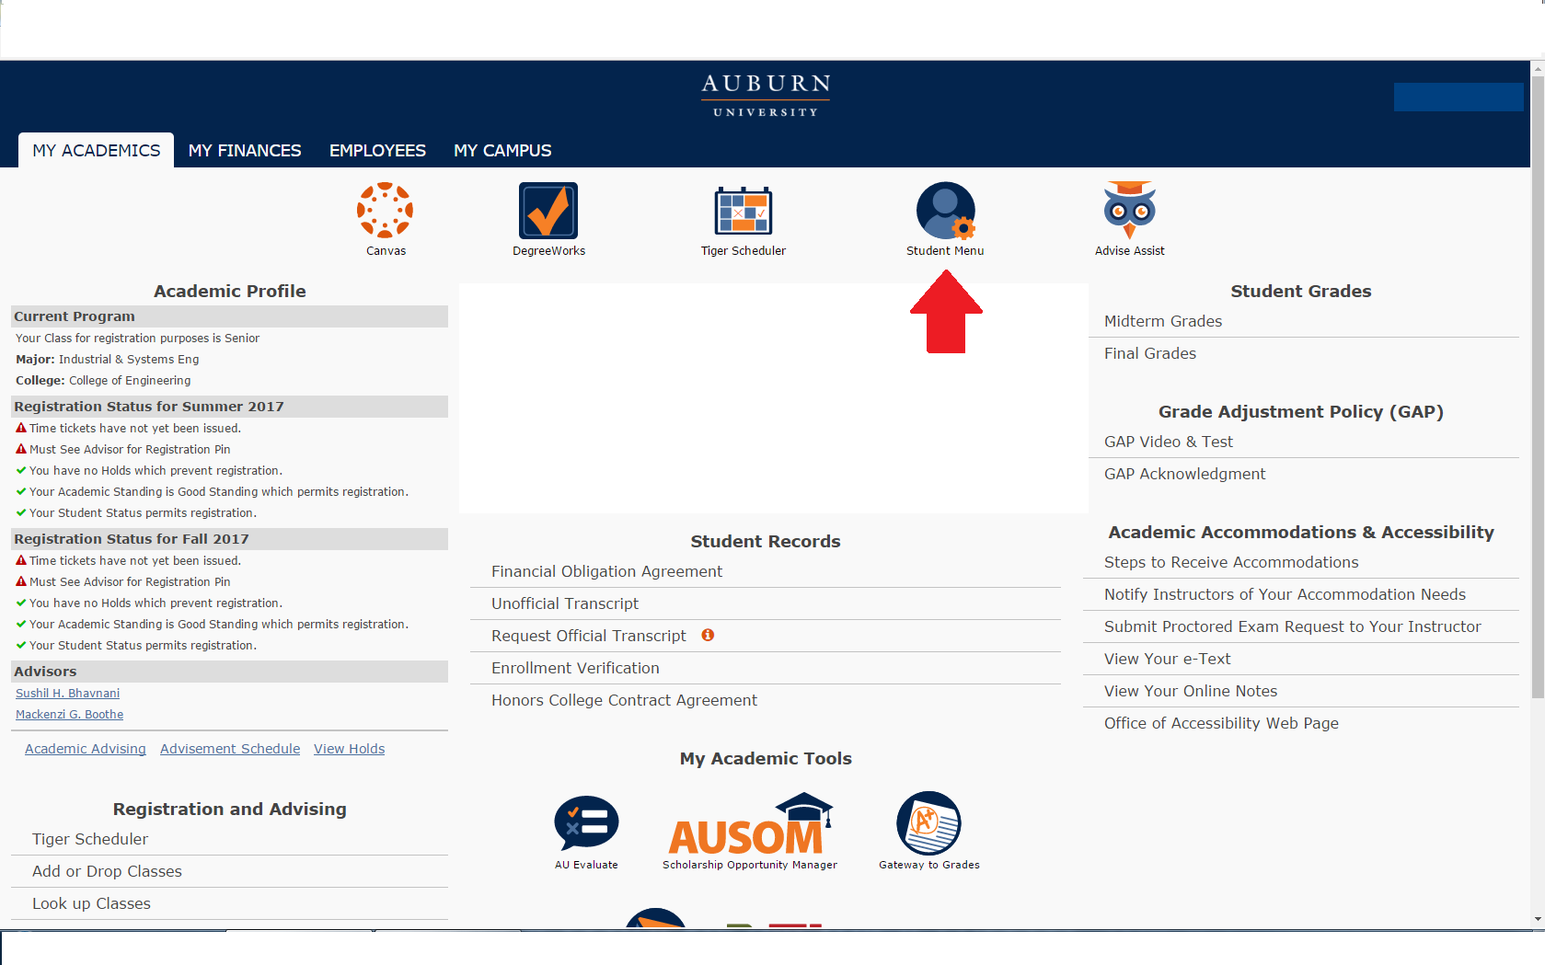

**2. Near the bottom, students will see an All Access tab. Select it to view classes.**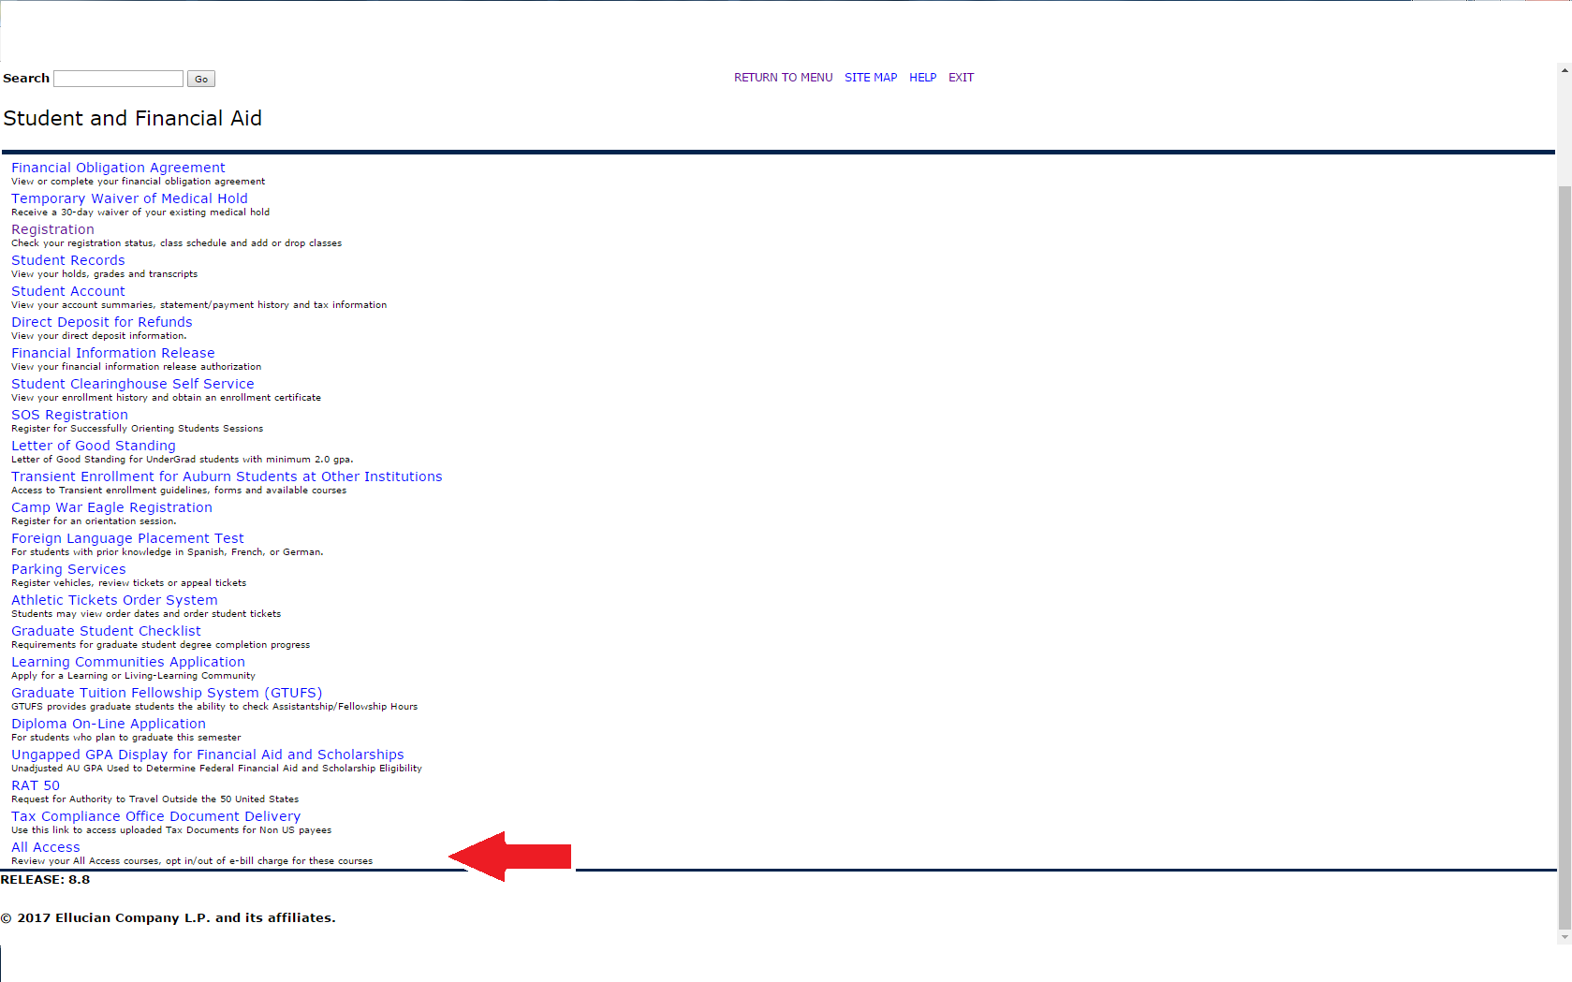

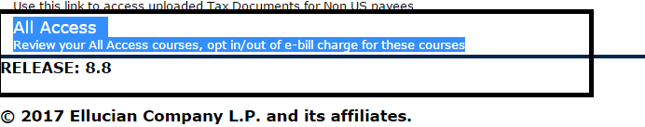

**3. Once in here, they will select their the current term:**

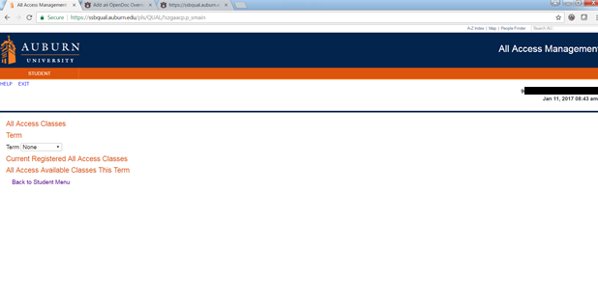

**4. Once the current term is selected, All Access courses will populate with options to change out to the right.**

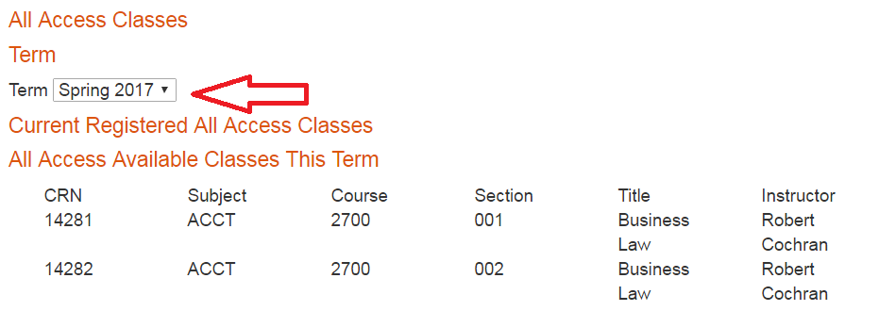

**5. Students can click the change button to opt in or out of the All Access material. NOTE: This does not change your registration in the class, just your purchase option for the course materials.**

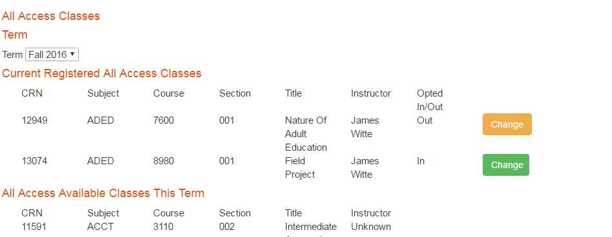

**6. You will be prompted to provide a reason for opting out of the class.**

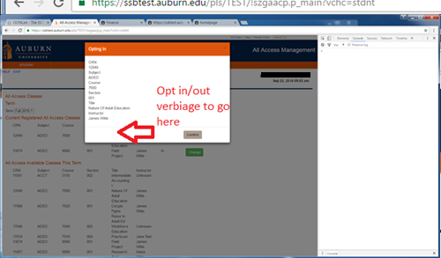

**7. If completed correctly, there will be a green ‘Success’ near the middle of the page.**

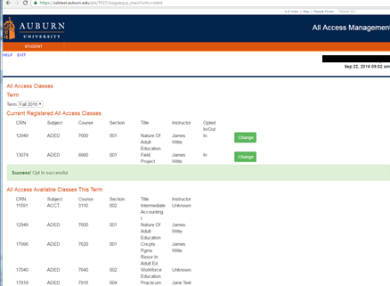

**You may opt in or out at any time before the fifteenth class day. After that day, charges are sent to the Bursar to be applied to your e-bill. We may not be able to reverse the charge after that date.**

**We are able to apply All Access charges for course materials to scholarships that are normally handled through our scholarship counter in store. We will also apply charges for student athletes to the Athletic Department if a student’s scholarship covers course materials.**