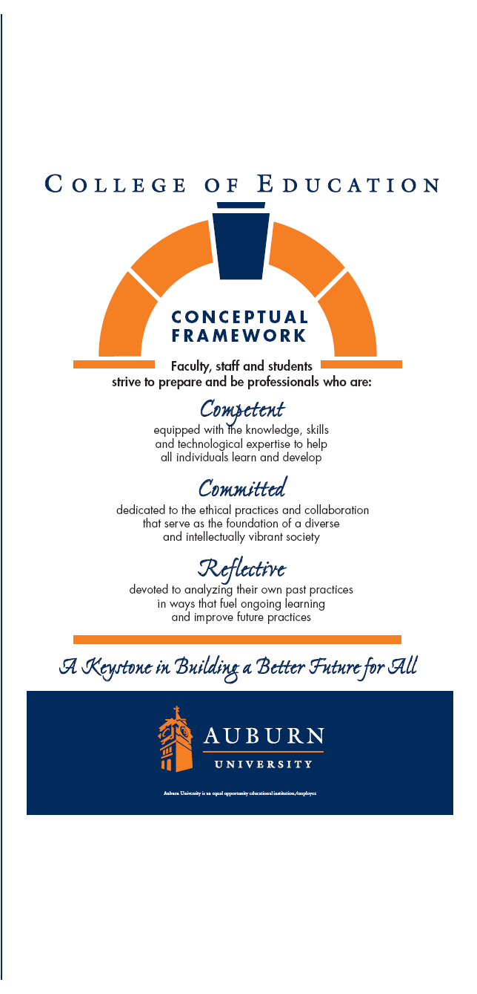

**ADED 8950**

**Doctoral Seminar in Adult Education**

**Summer 2022**

**Educational Foundations, Leadership and Technology**

College of Education

Dr. Leslie A. Cordie

Work: 334-844-3089

E-Mail: [lesliecordie@auburn.edu](mailto:lesliecordie@auburn.edu)

**Office:** Haley 4082

**ADED 8950 Seminar in Adult Education**

**Educational Foundations, Leadership, and Technology**

**Auburn University – Summer, 2022**

**Tentative Syllabus**

**Class Time:** Thursdays 5:00 - 8:50 p.m.

**Location:** Zoom/Remote Delivery

**Instructor:**  Dr. Leslie A. Cordie 4082 Haley Center

E-Mail: lesliecordie@auburn.edu Office: (334) 844-3089

**Call for appointment**

**1. Course Numbers: ADED 8950**

**Course Titles: Seminar in Adult Education**

**Credit Hours**: 3 semester hours

**Prerequisites**: Departmental approval

**Corequisites**: None

**2. Date Syllabus Prepared:** May 2022

1. **Required Texts**:

American Psychological Association. (2020). *Publication manual* (7th Ed.).

Washington, DC: Author.

Recommended Readings: Journals, textbooks, dissertations, research monographs, government documents, and other resources related to the specific topic.

1. **Course Description:**

This seminar will provide advanced students with in-depth exposure to the steps and process of developing and writing a dissertation. It will also provide an opportunity to critically evaluate and synthesize the literature, research and dissertations in the interdisciplinary field of adult education.

**5. Course Objectives:** Upon completion of this course, students will be able to:

* Describe and evaluate dissertations formats and chapters
* Identify the procedure for protection of human subject and consent elements
* Utilize the American Psychological Association (7th ed.) style
* Critically evaluate classic and current readings on a specialized topic.
* Self-assess skills in terms of research and writing

1. **Course Content and Philosophy:**

The content and schedule for the course will be determined by a learning contract between the student and the supervising faculty member. Students will meet as a class, in small groups, and individually with the professor and other support resources to discuss assigned readings, work in collaborative groups, and complete a variety of assignments in conjunction with the learning contract that focus on the course objectives.

There are approximately 10 sessions (Class Meetings and Individualized Sessions) with a variety of topics related to the development of the dissertation. This course is a blended format that will include Zoom sessions, online lectures, open access resources, discussions, group activities, face to face individual appointments, and other tasks to provide knowledge and skills application in terms of the dissertation journey.

This is a graduate education course, as such all participants are considered professionals, and are expected to **not only study but also practice** Andragogy by **taking responsibility for their learning.** Thus, the participant is expected to participate regularly, contribute to the class setting by participating in discussions and activities, and to be collaborative and supportive of all members of the learning setting.

Additional course materials will be made available through Auburn University’s learning management system (LMS) which is Canvas to support learning.

**Tentative Course Dates and Topics**

**Mandatory Sessions on May 19, June 2, June 16, July 7, July 21, and July 28**

**May 19 – Class! Overview of Course Syllabus and Expectations**

May 26 – Dissertation Management Strategies; Readings as Assigned; Individualized Learning

**June 2 – Class! Dissection of the Dissertation and APA Formatting**

June 10 – Credible Sources, Citation, and APA; Readings as Assigned; Individualized Learning

**June 16 – Class! Literature Reviews, Library Resources, and Sourcing**

June 23 – Research Questions and Methods; Readings as Assigned; Individualized Learning

June 30 – Human Subjects Research; Readings as Assigned; Individualized Learning

**July 7 - Class! CITI and the IRB Process**

July 14 – Chapters 4 and 5 of the Dissertation; Readings as Assigned; Individualized Learning

July 21 - **Class! Proposal Success Stories**

**July 28 – Class! Finalize Learning Contract Outcomes; Next Steps in the Doctoral Journey**

**7. Tentative Course Requirements/Evaluation:**  Course requirements for the main course assignment/project will be determined by learning contract between the professor and the student. However, students as a minimum will be required to develop:

1. Complete the CITI Training Modules
2. Initial Learning Contract Draft
3. Final Learning Contract and Timeline for Dissertation Process
4. PhD Self-Assessment / Evaluation
5. Attendance / Participation
6. Introduction and Progress Reports (2)
7. Citation Manager Exploration

|  |  |
| --- | --- |
| **Assignment** | **Due Date** |
|  |  |
| Introduction on Flipgrid | May 25 (week 1) |
| Learning Contract Draft - Submission | June 1 (week 2) |
| Learning Contract Draft – Peer Review | June 8 (week 3) |
| Progress Report – Reflection 1 | June 15 (week 4) |
| Citation Manager Exploration | June 22 (week 5) |
| CITI Certificates | July 6 (week 7) |
| Progress Report – Reflection 2 | July 20 (week 9) |
| PhD Self-Assessment | July 27 (week 10) |
| Final Contract and Dissertation Timeline | July 28 (week 11) |
| Attendance at Mandatory Sessions and Participation in Individualized and Group Sessions | Final Grade |

**Evaluation Procedures:** The final grade for the course will be based on the completion of the learning contract, documentation of completed assignments, class participation, and discussion. The main components for evaluation include:

Learning Contract Draft 10 points

CITI Certificates 20 points

Final Contract and Dissertation Timeline 30 points

PhD Self-Assessment 10 points

Flipgrid – Introduction and Progress Reports (2) 15 points

Attendance/Participation 10 points

Citation Manager Exploration 5 Points

Total 100 points

The following grading scale will be used:

A = 90 – 100 points

B = 80- 89 points

C = 70- 79 points

D = 60 – 69 points

F = Below 60 points

**A final grade of Satisfactory (S) or Unsatisfactory (U) will be awarded. Thus, a grade of range of scores between 80-100 will be deemed a Satisfactory grade.**

1. **Class Policy Statements:**
2. Students are expected to participate in all class discussions and participate in all exercises. It is the student’s responsibility to contact the instructor if assignment deadlines are not met. Students are responsible for initiating arrangements for missed work.

B. Attendance is required at each class meeting. Students who miss class because of illness need a doctor’s statement for verification of sickness and should clear the absence with the instructor the day they return to class. Other unavoidable absence from campus must be documented and cleared with the instructor in advance. Absences may affect your Final Grade; please see the Student Handbook for excused absences based on Auburn University policy.

C. Students who need accommodations are asked to electronically submit their approved accommodations through AU Access and to arrange a meeting during office hours the first week of classes, or as soon as possible if accommodations are needed immediately. If you have a conflict with my office hours, an alternate time can be arranged. To set up this meeting, please contact me by e-mail. If you have not established accommodations through the Office of Accessibility, but need accommodations, make an appointment with the Office of Accessibility, 1228 Haley Center, 844-2096 (V/TT).

D. The University Academic Honesty Code and the Student Policy eHandbook <http://www.auburn.edu/student_info/student_policies/>

will apply to this class.

E. Please note: We expect you to produce original work for this class. You may not submit work for this class that you have previously completed for a different class. If you have any questions, please see us prior to submitting an assignment. You will receive a zero for work that is reflective of another course’s work, unless you have cleared this with the professor.

F. As faculty, staff, and students interact in professional settings, they are expected to demonstrate professional behaviors as defined in the College’s conceptual framework. These professional commitments or dispositions are listed below:

* Engage in responsible and ethical professional practices
* Contribute to collaborative learning communities
* Demonstrate a commitment to diversity
* Model and nurture intellectual vitality

**Appendix - Course Assignment Details**

**Learning Contract**

A Learning Contract is a plan for acquiring specified knowledge, understanding, skills, attitudes or values by a learner. Basically, a learning contact is simply a means for helping the learner structure learning projects systematically. A typical contract contains the following:

* Specific learning objectives to be accomplished;
* The resources and strategies to be used in accomplishing the objectives;
* The evidence that will be collected to indicate the extent to which the objectives have been accomplished;
* How the evidence will be judged or validated;
* The target date for completing each objective

In this course, the general dissertation assignments involve development of the proposal (chapters 1, 2 and or 3). Components of the chapters allow for specific parts of the chapters to be developed. For example, chapter 1 has several components, including a problem statement, background, limitations, significance, definitions, etc. Alternative options may be revisions of chapter 2, developing your dissertation presentation, validating a survey, pilot testing, working toward a publication, and others.

For the learning contract, you must be specific about what you would like to accomplish this semester.

**Final Learning Contract and Dissertation Timeline**

Now that you have completed the semester, and have a better idea of your dissertation topic, along with your strengths and weaknesses, finalize your learning contract.

* Reflect on what was accomplished this semester? What was completed or still is a work in progress?
* Update your learning contract to include a full timeline for a minimum of the next 3 semesters
  + Develop a flowchart or outline of the goals and timeframes involved in making progress toward the dissertation completion.
  + Key milestones should be detailed with dates; Include a timeline that works backwards from a goal date for graduation, if possible
  + Add any additional items that were not listed on the original document
  + Add any additional courses or credit hours that are needed toward developing your plan of study or research
  + Consider all timeframes for IRB, conducting the research, personal concerns, etc.
  + Be realistic in terms of the writing and revision process, and advisor / committee expectations

**CITI Certificate**

In order to conduct research, all personnel are required to complete and maintain up to date human subjects training. You must complete the web-based human subjects research (HSR) Training through the Collaborative Institutional Training Initiative (CITI) at the University of Miami. For this course, you mu complete the Basic Course. If you plan on conducting your research over the Internet or with a population under 17, there are additional modules you will need to complete. The training is free through Auburn University. Please see <https://cws.auburn.edu/OVPR/pm/compliance/irb/training>

For this assignment, you must provide the certificate to show that you have completed at least the Basic Course

**PhD Self-Assessment**

An annual review is required of each PhD student in any program. EFLT has developed a form that allows for self-assessment and discussion with their major advisor. This ensures that both students and advisors be held accountable for timely progress and for constructive feedback Research suggests that formal annual evaluations tend to increase the number of students who complete, and are therefore preferable to sporadic and informal reviews.

PhD Form to be made available.

**Attendance / Participation**

Student participation is required for all class activities including responses to class discussions, surveys or polls, and any other class activities (online or in class). Just logging in with your video off or logging in with video and not actively participating during our virtual seminar meeting does not count as active participation in the course.

If you have a professional conflict and have to log in late, log in and are not able to participate actively, or are unable to join us for our meeting in real time, you must inform the course instructor of your professional conflict (email).

**Flipgrid – Introductions and Progress Reports/Reflections (2)**

There are several reflection assignments in the course. This course requires a variety of activities that engage students with the content and other students, including using Flipgrid, an external recording tool. You are required to share your thoughts and ideas on your progress and ways to move forward in this dissertation journey!

***Introduction***

Create your introduction video using Flipgrid by answering the following as best as possible:

* What would you like us to know about you?
* What is your "WHY" for wanting to complete the PhD?
* Tell us what your topic might be for the dissertation.
* What are your expectations for this course and for yourself.
* Anything else you would like to share

***Progress Reports (2)***

Here are the questions prompts to answer:

* Completion - What progress has been made in the past few weeks? Where are you at in terms of developing and completing your learning contract and other course assignments?
* Challenges - What challenges have been encountered in the past few weeks? Do you have any new expectations or concerns on any of the assignments?
* Meaning/Usefulness - What lecture, reading, resource, activity or discussion had the most meaning or was most useful so far? Share any new resources you might have found that others might find helpful!
* Engagement/Participation - Grade your participation/engagement in the process and course on a scale of zero to 5, with 5 being the highest.
* Topic for Dissertation - Discuss what you know about that phenomenon at present, as well as what additional information you need to learn to prepare to address it and how you will move forward.