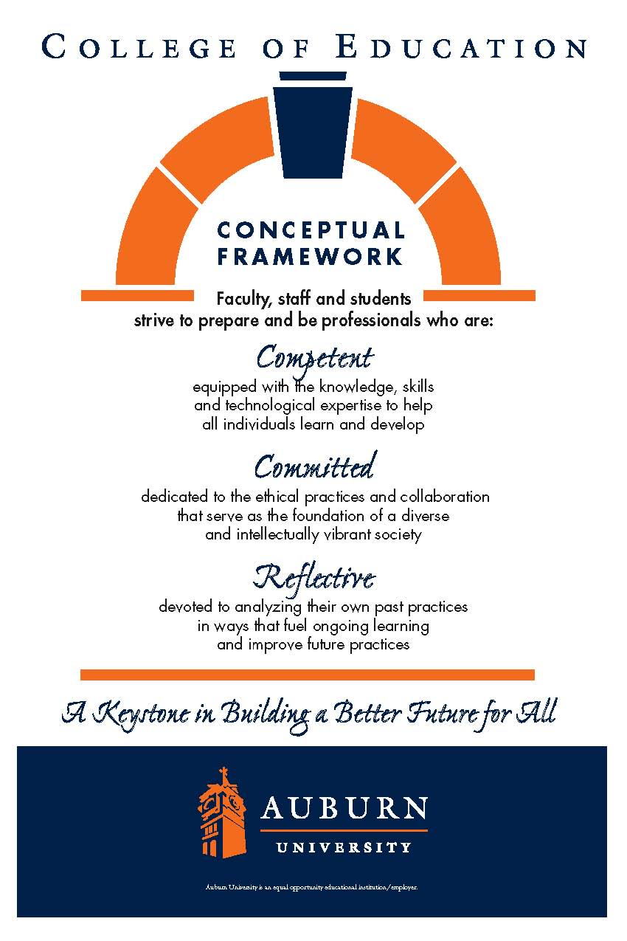**CTRD 3000-ECA: Fundamentals of Language and Literacy Instruction I**

**Summer 2022**

Schedule and Contact Information**:**

Class: Mondays & Wednesdays, 2423 HC, 9:00-10:50 AM

Lab teaching: Summer Reading Tutoring, Mondays & Wednesdays, 2423 HC, 8:00-8:45 AM June 1 – July 20

Instructor: Bruce A. Murray, PhD, Professor, Dept of C&T

Office: 5066 Haley Center. Telephone: (334) 844‑6934 (office)

Cell: 334-524-2476. E-mail: [[murraba@auburn.edu](mailto:murraba@auburn.edu)](mailto:murraba@auburn.edu)

Reading Genie website (please bookmark—many useful materials here).

<http://wp.auburn.edu/rdggenie/>

*Office hours:* Mondays and Wednesdays, 4:00-4:50 PM, and likely at other times as well. I hope you will feel welcome to e-mail, telephone, or Zoom to talk about lesson plans, assessments, or other issues.

Catalog description**.** Prerequisites: Admission to Teacher Education. Research-based theory and teaching strategies to meet the language and literacy needs of all children, especially those at risk of reading difficulties. Includes laboratory teaching experience.

CTRD 3000 focuses on teaching children how to read during the developmental stages of emergent literacy, beginning reading, and growing independence and fluency. Students at each of these stages are commonly found in every grade in today’s elementary schools. You will learn to teach students to break the code of alphabetic writing, identify and spell words, and develop fluent reading. As we survey each developmental stage, we will critically examine prevailing theories and practices in the light of scientific studies of reading. CTRD 3000 includes a field experience tutoring primary-grade students who are not yet fluent readers. Thus, as you study the research on teaching children how to read, you will apply what you learn in practical teaching experiences.

Text:Murray, Bruce (2020). *Making sight words: Teaching word recognition from phoneme awareness to fluency* (2nd edition). Ronkonkoma, NY: Linus.

Because decodable texts are engineered to help beginners apply phonics successfully, two volumes of stories will help your student maximize reading progress. These books are recommended but not required for this course:

* Bruce & Geri Murray (2019), *Lad and His Pals* (Auburn AL: Geniebooks) features 14 engaging decodable stories for practicing the five short vowels and the consonant digraphs *sh*, *ch*, and *th*.
* Bruce & Geri Murray (2019), *Fun and Games with Lad and Slim* (Auburn AL: Geniebooks) has 15 engaging decodable stories for advanced beginners: two stories for each long vowel, as well as stories for more advanced vowel digraphs (*er*, *ir*, and *ur*; *ar* and *or*; *ou* and *ow*; *au* and *aw*; and *oi* and *oy*).

Both books are sold as print books at the AU Bookstore, as Kindle eBooks on Amazon, and as Apple Books for the iPhone, iPad, and iPod touch at the iTunes Store.

Course goals**.** Upon completion of this course, students will be able to:

* Understand the nature of our writing system and the challenges children face at each stage of learning to read.
* Recognize the special difficulties in learning to read for children marginally prepared by home literacy experiences.
* Understand, assess, and teach the component abilities involved in learning an alphabetic writing system, including phoneme awareness, letter recognition, and concepts about print.
* Understand how children can be taught to break the alphabetic code of written English, to identify words from their spellings, and to achieve early reading independence.
* Understand how children can be helped to gain reading fluency and develop interest in reading that extends beyond the classroom, using a variety of books and multimedia materials.
* Design explicit lessons that include clear, developmentally appropriate explanations, modeling that dramatizes how to solve a problem, simplified practice allowing every student to succeed, extended practice reading connected text, and valid assessment to provide direction for further instruction.
* Tutor struggling readers in the primary grades to make measurable progress in reading.

COURSE REQUIREMENTS

Attendance**.** Class attendance and engaged participation are essential to achieving the goals of this course. I will assess attendance by checking Panopto view records. Missing class is like skipping a chapter in a book—what follows is harder to understand. Excused absences are defined by university policy: You may be excused for personal illness, a serious illness or death of someone in your immediate family, a field trip, a religious holiday, or a subpoena. For a provisional excuse, please notify me on or before the day you miss by leaving a message by e-mail or telephone (no documentation is necessary). For a fully excused absence, you will need to provide documentation for your absence.

You will earn up to 60 points by attending class by viewing Panopto recordings and attending Zoom meetings (see grading plan below). Quizzes missed because of unexcused absences may not be made up (though you can still submit the content literacy guide for 5 points). Late assignments lose 10% credit per unexcused *weekday* late (including weekdays when we don't meet) to a maximum of 30% lost credit. For example, a 20-point assignment due Thursday would be worth at most 14 points by the following Tuesday. If your absence is excused, any assignment will be due the following weekday and will begin to incur late penalties on the second weekday unless you provide daily updates of continuing excusing information.

Absence from tutoring responsibilities limits your student’s reading progress and may inconvenience parents. If in an emergency you cannot teach your student at the agreed-on time , please call the parent well *before* lab to arrange an alternate time for tutoring.

Grading Plan.Approximately 700points may be earned by various means. Semester grades will be calculated by determining the percentage of this total, where 90% (627 points with rounding) is *A*,80% is *B*,70% is *C*,and 60% is *D.* Please note that this is only a plan; point totals for course achievements may change during the course of the semester if assignments are added or deleted. You will earn points for the following achievements:

🎖 Attendance(60 points). 3 points may be earned for viewing each entire Panopto video, attending a Zoom meeting, or for a fully excused absence. Watching part of a video will earn 1-2 points.

🎖 Tutoring(200 points). 6 reflections and plans @ 20 points each (120 points), a completed pretest interpretation form (10 points), 2 videos @ 10 points each (20 points), and a literacy report (50 points).

🎖 Quizzes(150 points). 15 quizzes @ 10 each.

🎖 Lesson designs(90 points). 3 lessons @ 30 points each (20 for draft; 10 more for publication).

🎖 Midterm and final exams(200 points). Each exam will be worth 100 points.

Tutoring.To apply what you are learning, you will plan, teach, and evaluate lessons and develop a literacy report for a primary-grade struggling reader. Twelve tutoring sessions are scheduled (see calendar). You must successfully complete the tutoring to receive credit for this course.

Grades will be based on your lesson plans and literacy report, not on an evaluation of your teaching. Your lessons will follow a four-activity routine adapted from the Reading Recovery program, based on the work of Marie Clay. In each lesson you will assess your student’s progress in reading a familiar book, teach your student a new correspondence with a letterbox lesson, introduce a new book and scaffold as your student reads aloud, and help your student write a message. Every week you will write a brief reflection on the previous lesson and a plan for the lesson to be taught next (see calendar). Your reflection and plan must be submitted by Canvas upload on due dates Wednesday after tutoring but before 4:45 PM Thursday. Detailed checklists will guide your planning.

At the end of the semester, you will write a report for your student’s parents. The report will record your observations of the student’s behavior, explain what you taught, discuss the student’s current reading abilities and needs, and make recommendations to teachers and parents. This report must be submitted in Word by Canvas upload.

Materials needed for tutoring

🖈Tri-folder project board, a.k.a. a cubby. We will provide this for you.

🖈Primary writing paper (the kind with dotted guidelines between solid lines) and pencils. See Canvas/tutoring materials.

🖈Letter manipulatives. Plastic lower-case letter tiles (available from the AU Bookstore) are easiest to handle. A double-sided set of paper letters to laminate and cut out may be downloaded from Canvas/Tutoring materials.

🖈Letterboxes (Elkonin boxes) are cardstock squares showing the number of phonemes in a word. Directions for letters and letterboxes are in *Making Sight Words,* Practical Chapter 3. Both you and your student will need letter manipulatives and letterboxes.

Tutoring policies

1. Dress appropriately in the “uniform” of a teacher. Your student should recognize you as a teacher by your professional appearance on screen.

2. Have your lesson plan and materials completely prepared before initiating the lesson.

3. Set up your materials at least 10 minutes before your scheduled lesson time to be ready to meet your student.

4. Use a timepiece to pace your 45-minute lesson. Start the lesson at the appointed times so the parent can stay on schedule. You may not keep your student online longer than scheduled.

5. Don’t allow your student to stray from the lesson. Recognize and reward your student’s work and attention, and provide mild but consistent consequences for disruptive behavior.

6. Don't give your student any material rewards. This confuses the motivation for learning for the student. Your friendly attention is ample reward.

7. You are responsible for your student. Stay with the student throughout the lesson.

8. Contact your student's parent early to reschedule the lesson time if, in the event of serious illness or emergency, you cannot meet your tutoring obligation.

9. Always make decisions based on what is best for the student. Enjoy your tutoring experience. What's important is that your student feels your personal warmth and sees your enthusiasm for reading.

Lesson design project**.** We will publish a website with our best lesson ideas for students in three reading stages:

🛉 *Emergent literacy,* ideas for teaching letter recognition, phoneme awareness, or concepts about print.

🛉 *Beginning reading,* ideas for teaching students to decode or spell words.

🛉 *Growing independence and fluency,* ideas for teaching students to read with automatic word recognition, which allows faster, smoother, more expressive, and silent reading, and which encourages voluntary, avid reading.

You will design one explicit lesson for each of these stages. You may start from scratch or adapt a lesson from another source (methods text, journal, website, teaching observations, etc.). In selecting activities, keep in mind that the outcome we’re after is learning, whether or not the lesson is fun or popular. Your instruction must be based on scientific studies of reading. Design complete lessons with well-defined goals, easy-to-understand explanations, explicit modeling, simplified practice guided by the teacher, application in longer connected texts, and assessment to determine whether children have learned what the lesson is designed to teach.

You will present drafts of your lesson ideas periodically for peer review and receive feedback (see calendar). I will grade the drafts for content (not mechanics) to help you revise and strengthen the lessons. Late in the semester, I will show you how to make web pages on Wix.com from your text files. Your lessons will be published on your own public web pages to meet media literacy standards. The design index site will link to your lessons. After the project is graded, you may delete the pages from your web page after, or you may choose to remove your email address from your posted lessons. If students do not wish their designs published, I will remove them from the index after students introduce their designs in class, after which the design index page will be linked to the Reading Genie site to publish the designs.

Quizzes and reading guides**.** Brief quizzes will assess your comprehension of each reading on the day the reading is assigned (see calendar). Quizzes are designed to be easy enough that a careful reading will earn a good score without extensive study, but too difficult to finesse using background knowledge and test-taking skills. Reading guides are available to help you get the most important points from each chapter. Completed guides may be used while taking quizzes but not exams; they will count for 5 of the 10 points on quizzes. All quizzes will be taken on Canvas.

Exams**.** The midterm and final exams will be based on both class work and readings, with primary emphasis on material from *Making Sight Words*. Exams will feature both objective questions (multiple choice, true-false, and matching questions) and essay items (brief explanations, abbreviated lesson designs with explanation, modeling, and a practice activity, and one extended essay selected from several options, planned using an outline, web, or graphic). The midterm exam will cover expository chapters 1-6 and practical chapters 1-6, and the final exam will cover expository chapters 7-10 and 12 and practical chapters 7-9. Both exams will be taken on Canvas.

University and College Policies

**Participation**. All students are expected to participate in all class discussions and participate in all exercises. It is the student’s responsibility to contact the instructor if assignment deadlines are not met and for initiating arrangements for missed work.

**Unannounced Quizzes**. There will be no unannounced quizzes.

**Accommodations**. Students who need special accommodations in class, as provided for by the American Disabilities Act, should arrange a confidential meeting with the instructor during office hours the first week of classes – or as soon as possible if accommodations are needed immediately. You must bring a copy of your Accommodation Memo and an Instructor Verification Form to the meeting. If you do not have these forms but need accommodations, make an appointment with the Program for Students with Disabilities, 1244 Haley Center, 844-2096.

**Academic Honesty Policy**. All portions of the Auburn University student academic honesty code (Title XII) found in the Tiger Cub will apply to this class. All academic honesty violations or alleged violations of the SGA Code of Laws will be reported to the Office of the Provost, which will then refer the case to the Academic Honesty Committee.

**Professionalism**. Faculty, staff, and students in professional settings are expected to demonstrate professional behaviors as defined in the College’s conceptual framework. These professional commitments or dispositions are as follows: Engage in responsible and ethical professional practices; contribute to collaborative learning communities; demonstrate a commitment to diversity; model and nurture intellectual vitality.

Summer Semester 2022: Tentative Calendar

Complete readings *before* the class for which they are assigned. Comprehension of each reading will be assessed by a brief quiz. Assignments and due dates are subject to change. Lesson plans should be submitted electronically by 4:45 PM Thursdays.

Symbol Key

Assigned reading 🕮; Quiz ✪; Expository Ch. EC; Practical Ch. PC; Written assignment 🖉; Reflection & Plan 🖉RP#

# May 2022

|  |  |  |  |  |  |  |
| --- | --- | --- | --- | --- | --- | --- |
| Sun | **Monday** | Tu | **Wednesday** | Thu | Fri | Sat |
| 15 | 16 | 17 | 18 Course intro. 🕮 **EC 1** A new view of sight words. 🕮 **PC 1** How to introduce a new book. | 19 | 20 | 21 |
| 22 | 23 🕮 **EC 3** How beginners develop the ability to read words & 🕮 **PC 2** How to scaffold word learning during oral reading. ✪ **Q EC 1.** Booktalks.  🖉 In class: Letter to student. | 24 | 25 🕮 **PC 5** How to assess to find out where reading is breaking down [bring pretest materials to class]. Managing behavior.  ✪ **Q PC 2** | 26 | 27 | 28 |
| 29 | 30 Memorial Day | 31 |  |  |  |  |

# June 2022

|  |  |  |  |  |  |  |
| --- | --- | --- | --- | --- | --- | --- |
|  |  |  | 1 Tutoring (pretests). Interpreting assessments; how to write a reflection & plan.✪ **Q PC 3** | 2 🖉  RP#1 | 3 | 4 |
| 5 | 6 Tutoring. 🕮 **EC 2** How alphabets work. 🕮 **PC 3** How to teach a letterbox lesson.  ✪ **Q EC 3.** | 7 | 8 Tutoring. 🕮 **EC 4** The language processing system of skilled readers.  ✪ **Q PC 5.** 🖉 Pretest interpretation form. | 9 🖉  RP#2 | 10 | 11 |
| 12 | 13 Tutoring. 🕮 **EC 6** Learning to detect phonemes in spoken words. ✪ **Q** **EC 2.** | 14 | 15 Tutoring. 🕮 **PC 6** How to take a running record. Directions: EL design. ✪ **Q** **EC 4.** | 16 🖉  RP#3 | 17 | 18 |
| 19 | 20 Juneteenth | 21 | 22 Tutoring. 🕮 **EC 5** Preparing students to learn to read. ✪ **Q** **EC 6.** | 23 | 24 | 25 |
| 26 | 27 No class: Finals for Mini-semester I | 28 | 29 Tutoring. 🕮 **PC 4** pp. 286-290, How to teach concepts about print. 🖉 Design: Emergent literacy ✪ **Q EC 5.** | 30 🖉  RP#4 |  |  |

# July 2022

|  |  |  |  |  |  |  |
| --- | --- | --- | --- | --- | --- | --- |
|  |  |  |  |  | 1 | 2 |
| 3 | 4 Independence Day | 5 | 6 Tutoring. **Midterm exam** (in class). | 7 🖉  RP#5 | 8 | 9 |
| 10 | 11 Tutoring. 🕮 **EC 7** How to teach phonics for sight word learning. Video: Scaffolding oral reading. Directions: BR design.  ✪ **Q PC 6.** | 12 | 13 Tutoring. 🕮 **PC 7** How to develop fluency through repeated readings. Video: LBL.  🖉 Design: Beginning reading. | 14 🖉  RP#6 | 15 | 16 |
| 17 | 18 Tutoring. Creating webpages on Wix.com. Extra credit: Decodable texts. 🕮 **EC 8** Choosing texts for reading instruction. Directions: GF design. ✪ **Q** **EC 7.** | 19 | 20 Tutoring (posttests). Interpreting posttests. **PC 9** Writing a literacy report.  🖉 Design: Growing independence and fluency ✪ **Q PC 7.** | 21 | 22 | 23 |
| 24 | 25 🕮 **EC 9** Moving from decoding to fluency. ✪ **Q** **EC 8**. | 26 | 27 🕮 **EC 10** Developing word recognition through spelling. ✪ **Q EC 9.**  🖉 Literacy report. Peer review in class.  🖉 Designs in HTML | 28 | 29 | 30 |
| 31 | 1 🕮 **PC 8** How to teach spelling as wordmapping. Bonus Spelling EC Quiz.  ✪ **Q** **EC 10.** 🕮 **EC 12** Introduce lesson designs. |  | Aug 1-3 Virtual Learning centers review activities. Bonus Replacement Quiz: Landmarks and pitfalls.  Aug 1-5 ✪ Final Exam (as Canvas quiz). |  |  |  |