# RSED CURRICULUM IN EARLY CHILDHOOD SPECIAL EDUCATION: LITERACY AND DEVELOPMENTAL DOMAINS

Auburn University Department of Special Education, Rehabilitation, & Counseling

# Course Number: RSED 5110/6110/6110D

**Course Title: Curriculum in Early Childhood Special Education: Literacy and Developmental Domains**

**Meeting Time/Place: RSED 5110 and 6110 students will meet On Campus**

**On Campus In Person meetings: Tuesdays & Thursdays 5:00pm to 8:45pm ROOM: 1212 Haley Center**

**RSED 6110D distance graduate students will complete the course in an Asynchronous format. Only RSED 6110D students can complete class in asynchronous format.**

**Office hours: Office Hours TBA and by appointment**

**Credit:** 3 semester hours

**Instructor:** Dr. Suzanne Woods-Groves, Ph.D.

**Instructor’s email:** [woodssu@auburn.edu](mailto:woodssu@auburn.edu)

**Instructor’s phone:** 334-844-7621

**Office location:** Haley Center 1232C

1. **Date Syllabus Prepared:** May 2023

* **You should obtain your textbooks by the first day of class**
* **Electronic versions of the Grisham-Brown textbook Blended Practices can be purchased via REDSHELF**
* **See REDSHELF information on the HOME PAGE of the CANVAS course and at the end of this syllabus.**

**REQUIRED TEXTBOOKS:**

**Grisham-Brown, J., Hemmeter, M. L., & Pretti-Frontczak, K. (2017). Blended practices for teaching young children in inclusive settings, 2nd Edition. Paul H. Brookes Publishing  
Company. (Available via Redshelf or other vendor)**

|  |
| --- |
| Hong, B., & Diamond, L., (2019). Teaching reading: Sourcebook, 3rd Edition, CORE. ISBN 9781634022354 **(Available via Auburn Bookstore or other vendor)** |

**ADDITIONAL READINGS available via CANVAS**

**MATERIALS TO CHECK OUT FROM LEARNING RESOURCE CENTER**

**Beginning May 18th you will be able to check out the PELI Assessment Kit from the Learning Resource Center (LRC) located in Haley Center 3408 & 3410. You will need your PELI Assessment Kit for class beginning Tuesday May 23rd.**

**REQUIRED TECHNOLOGY:**

All students in this course are expected to have all the equipment and software needed to be successful in the course. You will need to access weekly recorded lectures, assignments, quizzes, and materials posted via CANVAS and PANOPTO. You will complete and submit your exams and assignments via CANVAS. Ensure you have a working computer and reliable internet connection. Be sure you have installed and have access to all of the software required to participate in the course and complete your assignments (Canvas, PDF reader, Panopto). **On campus students should bring their laptops and or tablets to class each week. Your device should have a webcam and with video and audio capability.**

# 3. COURSE DESCRIPTION:

This course is designed in a “flipped classroom format.” In this course you will have instructor-centered lecture recordings each week that pertain to course content you will watch outside of class. In class meetings will pertain to additional discussion, lecture, hands on activities, and other activities. **RSED 5110/6110 students will meet each week in person on campus.**

* The course will include weekly assigned readings, assignments, lectures, activities, and quizzes.
* **The course is not self-paced** and you will need to ensure you keep up with the pace of the course and to complete weekly assignments.
* This course is organized by modules to help with the organization of the information and assignments as you move through the course.

Instruction in this course promotes an understanding of family and child centered practices that include the following: development, implementation, and evaluation of appropriate routine based and curriculum activities for children with mild learning/behavior disabilities and their families in grades Pre K to 2nd grade. Content also includes various curricular and development theories, assistive technology, assessment, and program planning.

**4. Alabama Student Learning Outcomes: After completing this course you will:**

|  |
| --- |
| **Standard 1 Learner Development and Individual Learning Differences**  Beginning special education professionals understand how exceptionalities may interact with development and learning and use this knowledge to provide meaningful and challenging learning experiences for individuals with exceptionalities. Prior to program completion: |
| 1.1.1  Understand how language, culture, and family background influence the learning of individuals with exceptionalities. * # ^ |
| 1.1.1  Understand how language, culture, and family background influence the learning of individuals with exceptionalities. * # ^ |
| 1.2.1  Support and facilitate families’ and caregivers’ roles in providing developmentally appropriate learning experiences addressing all areas of development. * |
| 1.2.2 Support and develop interventions to address individual needs in the developmental domains: social; emotional; cognitive; communication skills; and gross and fine motor skills. * # ^ |
| **Standard 2 Learning Environments**  Beginning special education professionals create safe, inclusive, culturally responsive learning environments so that individuals with exceptionalities become active and effective learners and develop emotional well-being, positive social interactions, and self-determination. Prior to program completion: |
| 2.1.1  Collaborate with general educators and other colleagues to create safe, inclusive, culturally responsive learning environments to engage individuals with exceptionalities in meaningful learning activities and social interactions. * |
| 2.1.2  Use motivational and instructional interventions to teach individuals with exceptionalities how to adapt to different environments. * # ^ |
| 2.2.1  Structure the education environment to provide optimal learning opportunities across all domains for children with various exceptionalities. *^ |
| 2.2.2  Implement basic health, nutrition, and safety management procedures for all children.* |
| 2.2.3  Plan instruction for individual functional life skills, adaptive behavior, and enhanced social participation across environments.* # |
| 2.3.1  Plan instruction for individual functional life skills, adaptive behavior, and enhanced social participation across environments.*# |
| **Standard 3 Curricular Content Knowledge**  Beginning special education professionals use knowledge of general and specialized curricula to individualize learning for individuals with exceptionalities. Prior to program completion: |
| 3.1.1  Understand the central concepts, structures of the discipline, and tools of inquiry of the content areas they teach, and organize this knowledge, integrate cross-disciplinary skills, and develop meaningful learning progressions for individuals with exceptionalities. [“General curricula” means the academic content of the general curricula including math, reading, English language arts, science, social studies, and the arts. “Specialized curricula” means the content of specialized interventions or sets of interventions including, but not limited to academic, strategic, communicative, social, emotional, and independence curricula.] * # + ^ |
| 3.1.2  Understand and use general and specialized content knowledge for teaching across curricular content areas to individualize learning for individuals with exceptionalities. * # + |
| 3.1.3  Modify general and specialized curricula to make them accessible to individuals with exceptionalities. * |
| 3.2  **Candidates in early childhood special education (P-3) will also** determine the appropriateness of and implement curricula to meet the needs of children with various exceptionalities across a variety of settings. * |
| 4.1.1  Select and use technically sound formal and informal assessments that minimize bias. * + |
| 4.1.2  Use knowledge of measurement principles and practices to interpret assessment results and guide educational decisions for individuals with exceptionalities. * + |
| 4.1.3  Collaborate with colleagues and families to use multiple types of assessment information in making decisions about individuals with exceptionalities. * |
| **Standard 5 Instructional Planning and Strategies**  Beginning special education professionals select, adapt, and use a repertoire of evidence-based instructional strategies to advance learning of individuals with exceptionalities. Prior to program completion: |
| 5.1.1  Consider an individual’s abilities, interests, learning environments, and cultural and linguistic factors in the selection, development, and adaptation of learning experiences for individuals with exceptionalities. (Instructional strategies include intervention used in academic and specialized curricula.) * # |
| 5.1.3  Use augmentative and alternative communication systems and a variety of assistive technologies to support the communication and learning of individuals with exceptionalities. *^ |
| 5.1.4  Use strategies to enhance language development and communications skills of individuals with exceptionalities. *^ |
| 5.1.6  Teach to mastery and promote generalization of learning. * # (fading procedures) |
| **Standard 6 Professional Learning and Ethical Practice**  Beginning special education professionals use foundational knowledge of the field and the Professional Ethical Principles and Professional Practice Standards of the Council for Exceptional Children to inform special education practice, to engage in lifelong learning, and to advance the profession. Prior to program completion: |
| 6.1.2  Understand how foundational knowledge and current issues influence professional practice. * |
| 6.1.3  Understand that diversity is a part of families, cultures, and schools, and that complex human issues can interact with the delivery of special education services. * |
| 6.2  **Candidates in early childhood special education (P-3) will also** understand and apply Alabama standards for pre-school education. * # + |

**Note.** How indicator is addressed: *readings & test, # ELO project, + PELI project, ^ case study or Module

**Justification for Graduate Credit.**

Undergraduate and Graduate students are dually enrolled in this course. Graduate students who are enrolled in this course are enrolled in the RSED 6110 level. Undergraduate students are enrolled in the RSED 5110 level of this course. **Justification for Graduate Credit: The RSED 6110 version of this course will have some assignments that differ from undergraduate RSED 5110 assignments.** Graduate Level Students in RSED 6110 will sequentially progress through course material. Learners will acquire knowledge of course material and then will apply course knowledge within activities or projects. Finally, learners will exhibit a synthesis of their independent learning by creating a cumulative project that designed supports for a case study of a young child with disabilities within an inclusive setting. Learners will include evidence-based methods in their project and will provide a synopsis of area specific current research.

* 1. **COURSE CONTENT SCHEDULE This syllabus** is a tentative outline for the course and is **subject to change** with advance notice from the instructor.

|  |  |  |  |
| --- | --- | --- | --- |
| **Dates** | **Topic** | **Readings** | **Assignments & Due Date** |
| **05/18**  **Thurs.**    **MODULE 1** | **Module 1:**  Course Introduction  Course Expectations & Assignments  Overview of DEC and ECSE practices  MTSS & RTI  High-quality instructional tiers.  Embedded Learning Opportunities  Universal Design for Learning | **Textbook**  **Blended Practices** Chapters1 to 4  **Reading Sourcebook**  pp. 744 to 754 | **DUE Monday 05/22 by 11:59pm**   * **Quiz 1** * **Application Activity** * **Participation Points**   Watch 100% of **Lecture video** MODULE   * **Critical Thinking Activity**   RSED 5110/6110 complete critical thinking activity in on campus class meeting |
| **05/23**  **Tues**  **MODULE 2** | **Module 2:**  Instructional Support Practices  Embedded Learning Opportunities  Universal Design for Learning  Essential Components of Reading  Language Development  PELI Introduction  State Standards K-12  Preschool Standards  IES Practice Guides  Health & Safety ECSE | **Textbook**  **Blended Practices**  Chapter 5 & 6  **PELI Manual**  Chapter 1 & 2  **Reading Sourcebook**  The Big Picture  pp. 1-18 | **DUE Tuesday 05/30 by 11:59pm**   * **Quiz 2** * **Application Activity** * **Participation Points**   Watch 100% of **all Lecture videos in MODULE**   * **Critical Thinking Activities**   RSED 5110/6110 complete critical thinking activity in on campus class meeting |

|  |  |  |  |
| --- | --- | --- | --- |
| **Dates** | **Topic** | **Readings** | **Assignments & Due Date** |
| **05/25**  **Thurs**  **MODULE 3** | **Module 3:**  PELI Kit Administration  Planned Instructional Sequences  Structure of Reading  Phonemes  Sound Structure  Morphemes  **Bring PELI Kit to Class** | **Textbook**    **Reading Sourcebook**  **Chapter 1**  **pp. 22 to 47**  **PELI Manual Chapter 3** | **DUE Tuesday 05/30 by 11:59pm**   * **Quiz 3** * **Application Activity** * **Participation Points**   Watch 100% of **all Lecture videos in MODULE**   * **Critical Thinking Activity**   RSED 5110/6110 complete critical thinking activity in on campus class meeting |
| **05/30**  **Tues**  **MODULE 4**  **ZOOM Class Meeting** | **Module 4 ZOOM Class Meeting**  **No ON Campus Meeting**  Early Literacy  Print Awareness  Letter Knowledge  PELI Alphabet Knowledge  Systematic Instruction & Prompting  **You will need your PELI KIT for our ZOOM Class** | **Textbook**  **Reading Source book**  **Chapters 3 & 4**  **Blended Practices Ch 7**  **PELI Manual Chapter 4** | **DUE Friday 06/02 by 11:59pm**   * **Quiz 4** * **Application Activity** * **Participation Points**   Watch 100% of **all Lecture videos in MODULE**   * **Critical Thinking Activity** |
| **06/01**  **Thurs.**  **MODULE 5** | **Module 5**  **EXAM 1 Opens**  **Complete via CANVAS**  **No Class Meeting** | **Exam 2 covers Modules**  **1 to 4 and all material addressed** | **DUE Monday June 5th by 11:59pm**  **Complete EXAM 1 via CANVAS** |

|  |  |  |  |
| --- | --- | --- | --- |
| **Dates** | **Topic** | **Readings** | **Assignments & Due Date** |
| **06/06**  **Tues**  **MODULE 6** | **Module 6**  Early Literacy  Phonological Awareness  PELI Vocabulary/Language Dev.  Collaboration in IEP planning  Assessment  Writing Goals/Objectives  **Bring PELI Kit to Class** | **Textbook**  **Reading Source book**  **Chapter 5**  **Blended Practices Ch 8**  **PELI Manual Chapter 5** | **DUE Monday 06/12 by 11:59pm**  Submit all Assignments via CANVAS   * **Quiz 5** * **Application Activity** * **Participation Points**   Watch 100% of **all Lecture videos in MODULE**   * **Critical Thinking Activity**   RSED 5110/6110 complete critical thinking activity in on campus class meeting |
| **06/08**  **Thurs**  **MODULE 7**  **ZOOM CLASS MEETING**  **No on campus meeting** | **Module 7 ZOOM Meeting**  **No On Campus Meeting**  Assessment  Language & Literacy  Prompting Literacy in Early Childhood Settings  PELI Comprehension | **Textbook**  **Blended Practices**  **Chapters 10 & 11**  **PELI Manual Chapter 6** | **DUE Monday 06/12 by 11:59pm**   * **Quiz 6** * **Application Activity** * **Participation Points**   Watch 100% of **all Lecture videos in MODULE**   * **Critical Thinking Activity** |

|  |  |  |  |
| --- | --- | --- | --- |
| **Dates** | **Topic** | **Readings** | **Assignments & Due Date** |
| **06/13**  **Tues**  **MODULE 8** | **Module 8:**  PELI Phonological Awareness  Scoring & Interpreting PELI  Assessment  Decoding & Word Recognition  Phonics  Social Emotional Part 1 | **Textbook**  **Reading Sourcebook pp. 161 to 168**  **& Chapter 6**  **Blended Practices**  **Chapter 9**  **PELI Manual**  **Chapters 7 & 8** | **DUE Tuesday 06/20 by 11:59pm** Submit all Assignments via CANVAS   * **Quiz 7** * **Application Activity** * **Participation Points**   Watch 100% of **all Lecture videos in MODULE**   * **Critical Thinking Activity**   RSED 5110 6110 COMPLETE in class |
| **06/15**  **Thurs**  **MODULE 9** | **Module 9:**  Social Emotional Development  Building Relationships Creating Social Stories  Conflict Resolution  Tucker the Turtle | **Assigned Readings CANVAS**  Controlling Anger  Review Resources Tucker Turtle & Book Nook | **DUE Tuesday 06/20 by 11:59pm** Submit all Assignments via CANVAS   * **Quiz 8** * **Application Activity** * **Participation Points** * **Critical Thinking Activity**   RSED 5110 & 6110 COMPLETE in class |
| **06/20**  **Tues**  **MODULE 10** | **Module 10:**  Part 2 Social Emotional Development  Social Emotional Teaching Strategies  Play Organizers  Stages of Learning | **Assigned Readings in CANVAS**  **Building Supportive Relationships**  **You’ve Got to Have Friends** | **DUE Wed. 06/21 by 11:59pm**   * **Quiz 9** * **Application Activity** * **Participation Points** * **Critical Thinking Activity**   RSED 5110 & 6110 COMPLETE in class |
| **Final Exam opens June 23rd & is DUE June 26th** | **Final Exam opens June 23rd & is DUE June 26th**  **Complete Final Exam via CANVAS** |  | **Final Exam opens June 23rd & is DUE June 26th**  **Complete Final Exam via CANVAS** |

# 7. COURSE REQUIREMENTS/EVALUATION:

**Students are required to**

* 1. Successfully complete all required activities, quizzes, and projects and will submit their projects via CANVAS no later than the date designated for each project,
  2. Take and pass all required exams,
  3. Watch videos in MODULES
  4. Read assigned materials within the delineated time.
  5. Attend weekly in person class meetings
  6. RSED 6110D distance education graduate class should complete all course requirements by due dates in syllabus.

**STUDENT EXECTATIONS**

**If you have any problems logging into the course, be sure to contact OIT and alert me by regular email or voicemail (text, etc. depending on your desires as an instructor).**

[IT Service Desk](http://www.auburn.edu/oit/)

As students you have control of the notification settings in your Canvas accounts. You should set up your notifications to alert you when an Announcement is posted, an Assignment is due, a grade is released, etc. For students new to Canvas, please review the following video [this link to a 7 minute “Getting Started with Canvas” video (and transcript) created by Canvas LMS](https://vimeo.com/74677642).

**ASSIGNMENTS AND EXAMS**

# Exams (2 Exams) Exam 1 = 300pts Final Exam = 300pts Total Points = 600

A requirement of this course is the completion of **two 70-minute online examinations** (CANVAS) see point values for exams below. All Exams will consist 30 items which will include a variety of item times such as multiple choice, true/false, applied activities, and matching questions. All students will access and complete their exams via CANVAS. These exams are timed and must be completed during the allotted time period and due date. All exams must be completed individually and must represent your own work and responses.

# 2. Check for Understanding Quizzes (9 Quizzes, = 10 points each) Total Points = 90

There will be 12 online quizzes each worth **10 points**. The quizzes will focus on the required readings, course materials, and class activities. These Check for Understanding Quizzes are designed for you to evaluate your understanding of course material and assignments. **You can take the Quiz up to 3 times. Your highest grade will be recorded.**

**You should complete these quizzes individually with your answers representing your own work.**

# 3. Application Activities (10 Application Activities) Total Points = 440

**There will be 10 Application Activities, See the Evaluation section for assigned points.** Each Application Activity is designed to offer you a chance to demonstrate critical thinking and explore concepts and skills introduced within this course. **The Application Activities can only be COMPLETED ONCE and ARE NOT TIMED**.

# 4. Participation Points Watch Module Lectures (450 points)

You are required to **WATCH ALL LECTURES IN THEIR ENTIRETLY (100%)** within each MODULE. Each MODULE is worth 50 points. Participation points are earned by **watching 100% of each lecture** and by watching **all of the lectures in each MODULE. CANVAS.** **Panopto statistics record individual views and the viewing length times for each lecture. Lectures must be watched by the due date indicated in the syllabus.**

**5. Embedded Learning Opportunities Plan (Parts A-D) (280 points)**

**You will use provided case studies to develop an embedded learning opportunities plan (ELO Plan). You will complete a four-part ELO Plan.** The ELO four parts include the following: (a) Part A: Student Background, (b) Part B: Data Driven Planning (What to teach); (c) Part C: Materials, Settings, and Implementation (With what, where, and how to teach); and (d) Part D: Data Progress Monitoring, Graphing, and Interpretation (Data-driven decision-making).

Graduate students will complete ELO Plan (Parts A- D) and also submit a synopsis of evidence-based methods and peer-reviewed research articles to support your ELO plan systematic instruction choice.

**6**. **In Class Critical Thinking Activity (10 Critical Thinking Activities = 50 points each) Total Points = 500**

**The Critical Thinking Activity must be completed in on campus class meetings**. These activities provide you with hands-on learning experiences where you will apply concepts learned through lectures, readings, application activities, and other class materials.

**7. PELI Assessment & Lesson Planning Project (280 points).**

You will administer a PELI Assessment. You will use assessment data to develop an early literacy lesson. This project allows you to demonstrate you proficiency in administering, scoring, & interpreting the PELI assessment. It also allows you to apply your knowledge of data driven instructional planning and lesson development.

**8. EVALUATION:** Final grades will be based on points assigned through completion and evaluation of course requirements and grades will be assigned on the basis of number of accumulated points, as follows:

|  |  |  |  |
| --- | --- | --- | --- |
| **ASSIGNMENTS** | **Points per activity** | **Total Points Possible** | **Approximate**  **% grade** |
| **Check for Understanding Quizzes (9)** | 10 | 90 | 3.4% |
| **Application Activities (10)** | -- | 440 | 16.6% |
| **Participation Points Watch All Lectures (9 MODULES)** | 50 | 450 | 17% |
| **Embedded Learning Opportunity Plan (Parts A-D)** | 280 | 280 | 10.6% |
| **In Class Critical Thinking Activities (10)** | 50 | 500 | 19% |
| **1 Exam = 300pts and 1 Final Exam = 300pts** | 300 | 600 | 22.8% |
| **PELI Assessment & Lesson Planning Project** | 280 | 280 | 10.6% |
| **Total Points** |  | **2,640** | **100%** |

# Final Course Grades will be Assigned for Undergraduate or Graduate as follows:

|  |  |  |
| --- | --- | --- |
| **Letter Grade** | **Percentage** | **Points** |
| **A** | **90 - 100** | **2,376 to 2,640** |
| **B** | **80- 89** | **2,112 to 2,375** |
| **C** | **70-79** | **1,848 to 2,111** |
| **D** | **65-69** | **1,716 to 1,847** |
| **F** | **64 and below** | **1,715 and below** |

1. **CLASS POLICY STATEMENTS**

***Extra Credit:* No extra credit opportunities will be provided. Final grades will be comprised of points earned on the activities, tests, and projects described in the syllabus.**

**COVID Related Policies**

Due to the Coronavirus pandemic, public health measures have been implemented across Auburn’s campus. Students should stay current with these practices and expectations <https://auburn.edu/covid-resource-center/>

# ACADEMIC INTEGRITY

Auburn University has adopted an Honor System proposed by its students and faculty to promote academic integrity and has enacted the following code:

*“We, the faculty, instructors, and students of the (University course here) pledge to fulfill our mutual responsibilities to each other and the academic community at large with honor and integrity in order to build and maintain a climate of respect and trust that will enhance our research, teaching, and learning. We will support the Honor System of the School, and will not tolerate activities that undermine academic integrity.”*

Academic dishonesty is an offense that will be reported to the Academic Honesty Committee. Please refer to the following document for further information regarding academic honesty: [Auburn University Student Academic Honesty Code](https://sites.auburn.edu/admin/universitypolicies/policies/academichonestycode.pdf)

**Academic Honesty Policy**: All portions of the Auburn University student academic honesty code (Title XII) found in the Student Policy eHandbook will apply to university courses. All academic honesty violations or alleged violations of the SGA Code of Laws will be reported to the Office of the Provost, which will then refer the case to the Academic Honesty Committee.

**Honesty Code**: The University Academic Honesty Code and the Tiger Cub Rules and Regulations pertaining to Cheating will apply to this class. The Auburn Academic Honesty Code is found in both the Tiger Cub and the Student Government Association’s Code of Laws. Students are to read the honor code carefully, making sure they understand the policy, its implications for their work (e.g. tests, reports, papers, projects), and the consequences of code violation. Non-compliance with this policy will result in formal action with the university academic honesty procedures. Among other things, students are responsible for understanding the definition of plagiarism. Individuals are to (a) reference materials they use, and (b) reference only material they access directly. Individuals who copy or use ideas from the works of others without properly acknowledging the author, risk grave consequences.

**Excused Absences:** Students are granted excused absences from class for the following reasons: Illness of the student or serious illness of a member of the student’s immediate family, death of a member of the student’s immediate family, trips for student organizations sponsored by an academic unit, trips for University classes, trips for participation in intercollegiate athletic events, subpoena for a court appearance and religious holidays. **Students who wish to have an excused absence from this class for any other reason must contact the instructor in advance of the absence to request permission. The instructor will weigh the merits of the request and render a decision. When feasible, the student must notify the instructor prior to the occurrence of any excused absences, but in no case shall such notification occur more than one week after the absence. Appropriate documentation for all excused absences is required.**

**Make-Up Policy:** Arrangements to make up missed major examination (e.g. hour exams, mid-term exams) due to properly authorized excused absences. Except in unusual circumstances, such as continued absence of the student or the advent of University holidays, a make-up exam will take place within two weeks from the time the student initiates arrangements for it. Except in extraordinary circumstance, no make-up exams will be arranged during the last three days before the final exam period begins. The format of the make-up exam will be (as specific by the instructor).

**Accommodations**: Students who need accommodations are asked to electronically submit their approved accommodations through AU Access and to arrange a meeting during office hours the first week of classes, or as soon as possible if accommodations are needed immediately. If you have a conflict with my office hours, an alternate time can be arranged. To set up this meeting, please contact me by e-mail. If you have not established accommodations through the Office of Accessibility, but need accommodations, make an appointment with the Office of Accessibility, 1228 Haley Center, 844-2096 (V/TT).

***Assignments:*** All written assignments are expected to use person-first language (i.e. “child with a disability” rather than “disabled child”). Written assignments are expected to be typewritten, grammatically accurate, and free of spelling and typographical errors. Assignments are to be of a quality that would be expected of a professional. **Please do not email me assignments, they will not be graded. All Assignments must be submitted via CANVAS or through Auburn BOX when indicated and typed.**

**All assignments must be turned in when due via CANVAS unless otherwise indicated. Assignments must be turned in by the student completing the assignment. No late assignments will be accepted unless the instructor has received prior notice of absence (via phone, email, etc…) that can be verified as a university approved excuse. When prior notice is provided and the student has a university approved excuse, he or she will have one week from the time he or she returns to class to turn in the assignment.**

***Professionalism:*** As faculty, staff, and students interact in professional settings, they are expected to demonstrate professional behaviors as defined in the College’s conceptual framework. These professional commitments or dispositions are listed below:

* + Engage in responsible and ethical professional practices
  + Contribute to collaborative learning communities
  + Demonstrate a commitment to diversity
  + Model and nurture intellectual vitality

**Classroom Behavior: “**Behavior in the classroom that impedes teaching and learning and creates obstacles to this goal [learning] is considered disruptive and therefore subject to sanctions… Students have the responsibility of complying with behavioral standards… Examples of improper behavior in the classroom (including the virtual classroom of e-mail, chat rooms, telephone, and web activities associated with courses) may include, but are not limited to the following: arriving after a class has begun; use of tobacco products; monopolizing discussion; persistent speaking out of turn; distractive talking including cell phone usage; audio or video recording of classroom activities or the use of electronic devices (including cell phones) without the permission of the instructor; refusal to comply with reasonable instructor directions; employing insulting language or gestures; verbal, psychological, or physical threats, harassment, and physical violence.” (See *Tiger Cub*).

***Student Academic Grievance Policy:*** The purpose of this university policy is to “resolve academic grievances of students, which results from actions of faculty or administration. This resolution should be achieved at the lowest level and in the most equitable way. The burden of proof rests with the complainants.” See *Tiger Cub* for steps toward redress.

**Confidentiality:** Respect family rights to privacy, the identity of children and families will be confidential.

**Emergency Contingency statement:**

If normal class and/or lab activities are disrupted due to illness, emergency, or crisis situation, the syllabus and other course plans and assignments may be modified to allow completion of the course. If this occurs, an addendum to your syllabus and/or course assignments will replace the original material.

If you are experiencing stress that feels unmanageable (personal or academic) during the semester, Auburn University’s Student Counseling & Psychological Services (SCPS) offers a variety of services to support you. The mission of SCPS is to provide comprehensive preventative and clinical mental health services to enhance the psychological well-being of individual students, as well as the broader campus culture. As an instructor, I am available to speak with you regarding stresses related to your work in this course, and I can assist in connecting you with the SCPS network of care. You can schedule an appointment yourself with the SCPS by calling [(334)844-5123](tel:+13348445123) or by stopping by their offices on the bottom floor of Haley Center or the second floor of the [Auburn University Medical Clinic. (Links to an external site.)](http://auburn.edu/map/?id=150)

If you or someone you know needs to speak with a professional counselor immediately, the SCPS offers counseling during both summer term as well as the traditional academic year. Students may come directly to the SCPS and be seen by the counselor on call, or you may call [334.844.5123](tel:+13348445123) to speak with someone. Additional information can be found at [http://wp.auburn.edu/scs (Links to an external site.)](http://wp.auburn.edu/scs/).

**To opt in or out of an All Access class:**

**1.Log into AU Access, and then Select Student Menu:**

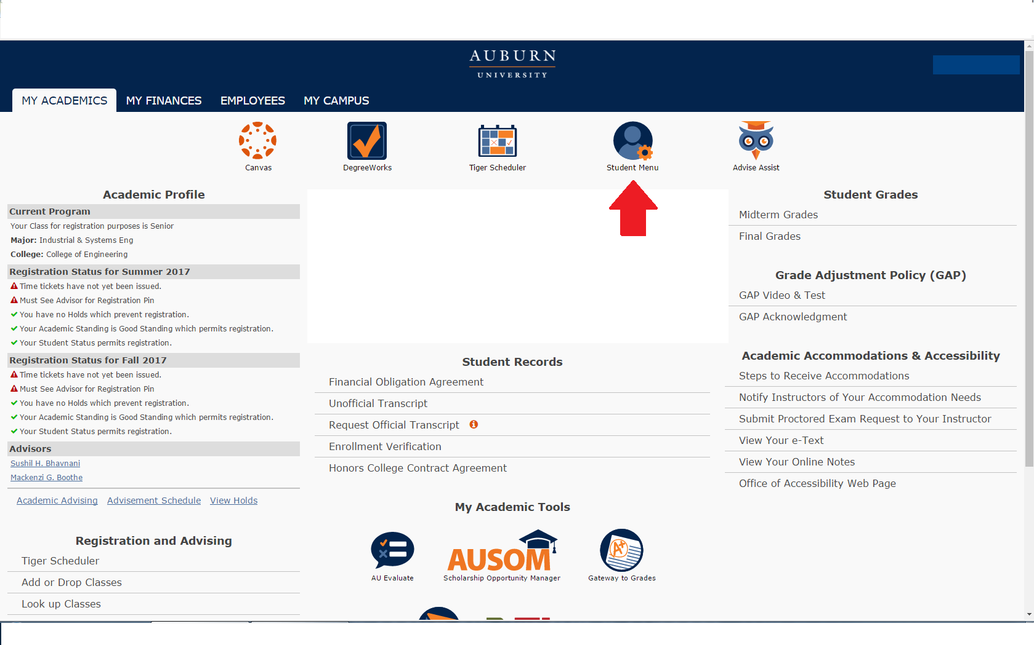

**2. Near the bottom, students will see an All Access tab. Select it to view classes.**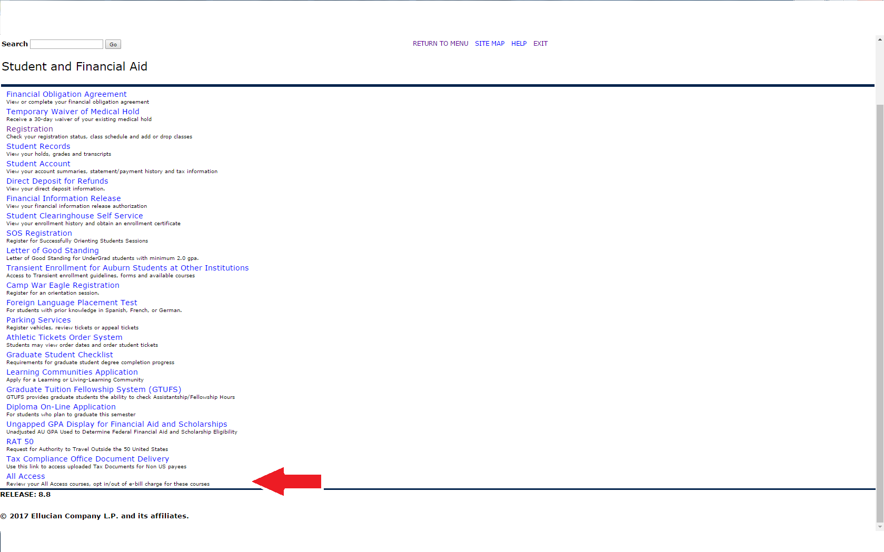

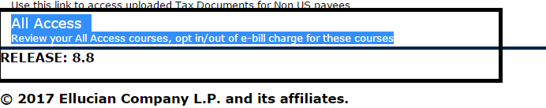

**3. Once in here, they will select their the current term:**

au access


**4. Once the current term is selected, All Access courses will populate with options to change out to the right.**

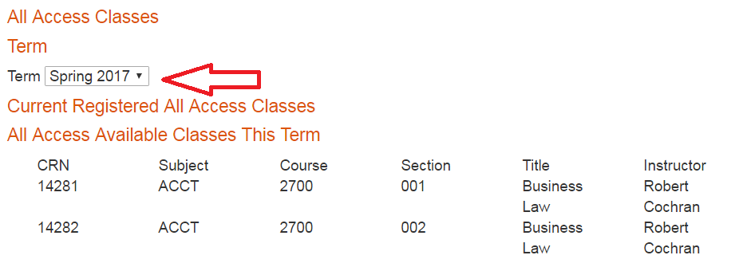

**5. Students can click the change button to opt in or out of the All Access material. NOTE: This does not change your registration in the class, just your purchase option for the course materials.**

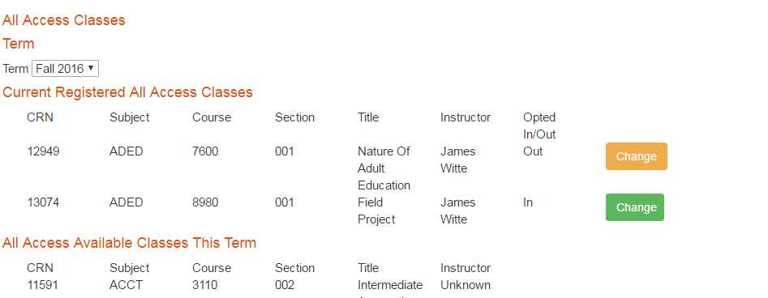

**6. You will be prompted to provide a reason for opting out of the class.**

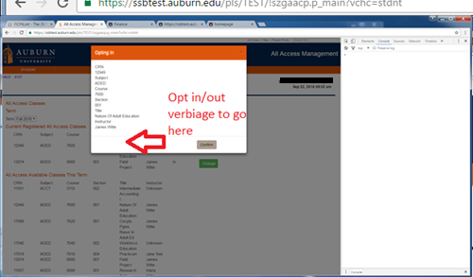

**7. If completed correctly, there will be a green ‘Success’ near the middle of the page.**

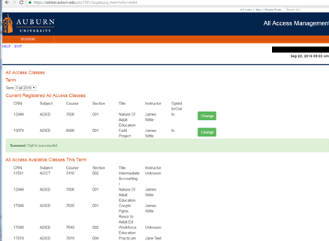

**You may opt in or out at any time before the fifteenth class day. After that day, charges are sent to the Bursar to be applied to your e-bill. We may not be able to reverse the charge after that date.**

**We are able to apply All Access charges for course materials to scholarships that are normally handled through our scholarship counter in store. We will also apply charges for student athletes to the Athletic Department if a student’s scholars**