**AUBURN UNIVERSITY**

**DEPARTMENT OF SPECIAL EDUCATION, REHABILITATION, AND COUNSELING**

**Course Syllabus**

1. **Course Number:** RSED 8030

|  |  |
| --- | --- |
| **Course Title:** | Disabilities and Professional Issues |
| **Credit Hours:** | 3 Semester Hours |
| **Class Meeting**  **Date/Time** | **RSED 8030 graduate students** will attend live ZOOM class meetings on Monday & Wednesday 5:00pm to 8:45pm and  designated on campus class meetings held in Haley 2222  **RSED 8030D distance graduate students** will complete the course in an asynchronous format and can also ZOOM in for class. Only RSED 8030D students can complete class in asynchronous format. |
| **Class Location** | Haley 2222 for delineated on campus meetings |
| **Prerequisites:** | Departmental approval |
| **Corequisites:** | None |
| **Instructors:** | Suzanne Woods-Groves Ph.D. |
| **Office Location:** | 1232C Haley Center |
| **Phone/E-mail:** | (334) 844- 7621  [woodssu@auburn.edu](mailto:woodssu@auburn.edu) |
| **Office Hours:** | ZOOM by appointment other office hours TBA |

1. **Date Syllabus Prepared:** May 2023

# Texts or Major Resources:

**REQUIRED TEXTS Available via ALL ACCESS or you can order from vendor**

* McLeskey, J., Maheady, L., Billingsley, B., Brownell, M. T., & Lewis, T. J. (2022). *High leverage practices for inclusive classrooms,* (2nd Edition). Routledge. ISBN-10 ‏ : ‎ 0367702304
* Pennington, R., Ault, M. J., Courtade, G., Jameson, J. M., & Ruppar, A. (2023). *High leverage practices and students with extensive support needs. Routledge. ISBN 978-0-367-77255-0*
* Bateman, D., & Yell, M. L. (2019). Current trends and legal issues in special education (1st Edition). Corwin. ISBN-10: 1544302002
* Publication Manual of the American Psychological Association, 7th Edition

# Required Readings: Available via CANVAS (Additional Readings will be announced)

# American Association on Intellectual & Developmental Disabilities AAIDD

<http://aaidd.org/news-policy/policy/position-statements#.WPEAPGe1tQ5> Policy Statement

Atkinson, D., & Walmsley, J. (2010). History from the inside: Towards an inclusive

history of intellectual disability. *Scandinavian Journal of Disability Research, 12*(4), 273-286. <https://storage.googleapis.com/jnl-su-j-sjdr-files/journals/1/articles/386/submission/proof/386-1-1378-1-10-20171117.pdf>

Carnine, D.. (1997). Bridging the Research-to-Practice Gap. *Exceptional Children. 63.* 513-521.

Hallahan, D., & Mercer, C. (2001). Learning disabilities: Historical Perspectives. Paper presented at the American Institutes of Research Learning Disability Summit in Washington DC <https://files.eric.ed.gov/fulltext/ED458756.pdf> Executive Summary.

McIntyre, D. (2005). Bridging the gap between research and practice. *Cambridge Journal of Education, 35*(3), 357-382.

World Report on Disability (2011). <https://www.who.int/teams/noncommunicable-diseases/sensory-functions-disability-and-rehabilitation/world-report-on-disability>

**Web Sites:**

* CEEDAR Center <http://ceedar.education.ufl.edu/>
* Consortium for Citizens with Disabilities <http://c-c-d.org/>
* Coalition for Teaching Quality <http://coalitionforteachingquality.org/main/index.cfm?ID=2>
* National Association of State Directors of Special Education  [(nasdse.org)](https://www.nasdse.org/)
* National Council on Teacher Quality <http://www.nctq.org/siteHome.do>
* Office of Special Education Programs <https://www2.ed.gov/about/offices/list/osers/osep/index.html>
* Politico <http://www.politico.com/education/>
* Higher Education Consortium for Special Education <http://www.hecse.net/>
* U.S. Department of Education <http://www.ed.gov/>
* Committee for Education Funding <http://cef.org/>

**REQUIRED TECHNOLOGY:**

All students in this course are expected to have all the equipment and software needed to be successful in the course. You will need to access weekly recorded lectures, assignments, quizzes, and materials posted via CANVAS and PANOPTO. You will complete and submit your exams and assignments via CANVAS. Ensure you have a working computer and reliable internet connection. Be sure you have installed and have access to all of the software required to participate in the course and complete your assignments (Canvas, PDF reader, Panopto).

# Course Description:

Critical and contemporary issues regarding disability and its relationship to the leadership roles of professionals in special education and rehabilitation.

# Student Learning Outcomes: students will:

1. Discuss the role of disability in society.
2. Explain the development of disability civil rights.
3. Examine the development of prominent legislation governing disability rights.
4. Evaluate the impact of other marginalizing conditions on disability (e.g., race, gender, and socioeconomic status).
5. Discuss and debate contemporary disability issues regarding education, related services, and adult services.
6. Articulate the issues related to the lifespan of disabilities.
7. Explore issues related to the preparation and retention of service providers for persons with disabilities.
8. Identify emerging and possible future issues in their related fields.
9. Develop an advocacy project

6. **COURSE CONTENT SCHEDULE This syllabus** is a tentative outline for the course and is **subject to change** with advance notice from the instructor.

|  |  |  |  |
| --- | --- | --- | --- |
| **Meeting Dates** | **Topic** | **Readings** | **Assignments & Due Dates**  **Submit All Assignments via CANVAS** |
| **05/17**  **Wed.**  **ZOOM Class Meeting**  **MODULE 1** | HLPs Collaboration  Working with parents  Plagiarism  Syllabus  Issues in Special Ed.  Advocacy  **Introduce Disabilities Service Project** | **Read Textbook(s)**  InclusiveHigh Leverage Practices (HLP) Ch.1 to 3  HLP for Learners with Extensive Support Needs Ch. 1 to 3  Trends & Legal Issues Ch 1 & 3 | **DUE Monday 05/22 by 11:59pm**   * APA Plagiarism quizzes and test in online Plagiarism training * Plagiarism website tutorial * Quiz 1 High Leverage Practices * Quiz 2-Plagiarism & APA * **Congressional Delegation Project** |
| **05/22**  **Mon.**  **ZOOM Class Meeting**  **MODULE 2** | HLPs Assessment practices  Using Data  Research to Prac. Gap  Legislation & FAPE  Advocacy  Comprehensive, Integrated Ci3T Models of Prevention  **Congressional Delegation Presentations**  **Introduce Disabilities proj** | **Readings to be completed by Wed 05/31**  InclusiveHLPs Ch. 4 to 6  HLPs for Learners with Extensive Support Needs Ch. 4 to 6  Trends & Legal Issues Ch 2, 3, 7  **Articles**:  1997 Carnine  2005 McIntyre | **DUE Tues. 05/30 by 11:59pm**   * Quiz 3 * Quiz 4 * **Disabilities Service Project Due & Presentations Due** |
| **05/24**  **Wed.**  **ZOOM Class Meeting**  **MODULE 3** | HLP Student Engagement  Accountability  Discipline  Special Ed Trends for Transition age youths  **Ethical Principles and Practice Standards**  **Introduce HLP Paper** |  | **DUE Tues 05/30 by 11:59pm**  Quiz 5  Quiz 6  **Disabilities Service Project Due & Presentations Due**  **HLP Paper topic due**  **DUE Wed 05/31 all assigned readings** |

|  |  |  |  |
| --- | --- | --- | --- |
| **Class Meeting Dates** | **Topic** | **Readings** | **Assignments & Due Dates** |
| **05/29**  **Mon.**  **No Class** | No Class Meeting  Memorial Day |  |  |
| **05/31**  **Wed**  **ZOOM Class Meeting**  **MODULE 4** | HLP Feedback  Trends in Early Childhood Special Ed., & Bullying  Innovation in Schools  **Introduce Advocacy Project**  **Student Disabilities Proj presentations due** | **Reading Assignments Due Mon 06/05**  InclusiveHLPs Ch. 7 & 8  HLPs for Learners with Extensive Support Needs Ch. 7 to 8 | **DUE Monday 06/05 by 11:59pm**  Quiz 7  Quiz 8 |
| **06/05**  **Mon**  **On Campus Meeting**  **MODULE 5 & 6** | Preparing General Ed. Teachers to support students with disabilities  School to prison pipeline  Discuss Advocacy Project | **Reading Assignments Due Wed 06/07**  InclusiveHLPs Ch. 9 & 10  HLPs for Learners with Extensive Support Needs Ch. 9 & 10 | **DUE Monday 06/12 by 11:59pm**  Quiz 9  Quiz 10 |
| **06/07**  **Wed.**  **No Class Meeting** | **Advocacy Project Work**  **Individual ZOOM meetings to discuss progress on HLP paper & PD Module** | **Reading Assignments Due Wed 06/12**  **Select two chapters from Ch 11**  T**o 22** from InclusiveHLPs    **And**  **Select two chapters from Ch 11 to 21**  HLPs for Learners with Extensive Support Needs | **DUE Monday 06/12 by 11:59pm**  **Advocacy Project Due** |

|  |  |  |  |
| --- | --- | --- | --- |
| **Class Meeting Dates** | **Topic** | **Readings** | **Assignments & Due Dates** |
| **06/12**  **Mon**  **MODULE**  **7**  **On Campus Class Meeting** | **Student Presentations**  **Advocacy Project & Presentation Due** | **Reading Assignments Due Wed 06/14**  InclusiveHLPs Ch. 23  Select two Chapters from Trends & Legal issues book | **DUE Wed. 06/14 by 11:59pm**  Quiz 11  Quiz 12 |
| **06/14**  **Wed.**  **MODULE**  **8**  **On Campus Class Meeting** | **Student Presentations**  **HLP & Issues Paper, PD, & presentation Due** |  | **DUE Wed. 06/14 by 11:59pm**  **HLP & Issues Paper, PD, & presentation Due** |
| **06/19**  **Mon.**  **No Class** | Juneteenth  No Class Meeting |  |  |
| **06/21**  **Wed.**  **No Class Meeting** | **EXAM Complete Online via CANVAS**  **Opens Tues. 06/20th and is DUE Wed 06/21 by 11:59pm** |  | **EXAM Complete Online via CANVAS**  **Opens Tues. 06/20th and is DUE Wed 06/21 by 11:59pm** |

# 7. Assignments/Projects:

* **Quizzes:**

Based on the readings indicated on the syllabus, students will complete 12 Quizzes throughout this course. The quizzes will be allow students to demonstrate their knowledge of key components and concepts presented in assigned readings and course material. Each quiz is worth **120 Total Points (12 each = 10 points).**

* **High Leverage Issues Paper, Presentation, and Discussion:** Students will each complete a comprehensive review of a pertinent high leverage practice relevant to educational stakeholders. The high leverage practice will reflect essential practices for supporting stakeholders, educators, and individuals with disabilities. *Students will broaden and deepen professional knowledge, and expand expertise with instructional technologies, curriculum standards, effective teaching strategies, and assistive technologies to support access to and learning of challenging content. * Conduct, evaluate, and use inquiry to guide professional practice. **Online Support Professional Development Module for High Leverage Practices.** Students will develop a Professional Development Online module for practitioners. See directions in CANVAS Module. This assignment is worth **300 points (Paper =150 points; Presentation and Discussion =150 points).**
* **Disability Services Presentation** Students will identify and research the services provided by an agency that serves persons with disabilities. *Students will evaluate progress toward achieving the vision, mission, and goals of programs, services, and supports for individuals with exceptionalities.*Students will use foundational knowledge of the field and professional **Ethical Principles and Practice Standards** <https://exceptionalchildren.org/standards/ethical-principles-and-practice-standards> to inform special education practice, engage in lifelong learning, advance the profession, and perform leadership responsibilities to promote the success of professional colleagues and individuals with exceptionalities. A review of the services provided by the agency selected will be presented in a video slide show presentation. **This presentation should include the following: (50 points)**
  + Administrative structure of the agency (e.g., federal, state, local)
  + Services provided
  + Description of consumers to be served
  + Eligibility requirements
  + Identification of service provider roles and responsibilities in that agency
  + Training requirements for positions within the agency
* **Advocacy Project and Presentation** -Students will identify and develop an advocacy project. **\***Students will apply knowledge of theories, evidence-based practices, and relevant laws to advocate for programs, supports, and services for individuals with exceptionalities. **\***Students will advocate for policies and practices that improve programs, services, and outcomes for individuals with exceptionalities. **(20 points)**
* **Congressional Delegation**- Students will research their congressional delegation. (Every member of Congress has a website.) You will have two Senators from your state and a Representative. (Feel free to include more than one representative as you may have one representative for the district your university is in and another one for your home address.) (**20 points)**

**Create a chart or some other visual that summarizes the following information:**

1. What are the names of your Senators and Representatives and the locations of their offices in Washington and near you?
2. What congressional district does your representatives represent (this will be a number, like the 6th Congressional district of South Carolina)?
3. What is the party affiliation of each member of your delegation?
4. How long has each member of the delegation been in office?
5. What committees do your Representatives serve on that might be relevant to education or disability?
6. Might you have any potential personal connections with members of your delegation (e.g. went to the same high school, neighbor of your parents)?
7. Is there anything else you learned that might assist you in being an effective advocate?
   * + **Exam:** Students will take an exam that will include a variety of types of questions- - multiple choice, short answer, fill-in- the-blank, and essay. The exam may include material from class lectures, readings, and the activities that will occur duringthe course. The exam will be available on Canvas. You will have one attempt to take the exam and there is a time limit (120 minutes). **(100 points)**

# 8. Evaluation Grading Scale:

Final grades will be based on points assigned through completion and evaluation of course requirements and grades will be assigned on the basis of number of accumulated points, as follows:

|  |  |  |
| --- | --- | --- |
| **Assignments** | **Points** | **Percentage Pts** |
| **Quizzes (12)** | 120 | 19.6% |
| **Exam (1)** | 100 | 16.4% |
| **Congressional Delegation Project** | 20 | 3.3% |
| **Disability Services Presentation** | 50 | 8.2% |
| **High Leverage Issues Paper, Presentation, Online Support MODULE and Discussion** | 300 | 49.2% |
| **Advocacy Project** | 20 | 3.3% |
| **Total Points** | **610** | **100%** |
|  |  |  |

**610 points Total**

**549-610 points A**

**488-548 points B**

**427-487 points C**

**366-426 points D**

**365 and below points F**

# 9. Justification for Graduate Credit

This course requires extensive analysis of scholarly journal articles in order to complete the position paper. This analysis requires students to use critical thinking skills to synthesize information from the class with the articles. The presentation requires extensive analysis of an existing agency in the field. This presentation requires students to analyze and apply all of the information presented in the course. This course also includes formative and summative examinations. These course requirements represent a rigorous standard of evaluation consistent with graduate credit.

**10. CLASS POLICY STATEMENTS**

***Extra Credit:* No extra credit opportunities will be provided. Final grades will be comprised of points earned on the activities, tests, and projects described in the syllabus.**

**COVID Related Policies**

Students should stay current with these practices and expectations <https://auburn.edu/covid-resource-center/>

# ACADEMIC INTEGRITY

Auburn University has adopted an Honor System proposed by its students and faculty to promote academic integrity and has enacted the following code:

*“We, the faculty, instructors, and students of the (University course here) pledge to fulfill our mutual responsibilities to each other and the academic community at large with honor and integrity in order to build and maintain a climate of respect and trust that will enhance our research, teaching, and learning. We will support the Honor System of the School, and will not tolerate activities that undermine academic integrity.”*

Academic dishonesty is an offense that will be reported to the Academic Honesty Committee. Please refer to the following document for further information regarding academic honesty: [Auburn University Student Academic Honesty Code](https://sites.auburn.edu/admin/universitypolicies/policies/academichonestycode.pdf)

**Academic Honesty Policy**: All portions of the Auburn University student academic honesty code (Title XII) found in the Student Policy eHandbook will apply to university courses. All academic honesty violations or alleged violations of the SGA Code of Laws will be reported to the Office of the Provost, which will then refer the case to the Academic Honesty Committee.

**Honesty Code**: The University Academic Honesty Code and the Tiger Cub Rules and Regulations pertaining to Cheating will apply to this class. The Auburn Academic Honesty Code is found in both the Tiger Cub and the Student Government Association’s Code of Laws. Students are to read the honor code carefully, making sure they understand the policy, its implications for their work (e.g. tests, reports, papers, projects), and the consequences of code violation. Non-compliance with this policy will result in formal action with the university academic honesty procedures. Among other things, students are responsible for understanding the definition of plagiarism. Individuals are to (a) reference materials they use, and (b) reference only material they access directly. Individuals who copy or use ideas from the works of others without properly acknowledging the author, risk grave consequences.

**Excused Absences:** Students are granted excused absences from class for the following reasons: Illness of the student or serious illness of a member of the student’s immediate family, death of a member of the student’s immediate family, trips for student organizations sponsored by an academic unit, trips for University classes, trips for participation in intercollegiate athletic events, subpoena for a court appearance and religious holidays. **Students who wish to have an excused absence from this class for any other reason must contact the instructor in advance of the absence to request permission. The instructor will weigh the merits of the request and render a decision. When feasible, the student must notify the instructor prior to the occurrence of any excused absences, but in no case shall such notification occur more than one week after the absence. Appropriate documentation for all excused absences is required.**

**Make-Up Policy:** Arrangements to make up missed major examination (e.g. hour exams, mid-term exams) due to properly authorized excused absences. Except in unusual circumstances, such as continued absence of the student or the advent of University holidays, a make-up exam will take place within two weeks from the time the student initiates arrangements for it. Except in extraordinary circumstance, no make-up exams will be arranged during the last three days before the final exam period begins. The format of the make-up exam will be (as specific by the instructor).

**Accommodations**: Students who need accommodations are asked to electronically submit their approved accommodations through AU Access and to arrange a meeting during office hours the first week of classes, or as soon as possible if accommodations are needed immediately. If you have a conflict with my office hours, an alternate time can be arranged. To set up this meeting, please contact me by e-mail. If you have not established accommodations through the Office of Accessibility, but need accommodations, make an appointment with the Office of Accessibility, 1228 Haley Center, 844-2096 (V/TT).

***Assignments:*** All written assignments are expected to use person-first language (i.e. “child with a disability” rather than “disabled child”). Written assignments are expected to be typewritten, grammatically accurate, and free of spelling and typographical errors. Assignments are to be of a quality that would be expected of a professional. **Please do not email me assignments, they will not be graded. All Assignments must be submitted via CANVAS or through Auburn BOX when indicated and typed.**

**All assignments must be turned in when due via CANVAS unless otherwise indicated. Assignments must be turned in by the student completing the assignment. No late assignments will be accepted unless the instructor has received prior notice of absence (via phone, email, etc…) that can be verified as a university approved excuse. When prior notice is provided and the student has a university approved excuse, he or she will have one week from the time he or she returns to class to turn in the assignment.**

***Professionalism:*** As faculty, staff, and students interact in professional settings, they are expected to demonstrate professional behaviors as defined in the College’s conceptual framework. These professional commitments or dispositions are listed below:

* + Engage in responsible and ethical professional practices
  + Contribute to collaborative learning communities
  + Demonstrate a commitment to diversity
  + Model and nurture intellectual vitality

**Classroom Behavior: “**Behavior in the classroom that impedes teaching and learning and creates obstacles to this goal [learning] is considered disruptive and therefore subject to sanctions… Students have the responsibility of complying with behavioral standards… Examples of improper behavior in the classroom (including the virtual classroom of e-mail, chat rooms, telephone, and web activities associated with courses) may include, but are not limited to the following: arriving after a class has begun; use of tobacco products; monopolizing discussion; persistent speaking out of turn; distractive talking including cell phone usage; audio or video recording of classroom activities or the use of electronic devices (including cell phones) without the permission of the instructor; refusal to comply with reasonable instructor directions; employing insulting language or gestures; verbal, psychological, or physical threats, harassment, and physical violence.” (See *Tiger Cub*).

***Student Academic Grievance Policy:*** The purpose of this university policy is to “resolve academic grievances of students, which results from actions of faculty or administration. This resolution should be achieved at the lowest level and in the most equitable way. The burden of proof rests with the complainants.” See *Tiger Cub* for steps toward redress.

**Confidentiality:** Respect family rights to privacy, the identity of children and families will be confidential.

**Emergency Contingency statement:**

If normal class and/or lab activities are disrupted due to illness, emergency, or crisis situation, the syllabus and other course plans and assignments may be modified to allow completion of the course. If this occurs, an addendum to your syllabus and/or course assignments will replace the original material.

If you are experiencing stress that feels unmanageable (personal or academic) during the semester, Auburn University’s Student Counseling & Psychological Services (SCPS) offers a variety of services to support you. The mission of SCPS is to provide comprehensive preventative and clinical mental health services to enhance the psychological well-being of individual students, as well as the broader campus culture. As an instructor, I am available to speak with you regarding stresses related to your work in this course, and I can assist in connecting you with the SCPS network of care. You can schedule an appointment yourself with the SCPS by calling [(334)844-5123](tel:+13348445123) or by stopping by their offices on the bottom floor of Haley Center or the second floor of the [Auburn University Medical Clinic. (Links to an external site.)](http://auburn.edu/map/?id=150)

If you or someone you know needs to speak with a professional counselor immediately, the SCPS offers counseling during both summer term as well as the traditional academic year. Students may come directly to the SCPS and be seen by the counselor on call, or you may call [334.844.5123](tel:+13348445123) to speak with someone. Additional information can be found at [http://wp.auburn.edu/scs (Links to an external site.)](http://wp.auburn.edu/scs/).

**To opt in or out of an All Access class:**

**1.Log into AU Access, and then Select Student Menu:**

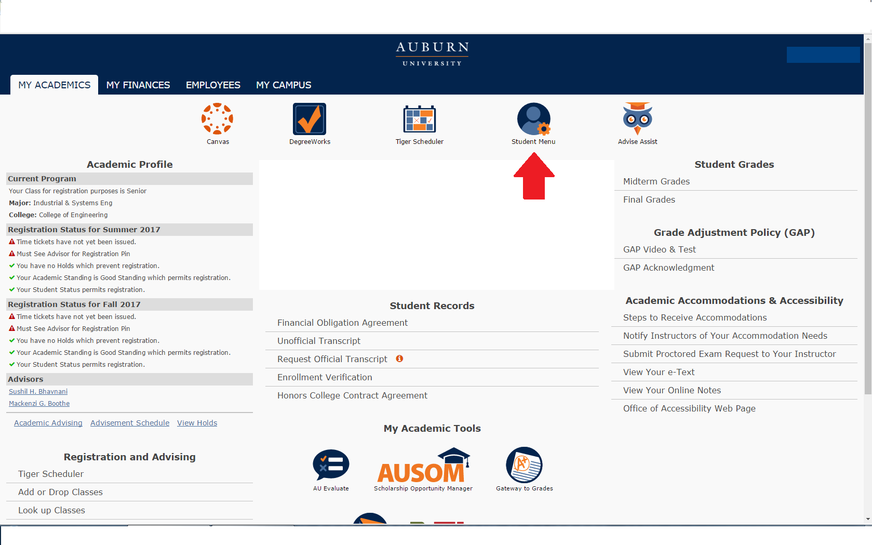

**2. Near the bottom, students will see an All Access tab. Select it to view classes.**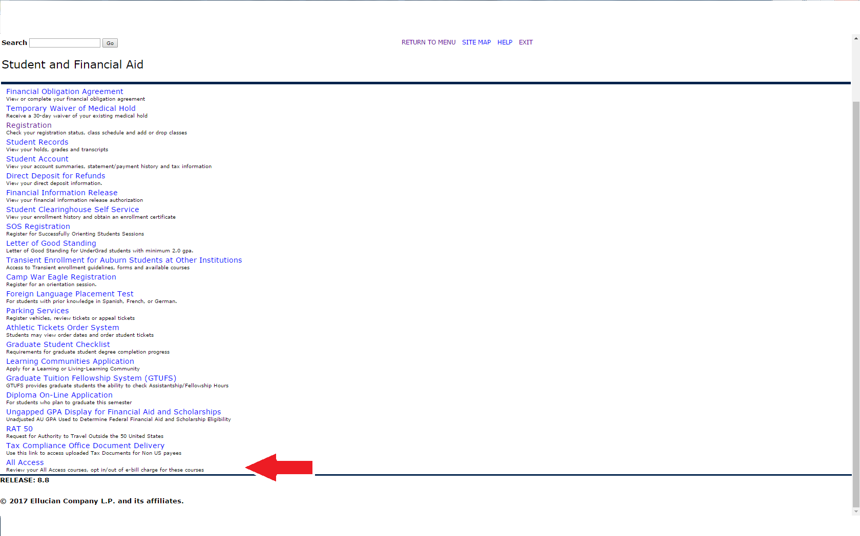

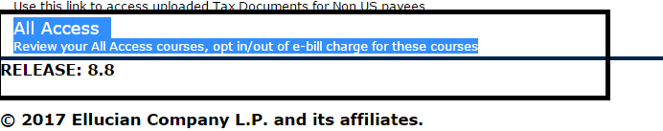

**3. Once in here, they will select their the current term:**

au access


**4. Once the current term is selected, All Access courses will populate with options to change out to the right.**

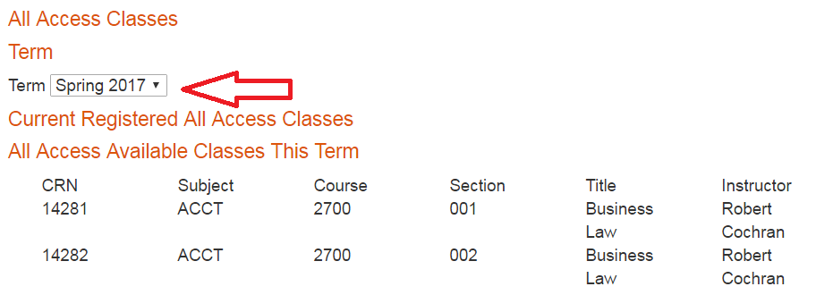

**5. Students can click the change button to opt in or out of the All Access material. NOTE: This does not change your registration in the class, just your purchase option for the course materials.**

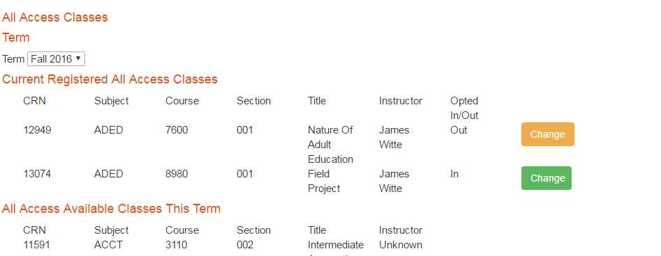

**6. You will be prompted to provide a reason for opting out of the class.**

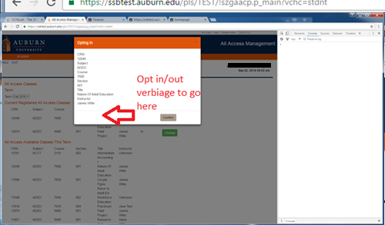

**7. If completed correctly, there will be a green ‘Success’ near the middle of the page.**

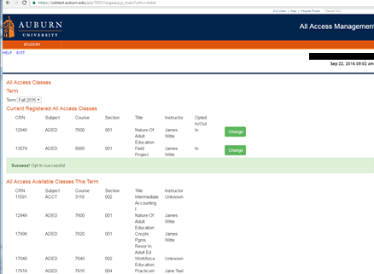

**You may opt in or out at any time before the fifteenth class day. After that day, charges are sent to the Bursar to be applied to your e-bill. We may not be able to reverse the charge after that date.**

**We are able to apply All Access charges for course materials to scholarships that are normally handled through our scholarship counter in store. We will also apply charges for student athletes to the Athletic Department if a student’s scholars**