**CTES7400 and 7400D Summer 2024**

**Auburn University**

Department: Curriculum & Teaching

Course Title/Credit: Techn & Media in ESL Education; 3 hrs

Room and Schedule: Haley 2454; Thursday 4:00 – 7:50 p.m.

Zoom Room: See Zoom tab in Canvas

Instructor: Dr. Jamie Harrison [jlh0069@auburn.edu](mailto:jlh0069@auburn.edu)

Phone Number: 334-844-8278

Office: Haley Center 5080

Office Hours: Online as requested.

**1. COURSE DESCRIPTION**

This course is a study of technology and media applications for teaching English to Speakers of Other Languages (ESOL). Students will examine ways to effectively incorporate technology and media into the ESL/EFL classroom.

You will come away from this course with a better understanding of yourself as a user of technology, the ways techonolgy enhances the language learning process, and a battery of techonological resources to support teaching and learning.

**Text:**

Walker, A. & White, G. (2013). *Technology enhanced language learning: Connecting theory and practice.* Oxford, United Kingdom: Oxford University Press.

Note: You may purchase a hard copy or use the provided All Access option. For more information about All Access, please read here: http://aub.ie/allaccess

Other readings as provided by instructor.

Other Expenses: Students will be exposed to a variety of technology applications which might require purchase; estimated cost $25.

**Course Objectives:** Engaged learners in this course can look forward to:

* Identifying and utilizing Internet-based and software resources for teaching ESL/EFL.
* Evaluating the effectiveness and appropriateness of a variety of technologies for teaching the English language student.
* Using computer and media technologies to address the ESL/EFL language domains of listening, speaking, reading and writing.
* Selecting and integrating appropriate instructional materials, media, and technology for ELL students at various language proficiency and age levels.
* Reflecting on the way technology can enhance the learning experience of ELLs of variety of levels in multiple contexts.
* Documenting your own growth as a user of technology in the classroom. You will gain online group interaction skills, increasing your comfort in both areas.
* Developing a positive relationship with technology from the perspective of a language instructor.

Active Learning Environment

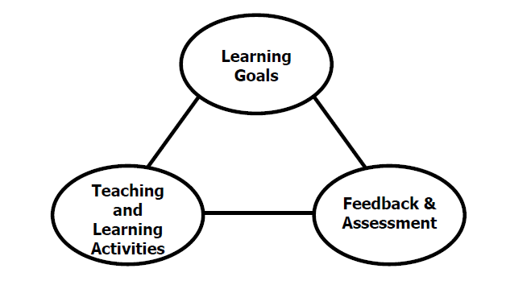

Figure 1. The key components of an integrated course design. (Fink, 2003).

This course has been designed with an active learning framework intended to integrate learning goals, teaching & learning activities, and feedback & assessment. This means you should expect to see a direct relationship between course goals, what we do in class, and how you are assessed. My hope is that you can use this course as a guide for developing your own English language courses.

A variety of teaching and learning experiences have been designed for this course to support the six key dimensions of significant learning (Fink, 2003).

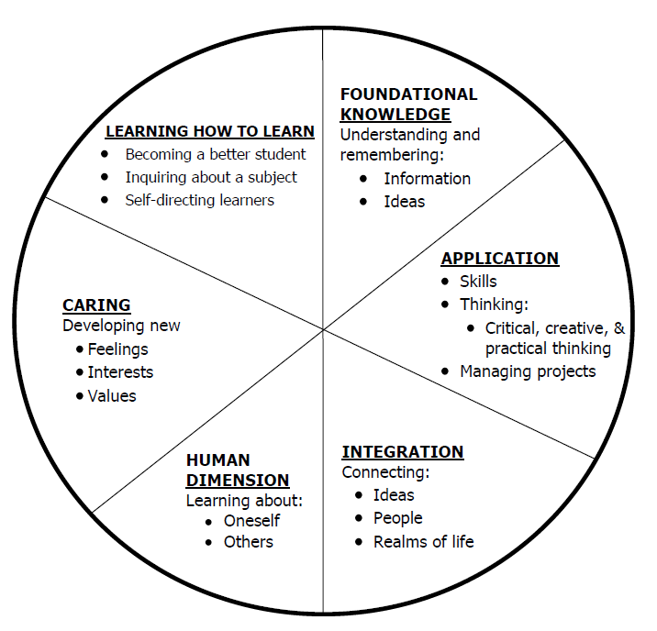

Figure 2. The taxonomy of significant learning (Fink, 2003)

Fink, L.D. 2003. A Self Directed Guide to Designing Courses for Significant Learning. San Fransisco: Jossey-Bass, pp. 37.

**2. COURSE REQUIREMENTS**

In an effort to understand how much is expected of a graduate student outside of classtime, I have utilized the “Course Workload Estimator” at <https://cte.rice.edu/blogarchive/2016/07/11/workload>

**ASSIGNMENTS**

**Technology tasks (15 @ 10 points each = 150 points):** You will participate in a variety of technology tasks throughout the semester. Each task will be accompanied with a reflection or discussion question. Tasks and reflections will be shared with classmates in informal discussion board setting. All tech tasks and reflections will be due on Wednesdays at 11:59 p.m.

**Student-led Chapter Active Learning Lecture (200 points):** You will prepare an active learning lecture/presentation about one of the chapters in the course text. The lecture/presentation will involve utilizing one of the presentation tools listed at <https://www.softwaretestinghelp.com/best-presentation-software/> (or others as recommended or approved by instructor). The lecture/presentation should discuss the key objectives of the chapter, introduce and elaborate on key terms and concepts, and include at least one [active learning strategy](https://teaching.cornell.edu/getting-started-active-learning-techniques) in addition to an activity that highlights a featured technology of the chapter.

**Technology Resource Curation (100 points):**

You will collect and vet a variety of tech apps and tools for a specific ESL context using an appropriate rubric for technology, media, website evaluation. Individually students will identify 25 different apps, software, websites, etc. addressing all language domains and reflect a variety of language levels for evaluation and review. Final product will be a Padlet or other curation platform (<https://themeisle.com/blog/best-content-curation-tools/#gref>) that could be shared with others in the same context.

**Tech Demo (100 points)**

You will choose a tech app/issue of interest to read up on/learn about (including news and academic research articles) related to the intersection of that technology and language learning/teaching. Students will prepare a demonstration for the class to generate discussion about applications to English language teaching and learning. Talk should include visuals, demos, and hands-on elements to engage us with the issue at hand. Potential topics include but are not limited to: Artificial Intelligence, Mobile language learning apps, virtual and augmented reality, Minecraft for language learning, translation apps, corpus tools, etc. Talk can focus on one app/tool or be a broad overview of many apps/tools of the same genre.

**Modern Classroom Project Unit (400 points)**

Students will develop a major unit of study using the Modern Classroom Project platform. More details will be provided in class.

**Weekly Participation (50 points)**

Weekly participation will include attendance and participation in weekly tech explorations. If you are absent it will be up to you to post to the weekly Discussion Board based weekly explorations.

Grading and Evaluation:

The grading scale will be:

**A = 1000 – 900**

**B = 899 – 800**

**C = 799 – 700**

**D = 699 – 600**

**F = 599 or below**

Attendance and Participation: Active learning experiences are only as powerful as you, the students in class, make them. Therefore, it is really important that you come to class each week and that you come prepared for group interactions and class discussions. As graduate level students, you should be able to prepare outside of class up to three hours per hour in class. That is up to nine hours of preparation. So, as part of this weekly preparation, please be sure to read and view any required material prior to class each week, complete all assigned discussion posts, and prepare for all group and individual assignments. **More than two unrequested and/or unexcused absences will result in a 10% reduction on your final average.**

Distance Student Requirements: The distance section is "synchronous - flexible" for distance students. My preference is that you join us synchronously as this will give you the optimum access to the active learning experiences designed for the course. **Please email me if you are not able to attend the in-person sessions due to scheduling conflict.** The following will be available to distance students:

- full Panopto or Zoom recording of weekly F2F class sessions

- Canvas modules that outline weekly expectations

- Canvas discussion boards

- flexible office hours

Distance students follow the same weekly schedule as F2F students, and adhere to all assignment due dates as listed in the syllabus or outlined in Canvas as the course proceeds.

Late Assignments: Late assignments lose 10% credit per unexcused day late to a maximum of 30% lost credit. Assignments will not be accepted beyond 2 weeks past the original due date without a doctor’s note.

Assigned Readings: Beyond the required textbooks, some additional readings will be available in Canvas. Readings will be discussed in various manners ranging from course Canvas discussions to embedded in class assignments. These readings contain information that will be included in the group quizzes, reflections, projects, examinations, and other course requirements.

Justification for Graduate Credit: CTES 7400 is a comprehensive course of study in technology and media applications for teaching English to Speakers of Other Languages (ESOL). Students will examine ways to effectively incorporate technology and media into the ESL/EFL classroom. You will come away from this course with a better understanding of yourself as a user of technology, the ways techonolgy enhances the language learning process, and a battery of techonological resources to support teaching and learning. The rigorous examination of technology and its implications for teaching and learning English as a second language justify the placement of this course at the graduate level.

.

**2. COLLEGE AND UNIVERSITY POLICIES**

**Participation:** Students are expected to attend class and participate in all class discussions, exercises, and activities.

It is the student’s responsibility to contact the instructor if assignment deadlines are not met. Students are responsible

for initiating arrangements for missed work.

**Attendance/Absences:** **Excused Absences**: Students are granted excused absences from class for the following reasons: Illness of the student or serious illness of a member of the student’s immediate family, death of a member of the student’s immediate family, trips for student organizations sponsored by an academic unit, trips for University classes, trips for participation in intercollegiate athletic events, subpoena for a court appearance and religious holidays. Students who wish to have an excused absence from this class for any other reason must contact the instructor in advance of the absence to request permission. The instructor will weigh the merits of the request and render a decision. When feasible, the student must notify the instructor prior to the occurrence of any excused absences, but in no case shall such notification occur more than one week after the absence. Appropriate documentation for all excused absences is required.

**Make-Up Policy:** Arrangements to make up missed major examination (e.g. hour exams, mid-term exams) due to properly authorized excused absences. Except in unusual circumstances, such as continued absence of the student or the advent of University holidays, a make-up exam will take place within two weeks from the time the student initiates arrangements for it. Except in extraordinary circumstance, no make-up exams will be arranged during the last three days before the final exam period begins. The format of the make-up exam will be (as specific by the instructor).

**Late Assignments:** Late assignments lose 10% credit per unexcused day late to a maximum of 30% lost credit.

**Unannounced Quizzes:** There will be no unannounced quizzes.

**Accommodations:** Students who need special accommodations in class, as provided for by the American Disabilities Act, should arrange a confidential meeting with the instructor during office hours the first week of classes – or as soon as possible if accommodations are needed immediately. You must bring a copy of your Accommodation Memo and an Instructor Verification Form to the meeting. If you do not have these forms but need accommodations, make an appointment with the Program for Students with Disabilities, 1244 Haley Center, 844-2096.

**Academic Honesty Policy:** All portions of the Auburn University student [Academic Honesty Code](https://sites.auburn.edu/admin/universitypolicies/Policies/AcademicHonestyCode.pdf) (Title XII) will apply to this class. All academic honesty violations or alleged violations will be reported to the Office of the Provost, which will then refer the case to the Academic Honesty Committee.

**Professionalism:** Faculty, staff, and students in professional settings are expected to demonstrate professional behaviors as defined in the College’s conceptual framework. These professional commitments or dispositions are as follows: Engage in responsible and ethical professional practices; contribute to collaborative learning communities; demonstrate a commitment to diversity; model and nurture intellectual vitality.

**Writing Center:** The Miller Writing Center provides free support on any writing you are doing while at Auburn, whether for a course or not. Trained consultants are available to work with you as you plan, draft, and revise your writing. For students in distance courses and students temporarily away from Auburn’s campus, the Miller Writing Center offers synchronous online consultations. Please check the Miller Writing Center website ([www.auburn.edu/writingcenter](http://www.auburn.edu/writingcenter)) for instructions and information about scheduling online appointments. If you have questions about the Miller Writing Center, please email [writctr@auburn.edu](mailto:writctr@auburn.edu) or call 334-844-7475 M-F  7:45am-4:45pm.

**Student eHandbook:** Please refer to <http://www.auburn.edu/student_info/student_policies/> for all AU student policies.

**Distance Learning Students**: Unless specific instructions have been given for a designated course, students in distance education courses shall take all closed resource examinations under the supervision of an approved proctor. Examples of approved proctors include a school superintendent, a principal of a high school, or a dean or department head of a college. Proctors shall be verified and exams shall be sent directly to the proctor who will manage the examination in a secure manner, requiring students to present a picture ID.

**Additional Resources:**

***Student Policy eHandbook:*** <http://www.auburn.edu/student_info/student_policies/>

***Health and Wellness Resources*** <https://cws.auburn.edu/studentAffairs/healthAndWellness/>

***Academic Support Services:*** <http://www.auburn.edu/academic/provost/undergrad_studies/support/>

4. TENTATIVE SCHEDULE

Please note that this is a tentative summary of the schedule and activities/due dates may change during the semester. Follow the assignments as posted on the weekly modules in Canvas. For reference, here is the link to the AU academic calendar: <http://www.auburn.edu/main/auweb_calendar.php>

**Weeks marked with asterisk (*) will be online only, possibly asynchronous. There might be others held online due to unforeseen circumstances as well.**

|  |  |  |  |
| --- | --- | --- | --- |
| Week | Topics | Reading (prior to class session) | Assignments |
| 1 5/16 | Course introduction  Digital competencies survey  Tech Standards Questionnaire  Modern Classroom Project  Tech spotlight: Voki  Tech spotlight: Flipgrid  Tech Exploration 1: Tech & Language Learning | TESOL Tech Standards  *What schools for tomorrow?*  Download and read syllabus  Order textbook | Tech task 1: Voki introduction  Tech task 2: Wakelet  Sign up for student-led Tech Demo (due dates vary)  Sign up for active learning chapter presentation (due dates vary)  Register for and begin Modern Classrooms Project [Free Online Course](https://www.modernclassrooms.org/) |
| 2 5/23 | Learning & Communication  CALL vs TELL vs MALL  Tech spotlight: Padlet  Tech spotlight: Perusall  Tech Exploration 2: Educational Technology  Presentation Software | Read Chapters 1 & 2 (W&W)  Reading 2: *TELL, CALL, and MALL: Approaches to Bridge the Langauge Gap* | Tech task 3: Padlet creation  Tech task 4: TBA |
| 3 5/30 | Tech & Media for Listening & Speaking  Tech spotlight: TBA  Tech spotlight: TBA  Tech Exploration 3: Video creation Software | Read Chapter 3  Reading 2: *A framework for Web 2.0 learning design* by Bower, Hedberg, Kuswara (in Perusall) | Tech task 5: TBA  Tech task 6: TBA  Modern Classroom Project Essentials Course documentation DUE |
| 4 6/6 | Tech & Media for Reading  Tech spotlight: TBA  Tech Exploration 4: Language Learning apps | Read Chapter 4  Reading 2: TBA | Student-led active learning lecture (Listening) ___________________________  Tech task 7: TBA  Student-led active learning lecture (Speaking) ___________________________  Tech task 8: TBA |
| 5 6/13 | Tech & Media for Writing  Tech spotlight: TBA  Tech Exploration 5: AI and ChatGPT  *Guest lecture with ESOL Community Outreach | Read chapter 5  Reading 2: TBA | Student-led active learning lecture (Reading) ____________________________  Tech task 9: TBA  Student-led active learning lecture (Writing) _______________________________  Tech task 10: TBA |
| 6 6/20 | Tech & Media for Multimodal Literacies  Tech spotlight: TBA  Tech Exploration 6: Corpus Tools | Read chapter 6  Reading 2: TBA | Student-led active learning lecture (Multimodal literacies) _______________________  Student-led active learning lecture (Assessment) ______________________________  Tech task 11: TBA |
| 7 6/27 | Tech & Media for Study Skills  Tech spotlight: TBA  Tech Exploration 7: VR and AR | Read chapter 7  Reading 2: TBA | Student-led active learning lecture (Study Skills) ______________________________  Student-led active learning lecture (Young learners) ___________________________  Student-led active learning lecture (Teaching) _______________________________  Tech task 12: TBA  Tech Demo Carousels |
| 7/4 | Independence Day – No Classes |  |  |
| 8 7/11* | Tech & Media for Young Learners  Tech spotlight: TBA  Tech Exploration 8: Gaming and gamification | Read chapter 8  Reading 2: TBA | Tech task 13: TBA  Tech resource curation (Padlet) DUE |
| 9 7/18* | Tech & Media for Assessment  Tech spotlight: TBA  Tech Exploration 9: TBA | Read chapter 9  Reading 2: TBA | Tech task 14: TBA  Modern Classroom Project DUE |
| 10 7/25* | Tech & Media for Teaching  Tech spotlight: TBA  Tech Exploration 10: TBA | Read chapter 10  Reading 2 TBA | Tech Task 15: TBA  Reviews of MCP DUE |
| FINAL EXAM | NONE |  |  |
|  |  |  |  |

**Important Dates:**

**May 16 Classes Start**

**June 19 No Classes – Juneteenth**

**July 4 No Classes – Independence Day**

**July 29 Classes End**