---------- Forwarded message ---------
From: La Quinta by Wyndham <laquinta@emails.wyndhamhotels.com>
Date: Sat, Jan 18, 2025 at 9:43 AM
Subject: You're All Set: Reservation Confirmation #88824EE044766
To: jankue@gmail.com

 | Jane Kuehne  GOLD Member: XXXXXX525H


Your Reservation Is Confirmed, Jane!

La Quinta Inn & Suites by Wyndham Birmingham Homewood
60 State Farm Parkway, Homewood, AL 35209 US (205) 290-0150
Confirmation Number: 88824EE044766
JAN 23 THU 2025 |  | JAN 25 SAT 2025

Hotel Details | Cancel | Directions

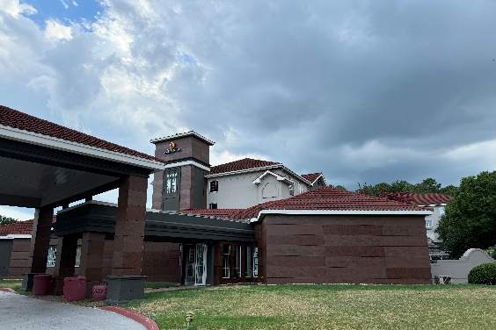 | Reservation Details  1 Room(s) / 2 Night(s)  1 King Bed, Premier Room, Non-Smoking  Number of Guests  1 Adult(s) / 0 Child(ren)  Check-In 3:00 p.m. Checkout 11:00 a.m.

Room Description  Free high-speed WiFi, mini-fridge, microwave, self-controlled temperature, bathtub/shower, coffee/tea maker, hair dryer, HDTV, bathroom amenities, alarm clock, desk, down/feather pillows, streaming web TV, iron, pillow-top mattress | Rate Details  Discounted Night with Points 6,000 Pts.  Discounted Nights with Points + Cash $130.20 USD  Taxes & Fees $26.04 USD  Total for Stay $156.24 USD

Deposit Policy
Reservations have to be guaranteed with a valid credit card number and expiry date
Cancellation Policy
Cancel 24 Hours prior to 4pm day of arrival to avoid 1 Night charge plus tax.

