Registration Confirmation - TESOL 2026 International Convention & Expo
Inbox

 | Jan 9, 2026, 11:28 AM
  TESOL 2026 <TESOL@showcare.com>
to me



  Date: 01/09/2026
  Registration File Number: 183139
  Gwendolyn Williams
  Department of Curriculum And Teaching
  Auburn, Alabama 36849-0001
  Email: eslresearcher@gmail.com

ATTENDEE REGISTRATION CONFIRMATION

Dear Gwendolyn Williams,
Thank you for registering for the TESOL 2026 International Convention & Expo from March 24-27, 2026, in Salt Lake City, Utah.
Please carefully review the information below.

  For the most up-to-date convention information, including schedules and program details, click the TESOL26 Website button.
  To make changes to your registration, you can log into your online account using the Account Access button.
  Connect with colleagues attending the convention, find resources, and access presentation handouts.
  Let's make TESOL 2026 our best convention yet!
  Have two or three hours to spare? Volunteer at TESOL 2026!
  TESOL26 Website
  Account Access
  Join TESOL 2026
  Convention Community
  Volunteer Now!

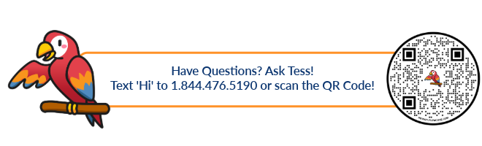

Note: Memberships purchased in conjunction with registration will be activated within 10 business days.

Transaction Summary

This summary reflects your registration fees and fees for any additional purchases you have selected. This financial summary is your receipt for payment of fees.

Purchase Details

Product | Quantity | Price

TESOL Member | Qty: 1 | $395.00

Total Amount Paid: | ​ | $395.00
Total Amount Refunded: | ​ | $0.00
Balance Due: | ​ | $0.00

Transaction Details

Date: 01/09/2026 05:28:41 PM
Name: Gwendolyn Williams
Payment Reference: ************0776
Payment Type Credit card
Amount: 395.00

Your Housing Reservation Information

The following room has been booked. Please refer to the Housing Policies for cancellations and changes.

Hotel Booked: Hyatt Regency Salt Lake City
Room Type: Standard Queen/Queen
Arrival Date: 2026-03-24
Departure Date: 2026-03-28
Guest Name: Gwendolyn Williams
Room Rate: $
Room Total: $1036.00

Housing Policies

- All hotel rates are quoted in and exclude taxes & fees. Hotel room rates are subject to applicable taxes that are in effect at check-out time.
- US government employee ID card may be required upon check-in at the hotel for government room rate validation.
- You will receive an email from your hotel with your confirmation number approximately 2 weeks before arrival. If you do not receive it, please check your spam folder before contacting your hotel.
- The organizer takes no responsibility should a room preference not be available at check-in. Please visit the hotel websites for check-in and check-out times. Should you need to arrive early, please book an additional night; early check-in requests cannot be guaranteed.
- Each guest must present a valid credit card upon check-in.

Housing Cancellation & Changes Policy

Cancellations to room reservations after 1 February 2026 will incur a one-time housing cancellation processing fee of $75 per room. You must contact tesol@showcare.com to request cancellation.
Additional information available for hotel policies and hotel cancellation policies.

Cancellation/Refund/Substitution Policy

You must request a refund in writing, and it must be received by March 1, 2026. No refund will be granted after March 1, 2026.

  To review complete registration and refund policies, click the Registration Policies button.
  Registration Policies

  Send refund requests via email to TESOL by clicking on the Refund Requests button
  Refund Requests

Need Help?

Contact us if you have questions about your registration or housing orders:
Email: tesol@showcare.com
Phone: +1-866-654-4049 or +1-514-380-9364

