Genetics and Seedling Improvements

David B. South

Abstract -- In the South, most landowners use genetically improved loblolly or slash pine seedlings from either first- or second-generation seed orchards. This may increase yield at harvest by 4 to 8 cunits/acre at a cost of about $8/acre. An additional 4 to 8 cunits/acre could be obtained by the use of controlled pollinated crosses or tissue culture plantlets. However, these advances in genetics could increase regeneration costs by an additional $30 to $325/acre.
The use of "morphologically improved"; seedlings (large-diameter seedlings grown at low nursery spacings are not available at most state nurseries but are produced at several private and industrial nurseries. These seedlings may cost $4 to $10 more per acre but may return $25 to $80/acre (present value) in greater early volume growth. Depending upon site, seedlings that provide a one-year advance in stand development can provide 2 cunits (low site) to 4.5 cunits (high site) more wood at age 15.

Results from a limited number of studies indicate there is a substantial opportunity for reducing regeneration costs by substituting competitive seedlings rather than applying a high level of mechanical site preparation with marginal seedlings. Reducing the total amount invested in regeneration while maintaining acceptable survival and growth is a realistic goal for non-industrial landowners with limited funds.

Keywords: morphology, genetics, tree improvement, regeneration, economics

INTRODUCTION
Today, the world population is about 5.7 billion. If it continues to increase at a rate of 1.5% per year, the population will double before the year 2100. As a result, there will likely be more than 11 billion people on earth by the year 2100. If the per capita consumption does not change, the world consumption of wood could be greater than 250 billion cubic feet (ft³)/yr by the end of the 21st century. This wood will come from an increase in harvesting of natural stands and/or from plantations. The amount of wood that is harvested from natural stands in the future will depend directly on the amount of fast-growing plantations we establish today. Some people now believe it is important to begin to intensively manage pine plantations in order to remove some of the pressures from natural pine and hardwood stands in the future. In some cases, the volume of usable wood from intensively managed pine plantations will be 5 times greater (on an area basis) than wood from natural hardwood stands.

Here in the South, some project a doubling of softwood prices in just 10 years (Abt et al. 1995). However, if all pine plantations were intensively managed to increase volume production by 40%, the price in 2010 might increase by only 50% (as compared to 1993 prices). Increasing demand in conjunction with a less accessible supply will certainly result in higher prices. Higher prices will result in opportunities for increased investment in intensive silviculture. Some practices that did not seem economical a few years ago are now worth considering.

COSTS OF NURSERY PRACTICES
There are some nursery management practices that are relatively inexpensive and can easily be economically justified. Such nursery practices include extra fertilization and top-pruning. Extra fertilization is conducted to increase seedling diameter (reducing culls) while top-pruning is done to improve the balance between roots and shoots. Top-pruning is very beneficial if seedlings are outplanted on droughty sites or in years with early spring droughts. In some years, top-pruning may increase survival by 12 to 24% (South and Blake 1994). Since top-pruned seedlings survive better than non-pruned seedlings and grow just as well, the benefit/cost ratio is very high. Top-pruning might cost about $10/nursery acre. Therefore adding 1 penny per acre to regeneration costs can, on some sites, improve survival by 24%.

Many company-owned nursery managers now grow some loblolly and slash pine seedlings at low seedbed densities (< 20/ft²). Loblolly and slash pine seedlings are considered to be "morphologically improved" if (1) they are grown at seedbed densities < 20/ft², (2) half or more of the plantable seedlings have root-collar diameters (RCD) greater than 5 mm and none less than 4 mm, (3) have a median root volume greater than 3 cm³, and (4) have been cultured and lifted to produce and retain fibrous roots. In addition, the morphologically improved seedlings are not taller than "regular" seedlings and have a higher root weight ratio than seedlings grown at 25 to 30/ft².

"Morphologically improved"seedlings can be obtained from two state nurseries, three private nurseries, and from more than six company nurseries (Table 1). A few managers now grow all their loblolly at densities below 20/ft². Except for South Carolina and Tennessee, most state nursery managers do not grow seedlings at low seedbed densities since they have to manage the nursery on a limited budget. Depending on whether the seedlings are sold at cost or for a profit, a nursery manager may charge $3 to $10 more for a thousand loblolly seedlings grown at 20/ft². At one private nursery, seedlings grown at 15/ft² only cost the customer $18 more than seedlings grown at 35/ft². Another private nursery sells "morphologically improved" seedlings for just $8 more per thousand seedlings. Typically, the RCD of seedlings in November may be 3.4 mm to 4.4 mm (Kormanik et al. 1995). In contrast, seedlings given extra fertilization and grown at 12/ft² may be 5.5 to 6.0 mm RCD by early November. Top-pruning can be important since seedlings may get too tall and have a shoot/root ratio of 9:1 (fresh weight) without multiple-top-prunings. Some nursery managers can produce loblolly pine seedlings that have a 10 mm average RCD at lifting. Except in South Carolina and Tennessee, private landowners may have to go to industry or private nurseries to purchase"morphologically improved" seedlings.

When "morphologically improved" seedlings cost $18 more per thousand, the regeneration cost will increase by $9 to $12/acre (@ 500 to 666 TPA). Is this investment worth the cost? The answer will depend in part on how much the"morphologically improved" seedlings improve survival and growth. On adverse sites where survival is limited by a lack of moisture, deep-planting large diameter seedlings with bigger roots will usually increase survival by 4 to 10 percent. On wet sites where soil moisture remains high, there may be little or no increase in survival. On these sites, faster growth of large-diameter seedlings will usually result in a volume increase (@ age 10 to 20) which is more than enough to pay for the investment.

Data with Douglas-fir suggest that seedlings with 6.5 mm RCD reach a height of 26 ft. approximately 0.6 to 3.7 years ahead of 3.5 mm seedlings (Blake et al. 1989). If a 1- to 2-year gain in stand development can be achieved with 6.5 mm seedlings instead of 4.5 mm seedlings, then the potential economic value can be calculated with a growth and yield program. Table 2 provides an example of how much gain in value can result in increasing early growth enough to be equivalent to a 1- to 2-year gain. For example, a 1-year advance in stand development (over typical 4.5 mm seedlings), increases the value of a 15-year-old plantation by $35 to $83/acre (depending on site). Of course these amounts would double if the real pulpwood stumpage price doubles by the year 2010 (Abt et al. 1995).

COSTS OF GENETIC IMPROVEMENT
For loblolly pine, the marginal cost of developing a tree improvement program may only be $7.50 per acre (Todd et al. 1995). This investment is expected to yield and additional 4 cunits/acre at harvest. Therefore, traditional breeding programs are very cost effective and have proven their worth not only in faster growth rates, but also in terms of disease reduction and in stem straightness. In comparison to silvicultural treatments that may cost $30 to $150/acre, traditional genetic improvement is a relatively inexpensive way to improve stand value at harvest. For this reason, it is almost impossible to find nurseries that still grow woods-run seedlings (Table 1).

In the South, there are two schools of thought regarding the use of the family block planting system (outplanting seedlings from a single mother tree). One school promotes family block planting for economic reasons. Many companies now sow by family in the nursery and employ family block planting. There are several reasons for sowing by family in the nursery but a main reason for family block planting in the field is to allocate the best families to the most productive sites. Some companies with large seed orchards, only outplant the best families. When only the best 3 families are used, the sites may produce an additional 4 cunits/acre at harvest (Todd et al. 1995).

The other school of thought is opposed to landscape-scale use of family block planting. Except in Texas, most state and private nurseries grow mixed seedlots. One reason is everyone who purchases seedlings gets roughly the same level of genetic improvement. Private landowners with adverse sites do not end up (by chance) with the best families. Although overall wood production could be increased by using only the best families, some state and federal personnel believe the gains are not high enough to justify perceived risks associated with family block planting. Some in this school believe this practice is not consistent with ecologically sound principles.

Industry researchers are looking for additional ways to improve stand uniformity as well as increasing volume growth. One method involves Mass Control Pollination. These methods are currently being worked on by several industry researchers. They are trying to find economical ways to produce seed from the best crosses. It is expected that using seed from the best three full-sib crosses will produce an additional 4 cunits/acre at harvest (Todd et al. 1995). One estimate of the cost of this process may amount to an additional $60 per outplanted acre (or $12 per cunit).

Clonal block planting of eucalypts is operational throughout the southern hemisphere. However, clonal block planting of pines is conducted operationally in only a few locations. Researchers are trying to discover ways to mass produce clones of pine using either rooted cuttings or somatic embryogenesis. It is expected that clonal production of loblolly pine will offer substantial benefits over full-sib family production (Frampton and Huber 1995). Here in the South, operational production of rooted cuttings of conifers can cost $250 per thousand cuttings. In New Zealand, operational production of tissue culture pines costs $650 per thousand. It is expected that using the best clone can increase yield at harvest by 4 cunits (Weir 1995). Using today's technology, this would cost about $125 to $325 per acre (or $30 to $80 per cunit).

COSTS OF SITE PREPARATION
The total cost of using "morphologically improved" seedlings from a second-generation seed orchard may only be $12 to $18/acre more than using"woods-run" seedlings grown at high seedbed densities. However, the costs involved with many intensive silvicultural practices will be much higher. For example, a shear- rake-pile and bed operation may cost $179/acre (Dubois et al. 1995). Some regeneration managers who question spending an extra $10 to $20/acre on better seedlings and better planting may not hesitate to spend $50 to $150/acre on intensive soil cultivation.

Approximate costs of various soil cultivation, fertilization, and weed control treatments for the southern US are presented in Table 3. Also listed are the additional volume gains required to "break-even" using a 6% real interest rate. For example, if $110/acre is spent on double bedding, a volume gain of 5.9 cunits/acre would be needed at harvest (age 15 for loblolly pine). The investment would earn less than 6% if the treatment produced less than this amount (when compared to planting on land with no site preparation).

Many foresters now realize that maximum volume production does not equate to maximum return on investment. However, the practice of efficiently spending a limited budget on the most economical regeneration practices requires a basic understanding of important biological interactions. Unfortunately, researchers in the past have usually concentrated on main effects. For the most part, nursery researchers test nursery treatments and silviculture researchers test site preparation treatments and "never the twain shall meet." This lack of integration can lead to inefficiency. Plantation establishment should be viewed as an entire process rather than a series of steps in isolation (Kimmins 1989). If nursery practices are fully integrated into silvicultural prescriptions, then overall establishment costs can be reduced (Todd 1989; South et al. 1993).

Some have suggested that improvements in seedling morphology will result in interactions between the planted seedling and the site (Figure 1; Fry and Poole 1980). In New Zealand, researchers have examined interactions between seedling size and site preparation methods (Albert et al. 1980; Balneaves 1989; Baker and Ledgard 1991). Seedling morphology in New Zealand is often defined using RCD. Conifer seedlings with RCDs as large as 10 mm have been tested (Baker and Ledgard 1991).

Here in the South, researchers have conducted numerous site preparation studies or seedling quality studies but only a few have been aimed at predicting the relationship between seedling size and site preparation treatments (Mitchell et al. 1988; Britt et al. 1991). In many cases, seedling quality studies were conducted with just one site preparation treatment. Likewise, researchers in the South often fail to document the mean RCD used in site preparation studies. In many studies with loblolly pine, the mean RCD at planting would be approximately 3.5 mm.

The paper by Schrock and others (1993) gives some perspective regarding important questions that need to be addressed if pine regeneration is to be viewed as an entire process rather than a series of steps in isolation. They believe there is an opportunity to improve the financial performance of investing in regeneration (largely by reducing costs while maintaining growth). Costs may be reduced by investing in seedling morphology in ways that have yet to be adequately addressed in the South.

SUMMARY
In the past, size recommendations for loblolly pine seedlings have concentrated on achieving adequate survival and have mostly ignored potential growth gains. If the objectives of management evolve to include high performance standards (e.g. seedlings that can compete against established weeds), then more studies need to be installed to examine potential interactions among seedling diameter and intensity of site preparation. Studies in the past have involved a relatively narrow range of seedling size and often seedlings larger than 6 mm RCD were not tested.

Recommendations for stock type and size must be made with respect to outplanting performance. Too often, recommendations are based on minimizing nursery production costs. In many cases this results in use of small-diameter seedlings. However, rarely are studies established to determine if these cost-saving measures are eliminated by the need for more intensive site preparation. Future research should be aimed at integrating nursery, genetics, and silvicultural practices in order to improve plantation performance while at the same time, reducing the overall cost of wood production.

LITERATURE CITED
Abt, R.C., F.W. Cubbage, and G. Pacheco. 1995. The timber supply situation in the southeast: implications for intensive management. pp. 1-6. In: Proc. 23rd Southern Forest Tree Improvement Conference. Asheville, N.C.

Dubois, M.R., K. McNabb, T.J. Straka, and W.F. Watson. 1995. Costs and cost trends for forestry practices in the South. Forest Farmer 30th Manual Edition. 54(3):10-17.

Blake, J.I. and D.B. South. 1991. Planting morphologically improved seedlings with shovels. Ala. Agr. Exp. Sta. Forestry School Series No. 13, 7 p.
Blake, J.I., L.D. Teeter, and D.B. South. 1989. Analysis of the economic benefits from increasing uniformity in Douglas fir nursery stock. Forestry Supplement 62:252-261.

Frampton, L.J.Jr. and D.A. Huber. 1995. Clonal variation in four-year-old loblolly pine in coastal North Carolina. p. 254-264. In: Proc. 23rd Southern Forest Tree Improvement Conference. Asheville, N.C.

Kimmins, J.P. 1989. Ecological implications of successional manipulation. p. 9-16. in Schivener, B.A. and J.A. MacKinnon (eds.). Learning from the past Looking to the future. B.C. Ministry of Forests. FRDA report 030.

Kormanik, P.P., S.S. Sung, T.L. Kormanik and S.J. Zarnoch. 1995. Hardwood cover crops: can they enhance loblolly pine seedling production. p. 86-94. In: Proc. 23rd Southern Forest Tree Improvement Conference. Asheville, N.C.

Schrock, P.D., D.B. South,and R.J. Mitchell. 1993. Integration of nursery practices with site preparation. p. 307-315. In: Proc. 7-th Biennial Southern Silvicultural Research Conference. USDA Forest Service Gen. Tech. Rep. SO-93.

South, D.B. Rationale for growing southern pine seedlings at low seedbed densities. New Forests. 7:63-92.

South, D.B. and J.I. Blake. 1994. Top-pruning increases survival of pine seedlings. Ala. Agr. Exp. Sta. Highlights Agr. Res. 41(2):9.

South, D.B., R.J. Mitchell, B.R. Zutter, J.M. Balneaves, B.L. Barber, D.G. Nelson, and J.B. Zwolinski. 1993. Integration of nursery practices and vegetation management: economic and biological potential for improving regeneration. Canadian Journal of Forest Research. 23:2083-2092.

South, D.B., J.B. Zwolinski, and H. Lee Allen. 1995. Economic returns from enhancing loblolly pine establishment on tow upland sites: effects of seedling grade, fertilization, hexazinone, and intensive soil cultivation. New Forests. 10:239-256.

Todd, A.M.D. 1989. Stock types for planting - what's available, what's required. pp. 24-32. in Schivener, B.A. and J.A. MacKinnon (eds.). Learning from the past Looking to the future. B.C. Ministry of Forests. FRDA report 030.

Todd, D., J. Pait, and J. Hodges. 1995. The impact and value of tree improvement in the South. pp. 7-15. In: Proc. 23rd Southern Forest Tree Improvement Conference. Asheville, N.C.

Weir, R.J. 1995. The impact of genetics on forest productivity. In: Tree Talk, Mississippi Forestry Association annual meeting. (In Press).

Table 1. Production of loblolly pine seedlings in southern nurseries.
 | Woods seed | Orchard seed | Family Sow | clonal stock | Morphologically  improved seedlings available
Alabama | no | yes | no | no | no
Arkansas*** | no | yes | no | no | no
Georgia | LP | yes | no | no | no
Louisiana | no | yes | no | no | no
Mississippi | no | yes | no | no | no
North Carolina | no | yes | no | no | no
South Carolina | no | yes | no | no | yes
Tennessee | no | yes | no | no | yes
Texas*** | no | yes | yes | no | no
Virginia | no | yes | no | no | no
USFS (Ashe) | no | yes | no | no | yes
Bowater | no | yes | yes | no | no
Champion | no | yes | yes | no | yes
Georgia Pacific | no | yes | part | no + | no
IP | no | yes | yes | no + | yes
Kimberly Clark | no | yes | part | no | no
MacMillian | no | yes | yes | no | yes
Packaging Corp | no | yes | part | no | no
Rayonier | no | yes | yes | no + | yes
Scott (KC) | no | yes | part | no | no
Smurfet | no | yes | yes | no | yes
Temple Inland | no | yes | yes | no | no
Union Camp | no | yes | yes | no + | yes
Westvaco | no | yes | yes | no + | no
Bosch | no | yes | no | no | no
IFSCO | LP | yes | no | no + | yes
Superior Trees | no | yes | no | no | yes
*** Will produce only hardwoods in 1996.
+ Clones (rooted cuttings) are being researched LP = Livingston Parish

Table 2. Projected merchantable volume gains by achieving a one-and two-year advance in stand development and subsequent gains in present value from planting loblolly pine seedlings capable of achieving such gains.
Year Advance | Site index (age 15) | Harvest Age | Yield gain (cunits/acre) | $ gain/acre
one | 60 | 15 | 4.5 | $83
 | 60 | 20 | 4.1 | $57
 | 50 | 15 | 3.1 | $57
 | 50 | 20 | 2.7 | $37
 | 40 | 15 | 1.9 | $35
 | 40 | 20 | 1.9 | $26
two | 60 | 15 | 9 | $166
 | 60 | 20 | 8 | $110
 | 50 | 15 | 6.2 | $114
 | 50 | 20 | 5.3 | $73
 | 40 | 15 | 3.9 | $72
 | 40 | 20 | 3.8 | $52
Volume gain/acre calculated from the NCSU Plantation Management Simulator for
upper-coastal plain sites. Assuming planting 600 trees per acre; a 6% real interest
rate; a stumpage value of $60/cunit; and a 26% tax bracket.

Table 3. Break-even yield analysis for various regeneration practices.
PRACTICE | BASELING COST PER ACRE¹ | Additional cost per acre² | Purportedly increases |  | Volume increase required to realize a 6% internal rate of return on add’l investment
 | -------------- $ ------------- |  | survival | growth | cunits/acre | % gain
NURSERY/GENETIC PRACTICES
(regular seedlings) | 18
top-pruning |  | 0.01 | yes | no | 0.001 | 0.007
antitranspirant |  | 0.03 | yes | no | 0.002 | 0.01
extra nitrogen fertilization |  | 0.06 | no | yes | 0.004 | 0.02
low seedbed density (15/sq. ft.) |  | 5 | yes | yes | 0.3 | 2
second generation orchard seed |  | 8 | no | yes | 0.4 | 3
vegetative mycorrhizal inoculum |  | 8 | yes | yes | 0.4 | 3
container grown seedlings |  | 90 | yes | no | 4.8 | 32
container grown plantlets |  | 300 | yes | yes | 16.2 | 108
SILVICULTURAL PRACTICES
(shear) | 55
(planting with dibble) | 35
add’l planting supervision |  | 10 | yes | yes | 0.5 | 3
chop-burn |  | 10 | no | no | 0.5 | 3
shovel planting |  | 15 | yes | no | 0.8 | 5
chop-single bed |  | 20 | yes | yes | 1.1 | 7
shear - P fertilization at planting |  | 27 | no | yes | 1.5 | 10
shear - insecticides for tip-moth |  | 30 | no | yes | 1.6 | 11
shear - band herbaceous herbicide |  | 38 | no | yes | 2.0 | 13
broadcast site - prep. herbicide + burn |  | 39 | no | yes | 2.1 | 14
shear - ripping |  | 40 | yes | yes | 2.2 | 15
chop - double bed |  | 55 | yes | yes | 3.0 | 20
shear - rake - pile |  | 70 | yes | yes | 3.8 | 25
shear - rake - pile - bed |  | 105 | yes | yes | 5.7 | 38
¹Assumptions: outplanting 600 trees per acre; pulpwood stumpage valued at $60/cunit; site produces 1 cunit/acre/yr with regular seedlings planted with a dibble after shearing only; no thinning; a 15 year rotation; and a 26% tax bracket.
²Cost per acre for each nursery and silvicultural practice in addition to baseline cost.

(Note: High prices in SE Georgia exceeded $60/cunit in 1995.)

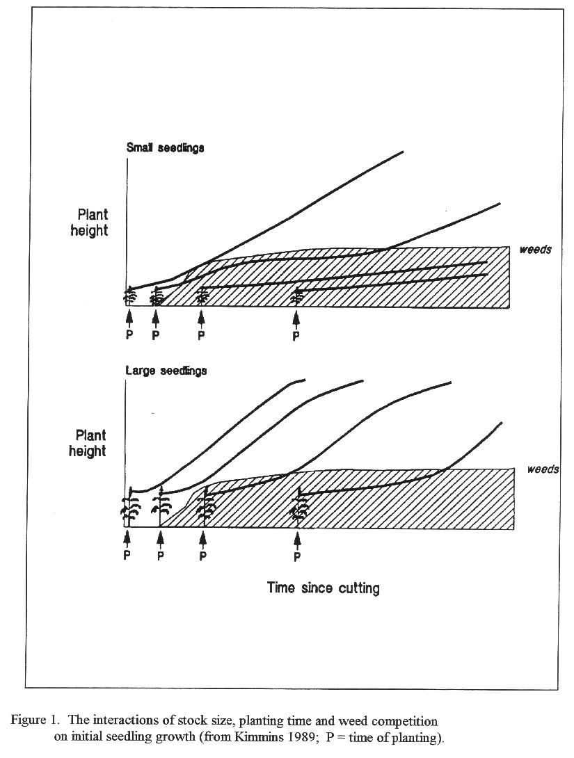

Professor, Auburn University Southern Forest Nursery Management Cooperative, Auburn University, Alabama.

