A New Insect Pest of Pine Nurseries Identified

South, D.B. and J.B. Zwolinski. 1993. A new insect pest of pine nurseries identified. Ala. Agr. Exp. Sta. Highlights Agr. Res. 40(1):16.

The incidence of malformed pine seedlings with multiple shoots (often referred to as "bushy-topped" seedlings) has increased dramatically in forest nurseries throughout the South, with some nursery managers reporting up to 30% crop injury. AAES research indicates that a new pest, Taylorilygus pallidulus (T bug), may be responsible for some of this damage.

Although southern pine seedlings were injured as far south as Florida and as far north as Virginia, researchers at the AAES were the first to suspect that a plant bug (family Miridae) was causing the problem. However, it was initially believed that the tarnished plant bug (Lygus lineolaris or L bug) was the only insect causing the injury.

Caging studies had demonstrated that L bugs feeding on the terminals of young loblolly pine seedlings would result in malformed terminals and the subsequent development of multiple shoots. Trapping studies in forest nurseries found a correlation between the amount of injury and the number of L bugs caught. Therefore, as nursery managers began to apply insecticides to control L bugs, the percentage of trees damaged was dramatically reduced, but not eliminated.

The first recorded trapping of T bugs, which also are in the family Miridae, at a pine nursery occurred in 1987 at Carters Nursery in Georgia. White sticky traps (Rebell®) were distributed throughout the nursery and the number of plant bugs trapped was recorded several times a week. Adult L bugs ranged in color from yellowish-green or yellowish-brown to brown, while adult T bugs were green (Figure 1). At various times in May, June, and July, the number of T bugs equaled or exceeded that of L bugs. However, at that time there were no published reports of T bugs injuring pine seedlings. Since L bugs were known to cause injury to conifers, the presence of T bugs was considered of secondary importance until 1991, when T bugs were suspected of causing bushy top symptoms in nurseries in South Africa.

A subsequent caging study by AAES researchers placed 35 adult T bugs along with newly germinated pine seedlings. A few days after the insects had been introduced into the cages, the growing tip on some seedlings died. Later, seedlings started sprouting multiple leaders with deformed needles. A total of 27% of the Pinus pinaster seedlings were injured by the insects. Seedling injury (Figure 2) was very similar in appearance to injury caused by L bugs.

Subsequently, Auburn researchers have found this insect in forest nurseries in Alabama, Georgia, South Carolina, South Africa, and Guatemala. It also occurs in Asia, Australia, Europe, and South America. It is therefore a potential pest of pine seedlings throughout the world.
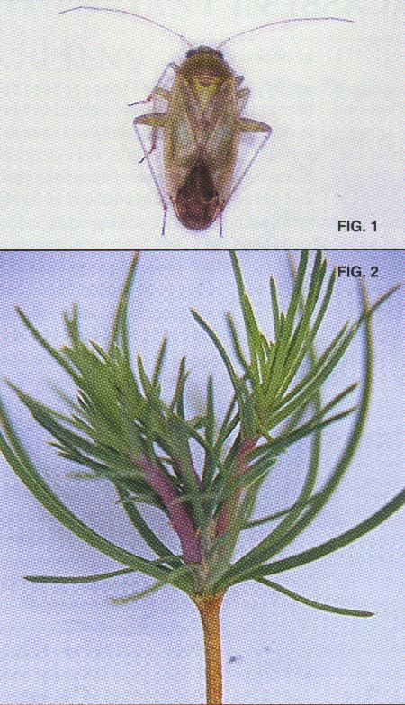

Fig 1. T bug, or the plant bug Taylorilygus pallidulus, which prior to 1959 was called Lygus apicalis.

Fig. 2. Shoot deformity resulting from T bug feeding on a young pine seedling.

