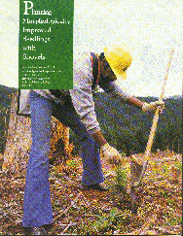
Planting Morphologically Improved Seedlings with Shovels

John I. Blake and David B. South¹
School of Forestry Series No. 13
Alabama Agricultural Experiment Station, Auburn University
Lowell T. Frobish, Director
Auburn University, Alabama, July, 1991
The authors express appreciation to James M. Vardaman for his support and manuscript review, to Plum Creek Timber Company for making available seedling survival and tree planting production data, to Weyerhaeuser Company for providing the cover photo, and to Tree Farmer magazine for the color separations for printing.
¹ John Blake is a Research Ecologist, USDA Forest Service and David South is a Professor, School of Forestry.

INTRODUCTION
In spite of the fact that shovels are commonly used to "operationally" plant seedlings on the West Coast, their use in the South presently is confined mostly to a few researchers and consultants who choose to plant morphologically improved seedlings ³. Annually, several thousand planting shovels are sold in the Pacific Northwest while less than 100 are sold in the South. The technique used with planting shovels has been described by Wickman (38) and is illustrated in Figure 1. The planting shovel referred to in this publication in the long handle planting shovel (TT 2-0) that has been reinforced with a gusset along the backspine of the blade (the blade is 12 inches long and either 5.5 or 6.5 inches wide). The objective of this publication is to discuss how planting with shovels might improve seedling performance when used in conjunction with southern pine seedlings with large root systems. Planting morphologically improved seedlings with large root systems can result in better survival and growth of southern pine plantations (23).
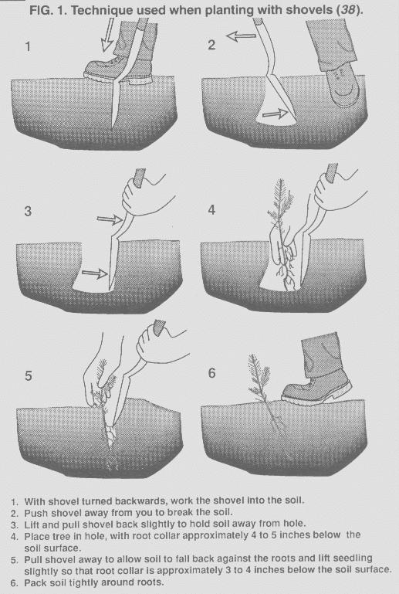
However, successful tree planting operations are not solely dependent on use of morphologically improved seedlings. It is critical to choose an appropriate set of planting specifications (how seedlings should be placed in the soil) and a system for insuring that the specifications are achieved by the planters (appropriate equipment, quality control inspections, incentives and/or penalties). Unfortunately, many landowners overlook the importance of these elements and over-emphasize superficial methods (e.g. machine planting vs. hand planting), or consider the cost of the operation and not the cost per surviving tree. However, selecting appropriate equipment does not help to achieve the planting specifications in a cost-effective manner. The objective should be to develop a system which insures a consistently high success rate across the range of expected planting environments. A target level of 90 to 95 percent survival is not unreasonable, even for operational plantings.
Operational data from a case study in the Pacific Northwest can be used to illustrate how survival can be increased by improving various regeneration methods. Due to poor seedling survival in the early 1970's, various steps were taken to increase regeneration success. Better planting supervision began in 1975 and as a result, survival was improved markedly, as shown in Figure 2. After 1978, survival was again enhanced by using morphologically improved stock, controlling competing vegetation, and improving planting and handling techniques. As a result of consistent survival, initial planting level was reduced from over 600 to fewer than 350 trees per acre. The integration of these practices resulted in reducing the cost of seedling establishment (1967 dollars) by more than half, as shown in Figure 3.
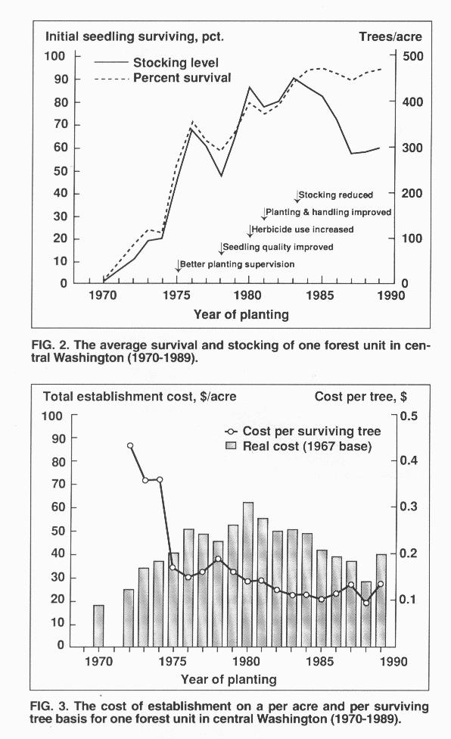

PLANTING QUALITY AND PERFORMANCE
When planting quality is discussed among experienced individuals, most agree on the traits that they consider desirable in terms of depth, root placement, packing, etc. What is not always agreed upon is a minimum acceptable standard for these traits. For example, how tight does the soil need to be packed around the roots or how deep should the seedlings be planted? As the planting environment becomes more adverse, more stringent requirement are needed to achieve a given level of seedling performance.

Because it is difficult to treat planting "quality" in a quantitative manner for all but a few traits, researchers tend to avoid the problem. As a result "planting quality," in practice, becomes an elusive personal or organization standard. However, as Table 1 shows, careful planting technique makes a difference. Unfortunately, it is not know which "careful" techniques led to the observed increases in survival.

In some cases specific techniques are known to influence survival. For example, in recent trials with loblolly pine, placing the upper portion of the root system 3-5 inches below the soil surface increased survival by 5 to 15 percent, Table 2, relative to placing the top of the root system only one-half to 2 inches below the soil surface. Loosely planted seedlings also have a very poor chance for survival. Shiver et al. (32) reported at 26 percent decrease in survival between firm and loose planted loblolly pine seedlings in the Georgia Piedmont. There is little published information on how planting techniques might influence tree growth. Deeper planting does appear to result in greater initial height growth, sufficient at least enough to offset the initial reduction in height after planting. In general, minimizing root distortions of southern pines during planting (twisting, balling-up, J-rooting, L-rooting, U-rooting) does not appear to improve either survival or height growth (37, 9, 36, 18, 12, 22, 14, 39, 30, 31). In fact, when planting a 6-inch-long root in a 5-inch hole, planting the seedling deep with a J-root can increase survival when compared to keeping the root straight and planting the seedling too shallow (6). Although windthrow due to root distortion can occur on poorly drained soils in the South (16), it appears to be more of a problem in windy climates such as New Zealand (21).

Where differences in seedling performance among planting techniques or equipment have been reported (e.g. 26, 30), it is rarely stated what specific factors affected performance. Differences observed may be confounded by the site conditions or the failure of individuals to use equipment properly. How, then, might one expect the use of shovels to influence planting quality and subsequent field performance? The main advantages of shovel planting compared to hoedads or dibble bars is a deeper hold to accommodate placement of the roots below the ground surface as well as a wider hold to facilitate rapidly inserting fibrous lateral roots. Shovel planting also can facilitate close root to soil contact, which is critical for adequate water uptake by transplanted seedlings (29). It is known from other planting tool trials (e.g. 24, 13) that those tools which enable development of the advantages noted above can increase survival substantially on difficult sites. A great many foresters and contractors in the Pacific Northwest have adopted shovels as a preferred planting tool for stock with large root systems even though the root systems are routinely pruned to between 6 and 7 inches. They believe it enables them to effectively meet planting standards. A few organizations require shovels as a matter of contract compliance.

ROOT SYSTEM DEVELOPMENT AND PERFORMANCE
Increase in root system size was a factor stimulating the adoption of shovels in other regions. Root development can be measured in a number of ways, such as surface area, volume displacement, and mass, or weight. A substantial amount of field data has been accumulated for Douglas-fir (Pseudotsuga menziesii (Mirb.) Franco), western hemlock (Tsuga heterophylla (Raf.) Sarg.), and ponderosa pine (Pinus ponderosa Laws.) seedlings showing that root quality, in terms of the amount of fibrous roots, is closely related to field survival as shown in Table 3. Seedlings with large diameters (greater than 4 millimeters) -4- usually survive better than smaller seedlings (less than 4 millimeters), but this is partially related to the fact that as average seedling diameter increases the absolute size of the root system increases. For seedlings with the same root collar diameter, the amount of roots can be an important factor affecting survival, as shown in Table 3. However, root system size along, within a given diameter class, does not appear to be directly related to long-term growth in the field (2).

There is good evidence that these observations are relevant to southern pines. It is known from field studies (Figure 4) that increased root development can be related to increased field survival of southern pines (17, 28, 15, 19, 11, 35). The relationship is consistent enough to expect that practices which favor better developed or more fibrous root systems (e.g. undercutting or wrenching, lower seedbed densities, mycorrhizae enhancement, careful lifting and handling, etc.) will result in better survival. In contrast, practices which result in smaller root systems can result in reduced survival. For example, the pruning of roots by tree planters can improve the ease of planting (when making a small hole with a dibble or hoedad), but can reduce outplanting survival (23). In addition, the stripping of roots by tree planters can cause a reduction in new growth (34) and result in poor survival (20).
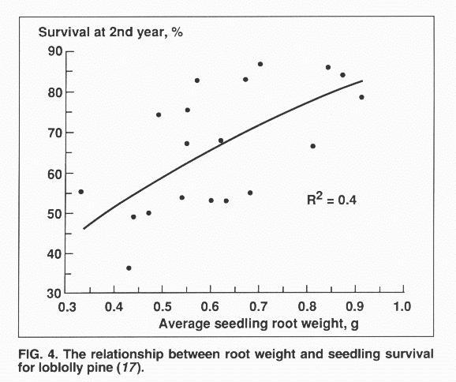
It is not easy to determine a single direct causal relationship between root development and survival. There is substantial research showing that the initiation of new roots following planting is positively related to the initial size of the root system (7, 1, 40, 41) and new root growth is important for seedling survival. It also is known that potential water uptake is related to the initial size of the root system in pine seedlings (7, 27). Until new roots develop, the existing root system must provide for most of the water uptake. These older roots generally have lower surface hydraulic conductivity and therefore total water uptake is dependent on the size of the root system. Furthermore, the larger the root surface area, the greater the opportunity for creating adequate root to soil contact.

What is the minimum acceptable and the optimum desirable root morphology for bareroot southern pine? A root system which is adequate to support the transpiration of the seedling during establishment meets these criteria. Obviously, the weather following planting is important, as is the initial moisture content of the soil near the roots. Transpiration potential depends heavily on the foliage surface area, which is directly related to the size of the seedlings. This implies a need for a favorable root-weight ratio (greater than 0.28), where the ratio expresses the relative dry mass of the root to that of the entire seedling.

Morphologically improved loblolly pine seedlings normally have a several fold larger average root volume or mass than Grade 3 seedlings (7, 33, 4). An acceptable root system for a morphologically improved loblolly pine or slash pine seedling, which will do well under a wide range of conditions, will have a root volume greater than 3 cubic centimeters, and the dry weight will be in the range of 0.8 to 1.4 grams -5- (the optimum might be closer to 2 grams). The fresh weight of roots from a morphologically improved longleaf pine seedling can exceed 10 grams.

PLANTER PRODUCTIVITY CONSIDERATIONS
When individuals compare different planting systems, they do not often recognize that planting specifications have a major impact on planter productivity (e.g. 10). For example, in both the South and Pacific Northwest, federal planting costs are often 50-100 percent greater than those of industry under similar site conditions. However, on comparable sites survival is usually no different, probably because the additional specifications or planting regulations rarely provide a marginal improvement in the conditions affecting seedling survival. Variation in planting rates and costs among private landowners also reflect, in part, the differences in planting specifications and the degree of enforcement. Poor hand planting specifications and lax crew supervision in the South have traditionally been the non-industrial landowner's nemesis.

In addition to the planting specifications and site conditions, the average size of the root system will affect planter productivity, as shown in Figure 5. The consequence of this is a tendency for planters to strip roots, discard larger seedlings, or open a hole which is less than adequate to accommodate the roots. Figure 5 illustrates the average effect that root system size, characterized by the absolute mass of the roots, has on average planter productivity. Lower productivity results from a combination of factors. The major impact occurs from the additional effort needed to actually plant seedlings with larger root systems so that the same planting specifications are achieved.
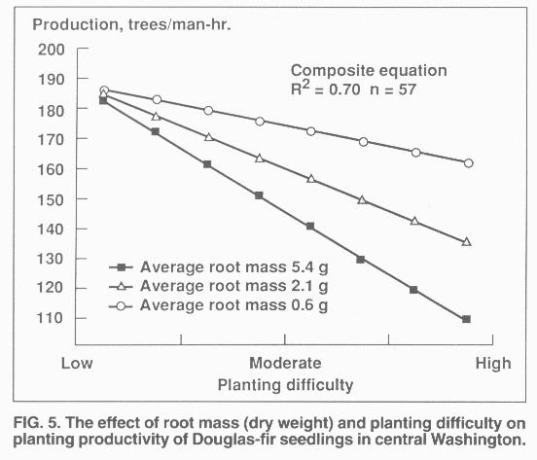
A reasonable set of planting specifications includes scalping organic debris away from the immediate location of the planting spot, opening a hole sufficient to accommodate the roots, placing the root system deep into the soil, and firmly packing moist mineral soil around the roots. Given similar planting quality standards, how might planting techniques or tools affect productivity? The highest rates reported using shovels are about 2,000 tree per man-day with 2+0 stock (38), and about 1,800 trees per man-day with large Douglas-fir transplants on friable loamy soils (personal observations) in Washington. These are less than the 3,000 tree per man-day commonly observed with hoedad crews planting morphologically unimproved seedlings on well prepared ground in the South, but similar to the maximum rates for dibble bar planting.
While it is frequently stated that planting with shovels will reduce planter productivity by approximately 20 to 30 percent (compared to hoedads and in some cases dibble bars), there is no good database to support this claim. Based on this estimate some contractors have been reluctant initially to work with shovels. Yet, contract prices on the west coast for crews working primarily with shovels have been as competitive as those with hoedads. In addition, the results of an extensive study of planter productivity showed no indication that average production was less with shovels when compared to hoedads under a wide range of conditions, as shown in Figure 6. These studies covered all types of soil texture and surface debris conditions with the exception of clay and clay loam soils. In British Columbia, Brown (5) also reported no differences in productivity between hoedads and shovels for seedlings with large root systems.
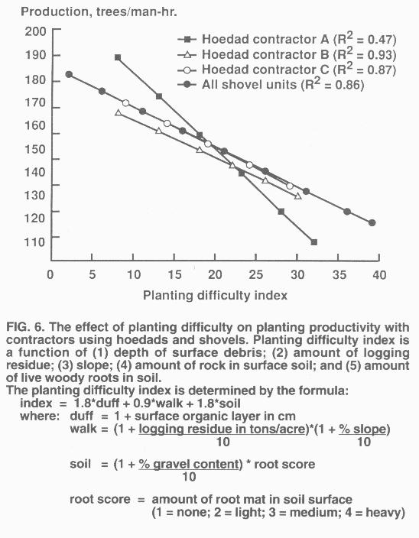
The technique involved and ergonomics of shovel planting are different than for other planting tools. Some contractors have reported a lower incidence of worker injury with shovel planting as compared with planting with hoedads. Planter productivity depends heavily upon the individual's capacity and training with the planting implement under a given set of specifications, site conditions, and root system size. Consequently, comparisons among techniques and equipment are best accomplished under standard conditions with professional planters experienced enough to maximize performance. The best combination of planting stock, specifications, and equipment can be determined only by evaluating the cost effectiveness of the system as a whole.

LITERATURE CITED
(1) Barden, C.J. 1987. Root Growth Potential and Outplanting Performance of Loblolly Pine Seedlings Raised at Two Nurseries. M.S. thesis, Va. Polytech. Inst. and State Univ., Blacksburg, Va. 124 pp.
(2) Blake, J.I. 1987. The impact of seedling diameter and root mass on the performance of Douglas-fir (Pseudotsuga mennziesii (Mirb.) Franco) and associated conifers. Internal Report to the Pacific Northwest. Forest. Indust., SilvaTech, Auburn, Ala. 70 pp.
(3) _______, L.D. Teeter, and D.B. South. 1989. Analysis of the economic benefits from increasing uniformity in Douglas-fir nursery stock. Forestry Suppl. 62:251-261.
(4) Boyer, J.N. and D.B. South. 1988. Loblolly pine seedling morphology and production at 53 southern forest nurseries. Tree Planters' Notes 39(3):13-22.
(5) Brown, R. 1982. Planting and organizing the planting project. P. 265-272 In: J.B. Scarratt, G. Glerum, and C.A. Plexman (eds.). Proc. Canadian Containerized Tree Seedling Symposium. Dept. Environ. Canadian Forest Serv., Sault Ste. Marie, Ontario, Canada.
(6) Brissette, J.C. and J.P. Barnett. 1989. Depth of planting and J-rooting affect loblolly pine seedlings under stress conditions. P. 169-175 In: Proc. Fifth Biennial Southern Silvicultural Research Conf., Memphis, Tenn. USDA Forest Service Gen. Tech. Rep. SO-74.
(7) Carlson, W.C. 1986. Root system considerations in the quality of loblolly pine seedlings. South. J. Appl. For. 10(3):97-92.
(8) Dierauf, T.A. 1984. Depth of planting study. Occ. Rep. 63, Va. Div. of Forestry, Charlottesville, Va.
(9) Gruschow, G.F. 1959. Observations on root systems of planted loblolly pine. J. For. 57:894-896. (10) Guldin, R.W. 1984. Site characteristics and preparation practices influence cost of hand planting southern pine. J. For. 82:97-100.
(11) Hatchell, G.E. and D.H. Muse. 1990. Nursery cultural practices and morphological attributes of longleaf pine bareroot stock as indicators of early field performance. USDA Forest Service Res. Pap. SE-277. 34 pp.
(12) Hay, R.L. and F.W. Woods. 1974. Root deformation correlated with sapling size for loblolly pine. J. For. 72:143-145.
(13) Hobbs, S.D. 1982. Effect of auger planting on survival and growth of Douglas-fir on droughty sites. Oregon State Univ. For. Res. Lab., Corvallis, Or. Res. Note 72. 5 pp.
(14) Hunter, S.C. and T.E. Maki. 1980. The effect of root curling on loblolly pine. South J. Appl. For. 4(1):45-49.
(15) Jorgensen, J.R. and E. Shoulders. 1967. Mycorrhizal root development vital to survival of slash pine nursery stock. Tree Planters' Notes 18:7-11.
(16) Klawitter, R.A. 1969. Wind damages improperly planted slash pine. South Lumberman 218(2709):24.
(17) Larsen, H.S., D.B. South, and J.M. Boyer. 1986. Root growth potential, seedling morphology, and bud dormancy correlate with survival of loblolly pine seedlings planted in December in Alabama. Tree Physiol. 1:252-263.
(18) Little, S. 1973. Survival, growth of loblolly, pitch, shortleaf pines established by different methods in New Jersey. Tree Planters' Notes 24(4):1-5.
(19) Marx, D.H., C.E. Cordell, and A. Clark III. 1988. Eight-year performance of loblolly pine with Pisolithus ectomycorrhizae on a good-quality site. South. J. Appl. For. 12(4):275-280.
(20) _______ and G.E. Hatchell. 1986. Root stripping of ectomycorrhizae decreases field performance of loblolly and longleaf pine seedlings. South. J. Appl. For. 19(3):173-179.
(21) Mason, E.G. 1985. Causes of juvenile instability of Pinus radiata in New Zealand. N.Z. J. For. Sci. 15:263-280.
(22) Mexal, J.G. and S. Burton. 1978. Root development of planted loblolly pine seedlings. P. 85-90 In: Proc. Root Form of Planted Trees Symposium. Victoria, B.C. Joint Report 8. British Columbia Ministry of Forests/Canadian Forestry Service.
(23) _______ and D.B. South. 1991. Bareroot Seedling Culture. Chapter 6. P. 89-115 In: M.L. Duryea and P.M. Dougherty (eds.). Forest Regeneration Manual. Kluwer Academic Publishers. Dordrecht/Boston (In Press).
(24) Miller, R.E. 1969. Can auger planting improve survival of Douglas-fir seedlings. USDA For. Serv., PNW Res. Note #99.
(25) Muller, C. 1983. Loblolly pine seedling survival study, 1979-80 and 1980-81 planting season. P. 27-34 In: Proc. 1982 Southern Nursery Confer. USDA For. Serv., Tech. Pub. R8-TP4.
(26) Mullin, R.E. 1964. Influence of planting depth on survival and growth of red pine. For. Chron. 40:384-391.
(27) Nambiar, E.K.S. 1984. Significance of first-order lateral roots on the growth of young radiata pine under environmental stress. Aust. For. Res. 14:187-199.
(28) Rowan, S.J. 1987. Nursery seedling quality affects growth and survival in outplantings. Ga. For. Comm. Res. Pap. 70. 15 pp.
(29) Sands, R. 1984. Transplanting stress in radiata pine. Aust. For. Res. 14:67-72.
(30) Senior, M.T. and A.E. Hassan. 1983. Field evaluation of tree transplanting methods. ASAE Paper #83-1606, St. Joseph, Mich. 19 pp.
(31) Seiler, J.R., D.J. Paganelli, and B.H. Cazell. 1990. Growth and water potential of J-rooted loblolly pine and eastern white pine seedlings over three growing seasons. New Forests 4:147-153.
(32) Shiver, B.D., B.E. Borders, H.H. Page Jr., and S.M. Raper. 1990. Effect of some seedling morphology and planting quality variables on seedling survival in the Georgia Piedmont. South. J. Appl. For. 14:109-114.
(33) South, D.B., H.S. Larson, J.N. Boyer, and H.M. Williams. 1990. Effect of seed spacing and seedling biomass on root growth potential of loblolly pine (Pinus taeda). New Forests 4:179-192.
(34) _______ and N.J. Stumpff. 1990. Root stripping reduces root growth potential of loblolly pine seedlings. South. J. Appl. For. 14:196-198.
(35) Tanaka, Y., J.D. Walstad, and J.E. Borrecco. 1976. The effect of wrenching on the morphology and performance of Douglas-fir and loblolly pine seedlings. Can. J. For. Res. 6:453-458.
(36) Ursic, S.J. 1963. Modification of planting technique not recommended for loblolly pine on eroded soils. Tree Planters' Notes 57:13-17.
(37) Wakeley, P.C. 1954. Planting the southern pines. USDA Agric. Monograph 18. 233 pp.
(38) Wickman. A. 1981. Tree planting technique. Tree Planters' Notes 32:22-23.
(39) Woods. F.W. 1980. Growth of loblolly pine with roots planted in five configurations. South. J. Appl. For. 4(2):70-73.
(40) Williams, H.M and D.B. South. 1988. Effect of fall irrigation at a sandy nursery on morphology and root growth potential of loblolly pine seedlings. South African For. J. 147:1-5.
(41) _______, _______, and G.R. Glover. 1988. Effect of bud status and seedling biomass on root growth potential of loblolly pine seedlings. Can. J. Forest Res. 18:1635-1640.

