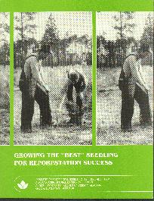
GROWING THE "BEST" SEEDLING FOR REFORESTATION SUCCESS

by David South and John G. Mexal

Forestry Departmental Series No. 12. December 1984
Alabama Agricultural Experiment Station
Auburn University
Auburn University, Alabama

COVER PHOTO. Successful artificial regeneration requires a combination of quality seedlings and quality plantings. In the past, hand planters were well supervised and seedling care was stressed more than speed of planting. Two-man planting crews were sometimes used. One planter would make the dibble holes and the other would carry the seedlings and see that they were properly planted. Seedlings were sometimes carried in buckets or trays to prevent drying of seedling root systems. In contrast, speed of planting is stressed today while quality supervision of planters may be lacking. Because large dibble holes take longer to make, planters often request small seedlings which require smaller dibble holes. In order to speed up the planting process, some planters will even strip lateral roots from the seedling. In some cases, short-term convenience is placed ahead of long-term reforestation goals.

INTRODUCTION
CHARACTERISTICS of the "best" seedling depend upon the objectives of the organization or individual buying or using the seedling. As objectives change, the desirable physiological and morphological traits of a "quality" seedling change. Factors that can affect seedling traits include provenance, climatological factors, planting site, time of transplanting, length of storage, method of transplanting, and last but not least, the financial goals of the organization or individual. The objective of this paper is to discuss the factors that go into determining the best seedling and the practices that might be used to grow such a seedling.
DEFINING THE BEST SEEDLING
A definition of the best seedling may vary from simple morphological descriptions to elaborate physiological measurements. However, the ultimate definition rests on successful establishment and growth following outplanting. A working definition of "planting stock quality" is as follows: "The quality of planting stock is the degree to which that stock realizes the objectives of management (to the end of the rotation or achievement of specified sought benefits) at minimum cost. Quality is fitness for purpose (70)." Therefore, a "quality" seedling will vary depending on management objectives. Since management objectives of organizations and individuals vary, so will the morphological, physiological, and economical traits of the best seedling. The following is a list of examples on how individual objectives can affect the definition of the best loblolly pine seedling.

- Individual: Tree planter paid for the number of seedlings planted.
Objective: To plant seedlings quickly.
Definition: A short seedling with a small root system.
Benefits sought: The requirement of only a small dibble hole means less time is required to plant each seedling. More seedlings can be packed into seedling bag and therefore less time is lost refilling bag.
- Individual: Tree planter who rides a machine planter.
Objective: To place seedlings into mechanical fingers.
Definition: A tall seedling.
Benefits sought: To keep human fingers away from mechanical fingers.
- Individual: Private landowner who farms.
Objective: To plant marginal cropland to pine seedlings.
Definition: Free or inexpensive seedlings.
Benefits sought; Income for children; low capital outlay.
- Individual: Planting contractor who is paid in part on survival.
Objective: To plant seedlings quickly and so they will live.
Definition: A short seedling with a 3- to 4-millimeter root-collar diameter; a live seedling that will survive stress.
Benefits sought: High initial survival; to plant quickly.
- Individual: Land manager of big paper company.
Objective: To plant X hectares and replant Y hectares before spring.
Definition: 1,000 live seedlings per bale.
Benefits sought: Acceptable survival; to keep track of the number of hectares planted by knowing bow many bales were used.
- Individual: Land manager of better paper company.
Objective: To increase volume production per hectare.
Definition: Stem diameter greater than 4 millimeters, shoot height less than 30 centimeters, prominent terminal bud, numerous primary lateral roots, heavy root system, good mycorrbizal infection of feeder roots, mature secondary needles, $20-$30 per thousand.
Benefits sought: High survival, increased volume production, shortened rotation, high internal rate of return.

It is apparent that desirable characteristics of a seedling can vary with individual objectives. Therefore, for the purpose of this paper, the objectives will be limited to two primary factors: survival and growth.

SEEDLING QUALITY

Species Selection
Paramount to other management decisions is the selection of the correct species to plant. The final product can dictate to a large extent the species to be planted. For example, eastern white pine (Pinus strobus L.) is preferred for manufacturing matchsticks. Slash (P. eLliottii Engelm.) and longleaf (P. palustris Mill.) pine are used for turpentine production, while longleaf pine is also excellent for poles. For sawtimber, loblolly (P. taeda L.), slash, and longleaf pine are favored. Oak (Quercus spp.) and walnut (juglans nigra L.) are often favored for furniture. Virginia pine (P. virginiana Mill.), eastern white pine, and Fraser fir (Abies fraseri (Pursh) Poir.) are often planted for use as Christmas trees.
If the objective is to maximize the production of softwood pulpwood in the South, then selection of the correct species is narrowed to a few southern pine species. The selection of the best species to plant is then dependent largely on the geographical region, the climate, the incidence of various pests, and specific site characteristics. Loblolly, shortleaf, longleaf, and slash pine make up 90 percent of the standing pine inventory (58). Virginia pine comprises 5 percent, while pond (P. serotina Michx.), pitch (P. rigida Mill.), spruce (P. glabra Walt.), table-mountain (P. punge s Lamb.), and sand (P. clausa (Chapm.) Vasey) pines make up the remaining 5 percent.
Loblolly pine is by far the dominant pine species in the South because it is adaptable to a wide range of sites and has a good growth rate. However, loblolly pine is susceptible to fusiform rust and tip moth attack, table 1. On most sites, loblolly pine will outperform other species in both survival and growth (7).

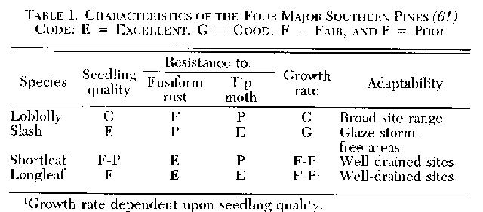
Shortleaf pine is best adapted to well-drained or droughty sites but is often characterized by relatively slow initial height growth. This could partially be due to poor seedling quality. As shortleaf seed is small, this trait combined with high sowing rates often results in small, spindly seedlings. Reduced sowing rates can improve seedling quality. Shortleaf is highly resistant to fusiform rust but highly susceptible to tip moth and little-leaf disease on poorly drained sites. Loblolly is usually preferred to shortleaf pine except on extremely dry sites in the northern limits of the loblolly pine range and where the risk of ice damage is severe.
The natural range of slash pine is almost completely delineated by the glaze storm-free region of the South. This species favors moderately to poorly drained soils. Morphological characteristics of slash pine seedlings are excellent, however it is highly susceptible to fusiform rust. Because of the potential damage from ice storms and fusiform rust, slash pine should be planted within its natural range and on wet sites where it clearly outperforms loblolly pine (56).
Longleaf pine is not limited by glaze storms but is confined for the most part to the Coastal Plain. Seedling quality of longleaf pine has often been poor due to small seedling diameters. Seedlings require a critical root collar diameter to bring them out of the 11 grass" stage. Small seedlings may stay in this form for 7 years or more and can frequently succumb to brownspot infections. Once out of the grass stage, height growth is excellent. Recent advances in herbaceous weed control can shorten the grass stage (36). Because of its excellent resistance to fire damage and fusiform rust, longleaf pine may be the preferred species on dry sites where problems with fire and fusiform exist.
Sand pine is an excellent example of a "minor" species outperforming other species on particular sites. In the sand hills of Florida, volume growth of sand pine was more than double that of any other species (9).

Provenance Selection
Once the best species to plant has been selected, then it becomes important to select the best provenance. The most conservative approach is to use local sources. Generally that approach will ensure adequate survival and growth. However, sources of wide geographic origin are often planted to increase individual tree yield with little or no loss in survival. Provenance trials are available for many states, and although they may be limited to specific soil types or locations, relative performance of divergent sources is illustrated to the land manager. General seed source recommendations have been developed for loblolly, longleaf, and shortleaf pines (65, 66, 67, 68, 69). The conclusion is that seed from the southern and eastern provenances perform better than local or more northern sources. For example, coastal loblolly pine provenances generally outperform interior provenances. However, because of possible injury from ice damage, moving seed too far north can be deleterious. Seed movement should be conservative if data are not available for the specific seed sources and area.

Genotype Selection
Tree improvement in the South has developed to the point where some organizations are producing second generation seed capable of producing a 25 percent increase in volume production over "wild" seed. Therefore, as long as the "improved" genotype is adapted to the site, the best seedling will be an improved seedling. However, if the improved seedling is not adapted for the site, seedlings from wild parent trees adapted to the site may be the best. For example, for marginal sites subject to drought in Texas, wild, drought-hardy loblolly pine from Texas would likely survive and grow better than improved loblolly pine from the Coastal Plain of Louisiana.
Seedling Grade
Seedling grades for southern pines suggested by Wakeley (61) were based upon diameter, among other factors. The grades for slash and loblolly pines were: Grade 1 greater than 4.8 millimeters; Grade 2 greater than 3.2 millimeters; Grade 3 less than 3.2 millimeters (cull). It is noted that no southern pine nursery in the South currently grades seedlings into three grades. Some nurseries cull small and diseased seedlings before shipping but forest nurseries in the South do not sell seedlings by grades as do some nurseries in other regions of the United States.
There have been numerous studies conducted on the effects of seedling grade on survival, figure 1. The general conclusion was that planting seedlings with larger diameters increased survival. In only a few cases did smaller seedlings have better survival. In one case, it is believed lower survival resulted from the tree planters not being able to get a large root system in a small dibble hole. In another case, it is believed the shoot/root ratio was better for smaller seedlings and therefore resulted in better survival during a summer drought (59).
Several seedling grade studies exist that report volume production 10 to 34 years after planting. The general conclusion from these indicates Grade 1 seedlings produced greater volume through increased survival and growth, figure 2. On the average, volume production was 25 percent greater for Grade I seedlings than for Grade 2 seedlings. Although these data suggest that large increases in forest productivity can result from planting Grade I seedlings, most loblolly pine seedlings produced in the South arc Grade 2 seedlings. A cursory survey of 53 nurseries by the senior author in 1982 indicated that 44 nurseries were producing less than 20 percent Grade I seedlings. Few nurseries produced a high proportion of seedlings with the following characteristics: stem diameter greater than 4 millimeters, shoot height less than 30 centimeters, prominent terminal bud, mature secondary needles (greater than 8 centimeters) at the terminal, numerous primary lateral roots, heavy mycorrhizal infection of feeder roots, and average root dry weight greater than 0.8 gram.
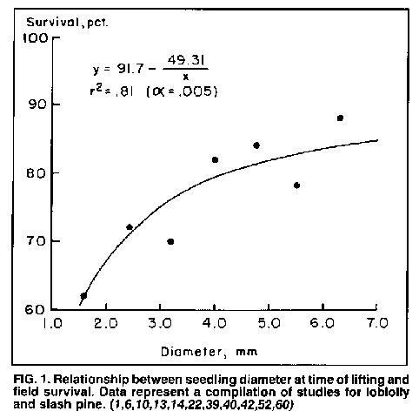

While the importance of seedling grade is recognized, the fact that so-called cull seedlings have performed as well as quality seedlings on occasion has also been recognized although not as well documented (61). The reason for this stems from a strong interaction between seedling height and site as well as an inability to identify the seedling's "physiological quality." On sites with heavy vegetation, taller seedlings often outperform shorter seedlings, but on droughty sites, shorter seedlings with lower transpirational surface area often outperform taller seedlings, table 2. On moist sites, seedling height had no effect on either survival or first-year height increment. However, on the droughty site, seedlings with the larger transpirational surface areas not only suffered greater summer mortality, but also grew less the first season. On this site, it appears that shorter seedlings may surpass taller seedlings with another growing season. Therefore, the correlation between survival and shoot/root ratios (dry weight) or height/diameter ratios will be low for sites and years when moisture is abundant and high when moisture is limited.
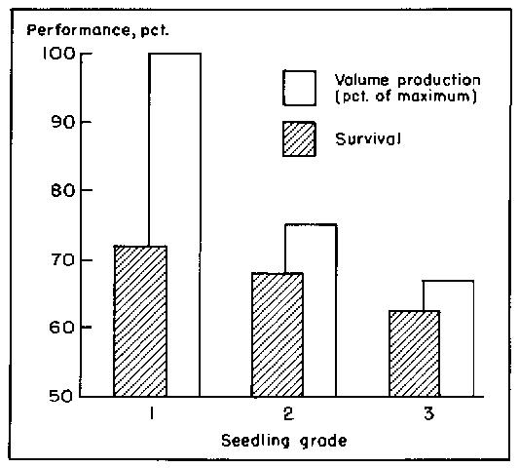
FIG. 2. Relationship between seedling grade at time of planting and field survival and growth 10 to 34 years later. Represents a compilation of data for loblolly and slash pine for studies: 30-34 years old (62); 15 years old (44); 13 years old (6); 13 years old (48); and 1 0 years old (21).
Wakeley (61) stated that no test had been developed to identify the physiological qualities of southern pine seedlings in advance of planting (61). Research during the past 30 years has progressed little in this regard. Seedling quality reflects the integration of a multitude of physiological and morphological characteristics. Taken in mass, seedling quality attributes such as root growth potential, height/diameter ratio, root weight, root starch concentration, leaf osmotic potential, mitotic index, root specific gravity, diameter, height, impedance ratio, chilling hours, mycorrhizal index, and shoot/root ratio (dry weight) may ultimately determine seedling performance. However, considering the complexity of the seedling, the planting site, and seedling-site interactions, a single factor for grading seedling quality may never be fully satisfactory (38).

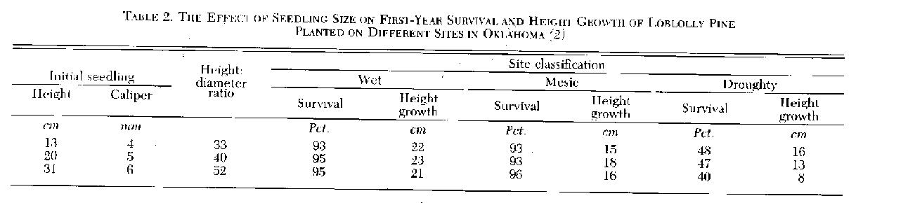

SEEDLING HANDLING
Several factors can alter the quality of seedlings produced in the nursery. These include planting date, storage, and handling. Some factors are beyond the nurseryman's control and therefore must also be of concern to the reforestation forester.
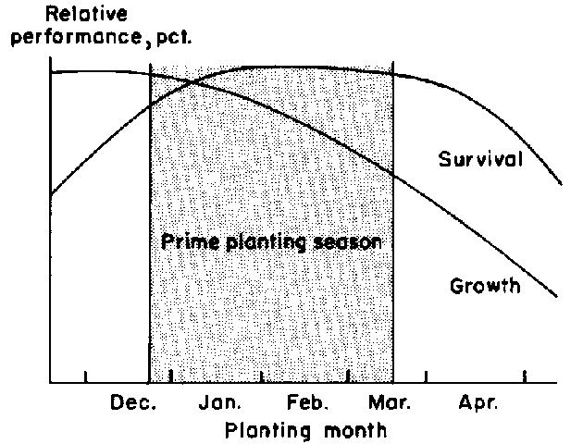
FIG. 3. Diagrammatic representation of the relationship between
planting date and subsequent performance of bareroot seedlings.
Planting Date
Historically, most southern foresters consider the "prime" planting season to be from mid-December to mid-March or the first of April. Planting during this time generally ensures high survival and growth, figure 3. Early planting (prior to December 15) is usually riskier for survival, but height growth is usually greater. For late planting (after march 15), survival can equal that for early planting, but growth is reduced due to the shortened growing season.
Freshly lifted seedlings. Wakeley (61) demonstrated the effect of planting date on first-year survival of major southern pine species. Survival was near 90 percent for freshly lifted seedlings planted between November 9 and March 1. Dierauf (12) examined early and late planting of loblolly pine seedlings in Virginia over 3 years and reported similar findings, table 3. After three growing seasons, survival of early planted seedlings was lower I year, but height growth was greater for early plantings for all 3 years. Mexal and Morris (31) found similar results, table 4. November plantings can prove successful when compared to March or April planting. There are operations in Georgia (20) and Florida that routinely successfully plant wet sites as early as the end of October.
For early planting to be successful, soil moisture must be adequate at time of planting and the coming winter must not be too severe. For example, Bilan (5) reported that loblolly seedlings planted in east Texas on November 11 had twice the root growth of seedlings planted in January. During this period, soil moisture was adequate and the daily minimum temperature was often above O'C. Bilan stated that, "Since pines with well developed root systems have a much better chance to survive dry spells than do the pines with superficial root systems, an early planting is recommended particularly for regions experiencing late spring or early summer droughts." However, the advantage of early planting will be less in regions where severe freezing temperatures are more common. In Virginia, Dierauf (15) stated that seedlings planted after the worst of the winter weather is over may have a higher chance of survival than seedlings planted in December. During severe winters, seedlings planted on cleared sites in December would be subjected to desiccation resulting from frozen ground and exposure to high winds.
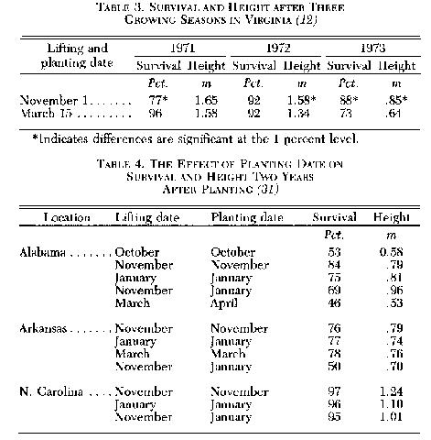
Successful planting outside the prime planting season can vary with seed source (4). One progeny survived transplanting regardless of timing (December 13 to June 3). However, two other progenies could not be successfully planted until after January 27, and one had to be planted before June 3. This illustrates the importance of understanding seed lots used in regeneration. Some lots may have a broad planting season while others may have a relatively narrow season. This can be an important consideration if the regeneration forester wishes to extend the planting season. Many foresters are already utilizing the late season, but few have considered the early season. Management plans should consider both seasons to ensure completion of planned regeneration activities. However, the forester should implement research results slowly since results from one region, or one climatic year, may not be reproducible somewhere else or in another year. Technology transfer should occur gradually to maximize gains with minimum losses.
Stored seedlings. Storage of seedlings at temperatures from I'C o 3'C is a necessary "evil" and should be used judiciously. The success of cool storage is dependent on several factors, including seed source and length of chilling before lifting (18,19). For example, two seed sources from Arkansas and Oklahoma differ dramatically in their cool-storage capabilities, figure 4. The more northern source (McCurtain County, Oklahoma) is less sensitive to periods f storage than the southerly source (Polk County, Texas). Both sources stored well after receiving chilling through December, but the northern source was affected less by storage prior to a December 13 lifting date. For greatest success, storage of seedlings would be minimized until the chilling-hour requirement for that source has been reached. Weyerhaeuser Co. currently stamps seedling bags with an expiration date dependent upon the date led and the number of chilling hours accrued. If loblolly seedlings are not planted shortly after lifting, then the seedling "quality," is a function of the chilling hours received. Failure to monitor chilling hours can result in reduced seedling survival, especially for years with warm fall weather. The fall of 1982 was unusually warm d losses from one nursery (apparently associated with long storage of seedlings with insufficient chilling) exceeded $220,000 (37). For those nurseries that must store seedlings, monitoring chilling hours and storing accordingly will improve quality.
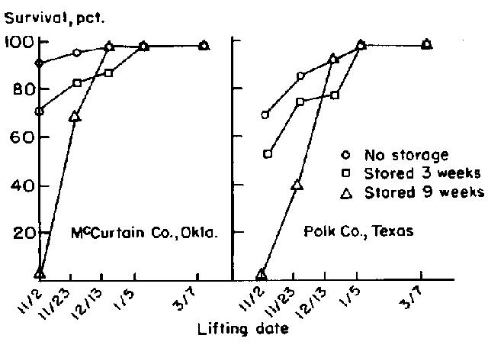FIG. 4. The effect of lifting date and time in storage on survival of two seed sources outplant4id in Arkansas (from Dunlap and Mexal, unpublished).
Planting quality. Many seedlings in the South are planted by hand. However, it is generally believed that machine planted seedlings perform better than hand planted seedlings. This could be a result of the machine being able to prepare a deeper planting hole as well as a more uniform seedling placement and soil packing, with less root exposure. In addition, machines do not tire and planting consistency at the end of the day should be the same as at the beginning. In one comparison, mean survival was 20 percent higher for sand pine seedlings planted by machine compared to dibble-bar (28). However, skips resulting from machine planting can average above 10 percent (20), and in some plantings can range as high as 20 to 30 percent (71).
Survey data from one company in Alabama suggest that supervision and speed of hand planting can affect seedling survival (34). For two planting seasons, company crews (paid by the hour) averaged 87 percent survival while contract crews (paid by the seedling) averaged only 81 percent survival. Seedlings planted with maximum care averaged 92 percent survival. Obviously, planting quality is directly proportional to the quality of supervision.
Factors such as available soil moisture, competing vegetation, planting depth, and quality of planting can strongly influence seedling performance. For example, for sand pine seedlings stored in unrefrigerated sheds, survival is dependent upon time in storage and level of weed competition, figure 5. For planting on prepared sites, seedlings could be stored unrefrigerated for 8 days with little loss in survival. However, on wooded sites survival was almost 30 percentage points lower for stored trees. Apparently, storage for 8 days reduced the vigor of seedlings to the point that they were unable to compete with established vegetation.
Planting quality can be influenced by seedling handling and exposure, planting depth, j-rooting, and root twirling. No matter how slight, mistreatment of the seedling can result in significant volume loss at the end of rotation. Mullin (35) reported red pine stand volumes were reduced 14 percent after 20 years simply by a change in planting crews, which infers a change in quality. Mexal et al. (32) found a loss of up to 1 meter of site index (S - I- 25) due to poor planting. The loss of site index was most pronounced on lower site lands. This is to be expected because moisture is limiting on these sites much of the year and root deformation compounds the problem.
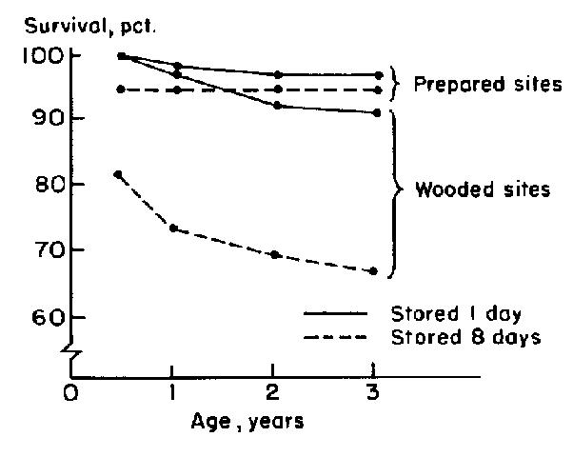
FIG. 5. The effect of unrefrigerated storage on survival of Ocala sand pine planted on two sites on January 21 (9).
Much root deformation can be explained by deep planting in a shallow planting hole. Tree planters tend to plant deep without considering either the length of the dibble bar or the length of the taproot. In addition, making a sufficiently deep planting hole to avoid root deformation usually requires more time and results in a reduction of pay for planters paid by number of seedlings planted. Planting seedlings to a standard depth would alleviate much deformation. However, this recommendation should not be rigid. Deep planting without deformation can be advantageous, figure 6. Seedlings should be planted as deep as a dibble bar will allow on droughty soils to ensure high survival and growth, but on heavier soils or soils that drain slowly, deep planting decreases survival accompanied by a concomitant loss of height advantage (27). Sands or loams can be planted deep (half of stem buried), but clay-loams or heavier soils should be planted only 2-3 centimeters above the root collar (43). Planting too shallow, of course, can be detrimental. A survey of operational plantings found shallow planting to be correlated with reduced survival in three out of four operational districts (72).
It is doubtful that desirable traits of a quality loblolly pine seedling will be the same throughout the South. Traits that result in high survival and rapid growth may vary by region, site, and planting method. For example, seedlings planted in drought-prone Texas will require a genotype adapted to the area as well as a short seedling with a low height/diameter ratio. Seedlings planted in the Coastal Plain of North Carolina could be taller and perform as well as higher quality seedlings due to lower average water deficits. Seedlings produced in Virginia may need to withstand long-term cold storage due to weather related delays in planting, whereas seedlings in Florida may need to be planted rapidly due to an inability to store well for most years. On Coastal Plain sites that are easy to plant, a Grade I seedling may be desirable for planting either by machine or by hand. However, Grade 2 seedlings may be preferred for hand planting on sites with fine textures in the Piedmont where deep dibble holes are difficult to make.
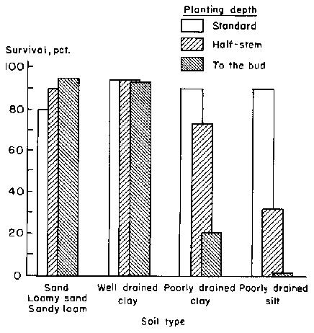
FIG. 6. Effect of planting depth on survival of southern pine seedlings. Sand to sandy-loam (27) -Grade 2 seedlings; well drained clay (43); poorly drained clay (53); poorly drained silt (53).
Most nursery managers in the South sow for one density with one or two mixed lots from the seed orchard. However, they provide only one or two choices of seedlings for outplanting. If the land base is small and uniform, one type of planting method is used, and planting is confined to the optimum planting season, this may be acceptable. However, if the land base covers a wide range of sites in several geographic provenances, the planting season's extended into the fall, and several types of planting methods and crews are used, then it would be better if the nurserymen could provide a range of seedling types. This can be accomplished by sowing various genotypes and at different densities.

NURSERY PRACTICES FOR PRODUCING QUALITY SEEDLINGS
There are a number of cultural practices available to the nurseryman who wishes to improve the quality of his nursery stock. However, some practices may increase production costs and therefore should be prescribed according to region, site, and planting method. When choosing cultural practices, the nurseryman must weigh the economics and the anticipated survival and volume growth of each treatment. It should be remembered that cheap and inexpensive are Dot necessarily synonymous when the entire cycle of a plantation is considered.

Handling Seed to Produce Uniform Seedlings
A goal of nurserymen is to produce a uniform crop of seedlings. However, a broad range of seedling morphologies is usually produced which often includes a number of cull seedlings. This is largely a result of uneven seed germination. Seed that are the first to germinate usually produce seedlings with the largest diameters, while culls usually arise from seed that germinate last. Therefore, the diameter distribution will be narrow for seed that germinate over a short period (a few days) and wide for seed germinating over several weeks. Seed handling is the major facto, that determines the length of time for germination to occur.
There are several practices that will help reduce the production of cull seedlings and narrow the distribution of diameters produced. Sowing empty seed along with full seed will cause many seedlings to grow closer to one another than need be. With loblolly pine, this can be avoided b ' soaking seed in water and removing the "empty seed" that float. Sowing seed with high germination rates (greater than 95 percent) will help produce uniform seedlings.
Sizing seed is important to produce uniform seedlings. In general, large seed germinate more quickly than small seed and thus produce larger seedlings (16). Sowing by seed size therefore results in more uniform germination.
Nurserymen quickly realized the importance of seed stratification for producing uniform seedlings. For species like loblolly pine, stratification can reduce the period required for germination by approximately three-fourths (3). The length of stratification can determine how rapidly emergence occurs.
Improper covering of seed during sowing can result in an erratic stand of seedlings. If a mulch is used, a uniform application depth is desired. Too sparse or too deep a covering can affect seedling emergence and growth. If no mulch is used, seed should be sown at a uniform soil depth.
Sowing by family will also increase seedling uniformity. Wasser (64) showed that seed from different families can germinate at differing rates. Subsequently, seed from a slow germinating family developed into seedlings with smaller diameter when sown in mixed lots. Average seedling diameter was more uniform when seed were sown by family.
Precision sowing of seed will increase seedling uniformity. Various sowers currently used in forest nurseries are not precision but are actually drills that often distribute seed in clumps. Cull seedlings can often arise from seed sown too close together. Precision sowers have been developed that will sow one seed at a time. This reduces clumping of seed and results in a reduction in the production of culls. One study from New Zealand reported that seedlings resulting from precision sowings produce higher initial volume when outplanted (57).

Practices for Producing Heavy Root Systems and Large Diameters
A goal of nurserymen is to produce seedlings with large diameters and heavy root systems. If properly planted, such seedlings will often outperform smaller seedlings of equal height.
Competition for water, light, and nutrients by weeds can greatly affect seedling morphology. Therefore, to produce large-diameter seedlings, the nurseryman must keep weed populations under control. This can be achieved with use of integrated weed control practices in combination with selective herbicides (45).
High soil bulk density will inhibit seedling root growth (33,73,23). Mitchell et al. (33) have shown that root mass of loblolly pine in a sandy loam soil can be reduced by 23 percent when bulk density is increased from 1.2 to 1.6 grains per cubic centimeter. To help avoid compacting the soil, nurserymen should avoid working the soil when wet and should keep tractor paths confined to the alleyways. Subsoiling, wrenching, and incorporation of organic matter can help reduce soil bulk density. Brown and Pokorny (8) have shown that bulk density can be decreased by 0.3 gram per cubic centimeter when 5 centimeters of pine bark is incorporated into the top 15 centimeters of soil.
Spacing between seedlings is another major factor influencing seedling morphology. Seedlings grown close together (at high densities) often have small diameters and light root systems. Optimum seedling spacing is dependent on desired seedling diameter, fertilization, soil moisture, drill spacing, date of sowing, and economics. In New Zealand, 5-centimeter spacings have proven desirable with "single" 13-centimeter drills. Mexal (30) suggests an optimum growing space per seedling of 50 square centimeters for loblolly pine (and prefers offset "double" drills with 5. 1-centimeter minimum distance between seedlings).
Early sowing will result in increased seedling diameters. In the past when fertilization was practiced less, nurserymen often sowed early. In 1957, sowing by the middle of April was considered late for nurseries in Florida and Georgia (I 7). At the Ashe Nursery in Mississippi, loblolly pine was sown from March 23 to 28 in 1966 (as compared to April 25 to May 6 in 1983). Currently, the Tilghman Nursery in South Carolina routinely sows in March. However, to keep seedlings from growing too tall, many nurserymen have delayed sowing until the middle of April or the first of May. While sowing late may limit height growth, it also adversely affects seedling biomass. Data from Georgia (46) indicate that for each day sowing is delayed, a 1. 2 percent decrease in seedling weight occurs by mid-winter. When height growth is controlled by other means, sowing early can help reduce the production of cull seedlings.
Monitoring soil fertility and making proper fertilizer and organic matter additions are essential if quality seedlings are to be produced on a continuing basis. Inadequate fertilization can result in undersized seedlings while overfertilization of certain elements can produce toxicity symptoms. Wide fluctuations in soil acidity levels and soil nutrient levels can be avoided by evaluating changes in soil nutrient values over time. A soil testing program for forest nurseries in the Southern Coastal Plain has been established to help nurserymen with fertility management of their soils (47).
An interaction between seed spacing and nitrogen fertilization exists. The lower the density or the greater the nitrogen per plant, the larger the seedling. In general, seedlings grown at close spacings respond proportionately more to nitrogen fertilization than seedlings grown at wider spacings. Switzer and Nelson (54) found that maximum yield for loblolly pine (in terms of the percentage of seedlings with root collars greater than 3 millimeters) could be achieved with an application of about 160 milligrams of N per plant.
Early formation of mycorrhizae is important if seedlings are to benefit from fertilization. This can be especially important for new nurseries or new seedbeds where pine seedlings are grown for the first time. Even with high levels of N, P, K, and Ca in the soil, loblolly pine seedlings in noninfested fumigated soil may not grow appreciably until ectomycorrhizae form (26). Since mycorrhizae can have an important impact on both seedling size and subsequent outplanting performance, nurserymen should be aware of practices that may adversely affect the formation of mycorrhizae (25,41,49).
If the planting site is adverse, then the species of mycorrhizal symbiont can be important. When planted on coal spoils, seedlings inoculated with Pisolithus tinctorius (Pers.) Coker and Couch have performed better than seedlings with other naturally occurring ectomycorrhizal fungi (24,63). Techniques involving fumigation, inoculation, and fertilization have been developed for tailoring seedlings with this fungal symbiont (11).
Diameter growth of seedlings can be inhibited by extended periods of anaerobic soil conditions. To avoid such conditions, nurserymen should not allow the soil to remain in a saturated condition. Nurserymen can help prevent this from occurring by
keeping infiltration rates adequate (above 8 centimeters per hour) and by not over-irrigating. Infiltration rates will be low in areas with high bulk density, plow pans, high water tables, and high silt or clay content. Some root diseases are more likely to occur in areas with poor infiltration.
Control of root diseases is important to the production of quality seedlings. Nurserymen should be aware of the environmental conditions which favor development and the cultural treatments which help prevent development of various diseases. Maintaining an adequate supply of soil organic matter, keeping soil pH levels low, keeping infiltration rates high, using a mulch to keep bed temperatures moderate, and soil fumigation are some cultural treatments that can be used to control diseases (51).
Practices for Controlling Seedling Height
There are three methods commonly used for regulating seedling height: (1) moisture stress; (2) root pruning; and (3) top pruning. Moisture stress can be used to slow terminal elongation. Nurserymen often reduce or stop irrigation of seedlings in August or September in an effort to reduce seedling height growth. Stransky and Wilson (50) found terminal elongation of loblolly pine slowed at 2 bars of soil moisture tension. Unfortunately, rainfall in the fall may thwart the nurseryman's efforts to stress seedlings. Seedling moisture stress may therefore be imposed by root pruning and/or wrenching. One study on loblolly pine indicated a single undercutting and wrenching resulted in a significant improvement in shoot/root ratio as well as a significant improvement in field survival (55).
For some nurseries with fine-textured soils and poor structure, undercutting or wrenching may be difficult to practice. In addition, height growth at some nurseries may be quite variable (as a result of sowing a mixture of families or when germination is spread over several weeks). Therefore, top pruning of seedlings may be required to keep seedlings from being unbalanced. If top pruned in August and only succulent tissue is cut, seedlings may recover and form new terminal buds by December. However, if top pruning occurs late and woody tissue is cut, a terminal bud may not form and auxiliary buds may develop slowly. Regardless of when top pruning occurs, growth of lateral roots may be reduced as the seedling channels its energies into repairing the severed shoot.
OPTIMUM USE OF NURSERY TECHNOLOGY
There are several technological advances presently available to nursery managers but which are not commonly used. Such advances include computer generated maps for use in land shaping, tile drainage, automatic calibration of pesticide applicators, automatic guidance of tractors, ultra-low-volume applications of herbicides, automatic irrigation systems, monitoring of pesticide levels in soil, foliar nutrient analyses, uniform application of lime and fertilizers, containerization, mycorrhizal inoculation, sowing by family, monitoring xylem water potential, use of soil tensiometers, monitoring carbohydrates in roots, continuous recording of weather information, precision sowing, monitoring seed efficiencies, modifying soil chemical and physical properties with organic amendments high in lignin, automatic alignment devices for lateral root pruners, high flotation/low compaction spray equipment, subsoilers, use of microcomputers, monitoring seedling morphology, and monitoring seedling outplanting performance.
There are four basic reasons why various technological advances are not commonly used in forest nurseries. The first is a lack of available data to indicate an economic benefit. For example, purchasing an automatic pesticide calibration unit for $3,000 may not be justified economically if data on pesticide overuse are not available. The second reason involves technological advancements which are proven to be uneconomical once the data are collected. The third reason deals with operating under budget restraints which do not allow taking advantage of technological advances. Purchasing a precision sower at a 20-million seedling nursery for $32,000 to improve seed efficiency by 2 percent (and thereby increase annual revenues by $8,000 by selling an additional 400,000 seedlings at $20 per thousand) may not be possible if the governmental agency is operating under an austerity budget. The fourth reason involves a lack of education due to insufficient economic analysis. The economic return for practices such as precision sowing and sowing by family are high, but nurserymen and nursery supervisors have often not provided the needed analysis. For example, many nurserymen are presently using much of the sowing technology developed 50 years ago when seed were from wild sources. Today, with the present net value of improved seed worth I cent per seed or more, technological improvements in sowing practices can be easily justified if seed efficiencies can be improved. For example, if an organization can increase seed efficiency by 6 percent and thereby plant an additional 3,000 hectares with improved seedlings (at 15 percent gain), the resulting increase in wood production could easily amount to $170,000 in today's dollars. Although technology for increasing forest productivity in this manner exists, management in few organizations has chosen to allocate to the nursery the needed resources to take advantage of this opportunity.
In addition, large economic benefits can also result from applying appropriate technological advances in the nursery to increase the production of Grade I seedlings. Depending on site and planting density, economic analysis indicates the present value resulting from planting Grade I seedlings instead of Grade 2 seedlings can exceed $100 per thousand seedlings. This suggests a great opportunity for increasing forest productivity through investing in nursery management practices that produce a greater proportion of quality seedlings.
Most of the technological advances in forest nurseries have only come after adequate economical analyses have been made and evaluated. Determination of which technological advances are useful and which should be discarded should be made only after performance data have been collected and subjected to economical analysis. Adoption of technological advances should not be made helter-skelter according to fad or opinion.

LITERATURE CITED
(1) BACON, G.J., P.J. HAWKINS, AND D. JERMYN. 1977. Morphological Grading Studies with 1-0, Slash Pine Seedlings. Aust. For. 40(4): 293-303.

(2) BAKER, K.A., D.A. IDEM, AND J.G. MEXAL. 1979. The Effects of Seedling Morphology and Planting Date on Survival and Early Growth of Loblolly Pine in the Oklahoma Region. Weyerhaeuser Co. For. Res. Tech. Rep. 042-2008/79/35, 10 pp.

(3) BARTON, L.V. 1928. Hastening the Germination of Southern Pine Seeds. J. For. 26:774-785.

(4) BEINEKE, W. F. AND T. 0. PERRY. 1965. Genetic Variation in Ability to Withstand Shock. pp. 106-109. In Proc. 8th S. Conf on For. Tree Improvement.

(5) BILAN, M.V. 1961. Effect of Planting Date on Regeneration and Development of Roots of Loblolly Pine Seedlings. Proc. 13th Congr. Int. Union For. Res. Organ., Vienna 2(l), Sect. 22/15, 5 pp.

(6) BLAIR, R. AND F. CECH. 1974. Morphological Seedling Grades Compared After Thirteen Growing Seasons. Tree Planter's Notes 25(l):5-7.

(7) BRANAN, J. R. AND E.J. P013TERFIELD. 1971. A Comparison of Six Species of Southern Pines in the Piedmont of South Carolina. USDA For Ser. Res. Note SE-171, 3 pp.

(8) BROWN, E. F. AND F.A. POKORNY. 1977. Potassium Distribution and Retention in Pine Bark and Sand Media. Hort. Sci. 12:343-344.

(9) BURNS, R. M. 1968. Sand Pine; A Tree for West Florida's Sandhills. J. For. 66:561-563.
(10) AND R. H. BRENDEMUEHL. 1971. Nursery Bed Density Affects Slash Pine Seedling Grade and Grade Indicates Field Performance. USDA Forest Serv. Research Pap. SE-77. 7 pp.

(11) CORDELL, C. E. AND D. H. MARX. 1983. The Operational Application of Pisolithus tinctorius ectomycorrhizae in forest tree nurseries for custom seedling production. pp. 117-120. In C.W. Lantz and J. Brissette, eds. Proc. 1982 Southern Nurserymen's Conf, 312 pp.

(12) DIERAUF, T. A. 1976. Fall Planting and Storage Using Non-dormant Seedlings, pp. 31-36. In C.W. Lantz ed. Proc. 1976 SE Area Nurserymen's Conf, 168 pp.

(13)DIERAUF, T. A. . 1973. Loblolly Pine Seedlings Grade Growth and Survival. Virginia Division of Forestry Occasional Report 40. 6 pp.

(14) DIERAUF, T. A. 1978. Root Pruning. Virginia Division of Forestry Occasional Report 52. 4 pp.

(15) . 1982. Planting Loblolly Pine. pp. 124-135 In R.C. Kellison and S. Gingrich, eds. Proc. Symposium on the Loblolly Pine Ecosystem. 335 pp.

(16) DUNLAP, J.R. AND J.P. BARNETT. 1983. Influence of Seed Size on Germination and Early Development of Loblolly Pine (Pinus taeda L.) Germinants. Can. J. For. Res. 13:40-44.

(17) FOSTER, A.A. 1957. Nursery Diseases. pp. 25-31. In F.M. Cossitt, ed. Proc. 1957 Nursery Training Session, Athens, Ga. 47 pp.

(18) GARBER, M.P. 1978. Dormancy of Vegetative Growth of Loblolly Pine Seedlings. Weyerhaeuser Co. For. Res. Tech. Rep. 0422010/78/87, 11 pp.

(19) GARBER, .M.P. AND J. G. MEXAL. 1980. Lift and Storage Practices: Their impact on Successful Establishment of Southern Pine Plantations. N.Z. J. For. Sci. 10(l):72-82.

(20) GODBEE, J. F. JR., J. L. RAKESTRAW, AND F. S. BROERMAN. 1983. Pine Plantation Survival: A Corporate Look at the Problem. pp. 21-26. In C.W. Lantz and J. Brissette, eds., Proc. 1982 Southern Nurserymen's Conf, 312 pp.

(21) HATCHELL, G.E., KW. DORMAN AND O.G. LANGDON. 1972. Performance of Loblolly and Slash Pine Nursery Selections. Forest Sci. 18:308-313.

(22) JORGENSEN, J.R. AND E.SHOULDERS. 1967 Mycorrhizal Root Development Vital to Survival of Slash Pine Nursery Stock. Tree Planters' Notes 18(2):7-11.

(23) LOWERTS, G.A. AND J.M. STONF-. 1982. The Effect of Soil Bulk Density on Nursery Sweetgum Seedling Growth. Tree Planter's Notes 33(2):3-5.

(24) MARX, D.H. 1975. Mycorrhizae and Establishment of Trees on Strip-mined Land. Ohio J. Sci. 75:288-297.
(25) MARX, D.H., W.C. BRYAN, AND C. F. CORDELL. 1977. Survival and Growth of Pine Seedlings with Pisolithus Ectomycorrhizae after Two Years on Reforestation Sites in North Carolina and Florida. For. Sci. 23:363-373.

(26) MARX, D.H., W.G. MORRIS AND J.G. MEXAL. 1978. Growth and Ectomycorrhizal Development of Loblolly Pine Seedlings in Fumigated and Nonfumigated Nursery Soil Infested with Different Fungal Symbionts. For. Sci. 24:193-203.

(27) MARX, D.H., McGEE, C. E. AND J. B. HATCHER. 1963. Deep-planting Small Slash Pine on Old Field Sites in the Carolina Sandhills. J. For. 61:382-383.

(28) MCNAB, W.H. AND B.H. BRENDEMUEHL. 1982. Choctawhatchee Sand Pine Survival, Height, and Biomass in South Carolina: Third-year Results. pp. 96-100. In Earle Jones, Jr., ed., Proc. Second Bien. Son. Silvi. Res. Conf. pp. 96-100. Atlanta, Ga.

(29) MEEKINS, E.H. 1964. A Case for Planting Graded Stock. Tree Planter's Notes 66:7-8.

(30) MEXAL, J.G. 1980. Seedling Bed Density Influences Yield and Performance. pp. 89-95. In Clark Lantz, ed., Proc. 1980 South. Nor. Conf, Lake Barkley, Ky. USDA Tech. Pub. SA-TP17.

(31) MEXAL, J.G. AND W. G. MORRIS. 1977. A Review of factors Influencing the Dormancy and Survival Potential of Bareroot Seedlings in the South. Weyerhaeuser Co. For. Res. Tech. Rep. 042-2008/77/44.

(32) MEXAL, J.G., R. L. MOSER, R.J. BRYANT, AND T. L. LANE. 1978. Root Quality in Plantations Affects Growth of Loblolly Pine. Weyerhaeuser Co. For. Res. Tech. Rep. 042-2008/78/53.

(33) MITCHELL, M.L., A.E. HASSAN, C.B. DAVEY, ANDJ.D. GRECORY. 1981. Effect of Soil Compaction on Root Development and Seedling Establishment. Am. Soc. Of Agri. Engineers Paper No. 81-1040.

(34) MULLER, C.A. 1983. Loblolly Pine Seedling Survival Study, 1979-80 and 1980-81 Planting Seasons. pp. 27-39. In C.W. Lantz and J. Brissette, eds., Proc. 1982 Southern Nurserymen's Conf, 312 pp.

(35) MULLIN, R. E. 1974. Some Planting Effects Still Significant after 20 Years. For. Chronicle 50(5): 191-193.

(36) NELSON, L.R., S.A. KNOWE, AND D.H. GJERSTAD. 1982. Use of Effective Herbicide Treatments for Artificial Regeneration of Longleaf Pine. Ga. For. Res. Pap. #40, Georgia Forestry Commission, Macon, Ga. 7 pp.

(37) OAK, S. 1983. Evaluations of a Loblolly Pine Seedling Survival and Storage Problem on the Sumpter, Chattachoochee, and Oconee National Forests, 1983. USDA Forest Service, Forest Pest Management, Asheville Field Office Report #83-1-2215 pp.
(38) RITCHIE, G.A. 1984. Assessing Seedling Qualitv. In Proceedings of the Bareroot Nursery Technology Workshop, Oregon State University, Corvallis, Ore., October 26-28, 1982.

(39) SHIPMAN, R.D. 1964. Low Seedbed Densities Can Improve Early Height Growth of planted Slash and Loblolly Pine Seedlings. J. For. 62:814-817.

(40) SHOULDERS, E. 1960. Seedbed Density Influences Production and Survival of Loblolly and Slash Pine Nursery Stock. Tree Planter's Notes 42:19-21.

(41) SHOULDERS,E. AND J.R. JORGENSEN. 1969. Mycorrhizae Increases Field Survival of Planted Loblolly Pine. Tree Planter's Notes 20:14-7.

(42) SILKER, T. H. 1960. Economic Considerations of growing and Grading Southern Pine Nursery Stock. Tree Planter's Notes 42:13-18.

(43) SLOCUM, G.K. AND T.E. MAKI. 1956. Some Effects of Depth of Planting in the North Carolina Piedmont. J. For. 54:21-25.

(44) SLUDER, E.R. 1979. The Effects of Seed and Seedling Size on Survival and Growth of Loblolly Pine. Tree Planter's Notes 30(4):25-28.

(45) SOUTH, D.B. 1984. Integrated Pest Management in Nurseries Vegetation. In Proceedings of the Integrated Forest Pest Management Svmposium. USDA Forest Service. Atlanta, Ga. June 1984. P. 247-265.

(46) SOUTH, D.B. 1984. Sowing Date Influences Seedling Weight. Auburn Univ. Southern Forest Nursery Management Cooperative Note #12. 3 pp.

(47) SOUTH, D.B. AND C. B. DAVEY. 1983. The Southern Forest Nursery Soil Testing Program. Ala. Agr. Esp. St. Cir. 265, 38 pp.

(48) SOUTH, D.B., BOYER, J.N., AND L. BOSCH. 1985. Survival and Growth of Loblolly Pine as Influenced by Seedling Grade - 13 Year Results. South. J. App. For. (IN PRESS).

(49) SOUTH, D.B. AND W. D. KELLEY. 1982. The Effect of Selected Pesticides on Short-Root Development of Greenhouse-grown Pinus taeda Seedlings. Can. J. of For. Res. 12:29-35.

(50) STRANSKY, J.J. AND D.R. WILSON. 1964. Terminal Elongation of Loblolly and Shortleaf Pine Seedlings Under Soil Moisture Stress. Soil Sci. Sec. Amer. Proc. 28:439-440.

(51) SUTHERLAND, J. R. AND R. L. ANDERSON. 1980. Seedling Disease and Insect Problems Related to Nursery Soil Conditions in North America. pp. 182-190. In Proceedings ofthe North American Forest Tree Nursery Soils Workshop. SUNY. Syracuse, N.Y.

(52) SWEARINGEN, J.W. 1963. Effect of Seedlings Survival and Depth of Planting on Early Survival and Growth of Slash Pine. Tree Planter's Notes 58:16-17.
(53) SWITZER, G.L. 1960. Exposure and Planting Depth Effects on Loblolly Pine Planting Stock on Poorly Drained Sites. J. For. 58: 390-391.

(54) SWITZER, G.L. AND L.E. NELSON. 1963. Effects of Nursery Fertility and Density on Seedling Characteristics, Yield and Field Performance of Loblolly Pine. Soil Sci. Soc. Amer. Proc. 27:461-464.

(55) TANAKA, Y., J. D. WALSTAD, AND J. E. BORRECCO. 1976. The Effect of Wrenching on Morphology and Field Performance of Douglas Fir and Loblolly Pine Seedlings. Can. J. For. Res. 6:453-458.

(56) TERRY. T. 1983. How to Establish a Pine Plantation. Forest Farmer 43(1):6-8.

(57) TREWIN, A.R. D. 1981. In-Bed Thinning, Culling and Grading of Bare-root Fine Seedlings. pp. 113-124. In C.G.R. Chavasse, ed., Forest Nursery and Establishment Practice in New Zealand. New Zealand Forest Research Institute Symposium No. 22. 330 pp.

(58) U.S. DEPARTMENT OF AGRICULTURE, FOREST SERVICE. 1982. An Analysis of the Timber Situation in the United States 1952-2030. Forest Res. Rep. 23, Govt. Print. Off., Washington, D.C. 499 pp.

(59) VENATOR, C. R. 1983. First-Year Survival of Morphologically Graded Loblolly Pine Seedlings in Central Louisiana. Tree Planter's Notes 34(4):34-36.

(60) WAKELEY, P.C. 1935. Artificial Reforestation in the Southern Pine Region. USDA Tech. Bul. 492, 115 pp.

(61) WAKELEY, P.C. 1954. Planting the Southern Pines. USDA Monog. 18, 233 pp,

(62) WAKELEY, P.C. 1969. Results of Southern Pine Planting Experiments in the Middle Twenties. J. For. 67:237-241.

(63) WALKER, R.F., D.C. WEST, AND S.B. McLAUGHLIN. 1980. Pisolithus tinctorius Ectomycorrhizae Enhance the Survival and Growth of Pinus taeda on a Southern Appalachian Coal Spoil. pp. 29-33. In James Barnett, ed., Proc. First Bien. Sou. Silvi. Res. Conf. Atlanta, Ga.

(64) WASSER, RONALD G. 1978. Tree Improvement Research - Pure vs. Random Sowing Study. pp. 15-19. In C. W. Lantz, ed., Proc. 1978 Southern Nurserymen's Conf, 170 pp.

(65) WELLS, O.O. 1983. Southwide Pine Seed Source Study - Lobloily Pine at 25 Years. South. J. App. For. 7:63-71.

(66) WELLS, O.O. AND C.C. LAMBETH. 1983. Loblolly Pine Provenance Test in Southern Arkansas 25th Year Results. South. J. App. For. 7:71-75.

(67) WELLS, O.O. AND P.C. WAKELEY. 1966. Geographic Variation in Survival, Growth and Fusiform Rust Infection of Planted Loblolly Pine. For. Sci. Monogr. 11, 40 pp.

(68) WELLS, O.O. 1970a. Variation in Longleaf Pine from Several Geographic Sources. For. Sci. 16:415-423.

(69) WELLS, O.O. 1970b. Variation in Shortleaf Pine from Several Geographic Sources. For. Sci. 16:415-425.

(70) WILLEN, P. AND R.F. SUTTON. 1980. Evaluation of Stock after Planting. New. Zealand J. For. Sci. 10(l):297-299.

(71) XYDIAS, G.K. 1980. Plantation Survival Studies of Continental Forest Industries. pp. 8-15. In James Barnett, ed., Proc. First Bien. Sou. Silvi. Res. Conf. Atlanta, Ga.

(72) XYDIAS, G.K. 1982. Factors Influencing Survival and Early Stocking Trends in Plantations of Loblolly Pine. pp. 101-108. In Earle Jones, Jr., ed., Proc. Second Bien. Sou. Silvi. Res. Conf. Atlanta, Ga.

(73) ZISA, R. P., H. G. HALVERSON, AND B.J. STOUT. 1980. Establishment and Early Growth of Conifers on Compact Soils in Urban Areas. USDA For. Ser. Res. Pap. NE-451.

