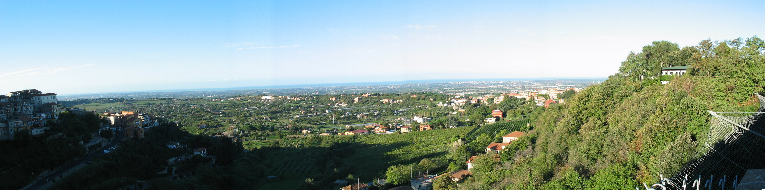
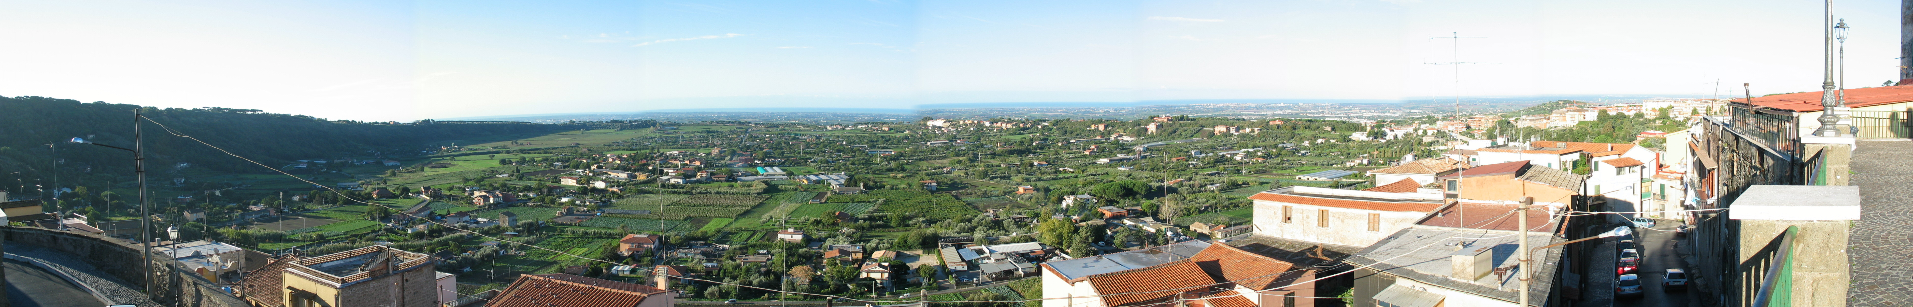
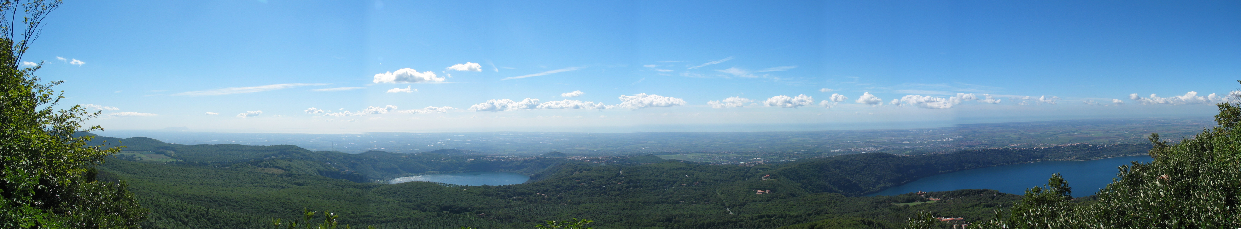
AU CHS@Ariccia, Italy – October 2003

