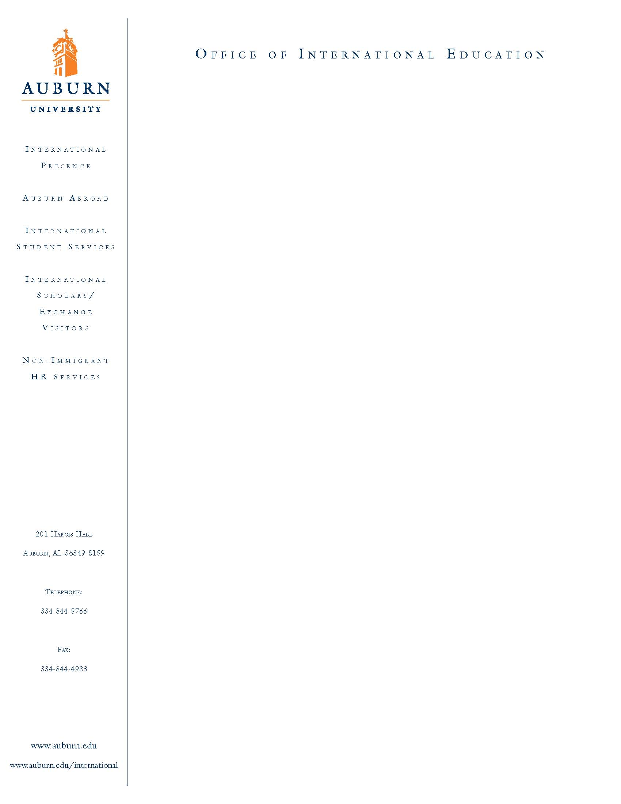
APPLICATION FOR THE SECAC - EA GLOBAL LEADERSHIP SCHOLARSHIP “PEACE STUDIES PROGRAM” Through IFSA-BUTLER at
QUEEN’S UNIVERSITY, BELFAST, NORTHERN IRELAND.

(SPRING SEMESTER 2010)

Legal Name: Mr./Ms.:____________________________________________________
Last First Middle

Auburn Banner ID #:_____________________ Birthdate: mm/dd/yyyy:___/___/___

College:_________________Major:______________Minor:_______________

Cumulative Institutional GPA as of Spring 2009:____________

Are there any disciplinary actions pending against you? __yes, ___ no

If “yes”, please explain:_________________________________________________

Scholarship/ aid:

Do you plan to use financial aid or scholarships that you are currently receiving, if chosen?__Yes ___No

If YES, please list those scholarships:_________________________________________

________________________________________________________________________

I understand that I must also complete the Auburn Abroad package and all necessary paperwork required for this scholarship and program and attach it to this application in order to be considered for this scholarship and program. I also understand that the Auburn University Office of International Education has the right to review all University records pertaining to may academic performance, discipline records and student accounts. I also understand that my acceptance will subject me to the rules and regulations of the study abroad program with regard to personal and academic performance.

I certify that the statements I have made on this application are correct and I will notify the Office of International Education immediately if circumstances change which compromise my successful participation in study abroad.

Signature:_______________________________ Date:_________________

Return with all application attachments to:

Deborah Weiss
Assistant Director, Auburn Abroad
Office of International Education, Auburn University
243 Foy Hall, Auburn, AL 36849
Email: weissds@auburn.edu
Ph: 334-844-5007, Fax: 334-844-4983 www.auburn.edu/studyabroad

