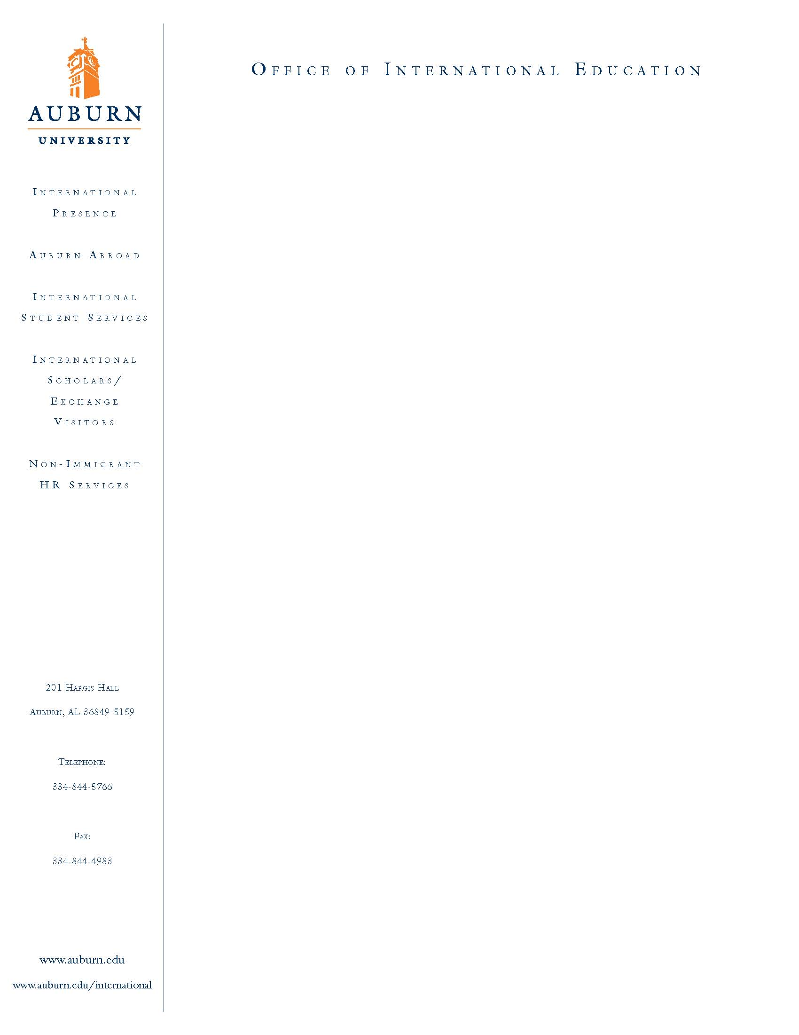
APPLICATION INSTRUCTIONS FOR

THE SECAC - EA GLOBAL LEADERSHIP SCHOLARSHIP
“PEACE STUDIES PROGRAM” Through IFSA-BUTLER at
QUEEN’S UNIVERSITY, BELFAST, NORTHERN IRELAND

(SPRING SEMESTER 2010)

More information about this program can be found at:
http://www.ifsa-butler.org/northern-ireland-overview.html
A Community Service Project will also part of this program.
One scholarship recipient will be selected from each of the institutions represented in the Southeastern Conference.

Applicants Need to Complete the Following Steps to be Considered for this Scholarship and Program:

1. Complete the following Applications:
  - SECAC Program Application: See Attached.
  - Auburn Abroad Application: http://www.auburn.edu/academic/international/forms/auab/FacultyLed_CompletePacket27May09.doc

- Prepare a statement (not to exceed two pages) describing your academic interests and what kind of service or community project you would be interested in pursuing while studying at Queens University in Belfast.

- Request a copy of your official Auburn Transcript (must show courses completed through Spring 2009).

- Enclose a one page resume indicating your achievements and extracurricular interests.

- Submit one letter of recommendation from a faculty member or advisor who can address your particular strengths and qualifications as they relate to this program.

- A campus interview may be requested. Once your application materials (#1 – 5) above have been submitted, you will be notified by our office.

Application DEADLINE is 2:00pm
EXTENDED TO SEPT. 25, 2009, FRIDAY.
Please submit all application materials to:
Deborah Weiss, Assistant Director, Auburn Abroad,
Office of International Education, Auburn University,
243 Foy Hall, Auburn, AL 36849
Ph: 334-844-5007, Fax: 334-844-4983
Email: weissds@auburn.edu, Website: www.auburn.edu/studyabroad

Next Steps:
Once the student has been selected for this scholarship, they will need to get a passport, will meet regularly with the Auburn Office of International Education and be directed to complete the following items: (a) Application for IFSA-Butler, Queens College, Northern Ireland Program and (b) the UK Visa.

