Auburn First Enrollment Tutorial

Enrollment Tutorial, Step 1

In your web browser, navigate to https://aub.ie/aufirst-parents.
Click on the “Enroll” button.
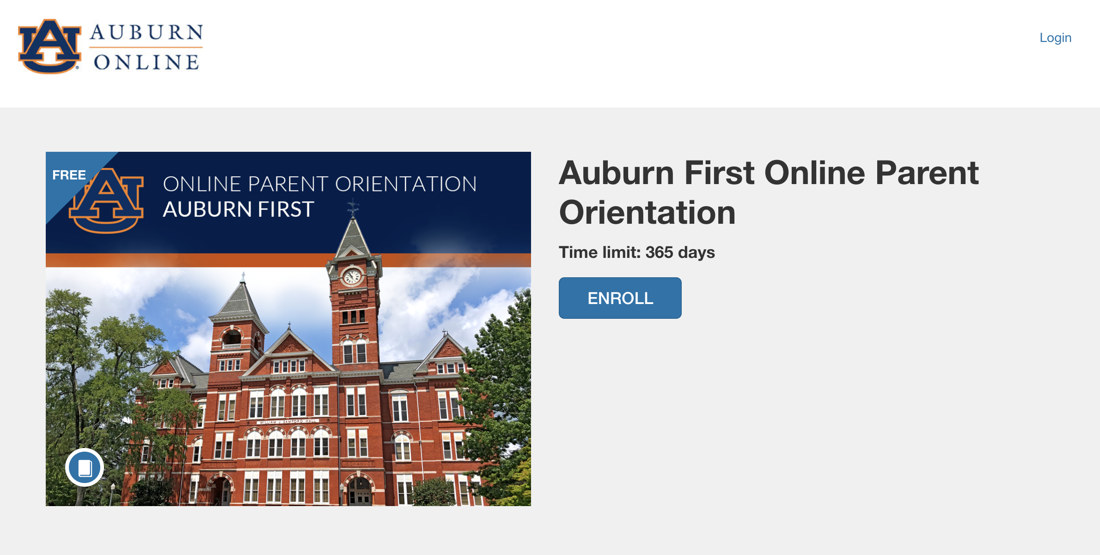

Enrollment Tutorial, Step 2

Enter your full name and email address and click the “Enroll in Course” button.

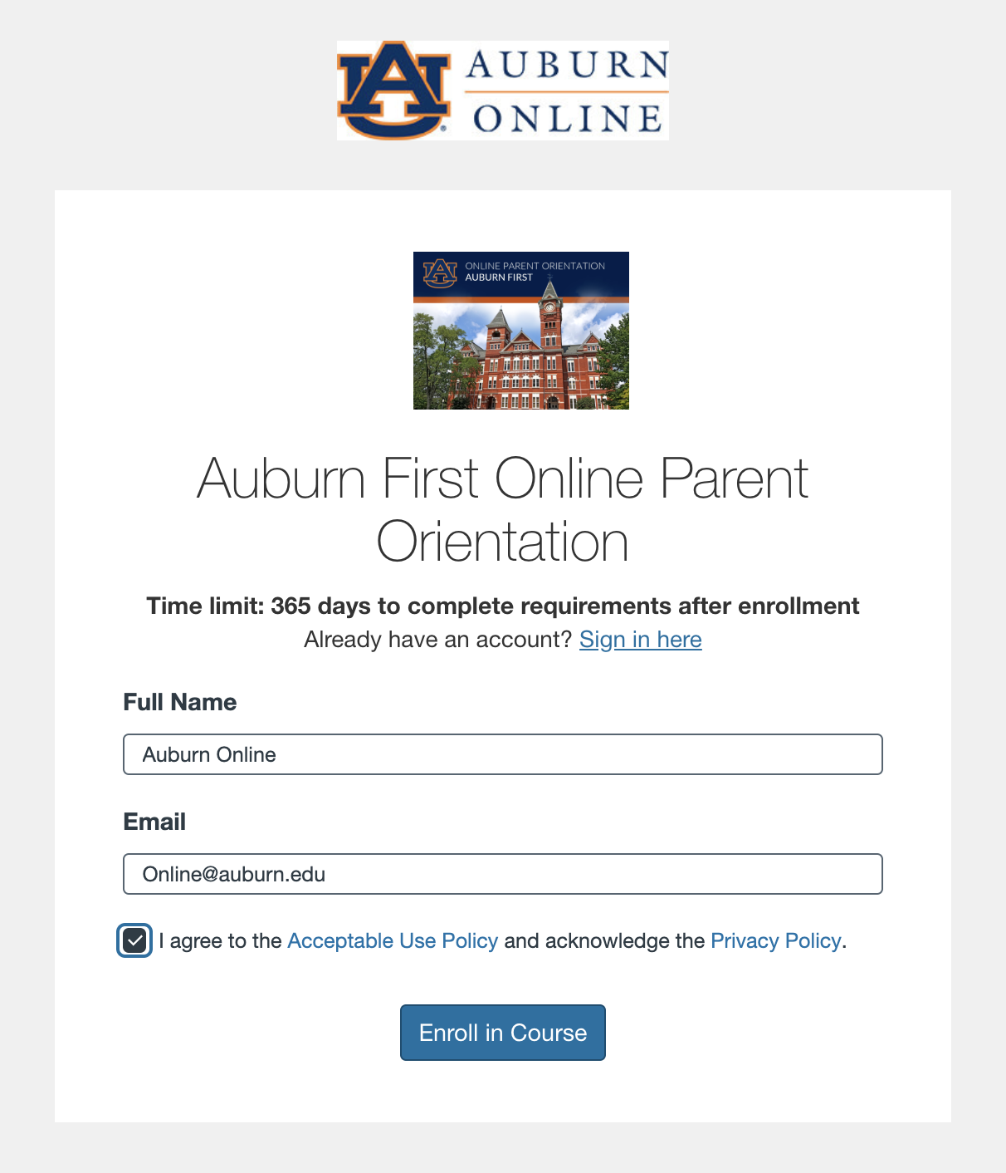

Enrollment Tutorial, Step 3

You will be prompted to check your inbox to confirm your registration.

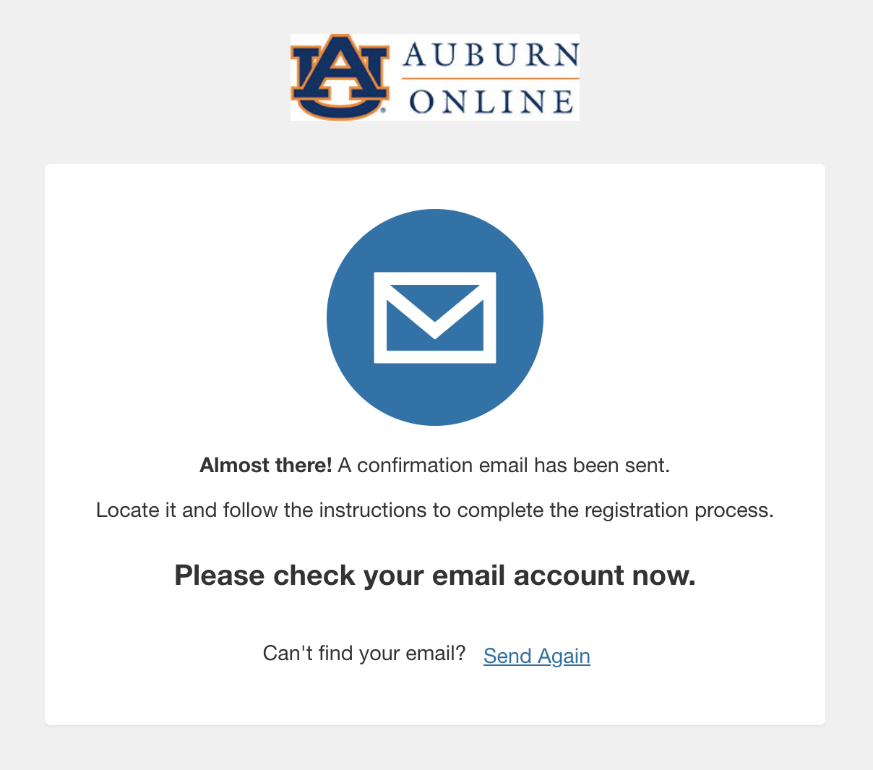

Enrollment Tutorial, Step 4

Now you have access to the course.
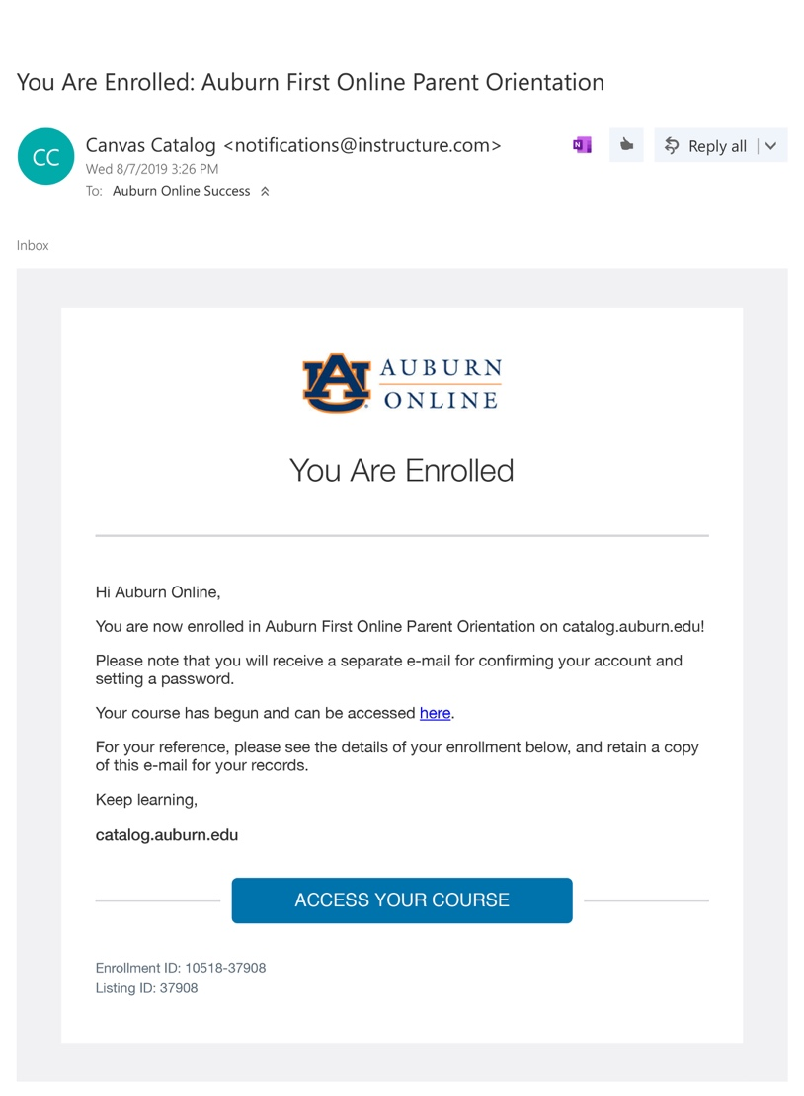

Enrollment Tutorial, Step 5

Complete your registration.
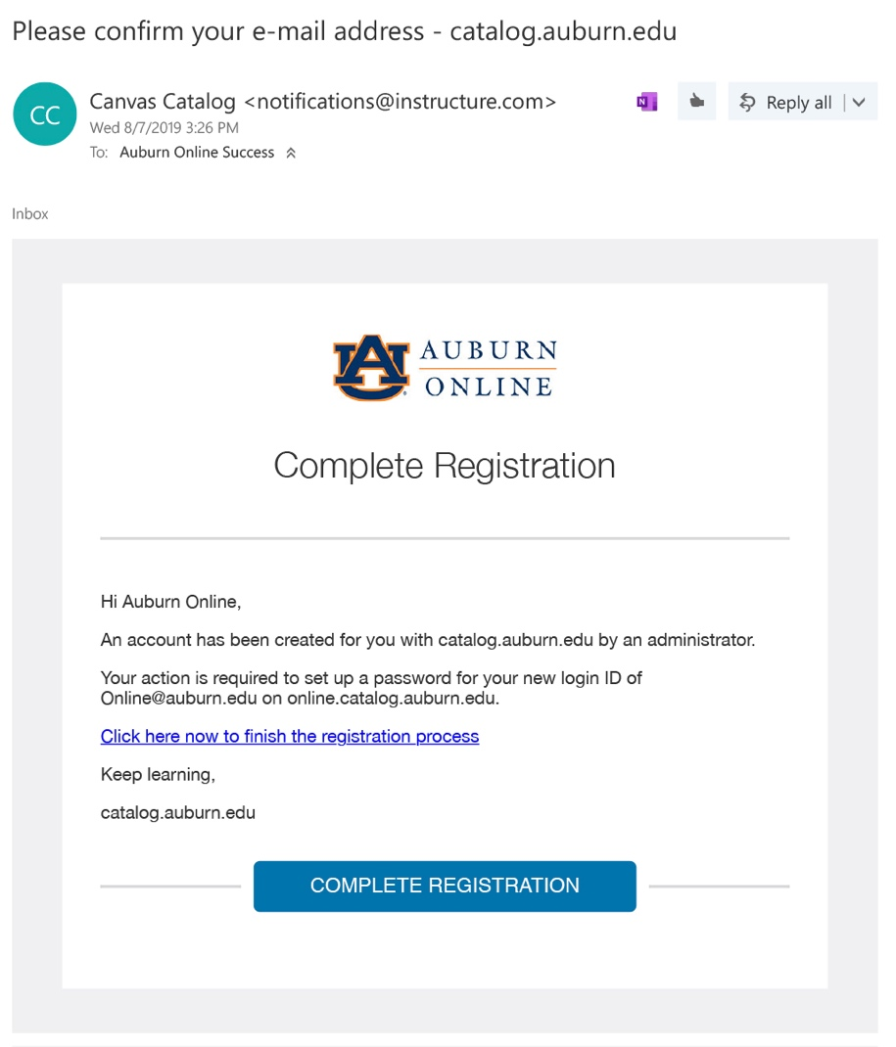

Enrollment Tutorial, Step 6

Setup a password for your new login ID for Auburn Catalog.
Note: Be sure that your password is at least 8 characters.

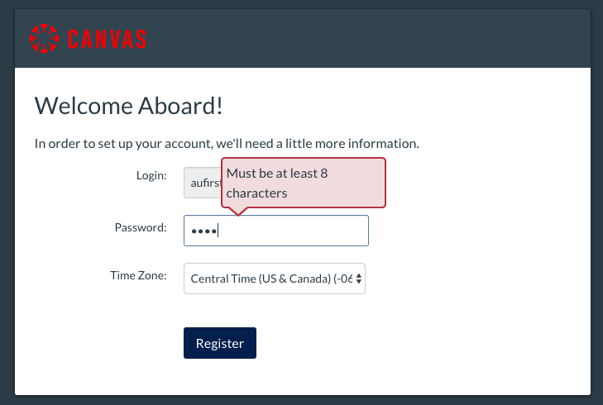

Enrollment Tutorial, Step 7

Visit https://auburncatalog.instructure.com/ to login to your account at any time.
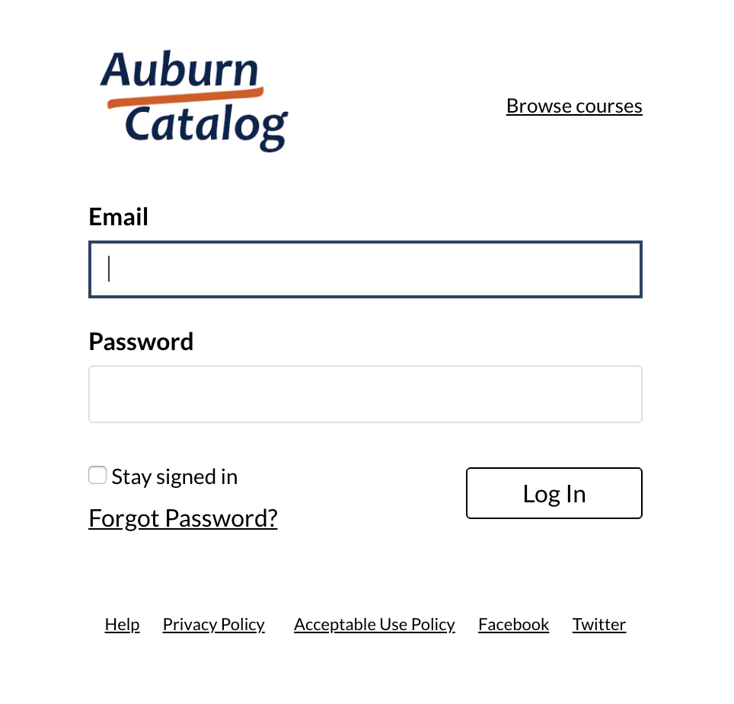

Enrollment Tutorial, Step 8

Click on the “Go To Course” button.
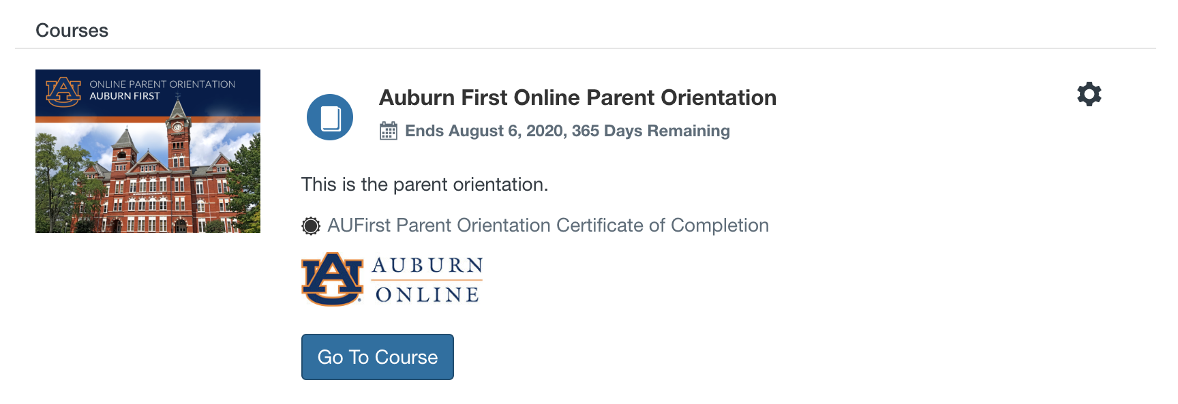

Enrollment Tutorial, Step 9

Now you can begin the course!
