# Introduction

All changes to programs and courses at Auburn University must be initiated and approved through the CIM application at the below links. CIM is a commercial product built for managing higher education curricula from initiation, through workflow, into inventory and ultimately the bulletin.

These links are published on the Curriculum Management page located under Resources for Faculty on the Office of the Provost website as well.

Programs: <https://nextbulletin.auburn.edu/programadmin/>

Courses: <https://nextbulletin.auburn.edu/courseadmin/>

Security is maintained by AU GID with each CIM user belonging to one or more roles. Figure 2 shows a few of the roles that have been defined for our operation. Roles must be kept up-to-date in order for the approval process to flow normally. The Office of Academic Effectiveness (OAE) will periodically ask that roles be reviewed by Associate Deans and Department Heads and the Office of the Registrar is responsible for making role updates. However, it is preferable that role changes are communicated to the Office of the Registrar at bulletin@auburn.edu as they occur. Out-of-date roles can result in stranded workflows, as will be further discussed in the Workflow section.

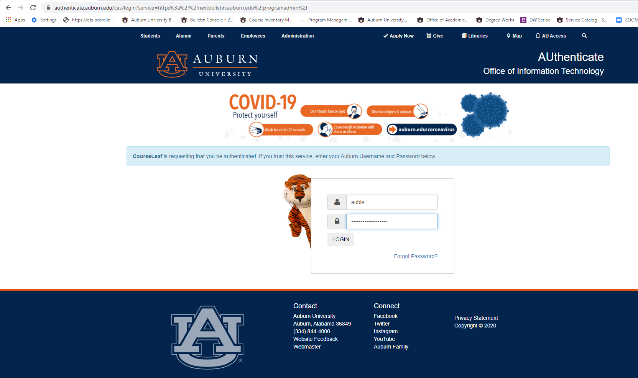

**Figure 1 – Authentication through CAS**

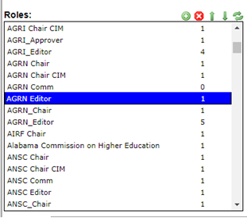

**Figure 2 – Roles**

# Editing Tips

Any faculty or staff may create Programs and Courses and edit those not yet in the workflow cycle. An overview and some tips are provided below.

The Search box can be used to narrow program or course lists by using the percent sign or asterisk for the wildcard. As seen in Figure 3a, %psyc% narrows the list to only those entries with the word *psychology* in either the Code or the Title. Searches are case-insensitive.

A set of pre-defined Quick Searches can further narrow the lists by status, undergraduate, or graduate.

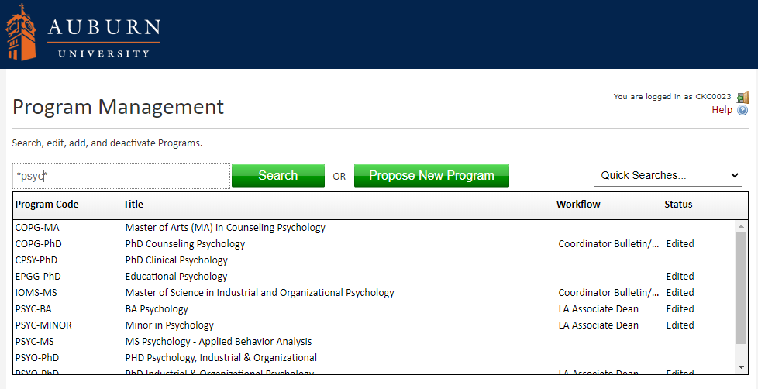

**Figure 3a – Program Sample Screen**

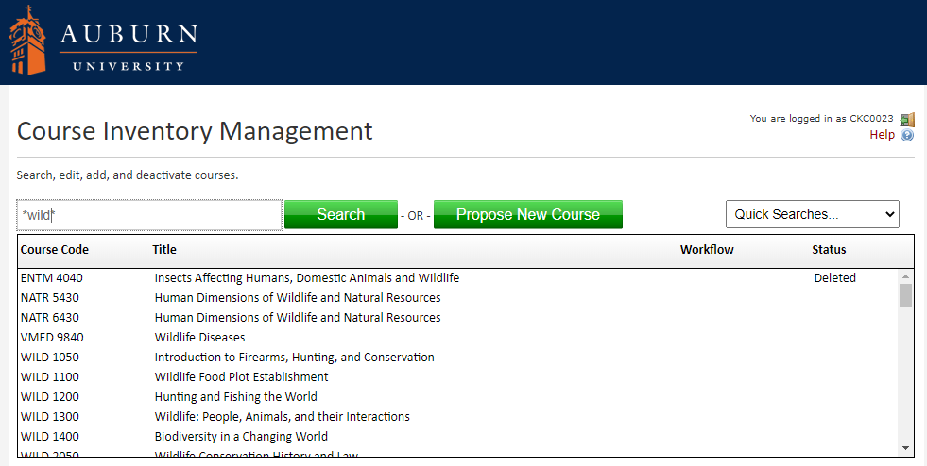

**Figure 3b – Course Sample Screen**

A text editor for free-form text boxes allows emphasis, subscripts and superscripts, hyperlinks, special symbols, and numbering, among other options. Titles should be kept free of punctuation marks as much as possible due to the data exchanges that occur among systems. While Courseleaf systems are generous with the allowed characters, other systems, including Banner and web pages that link to the data entered here, may not display them properly. Punctuation is subject to removal by administrators if system problems are expected.

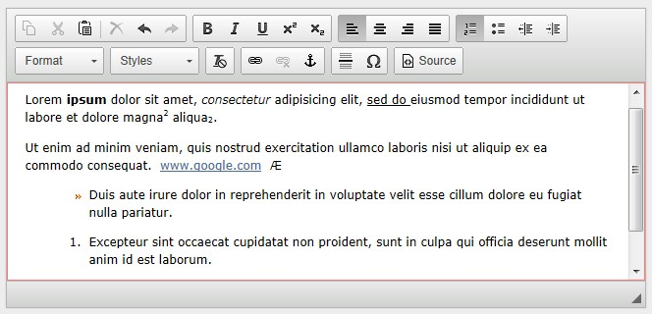

**Figure 4 – Examples of Text Editing Features**

Where appropriate, supporting documents may be attached from the user’s local computer. Every effort should be made to enter all information in the fields provided; however attachments may be useful for showing “before” details that can be used to compare against the current changes, or for attaching emails showing agreements needed from other departments.

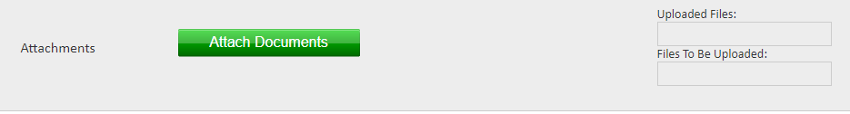

**Figure 5 – Attaching a Document**

Screenshots of the Program and Course Editing pages are shown in the next two sections.

**Programs**

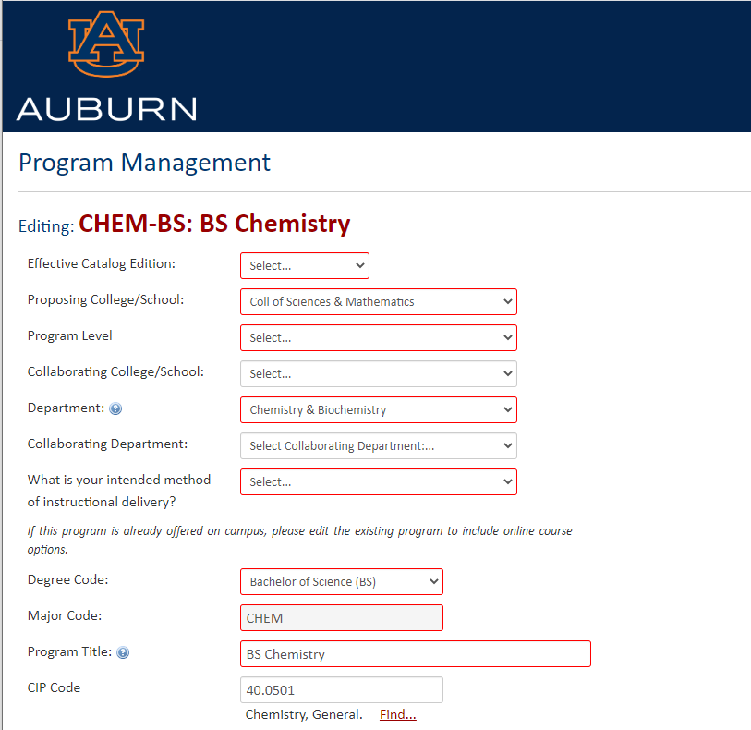

**Figure 6a – Program Example – Part 1**

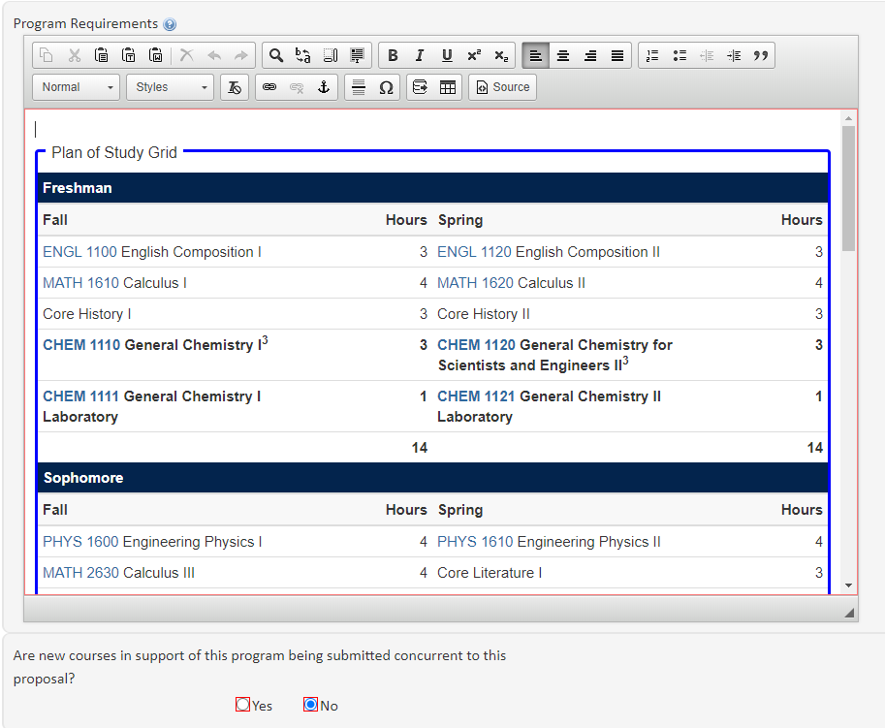

**Figure 6b – Program Example – Part 2**

**Courses**

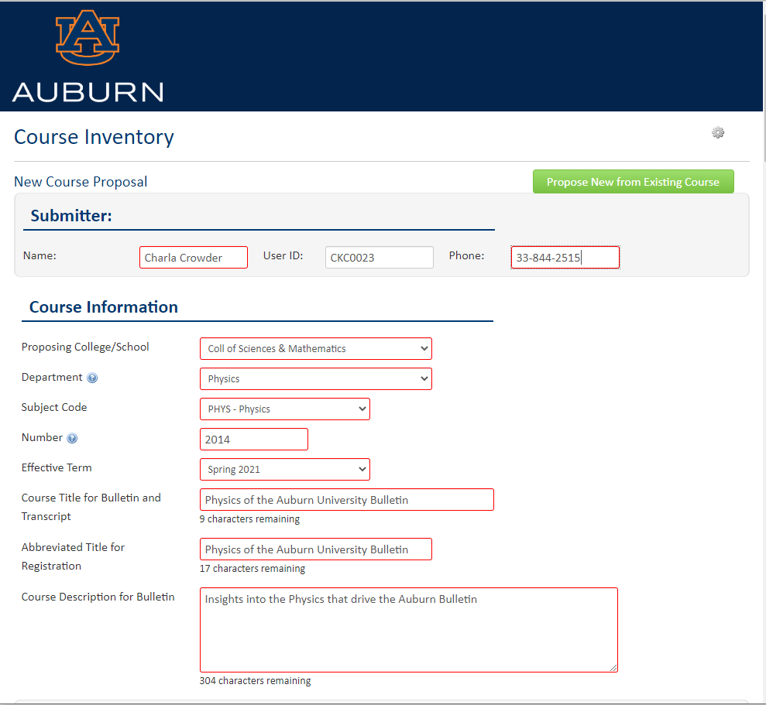

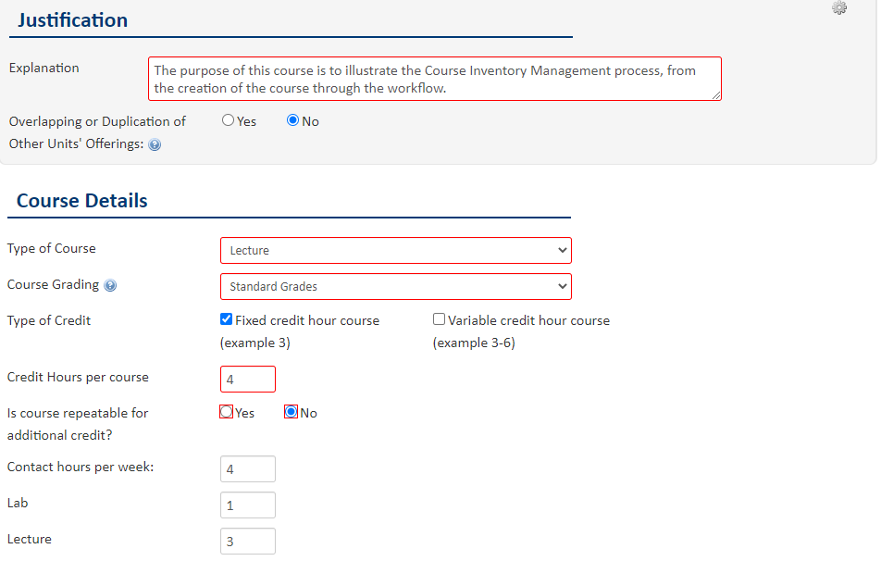

**Figure 7a – Course Example – Part 1**

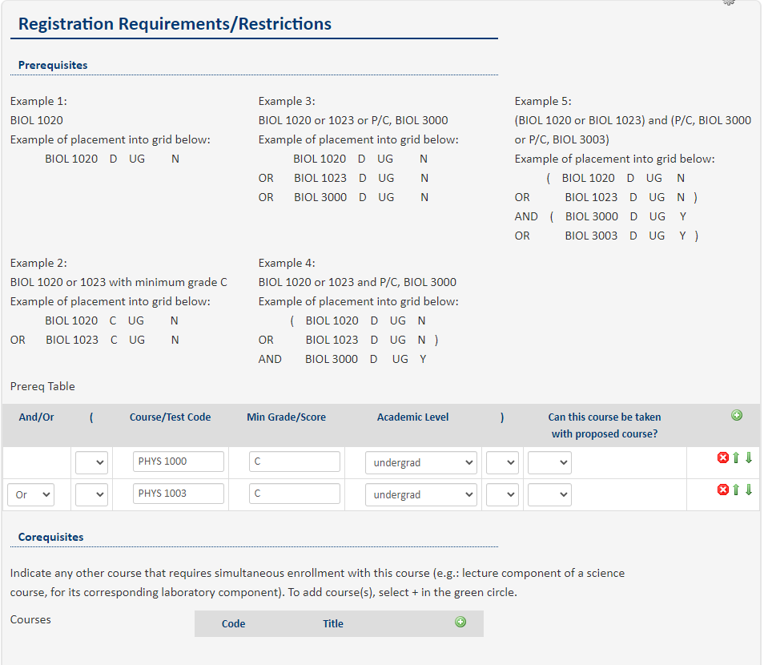

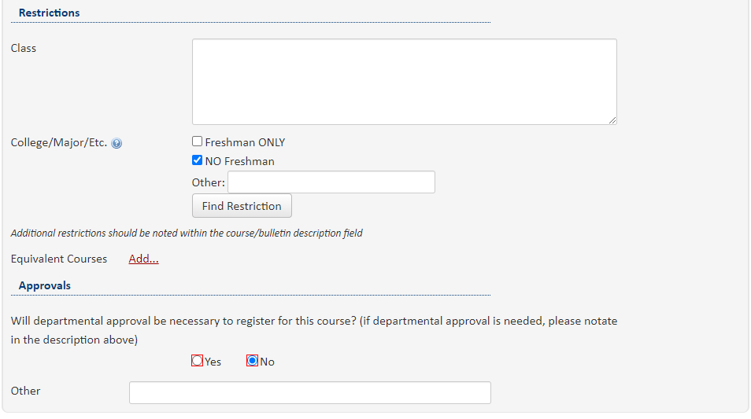

**Figure 7b – Course Example – Part 2**

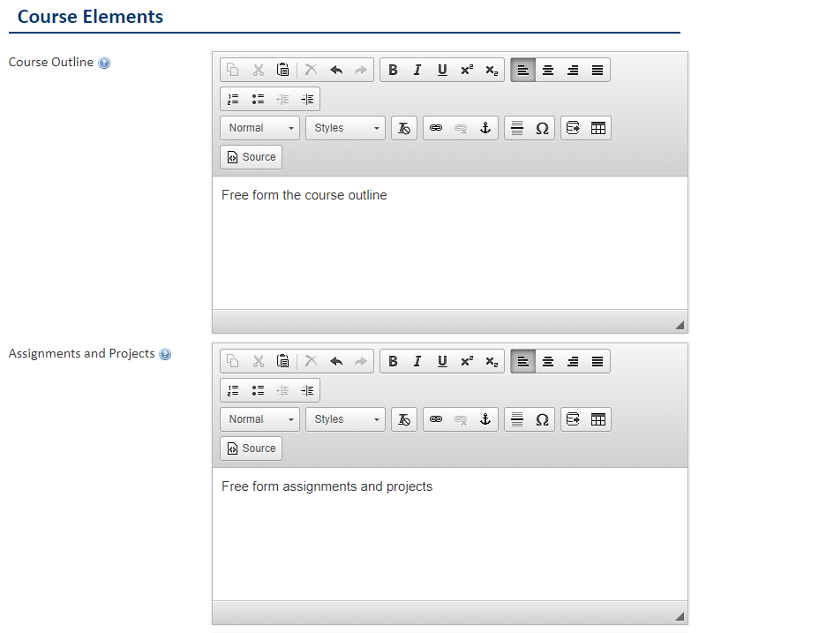

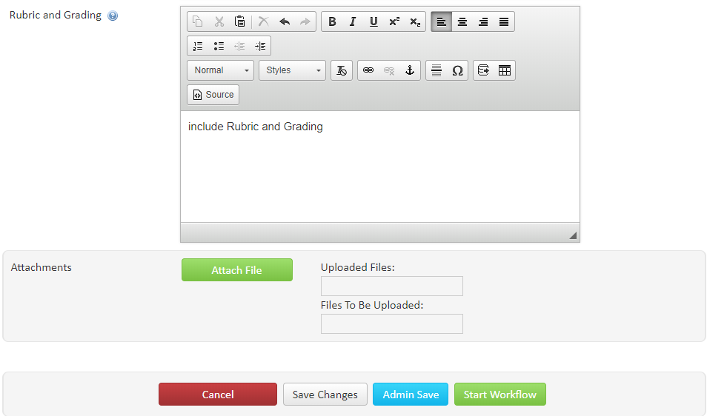

**Figure 7c – Course Example – Part 3**

# Common Topics

* Any data entry field outlined in red is required. An error message will indicate the required fields when an attempt is made to submit a form with missing data.
* Separate proposals are required for combined undergraduate and graduate (5000/6000) courses, because they require different workflow routes.
* The email volume is high from CIM, especially for associate deans and other committee members whose curriculum purview is wide. The email subject line indicates whether action is required or whether the notification is only informational.
* Notifications for course changes can come from seemingly unrelated colleges. For example, if a change is proposed to COMM 1000, Public Speaking, the committees for more than 70 different programs will be notified because they reference it in their curriculum.

# Workflow

Any program or course that is created or updated in CIM is subject to an approval process before becoming part of Auburn University’s inventory. The designated faculty or staff for the department creates or updates the page and clicks the Save & Submit button to move it to the first role in the workflow process. Each Approver will receive an email in turn, and can click the link to take action.

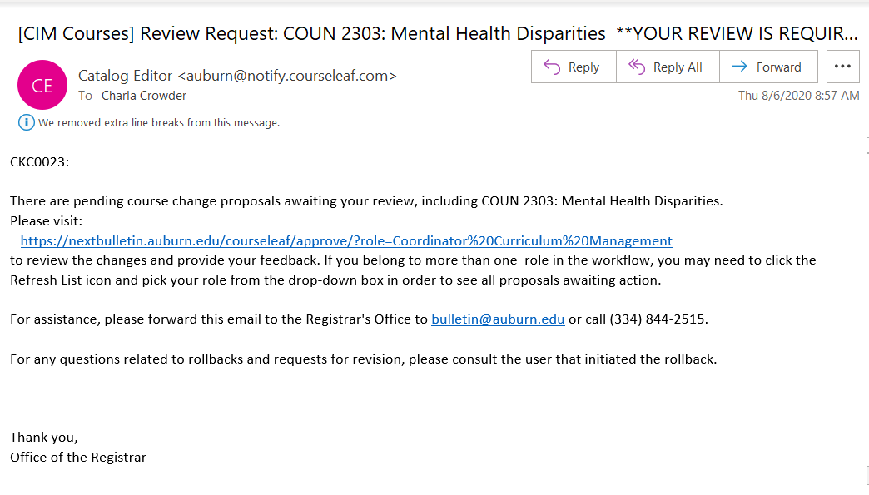

**Figure 8 – Sample Email for an Approver**

Upon clicking the link in the email (or by visiting [<https://nextbulletin.auburn.edu/courseleaf/approve/>](https://nextbulletin.auburn.edu/courseleaf) directly) the current user will arrive at the CourseLeaf Approval Page. Because many users belong to more than one role, and because the system is not always able to tell in which role the current user is acting, the first step should always be to select the correct role from the Your Role dropdown near the top of the page. It is wise to click the Refresh List icon next to the dropdown if the webpage has been open for a while or if several users are actively working on the same program or course at the same time.

From the approval page, the user can click ***Approve*** to move the workflow forward to the next Approver, ***Rollback*** to return the workflow to the previous Approver with comments, or ***Edit*** to make changes and move forward. Some roles are only FYI, meaning no action is required.

For non-FYI roles, the workflow **will not** move forward without approval from the user(s) in that role unless an administrator performs an overriding approval. For unimpeded operation and clean audit trails, it is imperative that roles be kept current and that Approvers respond in a timely manner.

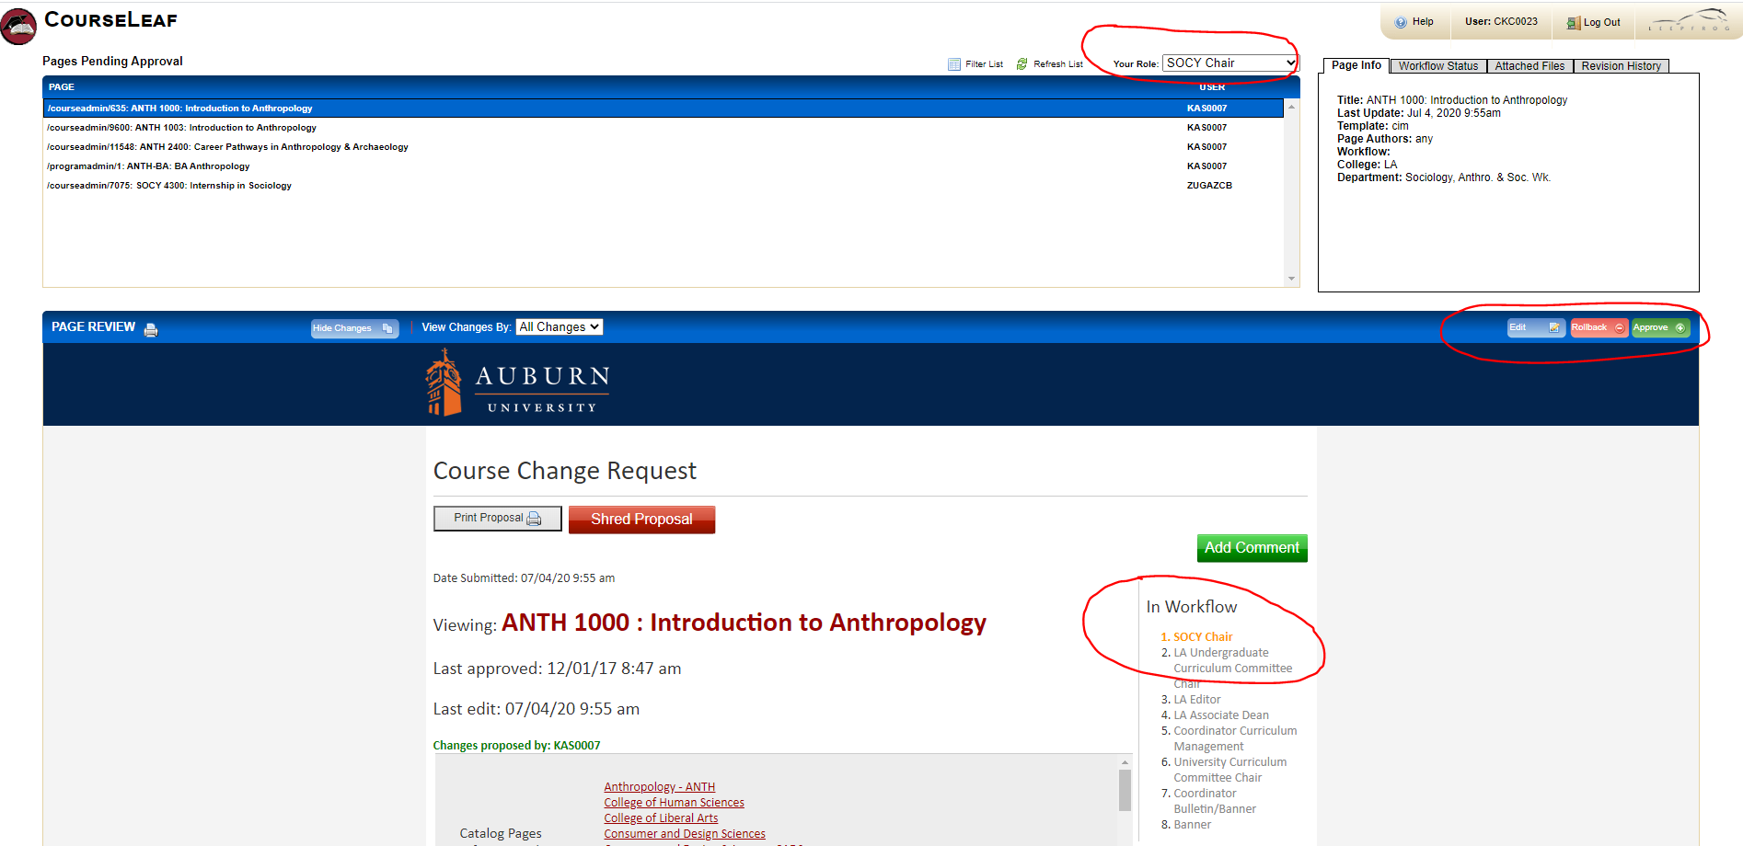

**Figure 9 – Workflow Approval at the Editor Step**

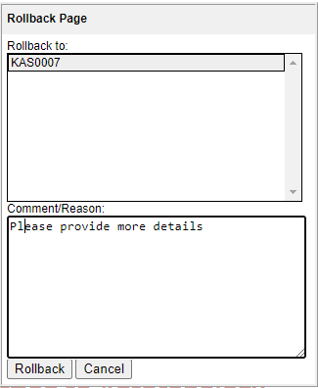

**Figure 10 – Rollback Example**

To the right of the program or course is a column titled “In Workflow.” If a role is shown in green, that stop has already been approved while a role shown in orange is the current stop and the program or course has yet to be approved at that stop. The roles listed beneath the orange and shown in black are the roles/stops remaining in the workflow.

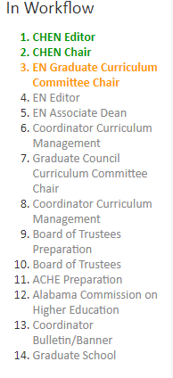

**Figure 11 – Workflow Example**

The history of the workflow builds up with each step and can be viewed at the bottom of the program or course. The rollback comments are not editable, even with assistance from support. To change a comment is to revise history, and it is not allowed.



**Figure 12 – Example of Workflow History**

**Explanation of BANNER Terms**

**Course Title for Bulletin and Transcript:** This is the title that appears in the Bulletin.

**Abbreviated Title for Registration:** This is the title that appears in most on‑line listings. The abbreviated title should be abbreviated in a way that makes the course title clear to the average user (for example, a potential employer reading a student transcript). The length for the title is limited to 30 characters. Do not use periods. Other punctuation, such as commas and hyphens should be used as appropriate. Use Roman numerals to designate first, second, third course in a sequence (e.g. ENGLISH COMPOSITION I, ENGLISH COMPOSITION II, etc.).

**Levels:** Ensure that the level(s) listed for a specific course are correct. 1000, 2000, 3000 and 4000‑level courses may only be offered at the undergraduate level. 5000‑level courses are only for Undergraduate programs with a 5th year (Architecture) and undergraduate courses offered with parallel graduate course. 6000‑level courses are for Graduate and Professional level, and 7000 and 8000‑ level courses are Graduate‑level‑only courses.

**Maximum and Minimum:** The maximum and minimum credit values indicate the number of credit hours for the course. Most fixed‑credit courses are Max Credit 3 and Min Credit 3; this is the default. However, some courses may be offered or taken for a credit value within a range (e.g. 1‑3) and that range is indicated here.

**Connector:** The code establishing the relationship between the maximum and minimum credit. The default is Fixed. Variable credit courses are courses where the student may choose the number of credit hours for a specific offering of the courses. Alternate courses are where the course may be offered only 1 or 5 credits. “To Be Arranged” courses are courses where the department will set the number of credit hours on a section by section basis.

**Maximum Repeat:** The maximum credit obtainable by repeating the course. Note that this is NOT the number of times a course may be repeated, but the maximum credit possible for a course. For most courses the MAX Repeat is the same as the MIN and MAX (3 credits).

A Max Repeat=99 indicates that a course may be repeated with a change in topic with no upper limit.

Session Duplicate: Indicates whether more than one section of the course can be taken during the session of a term. This may be possible in some special problems or special topics courses if there are different topics offered under the same course number but in a different section of the course.

**Grading Rule:** How a grade is calculated in the GPA: either Graduate or Undergraduate (professional courses have undergraduate grade rule).

**Grading Type:** Normal grading (A, B, C, D, F); Pass/fail courses are S/U and Thesis/dissertation courses are TD.

**Term Offered:** The specific terms the course is offered.

**Prerequisites:** This is where prerequisite information is entered for display in the Bulletin. The format used is that of the Bulletin. In Banner, prerequisites and corequisites function as prerequisites and can prevent students from enrolling in a course.

**Corequisites:** This is where corequisite information is entered. A corequisite must be taken the same term as the course.

**Prerequisite with Concurrency:** Prerequisite with concurrency indicates that the course may be taken before or in the same term of the course.

**Description:** The brief description of the course given in the Bulletin is entered here. The description should be written in standard text format. Term information (Fall, Spring, Summer) should not be included in the description text. Also, maximum repeat and change in topic should not be included in the description text. Check to be certain that “Credit will not be given for both COURSE1 And COURSE2” statements are accurate and included everywhere that it is relevant. Interdepartmental courses (STAT/MATH, CMBL/BIOL etc.) are co‑listed in the Bulletin only. Banner recognizes only one subject code per course, so these courses are listed twice. The brief description, excluding pre‑ and corequisites or prerequisites with concurrency, term offerings and credit/contact hours should not exceed 25 words. If you do not keep your Bulletin descriptions brief, the staff preparing the Bulletin will abbreviate them as necessary.

**Activities:** The type of component activities which make up the course offering. The designation code should match the actual course activity type. All 8990 courses are designated as DSR (Dissertation). All 7990 courses are designated as MST (Master’s Thesis). PRA (practicum) and INT (internship) may be used to indicate the same type of activity, at the discretion of the department.

**Contact and Credit Hours:** The number of contact hours for a specific course must be approved by the University Curriculum Committee. The contact hours represent the number of scheduled hours per week associated with the specific activity. The credit hours are number of hours of academic credit given for the successful completion of the course. Contact Hours do not necessarily equal credit hours. For undergraduate courses, the Academic Standards Committee has set the relationship between contact and credit hours as follows: LEC: 1:1; LAB 2:1. Departments may request LAB 3:1 or LAB 4:1 with appropriate justification. For more information, consult: Policy on Contact and Credit Hours.

**Max Enrollment:** The maximum section enrollment associated with an activity, in other words, the number of students per section. This information is important for scheduling the appropriate size of a classroom.

For answers to questions about the UCC, e-mail [bulletin@auburn.edu](mailto:bulletin@auburn.edu).